 | 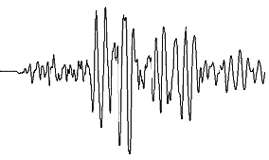 | 
How Often Do Earthquakes Appear on the Seismograph? ¹
(L. Braile, December, 2003; updated November, 2004)
braile@purdue.edu
http://web.ics.purdue.edu/~braile

Objectives: This document and related educational activities (explorations) is designed to help answer the question, how often do earthquakes appear on the seismograph? This is a common question asked by many people who view an operating seismograph including the AS-1 seismograph that is now widely used in educational seismology. In providing an answer to the question, we will also examine some statistics on the frequency of occurrence of earthquakes. This discussion focuses on the AS-1 seismograph and uses examples from an AS-1 station. However, the basic concepts related to seismographs and the frequency of occurrence of earthquakes are valid for all types of seismograph stations.

In addition to the web version of this document, MS Word and PDF versions are available at:
http://web.ics.purdue.edu/~braile/edumod/as1lessons/HowOften/HowOften.doc
http://web.ics.purdue.edu/~braile/edumod/as1lessons/HowOften/HowOften.pdf.

Monitoring Earthquakes: Seismographs are designed to monitor earthquake and other seismic activity by recording small variations in ground motion (vibrations) that propagate from the source (or sources) to the seismograph station and are sensed by the seismometer. The output of the seismometer (a electrical voltage) is usually converted to a digital signal by an analog to digital converter (an “A-to-D” electronic circuit) and displayed (and archived) by computer software.

 Last modified March 13, 2006
The web page for this document is: http://web.ics.purdue.edu/~braile/edumod/as1lessons/HowOften/HowOften.htm.
Funding for this development provided by IRIS and the National Science Foundation.
© Copyright 2003-4. L. Braile. Permission granted for reproduction for non-commercial uses.

For the AS-1 seismograph (for more information see the AS-1 Seismograph links at: http://web.ics.purdue.edu/~braile), the display and analysis software is AmaSeis (http://www.geol.binghamton.edu/faculty/jones/). An example of recorded seismograph data (a 24-hour record of ground motion at the station) is shown in Figure 1 for the AS-1 seismograph station WLIN. The screen display shows one day’s recorded data (September 27, 2003) and includes two recorded earthquakes.

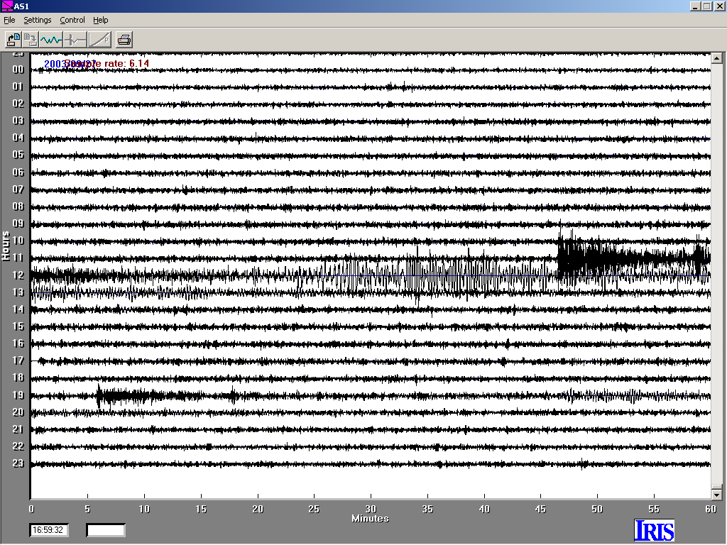
Figure 1. AmaSeis screen display (24-hour seismograph record) for September 27, 2003 for AS-1 seismograph station WLIN (West Lafayette, Indiana). Each line shows one hour of relative ground motion sensed by the AS-1 seismometer, amplified and converted to a digital signal, and stored and displayed by the AmaSeis software. The time is given in UTC (universal time or Greenwich Mean Time, GMT – Eastern Standard Time plus 5 hours in 24-hour time convention). Two earthquakes that occurred in southwestern Siberia, a magnitude 7.3 event (the signal starts at about 11:47) and a magnitude 6.3 aftershock (the signal starts at about 19:06), were recorded by the seismograph.

The number of earthquakes that are recorded on a seismograph depends on the number of significant earthquakes that occur, the type of seismograph, where the seismograph is located, and the background noise level. Small earthquakes that are located at small distances from the seismograph may be recorded. Large earthquakes (magnitude ~6.5 and larger) are usually recorded by seismographs all over the world. Some seismographs (generally the more expensive, research quality seismographs) are more sensitive, capable of recording a broader range of signals (broadband) and have low instrumental noise levels. The background noise level depends on the location of the seismograph, how close it is to noise sources (such as vehicles on roads, machinery, people walking, and structures and trees that cause ground vibration when the wind is blowing), and atmospheric and ocean conditions, even relatively far from the seismograph. For example, Figure 2 shows a 24-hour screen display for July 18, 2003 for station WLIN. Notice that the noise level is very low. However, noise levels are commonly much higher due to weather conditions. Figure 3 shows a 24-hour screen display for September 17-18, 2003 in which a much higher noise level is observed caused by ground motion caused by hurricane Isabel. All seismograph settings, including the gain (level of amplification) were the same for the records shown in Figures 2 and 3. These vibrations (often called microseisms) propagate efficiently through much of the continental lithosphere and result in relatively high noise levels at stations that as far away from the source as a thousand kilometers or more.

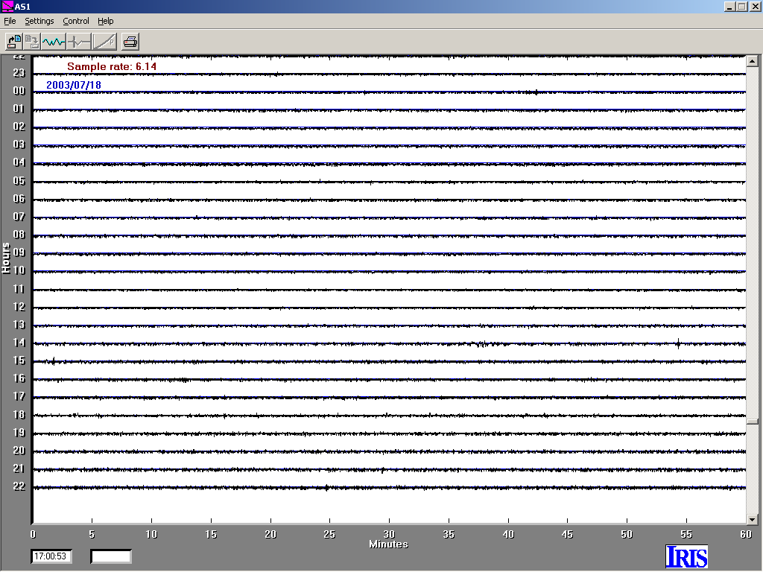
Figure 2. AmaSeis 24-hour screen display for July 18, 2003 for AS-1 seismograph station WLIN.

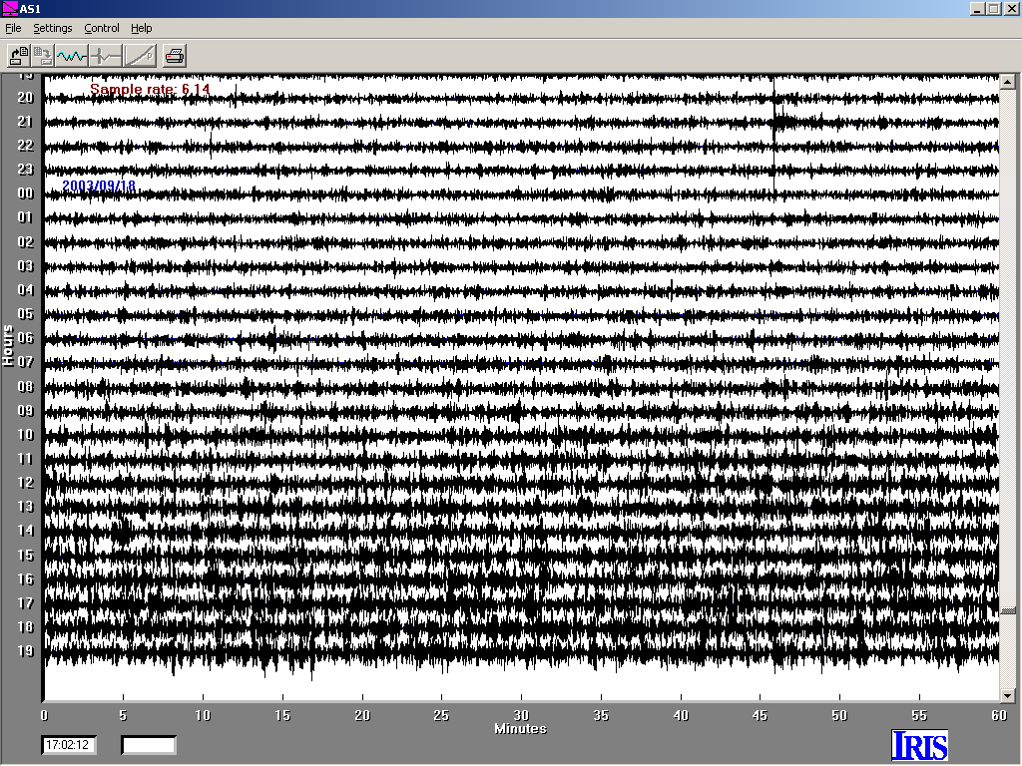
Figure 3. AmaSeis 24-hour screen display for September 18, 2003 for AS-1 seismograph station WLIN. The increase in noise level in the lower half of the display is cause by wave and wind action of hurricane Isabel off the coast of North Carolina. A magnitude 5.9 earthquake signal is visible at about 21:46 (September 17, 2003; near top of the screen).

Frequency of Occurrence of Earthquakes: How often earthquakes of a given size (magnitude) occur in a specified area or over the entire world has been studied for many years. The results (Table 1) represent important statistics on earthquake occurrence that allow forecasting of earthquakes (making a probability statement, not a prediction) and provide one answer to our question of how often earthquakes appear on the seismograph. For example, the data contained in Table 1 indicate that small earthquake occur much more often than large earthquakes and that number of events within each given magnitude range is about a factor of ten greater than the number in the next higher magnitude range. This relationship, called the frequency-magnitude or Gutenberg-Richter relationship (named after two prominent seismologists of the twentieth century), is also shown in graphical form in Figure 4 (note the logarithmic scale on the vertical axis).

Because most earthquakes are small and likely to be far away from our seismograph station, we will focus on the larger events to answer our question of how often earthquakes appear on the seismograph. Because most earthquakes of magnitude 7 or greater will be recorded by seismographs all over the world, we can examine the frequency of occurrence of M7+ earthquakes. The data in Table 1 (and Figure 4) indicate that about 18 M7+ earthquakes are likely each year (the statistics in Table one are averages of many years of earthquake occurrence data). This average suggests that we could expect a large earthquake (M7+) to be visible on our seismograph record about 18 times per year or an average of every 20 days. Of course smaller earthquakes, particularly those events that are relatively close to the seismograph station, may also be recorded by our seismograph but earthquakes that are much smaller are not likely to be recorded unless they are very close.

Table 1. Frequency-magnitude statistics for worldwide earthquakes (data from the US Geological Survey, http://neic.usgs.gov/neis/general/magnitude_intensity.html). The descriptors are convenient terms for describing consistently the size of an earthquake. Earthquakes smaller than magnitude 2 occur frequently but are not consistently recorded by seismographs.
Descriptor | Magnitude | Average Annually
Great | 8 and higher | 1 ¹
Major | 7 - 7.9 | 17 ²
Strong | 6 - 6.9 | 134 ²
Moderate | 5 - 5.9 | 1319 ²
Light | 4 - 4.9 | 13,000  (estimated)
Minor | 3 - 3.9 | 130,000  (estimated)
Very Minor | 2 - 2.9 | 1,300,000  (estimated)
¹ Based on observations since 1900.
² Based on observations since 1990.

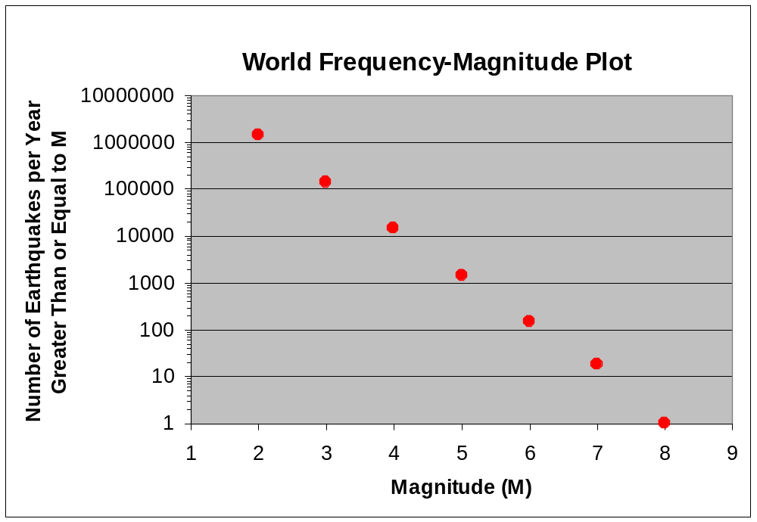
Figure 4. Frequency-magnitude plot for the data shown in Table 1. The statistics are for worldwide earthquakes per year.

Another approach to answering the question of how often earthquakes will appear in the seismograph is simply to utilize the experience of monitoring earthquakes at a particular seismograph station. For example, for station WLIN, 203 earthquakes have been recorded over a period of a little less than 4 years indicating that a recognizable earthquake signal will be visible on the seismograph, on the average, of about every 7 days. The AS-1 seismograph station WLIN is located in the relatively low seismicity central United States so most of the recorded earthquakes are large, relatively distant events (often called teleseisms).

One can view near real time displays of AS-1 seismographs (including station WLIN) by connecting to http://www.scieds.com/spinet/. To view near real time displays of many Global Seismograph Network (GSN, http://www.iris.edu/about/GSN/) stations, go to http://www.liss.org/. Further information about earthquake monitoring results from the WLIN station can be found at:
http://web.ics.purdue.edu/~braile/edumod/MagCalc/AS1Results.htm.

To further explore the frequency of occurrence of earthquakes (the results described above provide only average times between events), we can examine the frequency of occurrence of large earthquakes over a specific time period. We can use a catalog search (or event search) to obtain these data. Instructions for performing an Internet catalog search are available at http://web.ics.purdue.edu/~braile/edumod/eqdata/eqdata.htm. For example, a catalog search (using the methods described in the previously-mentioned instructions) of the USGS earthquake data archive was performed to find all magnitude 7 and larger earthquakes for the world from January 1, 1995 to December 3, 2003. A partial list of the results is shown in Table 2. A total of 173 earthquakes were included in the list. The time in days between M7+ earthquakes was determined from the dates and grouped into 5-day periods (1 [or less] to 5 days, 6 – 10 days, 11 – 15 days, etc.) and the results plotted as a histogram (bar graph) as shown in Figure 5.

Table 2. Partial listing of the catalog search for worldwide M7+ earthquakes from January 1, 1995 to December 3, 2003 (relevant headings are: CAT = catalog name; YEAR = Year; MO = month; DA = day; ORIG TIME = origin time [HrMnSS.ss, UTC time in Hours:Minutes:Seconds:Decimal Seconds]; LAT = latitude [negative for S latitude]; LONG = longitude [negative for west longitude]; DEP = depth in km; MAGNITUDE = magnitude and magnitude type [for explanation of magnitudes, see:
http://neic.usgs.gov/neis/general/magnitude_intensity.html]).

CAT YEAR MO DA ORIG TIME LAT LONG DEP MAGNITUDE IEFM DTSVNWG DIST
NFPO km
TFS

PDE 1995 01 06 223734.32 40.25 142.18 26 7.00 MwHRV 7CFG .......
PDE 1995 02 05 225105.14 -37.76 178.75 21 7.50 Ms GS .FFG .......
PDE 1995 03 19 235314.92 -4.18 135.11 33 7.10 Ms GS .DFG .......
PDE 1995 04 07 220656.89 -15.20 -173.53 21 8.10 MsBRK 5FFG .T.....
PDE 1995 04 21 003010.82 11.93 125.56 17 7.20 Ms GS ...G .......
PDE 1995 04 21 003446.09 12.06 125.58 20 7.30 Ms GS 4D.G .T.....
PDE 1995 05 05 035345.05 12.63 125.30 16 7.10 MsBRK .FFG .......
PDE 1995 05 16 201244.22 -23.01 169.90 20 7.80 MsBRK 3FFG .T.....
PDE 1995 05 27 130352.65 52.63 142.83 11 7.50 Ms GS 9CFG F......
PDE 1995 07 03 195050.62 -29.21 -177.59 35 7.20 Ms GS 6F.G .......

The histogram results (Figure 5) show that, although the average time between M7+ earthquakes (for the time period examined) is 19 days (approximately the same as the longer-term average of 20 days discussed above from the data in Table 1), the time between events varies considerably and is as large as 99 days. However, most of the time periods between events are relatively short – from 0 to 35 days. A few of the small time between earthquakes data (usually in the 1-5 days group) correspond to earthquakes that are aftershocks of a larger event (locations of the main shock and aftershock are very close) or “pairs” of events (two earthquakes of nearly the same magnitude that occur closely spaced in time and location). Also notice that the histogram shows a fairly smooth, decreasing pattern of number of events (in 5-day periods) versus time (days) as approximated by the smooth line fit to the data in Figure 5. If we included significantly more data (M7+ earthquakes from a longer time period) in our analysis, it is likely that the histogram would show an even smoother pattern.

Also, note that there are no significant peaks in the histogram meaning that the earthquake sequence that we analyzed does not show any periodicity. For example, if there was a prominent peak in the histogram for the 16-20 days bar, it would indicate that the earthquakes were occurring almost periodically (every 16-20 days). If earthquakes occurred periodically in time, we would not see longer times between events because there would always be an event at least every T days where T is period. Because we do not see a significant peak, the results suggest that earthquakes (at least the M7+ earthquakes that we have analyzed) are not controlled by periodic processes such as tides or seasons and occur much more randomly in time. However, it is possible to make some general statements about the frequency of occurrence of the M7+ earthquakes. As noted in Figure 5, the median time period between the M7+ earthquakes studied is 14 days. This statistic means that fifty percent of the time an M7+ earthquake is followed by another M7+ event (somewhere in the world) within 14 days. Similarly, fifty percent of the time, the time period between events is more than 14 days. Thus the median and the pattern of numbers of earthquakes shown in the histogram (Figure 5) provide us with a useful, although not precise, answer to the question of how often earthquakes will appear on the seismograph. Further, the exponential relationship seen in the data in Figure 5 is consistent with earthquakes being randomly spaced in time. We will explore this concept further to better understand the probability and statistics of randomly spaced event by using a simulation with dice.

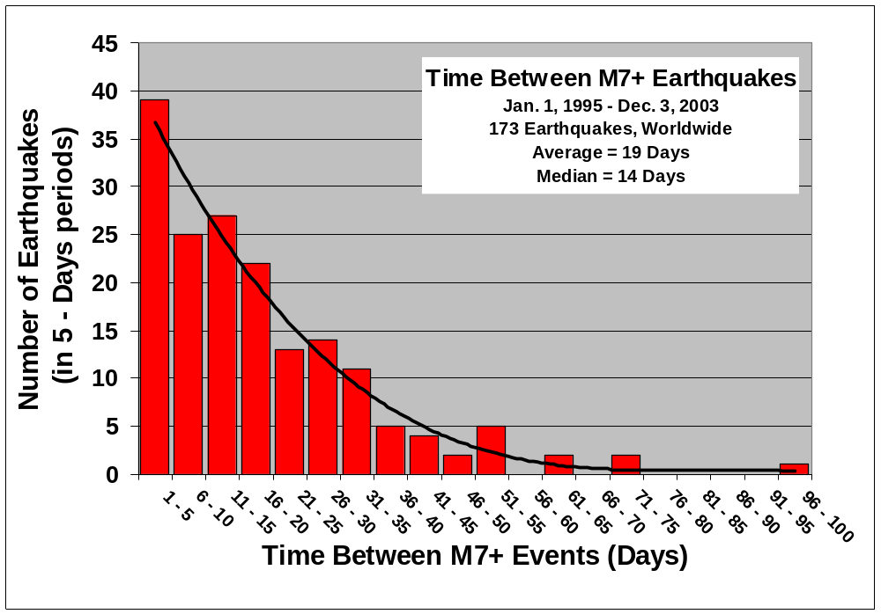
Figure 5. Histogram (bar graph) showing the number of days between occurrences of earthquakes of magnitude 7 or greater from January 1, 1995 to December 3, 2003. The heavy black line is a smooth curve fit to the data.

Suggestions for activities/exploration of the frequency of occurrence of earthquakes: To further explore the frequency of occurrence of earthquakes and the question of how often do earthquakes appear on a seismograph, try one or more of the following activities.

1. Perform a catalog search for M7+ earthquakes for a different time period than the search discussed here. Instructions for performing a catalog search are provided at: http://web.ics.purdue.edu/~braile/edumod/eqdata/eqdata.htm. Approximately a 5 year or greater time period is suggested to obtain sufficient data for reasonably reliable statistics. A time period beginning January 1, 1973 or later is suggested because the USGS online earthquake catalog is most complete after this date. Calculate the times between earthquakes (round off to the nearest day) for the resulting data (similar to the data shown in Table 2) and create a histogram (hand plot or graph using Excel or similar software). Compare your results with the histogram shown in Figure 5.

2. Perform a catalog search for M6+ earthquakes for a one or two year time period. Use the catalog search methods described in the web page listed in activity number 1 (above). Calculate the times between earthquakes (round off to the nearest day) for the resulting data (similar to the data shown in Table 2) and create a histogram (hand plot or graph using Excel or similar software). Because there will be more earthquakes per year for the M6+ search than for the M7+ search (the data in Table 1 and Figure 4 suggest that there will be about 10 times as many), group the time between events results into one or two day time periods to create the histogram. Compare the results with the histogram shown in Figure 5. Although the time scales will be different, the shape of the histogram should look similar to the histogram in Figure 5. What is the average (mean) time period between M6+ events? What is the median time period (half of the time periods are less and half are more)? Why might a seismograph not record all of these events?

One could also perform this search for a longer time period (about 20 years) for a smaller area such as California, Japan or Alaska. To perform such a search, use the Rectangular Area search (with appropriately chosen latitude and longitude ranges) in the USGS or IRIS online search tools described in the web page at: http://web.ics.purdue.edu/~braile/edumod/eqdata/eqdata.htm. An example of the results of searching for all magnitude 6 and greater earthquakes for a one year period is shown in Figure 6.

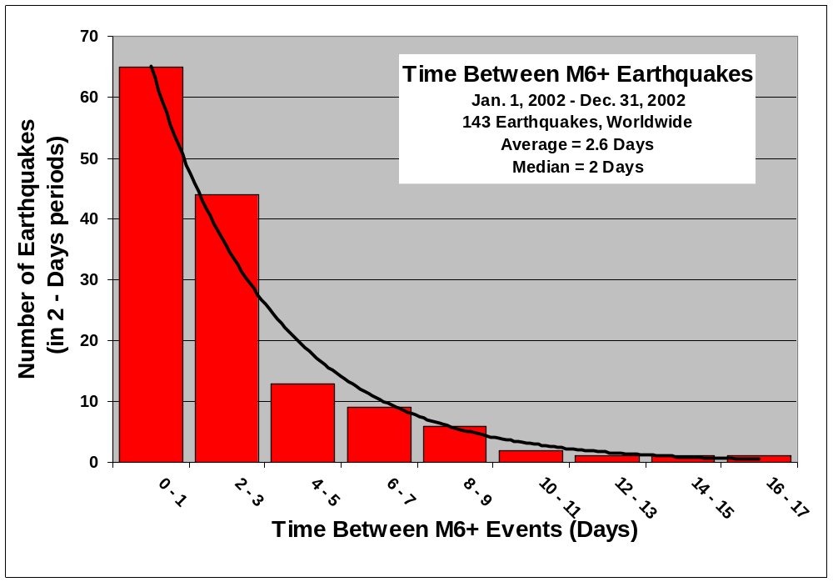
Figure 6. Histogram (bar graph) showing the number of days between occurrences of earthquakes of magnitude 6 or greater from January 1, 2002 to December 31, 2002. The heavy black line is a smooth curve fit to the data.

3. Perform a frequency-magnitude analysis (count events using the counter in the upper right hand corner of the SeisVolE screen; change the magnitude cutoff to count the number of events greater than or equal to the selected magnitude cutoff; Figure 6) for a specific area (such as California and Nevada (Figure 6) and a specific time period using the Seismic Eruption program (SeisVolE; http://www.geol.binghamton.edu/faculty/jones/, http://web.ics.purdue.edu/~braile/edumod/svintro/svintro.htm) or us the online earthquake search tools (see http://web.ics.purdue.edu/~braile/edumod/eqdata/eqdata.htm).

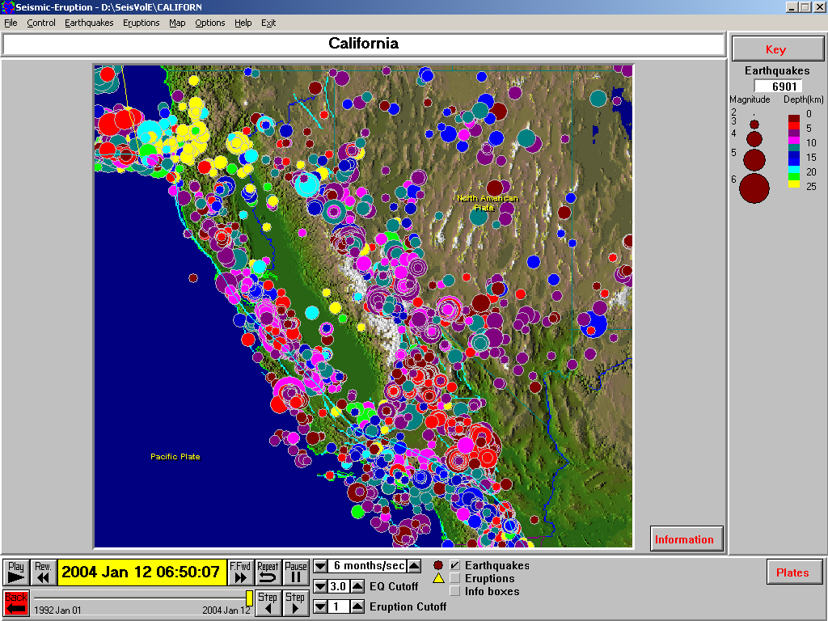
Figure 6. Example of epicenter map from the Seismic/Eruption program.

4. Examine noise levels at GSN stations using LISS (http://www.liss.org/)

5. After an event (with 24-hours, or copy the web page within 24 hours) examine seismograms from GSN stations using LISS, try to estimate location of event (which station is closest), note signal changes with distance and amplitude variation with distance

6. correlation demo to see periodicity

