 | 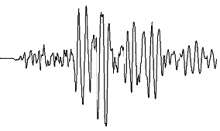 | 

Mystery Earthquakes Information ¹

 | Larry Braile  Professor, Purdue University  braile@purdue.edu  http://web.ics.purdue.edu/~braile/  December, 2006

Objective: The information contained here is related to the Interpreting Seismograms tutorial (http://web.ics.purdue.edu/~braile/edumod/as1lessons/InterpSeis/InterpSeis.htm). Specifically, this document contains the complete hypocenter information (Table 1) for the mystery events listed in the tutorial as well as links to the digital seismograms (Table 2).

This mystery event information (Excel file of hypocenter information and links to correct time seismograms) is available for viewing with a browser (html file) and for downloading as an MS Word document or PDF file at the following locations:
http://web.ics.purdue.edu/~braile/edumod/as1lessons/InterpSeis/MysteryEqs.htm
http://web.ics.purdue.edu/~braile/edumod/as1lessons/InterpSeis/MysteryEqs.doc
http://web.ics.purdue.edu/~braile/edumod/as1lessons/InterpSeis/MysteryEqs.pdf.

 Last modified December 28, 2006
The web page for this document is:
http://web.ics.purdue.edu/~braile/edumod/as1lessons/InterpSeis/MysteryEqs.htm
Partial funding for this development provided by the National Science Foundation.
© Copyright 2006. L. Braile. Permission granted for reproduction for non-commercial uses.

Table 1. Excel spreadsheet showing the hypocenter information for the 12 mystery events contained in the Interpreting Seismograms tutorial.
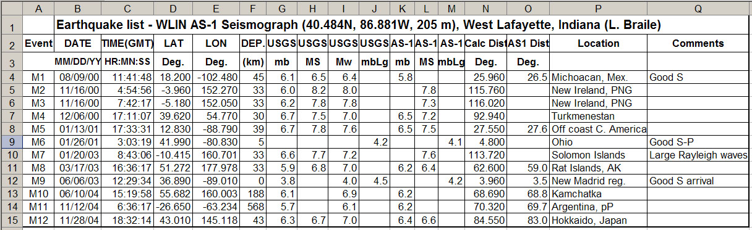
The excel file can be downloaded using the following link:
http://web.ics.purdue.edu/~braile/edumod/as1lessons/InterpSeis/MysteryEvents.xls.

Table 2. Seismogram download files for (correct time) mystery events.
EQ | Seismogram
M1 | http://web.ics.purdue.edu/~braile/edumod/as1lessons/InterpSeis/0008091147WLIN.sac
M2 | http://web.ics.purdue.edu/~braile/edumod/as1lessons/InterpSeis/0011160514WLIN.sac
M3 | http://web.ics.purdue.edu/~braile/edumod/as1lessons/InterpSeis/0011160802WLIN.sac
M4 | http://web.ics.purdue.edu/~braile/edumod/as1lessons/InterpSeis/0012061726WLIN.sac
M5 | http://web.ics.purdue.edu/~braile/edumod/as1lessons/InterpSeis/0101131740WLIN.sac
M6 | http://web.ics.purdue.edu/~braile/edumod/as1lessons/InterpSeis/0101260305WLIN.sac
M7 | http://web.ics.purdue.edu/~braile/edumod/as1lessons/InterpSeis/0301200902WLIN.sac
M8 | http://web.ics.purdue.edu/~braile/edumod/as1lessons/InterpSeis/0303171646WLIN.sac
M9 | http://web.ics.purdue.edu/~braile/edumod/as1lessons/InterpSeis/0306061231WLIN.sac
M10 | http://web.ics.purdue.edu/~braile/edumod/as1lessons/InterpSeis/0406101531WLIN.sac
M11 | http://web.ics.purdue.edu/~braile/edumod/as1lessons/InterpSeis/0411120647WLIN.sac
M12 | http://web.ics.purdue.edu/~braile/edumod/as1lessons/InterpSeis/0411281845WLIN.sac

