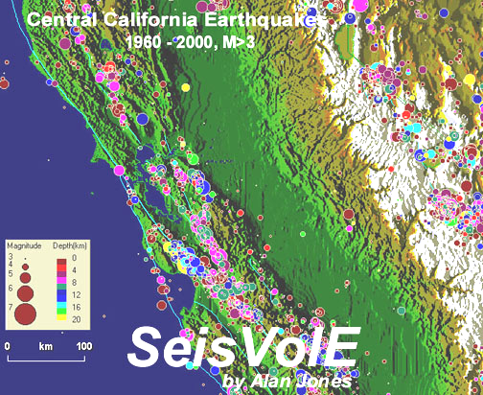 | - Using the  standard views  included in  SeisVolE©  
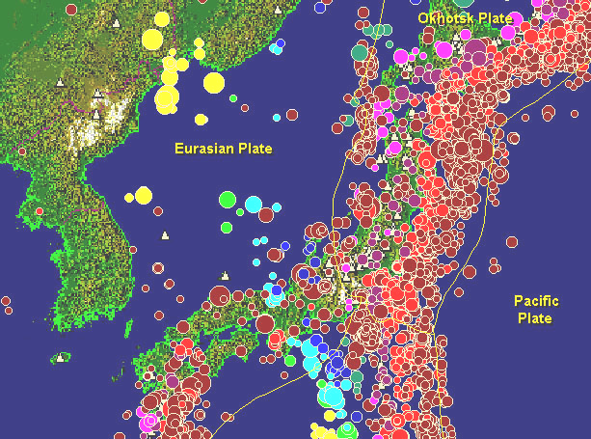 | Lawrence W. Braile,  Professor  Department of Earth and  Atmospheric Sciences  Purdue University  West Lafayette, Indiana  Sheryl J. Braile, Teacher  Happy Hollow School  West Lafayette, Indiana  January 14, 2002

Objectives: Many important characteristics of earthquake and volcanic activity, and the relationship of earthquakes and volcanoes to plate tectonics can be investigated and illustrated using the standard view that are available in SeisVolE. This module explores the distribution of earthquakes in space and time beginning with a global view and focusing in on smaller and smaller areas. The association of earthquakes and volcanoes with plate boundaries, and the frequency of volcanic eruptions are also investigated.

Information: SeisVolE provides many standard views that can be displayed on the screen by just clicking on a button. With these views, one can observe earthquake and volcanic activity in any location around the world and in any tectonic environment. For each view, the earthquake and volcanic activity is displayed in “speeded up real time” so that one can see not only where earthquakes have occurred, but also the patterns in time. To further enhance the display, the epicenters and volcanic eruptions are plotted with symbols that are scaled according to magnitude of the earthquake or eruption. Further, the epicenter symbols are color-coded to indicate earthquake depth. The earthquake and eruption data are displayed on a color background map that represents topography (shaded terrain or shaded relief maps; white and brown colors indicate the highest topography, usually mountains; shades of green represent lower elevations; shades of blue are used to display bathymetry – depth below sea level, with the darkest blue indicating the deepest water depths). The shaded relief maps are an attractive background and provide important and interesting information such as the locations of mountain ranges and deep-sea trenches that are associated with plate tectonics and the distribution of earthquakes and volcanoes. For each view, one can control the “playback speed”, time period viewed, and many other characteristics of the display with the buttons at the bottom of the screen and the menus at the top of the screen. If you make changes in the view and wish to save them for future reference, you can save the new view (select a different name) by selecting Save View As from the File menu. If you are going to make significant changes to a standard view, particularly a change in the shaded relief topographic file, it is best to save the view first using the Save View As command (use a different name) and then make your modifications on the new view. If you do not do this, it is possible to lose the shaded relief file from the standard view or otherwise corrupt the view so that it will not look the same as the original. If you wish to recover a view that has been corrupted, install a new version of SeisVolE (a good reason to keep the install file, seisvole.exe, in a TEMP or DOWNLOAD folder) in a temporary folder (use the browse option when the dialog box that describes the folder that SeisVolE will be installed in appears). Then select the appropriate files for a particular view in the temporary SeisVolE installation and copy and paste them into your regular version (in the SEISVOLE folder). You will usually need to copy and paste 4 files for each view. For example, if the corrupted view is the Kuriles, the files that you will need to copy are: Kuriles, Kuriles.sav, Kuriles.inf and Kuriles.plt in order to recover the original, standard view. The saved views (as well as the standard views) may be opened by selecting Open View in the File menu.

Earthquakes and Volcanic Eruptions in Space and Time: In this section we will look at earthquake and volcano activity in space and time. We will begin with a global view (Figure 3.1) and then examine smaller areas. By playing back the events from 1960 to 2000 (or the present), one can see how the activity varies (or is relatively consistent) through time. Some interesting questions to answer or consider are:

  - Where do most earthquakes occur?

3.2 Many earthquakes occur along continental margins. Are all continental margins seismically active?

  - Where do earthquakes occur within ocean basins?

3.4 Where are the most seismically inactive areas of the world?

  - Are most earthquakes shallow (less than about 70 km)? Where do deep (greater than 300 km depth) earthquakes occur?

3.6 When viewing earthquake activity through time, do you see any obvious patterns or are earthquakes occurring somewhere almost all the time?

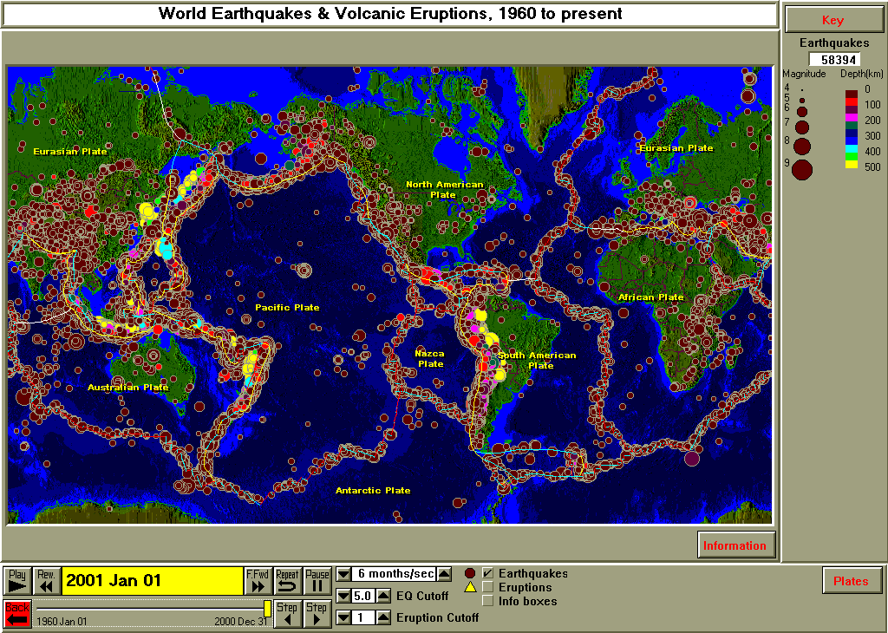
Figure 3.1 World earthquake, 1960-2000. For this view, plotting of eruptions has been turned off. Epicenters are colored circles (size proportional to magnitude, color-coded for depth). Plate boundaries are shown by colored lines.

Open the Pacific Ocean view (Figure 3.2) and observe earthquake activity and volcanic eruptions through time (1960-2000). You may wish to adjust the playback speed with the arrow buttons at the bottom of the screen. After adjusting the speed, or to view the activity again, click on the Repeat button. Notice that earthquake (Figure 3.2) and volcanic activity (Figure 3.3) is related, and nearly continuous around the Pacific Ocean basin, giving rise to the name “Pacific Ring of Fire”.

  - In viewing the earthquake and eruption activity through time, do you notice any relationship between earthquake and eruption activity? In space (location)? In time?

  - Although there is a small number of earthquake in Australia, the greatest earthquake activity of that area is in relatively narrow seismic zones that surround the continent of Australia. What is the explanation for this pattern?

  - Where are deep-focus (greater than 300 km depth) earthquakes? What is the relationship of deep focus earthquakes to nearby shallow earthquakes?

  - Identify several “volcanic arcs” – arc-shaped zones of both volcanic and earthquake activity.

  - The Pacific Ocean view represents about half of the area of the Earth’s surface. About what percentage of the Earth’s earthquakes occur in the Pacific area (use the counter in the upper right hand corner of the World and Pacific Ocean views, Figures 3.2 and 3.3, for the magnitude 5 and above events to calculate the percentage)?

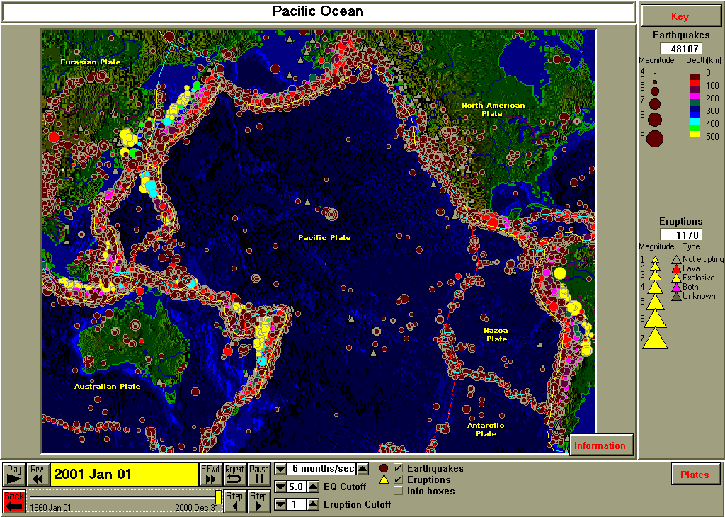
Figure 3.2. Earthquakes and volcanic eruptions (1960-2000) for the Pacific Ocean region.

3.12 You can use the earthquake counter to determine how many earthquakes of a given magnitude range occur in a time period. Set the magnitude cutoff to 8 and click repeat to find out how many earthquakes of magnitude 8 or greater occurred since 1960. Performing this exercise for several magnitudes and plotting the data results in the graph (histogram) shown in Figure 3.3.

Magnitude is a measure of the energy released by an earthquake, or the size of the earthquake. The magnitude scale is logarithmic so that each increase of one unit of magnitude corresponds to a ten-fold increase in the amplitude on a seismogram. In terms of energy released, an increase of one magnitude unit corresponds to approximately a 32 –fold increase in energy. The magnitude scale is not a 1 to 10 scale. Negative magnitude earthquakes occur very frequently (although because of the definition of magnitude, negative magnitude does not correspond to negative energy released), and the largest magnitudes earthquakes know are about 9.5, but magnitudes greater than 10 are possible, although very unlikely. There are several magnitude scales (although seismologists are increasingly using only the most reliable of the scales, the moment magnitude, whenever possible) and the scales differ primarily for very large earthquakes. For the purposes of plotting earthquake maps with SeisVolE and analyzing the numbers of earthquakes of different sizes within an area, it is sufficient to utilize the single magnitude that is provided in the earthquake catalog in SeisVolE. For additional information on measuring the size of earthquakes and the different magnitude scales, see: Bolt (1993 and 1999), Jones (1995), dePolo and Slemmons (1990), Johnston (1990), Monastersky (1994) or the Internet sites:
http://pubs.usgs.gov/gip/earthq4/severitygip.html
http://www.seismo.berkeley.edu/seismo/faq/magnitude.html
http://neic.usgs.gov/neis/general/handouts/general_seismicity.html
http://www.seismo.unr.edu/ftp/pub/louie/class/100/magnitude.html
http://lasker.Princeton.edu/ScienceProjects/curr/eqmag/eqmag.htm
http://www.eas.slu.edu/People/CJAmmon/HTML/Classes/IntroQuakes/Notes/earthquake_size.html

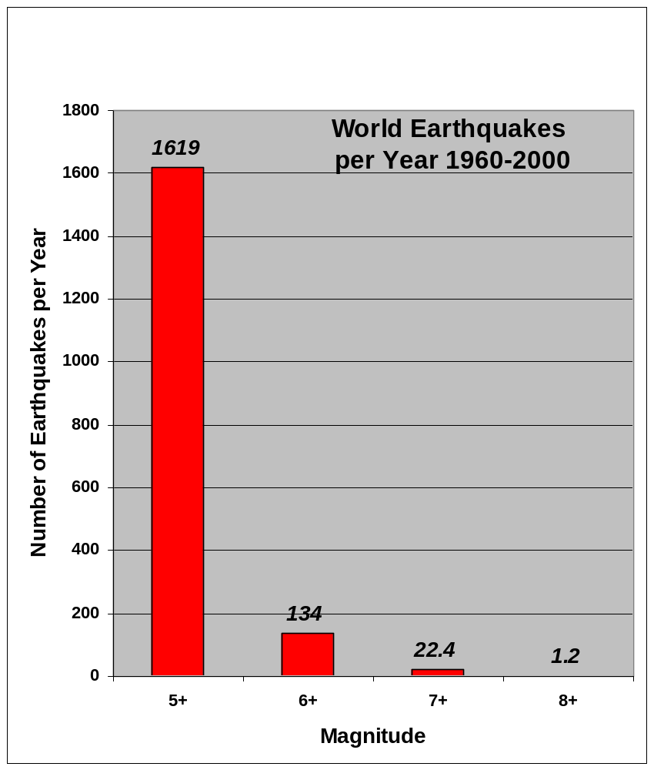
Figure 3.3 Number of earthquakes per year with magnitudes greater than or equal to 5, 6, 7, and 8. The results are from the world catalog for 1960-2000.
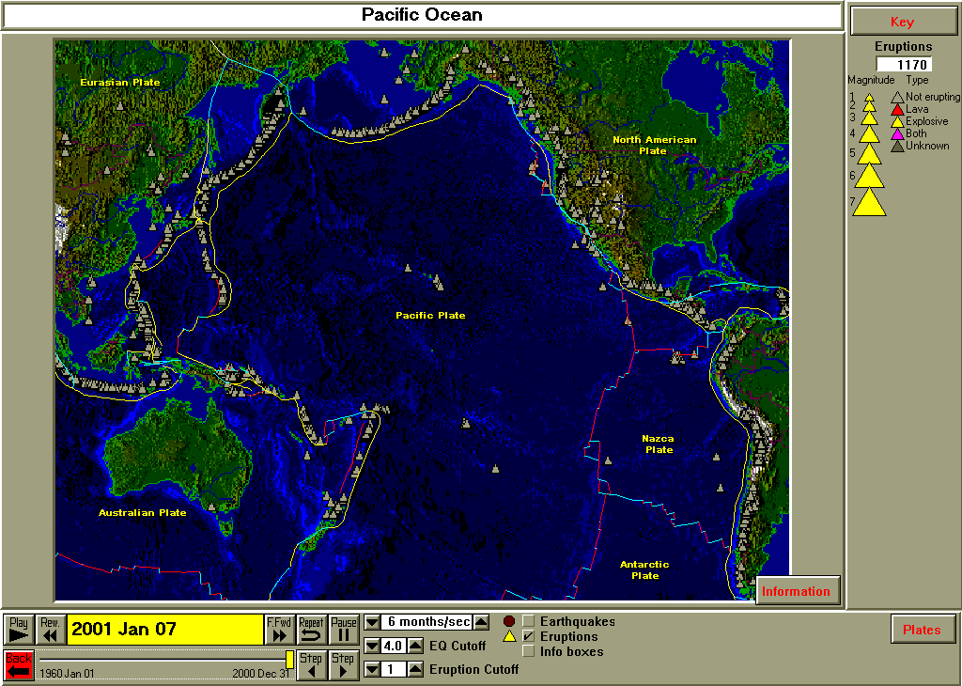
Figure 3.4. Volcanic eruptions (1960-2000) for the Pacific Ocean region. Volcanoes are shown by triangles.

Focusing in on a smaller, tectonically active region, open the South America view (Figure 3.5). The continent of South America has a very active earthquake and volcano zone along the west coast of the continent.

  - Notice that the west coast of South America is very active while the east coast has almost no earthquakes or volcanoes. What could be the cause of this difference?

  - Notice the trend of deep-focus earthquakes in the central part of western South America. Using the color coding of the epicenters (see Key in the upper right corner of the screen), how does the depth of focus of earthquakes vary with distance from the coastline?

  - What topographic and bathymetric (depth below sea level) features are associated with the earthquake and volcanic activity along the west coast of South America (these topographic features will be most visible on the screen before all the epicenters are plotted; restart the view with the Repeat button and then click on Pause)? What topographic and bathymetric (depth below sea level) features are associated with the earthquake and volcanic activity along the east coast of South America?

  - There is a distinct change in the intensity of earthquake activity along the west coast of South America as one goes south of the intersection with a trend of epicenters (a mid-ocean ridge and transform fault system with a characteristic “zigzag” pattern of epicenters) from the Pacific Ocean near the southern tip of the continent. There are also no deep-focus events adjacent to the coastline in this area. What plate tectonic (plate velocity) situation could explain these observations?

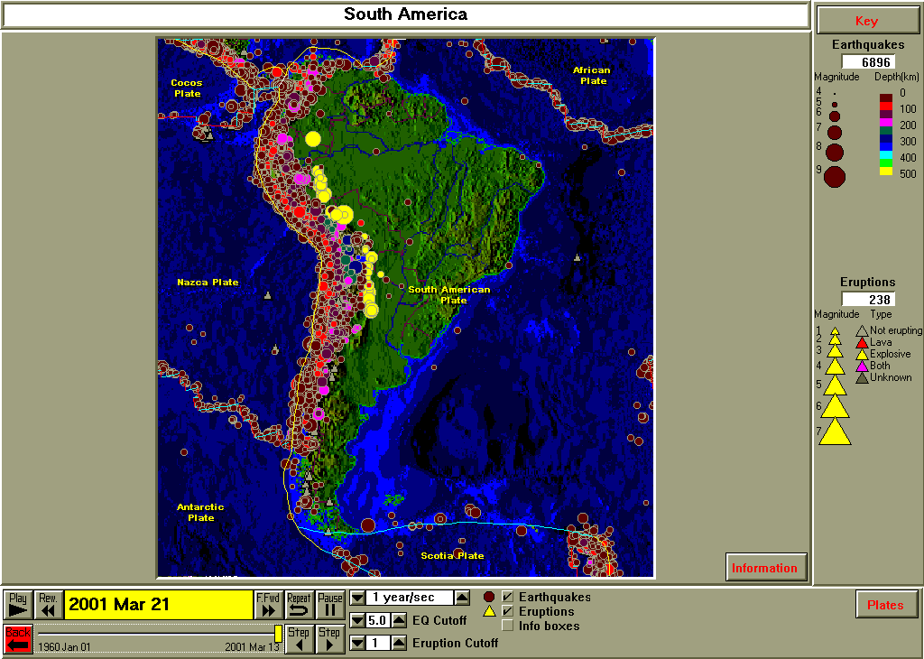
Figure 3.5. Earthquakes and volcanic eruptions (1960-2000) for South America.

Open the Japan view (Figure 3.6) to observe earthquake and volcanic activity in a western Pacific area – the Japan region. Two prominent trends of epicenters intersect in Japan. Notice the intermediate- and deep-focus earthquakes to the west of northern Japan and to the west of the south-trending zone of epicenters near the bottom of the map.

  - Compare the distribution of intermediate- and deep-focus earthquakes to the west of northern Japan with those in the south-trending line of epicenters near the bottom of the map. What are the similarities in the patterns? What are the differences?

  - We can further investigate the intermediate- and deep-focus earthquakes by making cross-section views (although there are some cross-sections in the standard views, there are no cross-sections available for the Japan area in the standard views; instructions for making cross-sections are included in Teaching Module 14). Figure 3.7 shows the Japan region and an area (white rectangle) in which the earthquakes are projected onto cross-section along the profile shown in red. The cross-section view of earthquakes to the west of northern Japan is shown in Figure 3.8. A similar cross-section was constructed for the epicenters that trend south from Japan. The cross-section view is shown in Figure 3.9. Both cross-sections illustrate dipping zones of earthquakes (called Benioff zones after the seismologist who first recognized them) that are caused by subduction (under-thrusting) of slabs of oceanic lithosphere. What is the angle of dip (in degrees; the cross-section diagrams are at a 1:1 scale – no vertical exaggeration, so you can measure with a protractor) of the two dipping slabs?

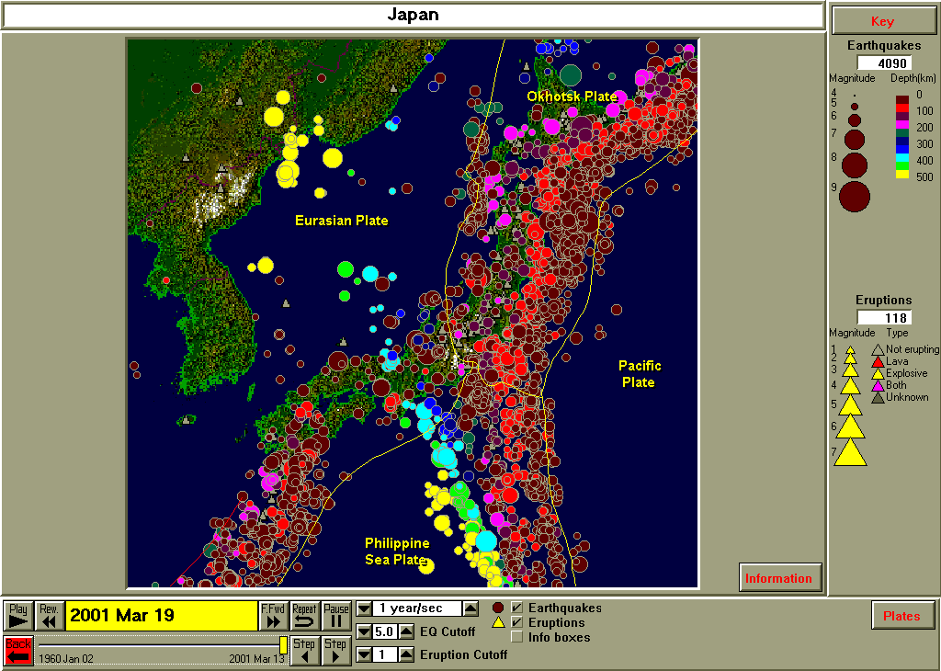
Figure 3.6. Earthquakes and volcanic eruptions (1960-2000) for Japan.

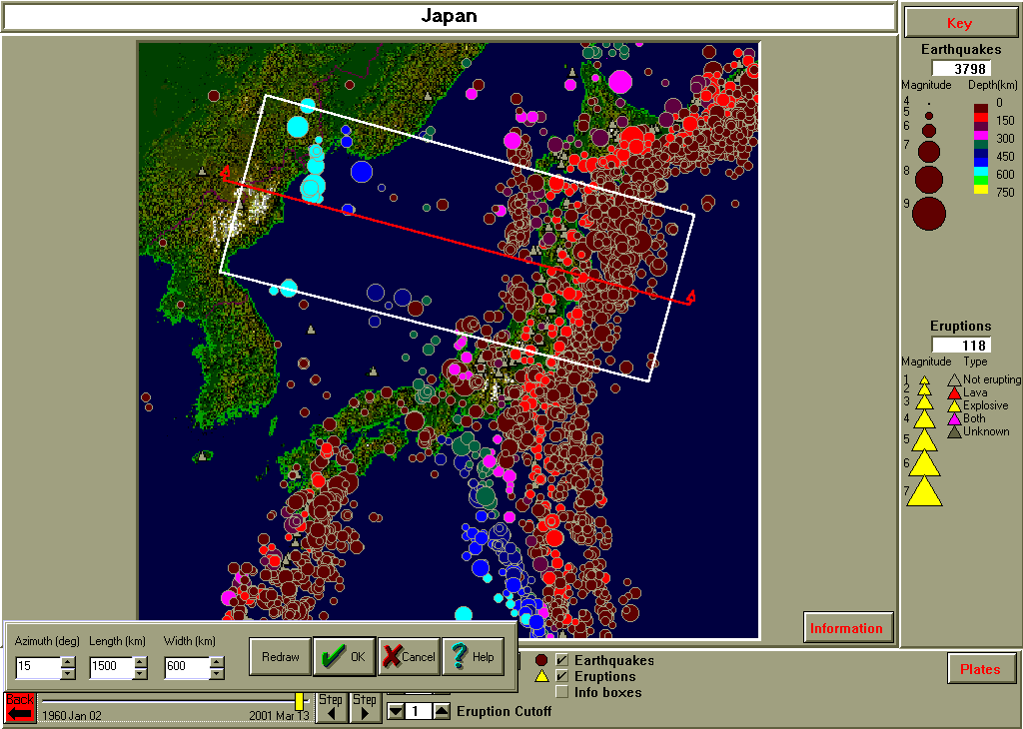
Figure 3.7. Area (white rectangle) and profile (red line) used to construct a cross-section diagram of earthquakes versus depth in the Japan region. Earthquake depths are color-coded (see Key in the upper right hand corner).

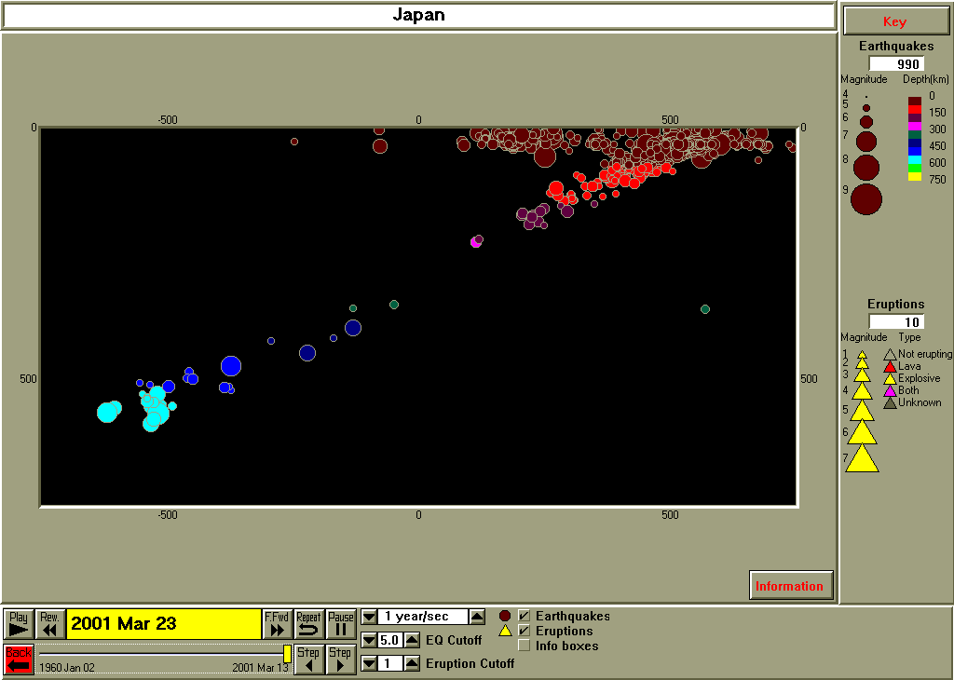
Figure 3.8. Cross-section diagram of earthquakes in the Japan region. Vertical scale is depth in km. Horizontal scale is distance (in km) along the profile shown in Figure 3.7. The cross-section is oriented WNW to the left and ESE to the right.

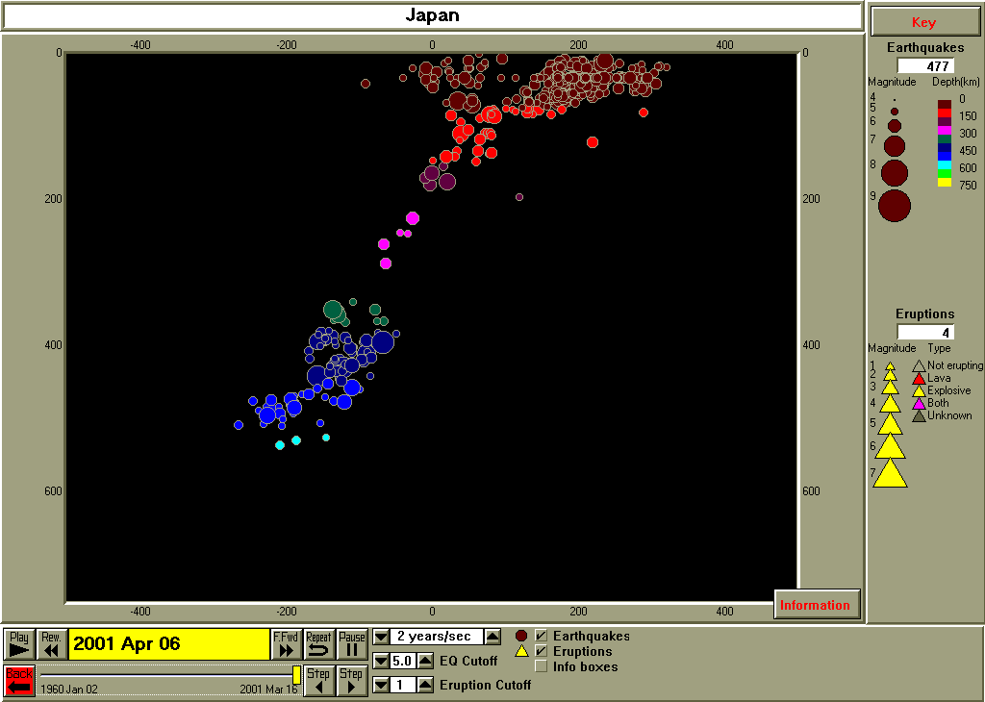
Figure 3.9. Cross-section diagram for the linear trend of earthquakes southeast of Japan. Vertical scale is depth in km. Horizontal scale is distance (in km) along the profile. The cross-section is oriented WSW to the left and ENE to the right.

Focusing in on a smaller, seismically active area, open the California view (Figure 3.10). All of the earthquakes in this area are shallow focus so the depth scale is adjusted to display depths from 0 to 25 km by different colors. The time period of view is 1992 to the present, so the 1992 Cape Mendocino earthquake (M7.0, 25 April, 1992), the 1992 Landers and Big Bear earthquakes (M7.5 and 6.6, 28 June, 1992), the1994 Northridge earthquake (M6.8, 17 January, 1994), the 1995 Cape Mendocino earthquake (M6.7, 18 February, 1995), and the 1999 Hector Mine earthquake (M7.4, 16 October, 1999) and the associated aftershocks are very prominent in the time series of events for California. Observing the earthquake activity for California in speeded up real time, it is clear that earthquake variations in time are greatly affected by the occurrence of large events.

  - Click on Repeat and observe the time sequence of events for California. How would you describe the occurrence of events in time? Does the time between events change? When a large earthquake occurs, where are earthquakes likely to occur in the next few weeks or months? Do events occur more frequently than normal in these areas after a large earthquake?

  - From observing the earthquake activity in California after large events (main shocks), how long do you estimate that aftershock sequences last?

  - The light blue lines near the west coast of central and southern California are faults of the famous San Andreas fault zone. To investigate earthquake activity along the San Andreas fault zone, one can open the Loma Prieta and Northridge views or us the Make Your Own Map capability (Teaching Module 11).

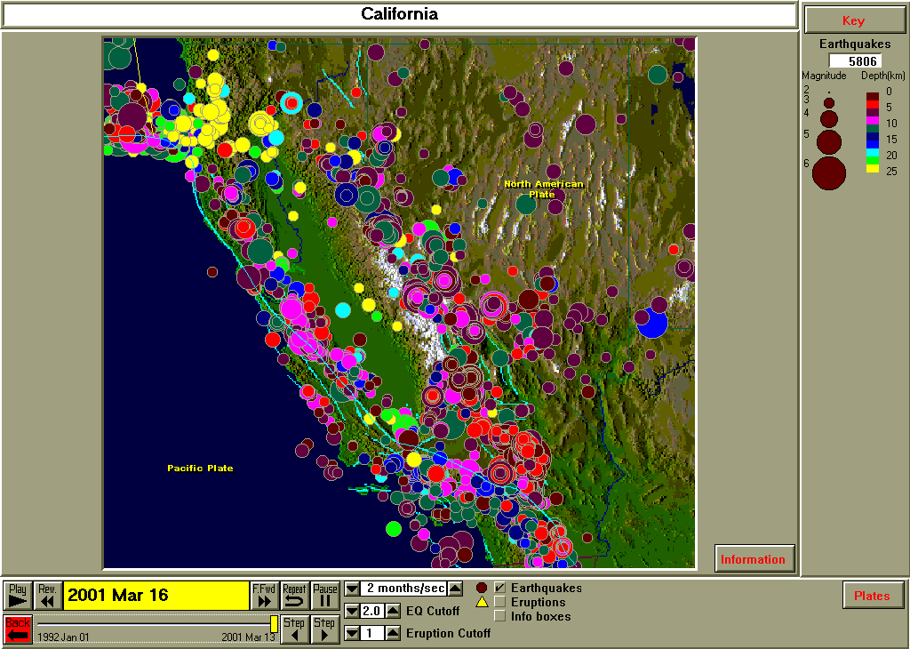
Figure 3.10. Earthquakes in California and Nevada, 1992-2001.

Plate Boundaries: SeisVolE includes several standard views that allow one to investigate the earthquake and volcanic activity at plate boundaries. Although our purpose is not to illustrate or describe all of plate tectonics (an excellent source of general plate tectonic information is the USGS color booklet, “This Dynamic Earth”, $6, available from the USGS at 1-888-ASK-USGS or on the Internet at http://pubs.usgs.gov/publications/text/dynamic/html; several hands-on plate tectonic activities are available at http://www.eas.purdue.edu/~braile), many important features of plate tectonics and characteristics of plate boundaries can be observed by examining the distribution of earthquakes and volcanoes along the plate boundaries. Views for three types of plate boundaries – divergent, convergent and transform – are available. For the divergent, or spreading plate boundary, the earthquake activity along the Mid-Atlantic Ridge (Figure 11) is an excellent example. Earthquakes occur on the ridge segments and on the transform faults that offset ridge segments (a close-up view can be obtained with the Make Your Own Map option).

  - Are the earthquakes along the Mid-Atlantic Ridge shallow or deep?

  - Does the “shape” of the earthquake pattern along the Mid-Atlantic Ridge look similar to the shape of the west coast of the European and African continents? Does it look similar to the shape of the east coasts of the North American and South American continents?

  - Is the Mid-Atlantic Ridge about half way in between the coastline of the continents on either side of the ridge (you can display a scale on the map by selecting the Map menu, Annotations/Scale; note that because the maps are plotted in a Mercator projection, the distance scale is not the same near the equator and at near the poles)?

  - If the Mid-Atlantic Ridge is a spreading center where new oceanic lithosphere is being created by magmatic (igneous intrusion and volcanism) processes, what is happening to the continents on either side of the Atlantic Ocean (notice that there is no deep-focus earthquake activity, and almost no earthquakes, along the Atlantic continental margins)?

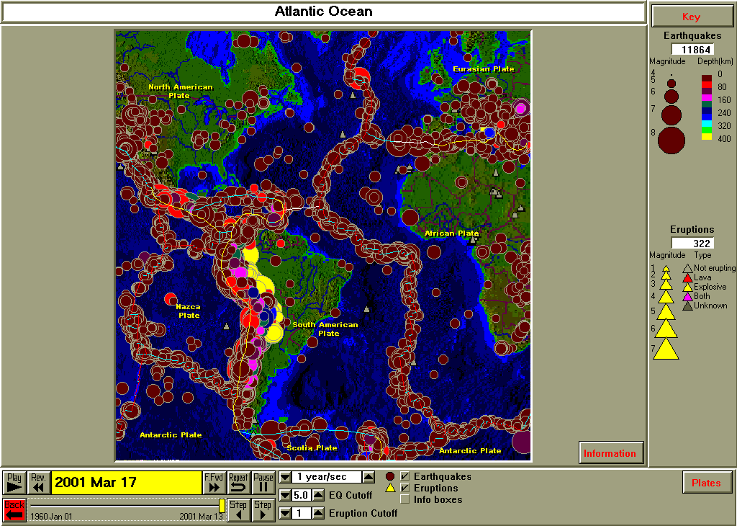
Figure 3.11. Earthquakes and volcanic eruptions in the Atlantic Ocean region, 1960-2001.

The margin of the Pacific Ocean basin consists primarily of convergent volcanic island and continental margins, with the associated deep-focus earthquakes in descending, subducted slab (as seen previously in figures 3.7, 3.8 and 3.9). An excellent example of a convergent margin is contained in the Kuriles and Kamchatka view (Figure 3.12). On the Pacific Ocean view one can see that the eastern edge of the Kuriles and Kamchatka arc and the trend of epicenters is a deep-sea trench (along the yellow line in Figure 3.12). In the Kuriles view, notice the pattern of intermediate- and deep-focus earthquakes.

  - Is the pattern of intermediate- and deep-focus earthquakes for the Kuriles similar to the pattern that was observed for Japan (Figures 3.7, 3.8 and 3.9)?

  - Use the map view (Figure 3.12) and the color coding of earthquake depths to estimate the dip angle (in degrees) of the slab that is being subducted (delineated by the hypocenters; hint: add a scale to the Kuriles view, make a rough sketch of the earthquake depths versus distance from the trench and measure the angle with a protractor; a more accurate analysis could be performed by making a cross-section view, Teaching Module 14)?

  - The subducted slab in the Kuriles is delineated by the dipping zone of earthquake hypocenters. The slab consists of what type of lithosphere? Where does it come from?

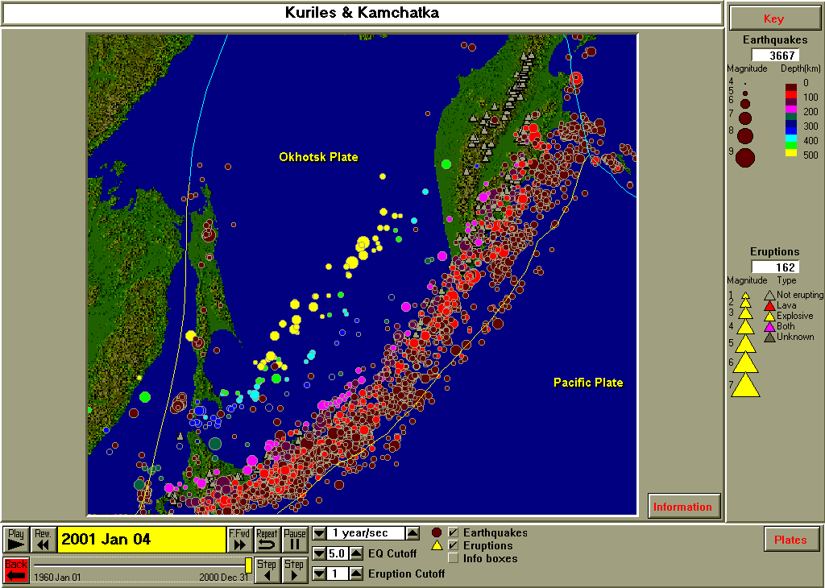
Figure 3.12. Earthquakes and volcanic eruptions in the Kurile Islands and Kamchatka Peninsula region, 1960-2000.

The Kuriles and Kamchatka are a very active area with many earthquakes (including large magnitude events) and volcanic eruptions.

  - Observe the time sequence of events in the Kuriles view. Note the many earthquakes, including prominent main shock and aftershock sequences similar to those observed in the California view, are present. The earthquake activity in the Kuriles is displayed in a space-time plot in Figure 3.13. From the space-time plot, does it appear the earthquakes appear nearly everywhere in space and time along the Kuriles? When there are distinct concentrations of events, does there appear that there is always a main shock at the beginning of the sequence?

  - The aftershock sequence associated with main shocks is found to define the fault plane that ruptured during the main shock event. What is the length of the fault plane (measure in degrees longitude; the earthquake zone in the Kuriles trends northeast, so the longitude values are not exactly equivalent to horizontal distance) for some of the prominent main shock/aftershock sequences shown in the space-time plot?

  - Can you identify an area (longitude range), or areas, where very large earthquakes have occurred in the past (since 1960) but have not occurred recently (last 20 years or so)? Based on the average level of activity for this area (you can determine the number of 8+ or 7+ events since 1960 using the earthquake counter on the Kuriles view by adjusting the magnitude cutoff) do you think that the area that you’ve identified is like to be the site of a large earthquake in the next several years? How would you estimate the probability of this occurrence using the historical record of seismicity (one can do perform this analysis using some of the tools available in SeisVolE that are described in other Teaching Modules)?
Figure 3.13. Space-Time diagram of earthquake activity in the Kuriles and Kamchatka region. Date of the earthquake is shown on the horizontal scale. Small tic marks are one year apart. Location (E Longitude) along the seismic zone is shown on the vertical scale. Only shallow (0-70 km depth) earthquakes are included. Circle size is proportional to magnitude. Magnitudes range from 5 (smallest circles) to 8.5 (largest circles).

An additional area illustrating a convergent margin is the Cook Inlet, Alaska view (Figure 3.14).

  - From the color-coded earthquake epicenters in Figure 3.14, what is the direction of dip (the down-slope direction) of the dipping zone of epicenters?

  - What is the approximate depth of the deepest earthquakes in this subduction zone?

  - Does the topography of the area appear to be related to the direction of plate convergence? What evidence can you suggest for your answer?

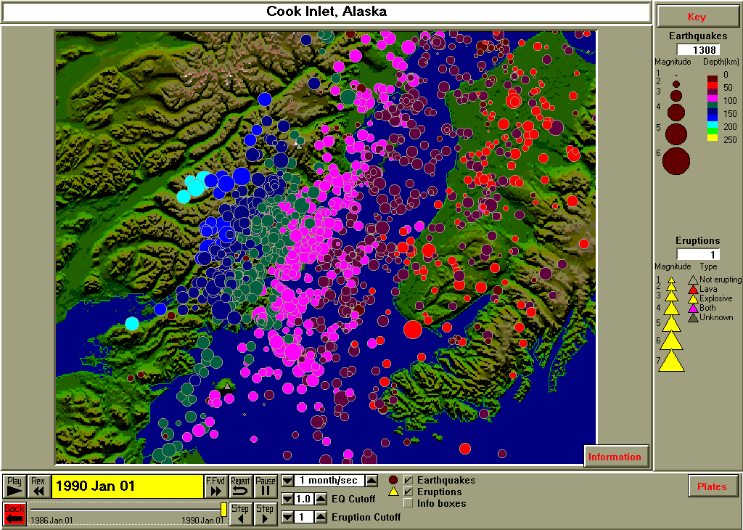
Figure 3.14. Earthquakes in the Cook Inlet, Alaska area, 1986-1989.

  - A cross-section view (a NW to SE profile) is available for the Cook Inlet area (Figure 3.15). Notice the detail afforded by the well-located hypocenters. The earthquakes display a curved slab with a relatively steep dip below 100 km. What is the dip of the slab below 100 km? Assuming that the oceanic lithosphere slab that is being subducted is about 70-100 km thick, and that the hypocenters are accurate, in what part of the slab do you think that the earthquakes occur?

  - Why don’t the earthquakes in the Cook Inlet area extend below 200 km (there are several possible answers; it may not be clear from the information available here which answer is correct)?

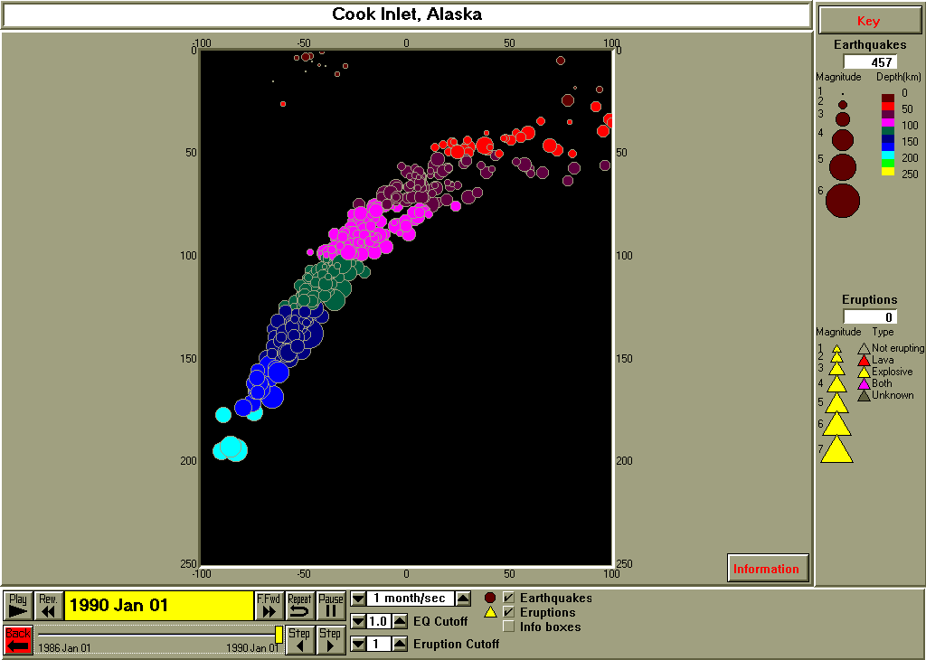
Figure 3.15. Cross-section diagram of earthquakes in the Cook Inlet, Alaska region. Vertical scale is depth in km. Horizontal scale is distance (in km). The cross-section is oriented NW to the left and SE to the right.

Earthquakes and Faults: The San Andreas fault system is a classic example of a transform fault in which the relative motion is primarily horizontal slip and the two side of the fault move in opposite directions. However, near the southern end of the San Andreas in California, the fault has a major change in direction resulting in significant compression across some of the faults in the San Andreas system and, thus, thrust or reverse faulting. The January 17, 1994 Northridge earthquake (Figure 3.16) occurred on one of these thrust faults.

  - The Northridge view shows the main shock location and aftershocks for the Northridge earthquake. Note the depth scale and the color-coding of the epicenters. What is the approximate depth of the main shock (it will be easier to determine the depths if the Magnitude/Depth scale, in the Earthquakes menu, is set to 25 km, then click Repeat)? What is the orientation (dip angle, direction of dip) of the fault plane for the Northridge earthquake as reflected by the aftershock locations? Where on this fault plane did the main shock occur?

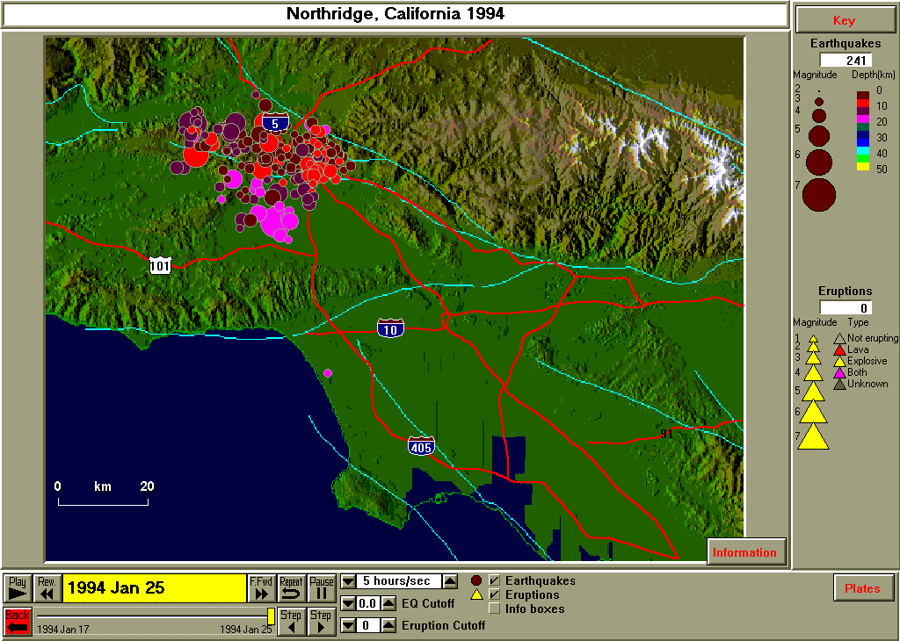
Figure 3.16. Main shock (large circle) and aftershocks of the Northridge earthquake (M6.8, January 17, 1994).

A cross-section display of the Northridge earthquake main shock and aftershock locations is available in the Northridge cross-section view (Figure 3.17).

  - If the local direction of compression in this area is SSW to NNE, which area of the Earth’s surface would you expect to be uplifted by the earthquake slip?

  - If the fault plane associated with the Northridge earthquake broke the surface (was exposed as a fault break on the Earth’s surface), where would you expect the break to be?
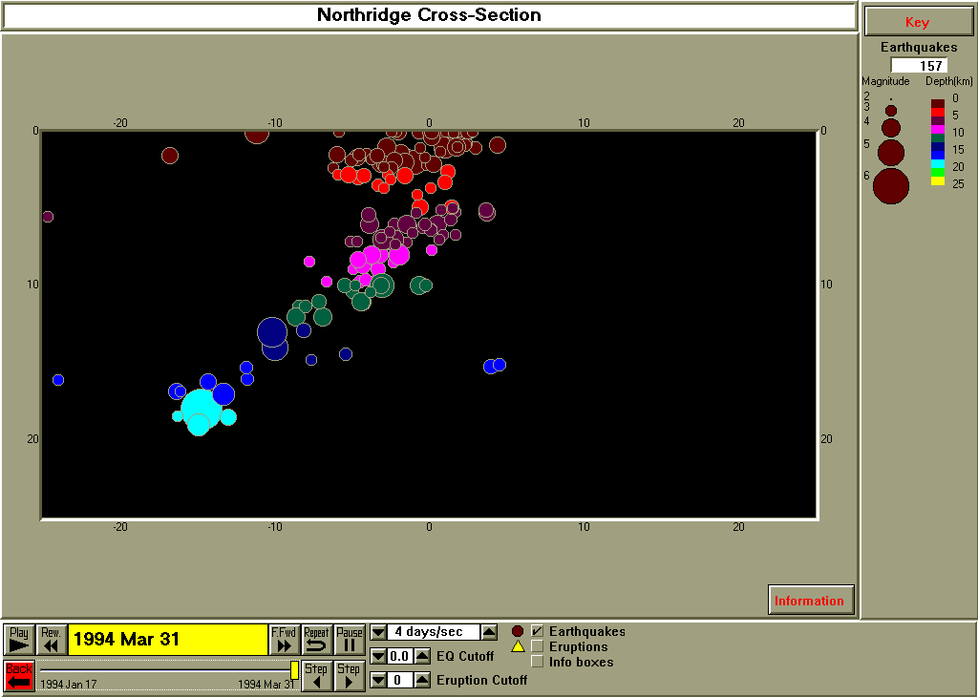
Figure 3.17. Cross-section view of the Northridge earthquake (large circle) and aftershocks. Vertical scale is depth in km. Horizontal scale is distance (in km). The cross-section is oriented SSW to the left and NNE to the right.

The central and northern portions of the San Andreas fault system consist primarily of transform (a type of strike-slip fault) faulting with relative horizontal motion. During the 1989 Loma Prieta earthquake, the western side of the central San Andreas fault (part of the Pacific plate) moved about 1.5 meters to the northwest relative to the eastern side of the fault which is part of the North American plate. The main shock and associated aftershocks of the Loma Prieta earthquake are shown in the Loma Prieta map view (Figure 3.18).

  - Add a scale (Map/Annotations/Scale from the menu) to the view (Figure 18) and measure the rupture length assuming that the aftershocks delineate the fault plane that slipped during the main shock.

  - On which fault (light blue lines) did the earthquake occur?

  - Most of the epicenters appear to be located slightly to the south and west of the fault trace. What are the possible explanations for this observation?

  - Notice the topography in the area of the San Andreas fault zone (several faults, not just the San Andreas on which the Loma Prieta earthquake occurred). In what ways could the faulting control or affect the topography?

  - Although the epicenter of the Loma Prieta earthquake was closer to Santa Cruz, the earthquake is often referred to as the 1989 San Francisco earthquake. Can you think of reason why this is so?

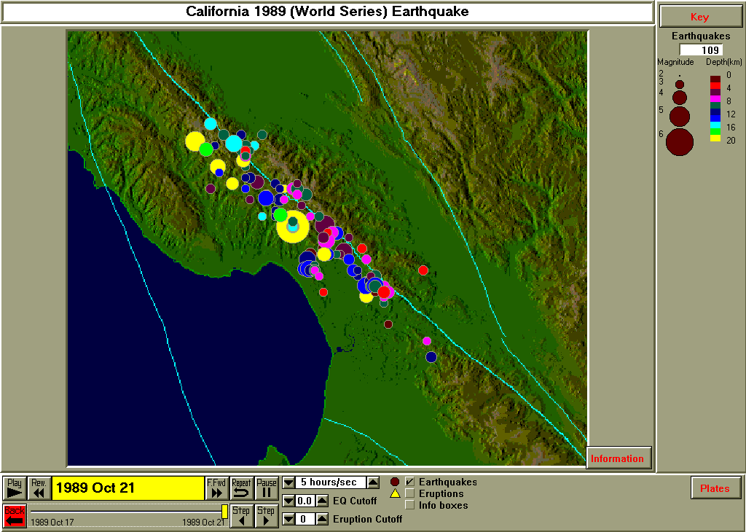
Figure 3.18. Main shock (large circle) and aftershocks of the Loma Prieta earthquake (M6.9, October 17, 1989).

The alignment of epicenters of the Loma Prieta earthquake and its aftershocks along the San Andreas fault (Figure 3.18) effectively defines the fault plane that slipped during this event in a map view.

  - Notice the alignment of epicenters (Figure 3.18) and the depths indicated by the colors of the circles. What is the approximate orientation of the fault plane with depth, that is, does the fault plane dip steeply into the Earth (nearly perpendicular to the Earth’s surface), or is the dip angle smaller (similar to the dipping zones of epicenters that are observed in subduction zones or in the Northridge thrust fault)?

  - We can view the depth extent of the Loma Prieta hypocenters using a 3-D perspective plot in the Loma Prieta 3-D view (Figure 3.19). This view indicates that the fault plane at depth is nearly vertical (notice that all of the hypocenters contained in the map view in Figure 3.18 appear to be aligned along a single vertical plane when viewed from the southeast from within the Earth’s crust; the fault planes of strike-slip faults and therefore of transform fault plate boundaries are nearly always approximately vertical). If the earthquakes shown in Figures 3.18 and 3.19 were located on a single dipping fault plane, what causes the scatter of the circles in Figure 3.19? Using the distance scale on the Loma Prieta map view, what is the approximate horizontal extent of this apparent scatter in the hypocenter locations?

After the 3-D view is opened, one can change the orientation of the view using the interactive 3-D tool available under the Control menu, Interactive 3-D.

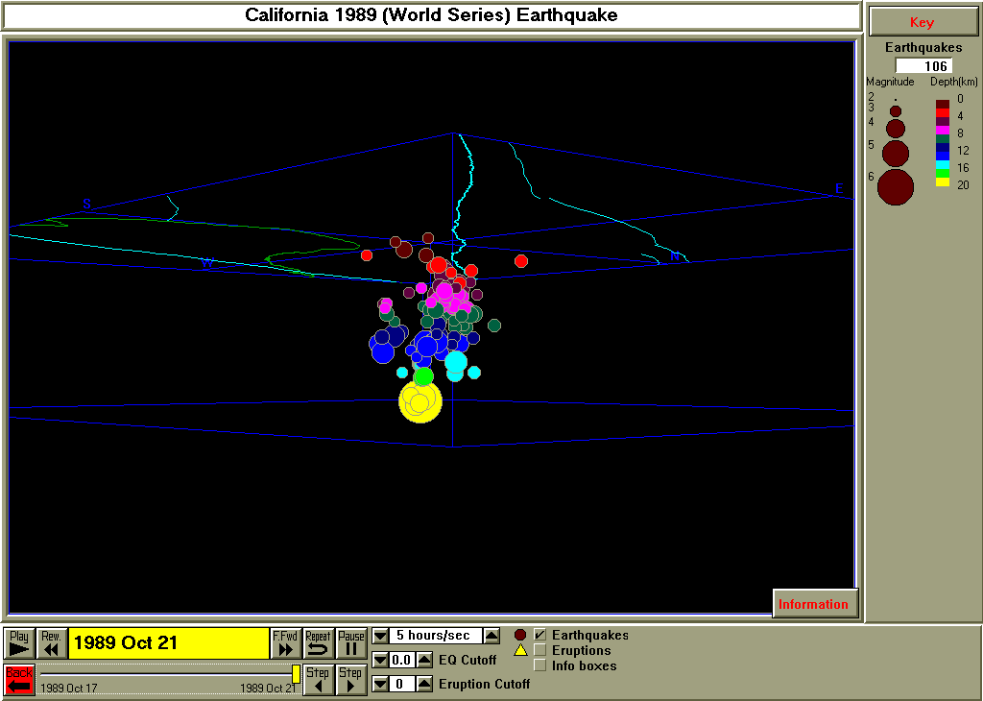
Figure 3.19. Three-Dimensional view of the Loma Prieta earthquake (large circle) and aftershocks. View is from within the Earth’s crust looking along the fault plane (fault traces on the surface are shown by light blue lines) to the NW.

Volcanic Eruptions: By turning off the earthquakes and turning on the eruptions at the bottom of the SeisVolE screen, one can more closely observe the volcanic eruption activity for volcanic areas of the world. The eruption magnitude cutoff (arrow controls at the bottom of the screen) can also be used to determine the time and location of eruptions of different magnitudes and count the eruptions (counter at the right hand side of the screen) of any size volcanic event. The Step feature, when used with eruptions, also allow one to view specific information (volcano name, dates of activity, eruption magnitude) about individual volcanoes and eruption events.

Several standard views in SeisVolE are useful for observing volcanic eruption activity in space and time. The Indonesia and Philippines view (Figure 3.20) displays an area of the world that contains some of the world’s most active and powerful volcanoes. As you observe the eruptions in time (1960-2000) the colored triangles and volcano names that appear on the screen show the locations of eruptive activity. The size of the triangles indicates the eruption magnitude and the color of the triangles indicates the type of the eruption. Additional information about these eruption characteristics can be found in the SeisVolE Help menu (see Eruptions under Contents).

  - As you view the eruptions in the Indonesia and Philippines area in time, do you notice any obvious patterns in the eruption activity?

  - Do the Indonesia volcanoes appear to be more active than the Philippine volcanoes? How could you find out?

  - What kind of plate boundary is associated with the Indonesia volcanoes (you can turn on the earthquakes in the view and click on Repeat to help answer this question)?

  - Are there more small eruptions than large eruptions (similar to what we have observed for earthquakes)?

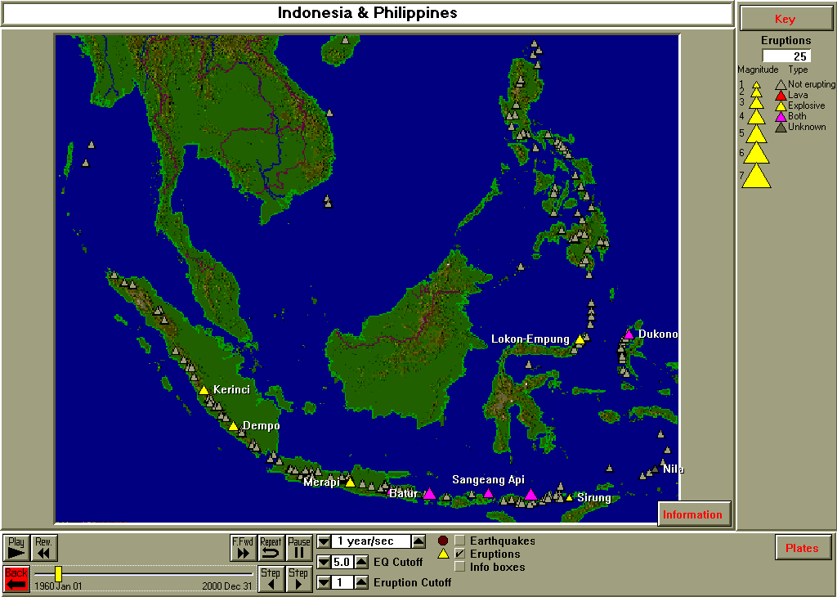
Figure 3.20. Volcanic eruptions in the Indonesia and Philippines region, 1960-2000. Volcanoes are gray triangles. Eruptions are shown by colored triangles (see Key in upper right) with associated volcano names. Time sequence was paused to display eruptions.

Using the eruption counter and the eruption magnitude cutoff, one can determine how many eruptions there are of a given magnitude range within an area. For example, for the Indonesia and Philippines area, the eruptions versus magnitude for 1960-2000 are graphed in Figure 3.21.

  - There was only one magnitude 5 or larger eruption in this area during the period 1960-2000. Can you find out which volcano it was and when the eruption occurred?

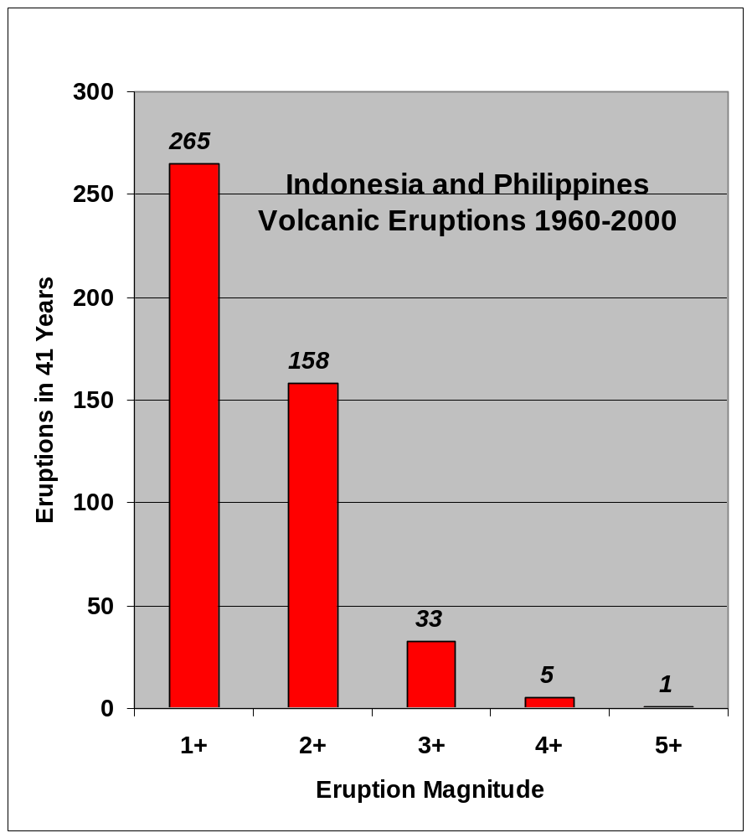
Figure 3.21. Volcanic eruptions versus magnitude of the eruption for the Indonesia and Philippines region, 1960-2000.

Another volcanically active area is the Kuriles and Kamchatka (Figure 3.22). We have previously examined the earthquake activity in this region and have seen that the plate boundary associated with this area is a convergent boundary, resulting in a prominent subduction zone that is reflected in the distribution of intermediate- and deep-focus earthquakes.

  - Observe the time sequence of volcanic eruptions in the Kuriles view. Can you find the volcano that has been most seismically active in this area since 1960? How could you analyze the eruption catalog using SeisVolE to be sure?

  - Do you see any obvious patterns in the eruptions versus time, or do they appear to be somewhat random?

  - The Kuriles was an area where we observed significant main shock and aftershock sequences. Observe both the earthquakes and the eruptions from 1960-2000. Do you see any obvious connection between the eruptions and the occurrence of large earthquake and aftershock sequences? Try the exercise with a magnitude cut-off of 6 and 7 also. Is any pattern evident?

  - The number of eruptions versus eruption magnitude for the Kuriles and Kamchatka area were determined with the SeisVolE eruption counter and eruption cut-off adjustment and the data are plotted in Figure 3.23. Compare this plot with the similar graph for Indonesia and the Philippines (Figure 3.21). It appears that the number of eruptions of magnitude greater than or equal to 1 and greater than or equal to 2 for the Kuriles and Kamchatka area are somewhat low in comparison to the Indonesia and Philippines data. For example, the two graphs are nearly identical for eruption magnitudes of greater than or equal to 3, 4 and 5. However, the number of eruptions for the 1+ and 2+ eruption magnitude categories is significantly different for the two graphs. Can you think of a possible explanation (remember that the eruption magnitudes 1 and 2 are relatively small volcanic events and that consider the differences in population of the two regions)?

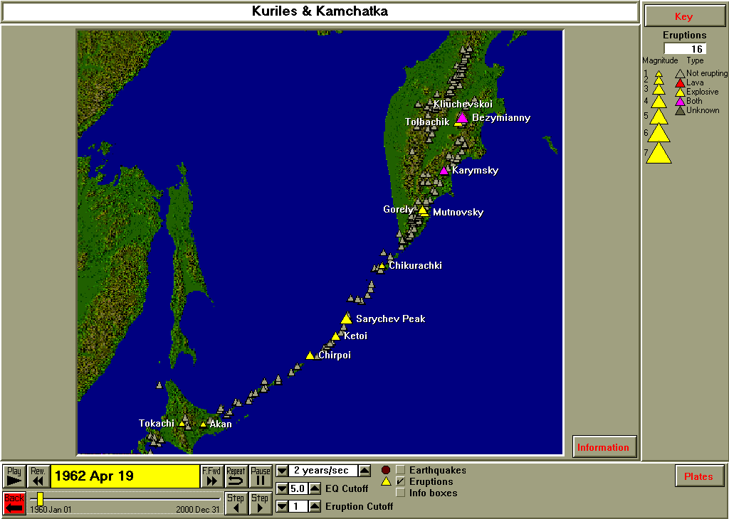
Figure 3.22. Volcanic eruptions in the Kuriles and Kamchatka region, 1960-2000. Volcanoes are gray triangles. Eruptions are shown by colored triangles (see Key in upper right) with associated volcano names. Time sequence was paused (in 1962) to display eruptions.

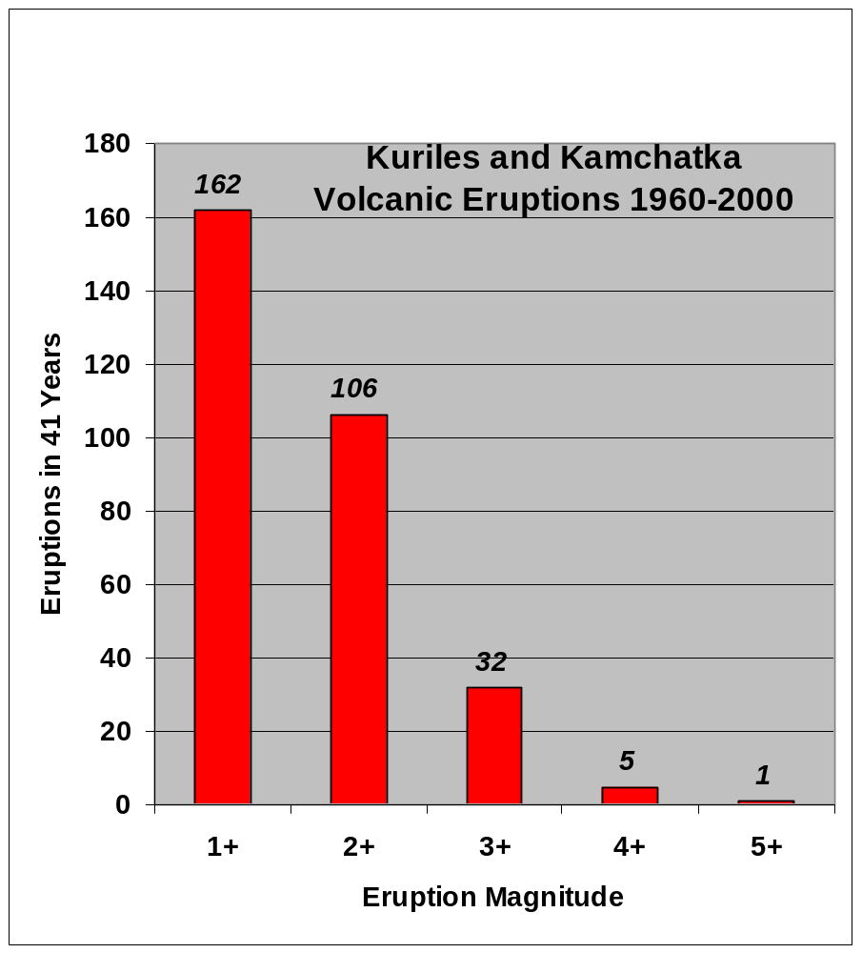
Figure 3.23. Volcanic eruptions versus magnitude of the eruption for the Kuriles and Kamchatka region, 1960-2000.

References:

Bolt, B.A., Earthquakes and Geological Discovery, Scientific American Library, W.H. Freeman, New York, 229 pp., 1993.
Bolt, B.A., Earthquakes, (4rd edition), W.H. Freeman & Company, New York, 366 pp., 1999.
DePolo, C.M., and D.B. Slemmons, Estimation of earthquake size for seismic hazards, in Neotectonics in Earthquake Evaluation (edited by E.L. Krinitzsky and D.B. Slemmons), Geol. Soc. Amer., Rev. Eng. Geol., VIII, 1-28, 1990.
Johnston, A.C., An earthquake strength scale for the media and the public, Earthquakes and Volcanoes, v. 22, 214-216, 1990.
Jones, L.M., Putting Down Roots in Earthquake Country, Southern California Earthquake Center, 30 pp., 1995. (Also available on the Internet at: [http://www.scecdc.scec.org/eqcountry.html]).
Monastersky, R., Abandoning Richter, Science News, v. 146, p. 250-252, October 15, 1994.

Go to List of SeisVole Teaching Modules (in Introduction to SeisVolE Teaching…; Module 0)

 Copyright 2001. L. Braile and S. Braile. Permission granted for reproduction for non-commercial purposes.

