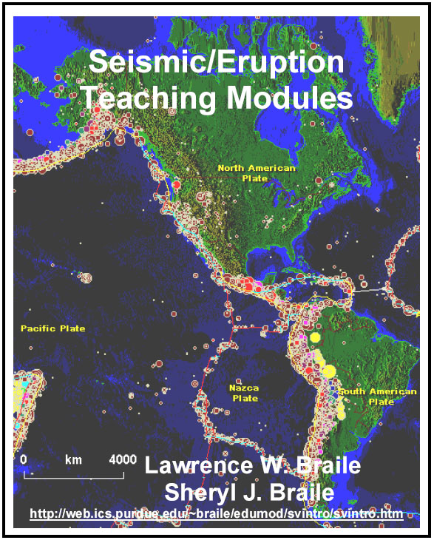
 | 

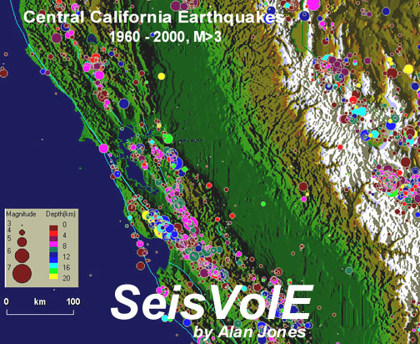 | Introduction to  SeisVolE teaching modules – Lessons, activities and demonstrations for the Seismic/Eruption (SeisVolE) earthquake and volcanic eruption mapping software©

Lawrence W. Braile, Professor, Department of Earth and Atmospheric
Sciences, Purdue University, West Lafayette, Indiana
(braile@purdue.edu, http://web.ics.www.eas.purdue.edu/~braile)

Sheryl J. Braile, Teacher, Happy Hollow School, West Lafayette, Indiana
(sbraile@purdue.edu)

February 4, 2002

Introduction: We are developing educational modules for teaching about earthquakes, volcano eruptions and related plate tectonic concepts using an interactive computer program for mapping called Seismic/Eruption (written by Alan Jones; the program is also called SeisVolE). The program includes up-to-date earthquake and volcanic eruption catalogs and allows the user to display earthquake and volcanic eruption activity in “speeded up real time” on global, regional or local maps that also show the topography of the area in a shaded relief map image (Figure 0.1). SeisVolE is an interactive program that includes a number of tools that allow the user to analyze earthquake and volcanic eruption data and produce effective displays to illustrate seismicity and volcano patterns. The program can be used to sort data and provide results for statistical analysis, to generate detailed earthquake and volcano activity maps of specific areas (Figure 0.2) or for specific purposes (Figure 0.3), to investigate earthquake sequences such as foreshocks and aftershocks, and to produce cross section (Figures 0.4 and 0.5) or 3-D perspective views of earthquake locations. The Seismic/Eruption program can be a powerful and effective tool for teaching about plate tectonics and geologic hazards using earthquake and volcano locations, and for learning (or practicing) fundamental science skills such as statistical analysis, graphing, and map skills. The program includes a number of “standard views” for examination of earthquake and volcano activity in various areas around the world, but can also be used to generate your own views and for teacher or student generated research projects. The teaching modules describe and illustrate how to use the Seismic/Eruption program effectively in demonstrations, classroom presentations and interactive presentations, and independent study/research. Because the program has many useful options and can be used to examine earthquake activity and volcanic eruption data, the modules provide instructions and examples of quantitative analysis, graphing of results, creating useful maps and cross section diagrams, and performing in-depth exploration and research. The examples are intended to illustrate the features and capabilities of the program and stimulate interest in using the program for discovery learning in Earth science, especially earthquakes, volcanoes and plate tectonics.

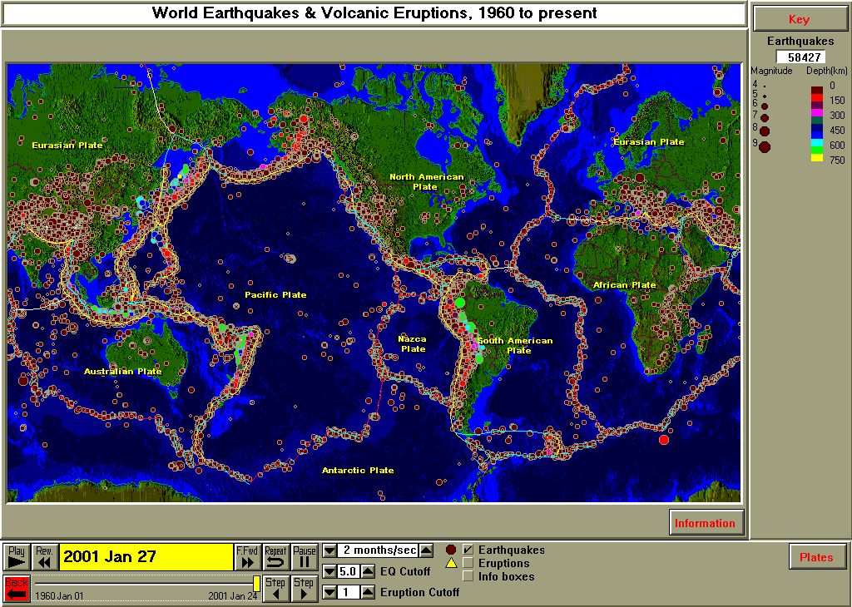
Figure 0.1. The SeisVolE screen display showing global earthquake epicenters (magnitudes 5 and above) for January 1, 1960 – January 24, 2001. Dots, scaled according to magnitude, are epicenters. Dots are color-coded according to earthquake depth. Plate boundaries are indicated by red (divergent boundaries), yellow (convergent boundaries) and blue (transform boundaries) lines. The buttons and slide bar near the bottom of the screen provide controls for the “speeded up real time” display of earthquakes and volcano eruptions. Many additional tools and options used to produce specific maps and to analyze data are provided in pull-down menus along the top of the screen (not shown in this image).

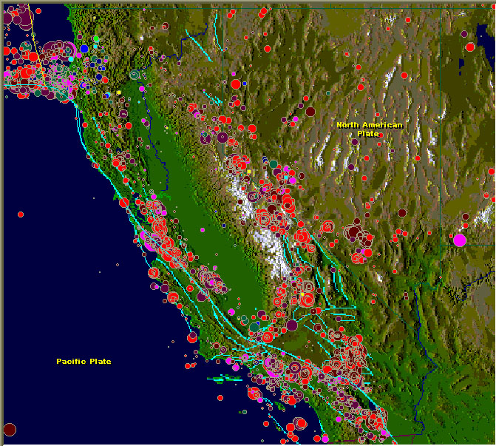
Figure 0.2. California and Nevada earthquakes, 1960 – 2000. Blue lines are major faults. Dots are earthquake epicenters. Dot size is proportional to earthquake magnitude. The background map is a shaded relief image of topography.

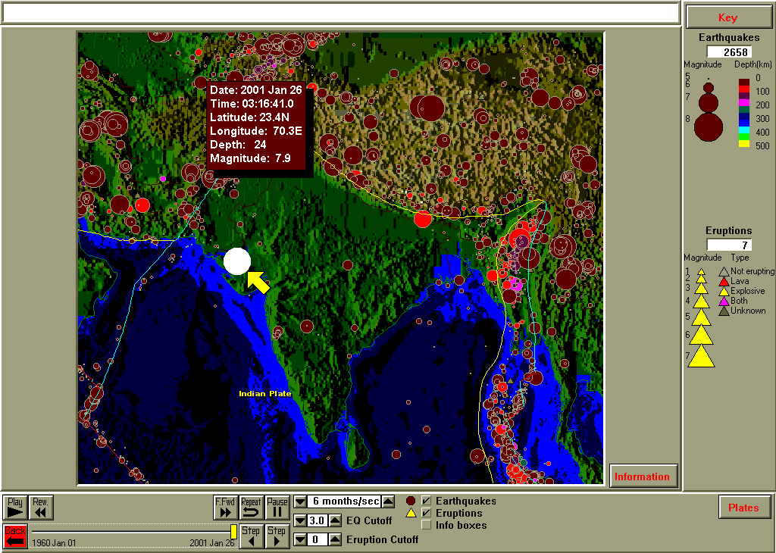
Figure 0.3. Screen display produced a few hours after the January 26, 2001 India earthquake (arrow and inset information) illustrating how a recent, significant earthquake can be displayed on a map of the historical seismicity to teach about the event in a “teachable moment”.

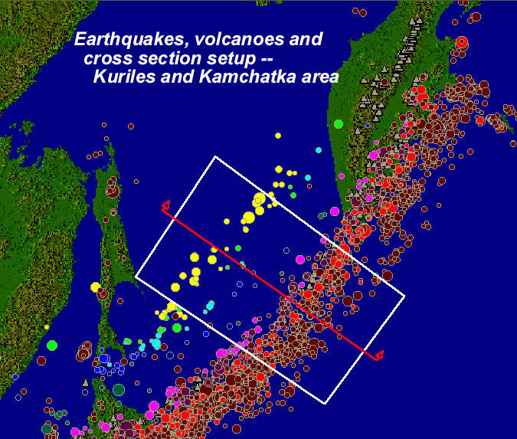 | Figure 0.4. Seismicity (earthquakes are shown by dots scaled according to magnitude and colored according to depth) and volcano (gray triangles) map of the Kurile Islands and Kamchatka peninsula area. The red line and the rectangle are related to a SeisVolE tool that allows the user to produce a cross section diagram. Earthquake locations within the rectangle are projected onto the cross section plane along the profile (red line) and can be displayed as a function of depth as shown in Figure 0.5.

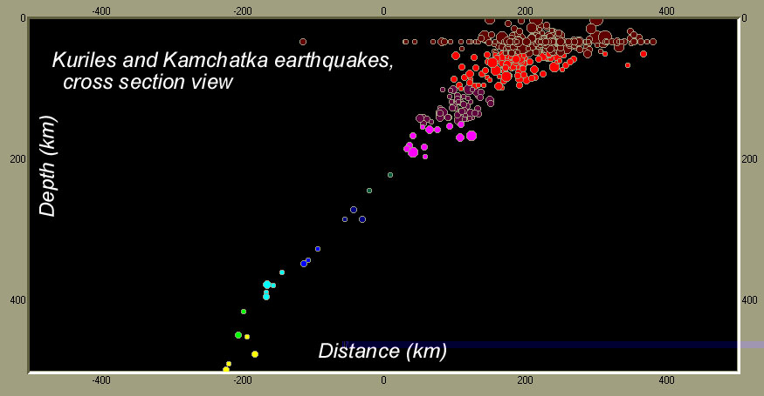
Figure 0.5. Cross section diagram showing earthquakes associated with a subduction zone (convergent plate boundary) in the Kurile/Kamchatka area (Figure 0.4).

Teaching Modules for Use with Seismic/Eruption: The inquiry-based Teaching Modules that we are developing include descriptions of demonstrations, lesson plans and activities for use with SeisVolE in teaching about earthquakes, volcanoes and plate tectonics. The modules are designed for use in grades 7 – 12 (the grades that include most of the Earth science curriculum in US schools), although they can easily be adapted for use at the middle school level (grades 5 – 6) or at the introductory college level. The modules contain instructions for use of specific features of the software and examples that illustrate the use of these features to demonstrate, analyze and explore earthquakes, volcanoes and plate tectonics. In many of the modules, an effective initial teaching strategy is simply to display the views and perform the analyses that are included in the examples. In most cases, the modules also provide specific suggestions and ideas for classroom use and for extension.

In most of the Teaching Modules, questions are provided to help direct exploration of the program, data and Earth science concepts. The questions are numbered and displayed in a different font (Arial, font size 10) so that they are readily identified in the document. Some of the questions are answered in the following text, or a hint for how to proceed to answer the question may be provided. Sometimes, “challenge questions” are included that require some exploration or research using the SeisVolE program, calculations or graphing, or consulting additional reference materials (on the Internet or printed matter). In general, a basic understanding of plate tectonics is assumed, although SeisVolE and the Teaching Modules can be used in a more “constructivist” approach to discover many of the important concepts related to plate tectonics and earthquake and volcanic activity.

Printing the Teaching Modules: Color versions of the SeisVolE Teaching Modules can be opened and printed on your color printer from the .pdf (Adobe portable document format) or .doc (MS Word document) files that are given below. To print this introduction document (with the listing and brief description of the Teaching Modules), use the following .pdf or .doc files: PDF version: 0. Introduction.pdf. MS Word (Microsoft Word) version: 0. Introduction.doc. The Word version is useful as one can cut and paste selected parts of the document to create your own version, cut out some of the material or extract questions to produce a handout for student use. The .pdf version is usually smaller in size and therefore takes less time to download. To create a copy of all of the Teaching Modules, use the .pdf or .doc versions from the list below and order them according to module (chapter) number. The number at the bottom right hand corner of each page is the module number followed by the page number.

The Seismic/Eruption Program and Computer Platforms: The SeisVolE computer program was written by Prof. Alan Jones of the State University of New York, Binghamton (SUNY-Binghamton) and is available for free download from his web page at: http://www.geol.binghamton.edu/faculty/jones. It runs on a Windows 95, 98, 2000, XP, or NT environment.

Macintosh users running Virtual PC (Connectix, http://www.connectix.com/) or SoftWindows (FWB Software, http://www.fwb.com/) can also operate the SeisVolE program on their computers. Both the Virtual PC and SoftWindows programs include a Windows (95, 98, or 2000) operating system that runs on recent Macintosh computers. These Macintosh, windows-emulator programs are available from the manufacturers or from Macintosh software dealers such as MacWarehouse (http://www.macwarehouse.com/).

Acknowledgments: The development of these teaching modules for use with the Seismic/Eruption program was funded by the Geoscience Education program of the National Science Foundation. We are grateful to Prof. Alan Jones who developed the Seismic/Eruption program, has regularly improved and updated it, and has generously made it available at no cost to educators and other interested users.

List of Teaching Modules for use with SeisVolE (preliminary list; many of these modules are under development – completed modules are highlighted in blue and have active links; some preliminary versions are in module #20; to print a color version, use the .doc or .pdf files); for convenient navigation, at the end of each teaching module is a link that will take you back to this list:

- Downloading and installing Seismic/Eruption (SeisVolE) – Instructions for obtaining the computer program, installing it on your machine and running SeisVolE. Additional data files (topography and earthquake catalogs) are also available for downloading and use with SeisVolE. PDF version: 1. Download.pdf. MS Word version: 1. Download.doc.

- Basic SeisVolE navigation and data – Information on basic operation of the SeisVolE program including the primary views, control, options and earthquake and volcano data contained in the program. PDF version: 2. Navigation.pdf. MS Word version: 2. Navigation.doc.

- Using the standard views included in SeisVolE – How to use the views that are included in SeisVolE to illustrate fundamental earthquake and volcano activity around the Earth, compare levels of activity and analyze earthquake and volcano activity in both space and time. PDF version: 3. Standard Views.pdf. MS Word version: 3. Standard Views.doc.

- Teaching about plate tectonics with Seismic/Eruption – Using Seismic/Eruption to demonstrate and learn about the connection between earthquake and volcano occurrences and plate tectonics.

- Earthquakes and plate boundaries – Study earthquake activity at the three major types of plate boundaries – divergent, convergent and transform boundaries.

- Volcanic eruptions and plate boundaries – Study volcanic activity at the three major types of plate boundaries – divergent, convergent and transform boundaries.

- Earthquake and volcanic eruption statistics – Illustration and analysis of earthquake and volcanic eruption data in space and time including basic statistical analysis.

- Frequency-magnitude relationship – Using the frequency-magnitude relationship to understand earthquake and volcanic eruption occurrences and the concept of forecasting future activity.

- Aftershock sequences – Analysis of earthquake aftershock sequences. Using the aftershocks to delineate the fault plane for a large earthquake. Evaluating the hazards related to aftershocks.

- Significant events, “teachable moment” – Using the SeisVolE data and display to show the location of a recent significant earthquake and its relation to the background seismicity. Ideas for taking advantage of the “teachable moment” that arises when a significant earthquake or volcanic eruption occurs and the event generates interest and news coverage.

- Make your own map – Using the tools and options available in SeisVolE, one can make a map showing earthquake and volcano locations (and the underlying shaded relief representation of topography of the area) for any region. For example, one can make a map of your state (or a state or country of interest to you) illustrating historical earthquake and volcanic activity, or a map that focuses on a location related to a specific event. PDF version: 11. Make your own map.pdf. MS Word version: 11.Make your own map.doc.

- Adding topographic data to SeisVolE and maps – How to add topographic data to your SeisVolE folder so that useful and attractive shaded relief maps can be produced for your “make your own map” displays. PDF version: 12. Topo Data.pdf. MS Word version: 12. Topo Data.doc.

- Importing earthquake data (Internet update, “.hy4” files) – How to update the earthquake list in SeisVole using the Internet so that up-to-date earthquake data are available in the earthquake catalog. Also, additional earthquake data for specific areas (for example, small magnitude aftershock data or small magnitude earthquake data for low seismicity areas) can be imported so that detailed maps and investigations of specific areas or specific earthquake sequences can studied.

- Making cross-section diagrams – Cross-section views, representing “slices through the Earth”, are useful displays of the depth distributions of earthquake locations (hypocenters) and aid in understanding the 3-D (or 4-D, including variations in time) patterns of earthquake activity and relationships to plate tectonics. This module illustrates the SeisVolE options and tools that are used to create cross-section displays for any location. PDF version: 14. Making cross-section diagrams.pdf. MS Word version: 14. Making cross-section diagrams.doc.

- Earthquake and volcanic eruption hazards – Using SeisVolE data and displays to evaluate the earthquake and volcanic hazards. Connections to other hazards activities and data. Discussion of earthquake and volcanic hazard awareness and preparedness.

- Suggestions for teacher and student research projects – The earthquake and volcano databases that are included in SeisVolE make it possible to explore seismic and volcanic activity on a global, regional or local scale. Time and spatial variations, trends and patterns can be investigated. Basic statistical and map displays can be produced to quantitatively and visually characterize earthquake and volcano activity in selected areas. Teacher and student questions about seismicity and volcanic activity can be answered, or at least explored. Suggestions for independent teacher and student research projects are provided. Many other questions and investigations are also possible.

- Connections to other seismology and Earth science activities, data, sites, maps, etc. – References for other seismology and Earth science educational modules and materials, and suggestions for additional, related topics to cover in connection with the SeisVolE Teaching Modules.

- Notes to teachers – Information on using SeisVolE and these activities in teaching, including discussion of how the activities address the national standards (NSES), how to implement the activities in different grade levels, and consideration of scope and sequence for these activities and related Earth science material for use in your curriculum. Information on hands-on activities and other information and materials related to earthquakes, volcanoes and plate tectonics is also provided.

- MS Excel data and graphing instructions – Information for using the Microsoft Excel program to produce tables of data and graphs related to the analysis of earthquake and volcano activities in SeisVolE. PDF version: 19. Excel Graphing Instructions.pdf. MS Word version: 19. Excel Graphing Instructions.doc.

- SeisVolE Teaching Modules – Preliminary, Draft Instructions – Because not all of the Teaching Modules have been completed at this time (December, 2001), preliminary descriptions of several of the most useful and important tools and capabilities of SeisVolE are included here. PDF version: 20. Preliminary Instructions.pdf. MS Word version: 20. Preliminary Instructions.doc.

Copyright 2001-2008. L. Braile and S. Braile. Permission granted for reproduction for non-commercial purposes.

