**Terrorism in the Heartland:**

**Vigilantism, Lynching, and the Klan in Indiana, 1858-1930**

Richard Hogan, Associate Professor

Purdue University, Sociology Department, College of Liberal Arts

West Lafayette, IN 47907-2059 [hoganr@purdue.edu](mailto:hoganr@purdue.edu)

A version of this paper was presented at the Indiana Academy of Social Science meeting,

Evansville, IN, 9 October 2015. Comments and suggestions from E. M. Beck and Sarah Mustillo were particularly helpful.

keywords: terrorism, repertoires, collective violence, Indiana history, KKK

9,7477 words (41 double spaced pages, including abstract, bib and appendix, 8 figures and 4 tables—a second appendix has been provided for the editor and reviewers.

**Terrorism in the Heartland:**

**Vigilantism, Lynching and the Klan in Indiana, 1858-1930**

**Abstract**

The general public has learned nothing from the social movements and political protest researchers who cut their teeth on the failure of mass society and collective behavior theories to explain the late (nineteen) Sixties anti-war movement. Now a band of neoliberal (conservative) scholars are returning to the cultural and psychological roots of these old theories of political protest. They tell us that resource mobilization and political process theories are outdated and cannot explain the new social movements—particularly, Occupy. In this regard, they are more distracting than dangerous, but the popular image of the terrorist is particularly susceptible to the ahistorical, cultural and psychological reductionism of these theories of the Sixties. In the interest of gaining some historical and macro-institutional perspective on the War on Terrorism, this paper looks at terrorism in Indiana between 1830 and 1930, focusing on the National Horse Thief Detective Association and the Ku Klux Klan, during two waves of terrorism: Civil War: 1858-1876 and Post-Reconstruction: 1877-1930.

We can blame it on 9-11, I suppose, but the confusion surrounding terrorism is reversing progress made since 1970 in the study of social movements and social change. Scholars and the mass media have returned to old theories of the Cold War era—mass society and collective behavior, to explain the “radical Islamic terrorist campaign,” which is corrupting women and children in Western Europe and even here in America’s Heartland (Callimachi 2015). How can we hope to turn the tide of fear and ignorance that seems to be perpetrating the twin threats of conservative reaction and anti-intellectual hysteria?

Let’s start by dealing with the confusion on concepts, starting with the concept of “radical” as opposed to “reactionary” and the difference between “terrorism,” “genocide,” and “rebellion.” Then we can appreciate the difference between “terrorism,” which is a strategy, and violence, which is a tactic. Lest we become thoroughly confused in meta-theoretical discourse, let us ground this exercise in the material world, following a structural but historical path, focusing primarily on the U.S.A., 1775-1930, and, particularly, on Indiana, 1858-1930. Thus we shall come to appreciate that terrorism is at least as old as the Declaration of Independence and as American as apple pie. We shall also come to see that terrorism is not necessarily violent or primitive, and that violence is not used exclusively by terrorists or primitives.

Eventually, we will consider the difference between the old repertoire of terrorism in the USA—particularly vigilantism and lynching, which we will examine in Indiana, 1858-1930, and the new (social movement) repertoire of terrorism, which includes Klan marches, public displays, and private meetings and ceremonies, characteristic of the second wave of the KKK, specifically in Indiana in the early 1920s. We shall consider the extent to which the same petit-bourgeois morality (interest in public order—see Author 1990) and even the same Horse Thief Detective association and the same Democratic or Republican parties[1] (organizations) provided the base for both rounds of collective action. As I will suggest, it was not interests or organizations but repertoire that explains the widely divergent political geography of lynching victimization and KKK events (both estimated from newspaper reports, coded by colleagues who provided the populations). Terrorists might use violence or not. They might use old school or thoroughly modern tactics, but they are still terrorists if they are attempting to strike fear in the heart of a civilian population.[2] We will consider how this perspective might inform our view of ISIS and foreign terrorists after we gain a better appreciation of terrorism in American as history and consider the possibility that terrorists may be returning to old school tactics, as was the case during the Civil Rights Movement (Morris 1984), with GOP candidates inspiring the reactionary wings of the party to defend the borders against the barbarians.

Some Definitions and Concepts

Let us begin with a lesson from political science. As indicated in Figure 1, liberals and conservative share general optimism about the institutional order (e.g., republican capitalism), but they differ in their opinions on human nature. A similar pattern distinguishes radicals and reactionaries, except that they are pessimistic about the institutional order. Reactionaries tend to see people as selfish, lazy, and greedy, and they believe that established institutions exacerbate this problem—republican capitalism is a license to steal, and the welfare state encourages sloth. Radicals see people as cooperative and productive but see established institutions as the source of anti-social, inhuman struggles for wealth and power.

**Figure 1**

**Political Attitudes Defined by Opinions on**

**Existing Institutions and Common People**

|  |  |  |
| --- | --- | --- |
|  | **Opinions About Existing Institutions** | |
| **Opinions About**  **Common People** | **optimistic** | **pessimistic** |
| **optimistic** | Liberal | Radical |
| **pessimistic** | Conservative | Reactionary |

source: adapted from Tom Ruth, California Government class lecture, spring 1970, Grossmont Community College, El Cajon California

When the institutional order is threated by radical revolutionaries or paramilitary bands of reactionaries, liberals and conservatives are inclined to forget their differences and form “progressive” coalitions that might offer some changes (reforms) within the institutional order (e.g. women’s suffrage, collective bargaining, or civil rights) in order to avoid regime change and the attendant dangers of communism, or anarchy, or civil war (Piven and Cloward 1977). When successful, these progressive coalitions include enlightened conservatives and liberals. In the U.S.A. these coalitions tend to tolerate reactionaries and to repress radicals.

Consider, for example, the events leading up to the American Revolution. The Sons of Liberty and the rest of the “Radical Whigs” (Bailyn 1967) were challenging the authority of the Crown, destroying stamps, harassing tax collectors and royal governors, and even throwing tea into Boston Harbor in 1773 (Maier 1974; Morgan and Morgan 1974). At the same time, Judge Lynch was terrorizing Loyalists in Virginia.

“Charles Lynch (1736-1796), a justice of the peace in Bedford County, Virginia, and his followers whipped and occasionally hanged suspected local Loyalists. Apparently, Lynch’s vigilantism was sufficiently notorious that ‘Lynch’s law’ became an American colloquial expression for vigilante violence.” (Brundage 1999: 297)

Although Lynch and his mob did hang people and were, in that sense, killers as well as terrorists, neither they nor their radical Whig counterparts, who also used collective violence to harm persons and to destroy property, were attempting to exterminate the Anglo-British people or the Anglo-Caucasian race. This was not “genocide,” which implies a campaign to exterminate a “genus” or species of persons that might be defined by cultural imaginaries, such as race, religion, or nationality. Genocide includes plans to exterminate Jews or Croats or Palestinians, not to mention Native Americans, who were routinely massacred in what might well be considered genocidal campaigns, justified by the principal that “the only good Indian is a dead Indian.” Generally, the colonial revolt of 1776 was neither terrorist plot nor genocide. It was a bourgeois colonial revolt, which provided cover for a variety of less scrupulous and more noble campaigns, including “workingmen’s and artisan ‘mobs’ of the North End and South End [of Boston]” (Brown 1975: 55), as well as the Southern lynch mobs, not just in Virginia, but particularly in South Carolina, where the Regulators were organized as something like a vigilance committee or citizen militia in the backcountry West of the Appalachian Mountains (Brown 1975: 96).

The differences between the lynching in Western Virginia, the vigilantism in South Carolina and the acts of rebellion in New England are significant. It appears that the Regulators were subsistence-plus “yeoman” farmers (Kulikoff 1989), engaged in a different sort of colonial revolt, a version of “internal colonialism,” in which Regulators and Anti-Regulators represented the conflicting interests of commercial capitalism and labor, albeit capital tied to slave relations of production and labor tied to petit bourgeois landed patriarchal exploitation of family labor (Rubenstein 1970). Here it is not clear that the bourgeois colonial revolt was anything more than an opportunity for east and west to mobilize and fight for new advantages, as Crown and Colonial leaders were fighting amongst themselves.

In contrast, Lynch and the Sons of Liberty defended the interest of bourgeois colonial revolt, in opposition to the Crown. While this interest united them, they differed primarily in target. The target of the Sons of Liberty and their allies were tax officials and other colonial government officials (Morgan and Morgan 1974, chapter XI). Judge Lynch targeted civilians. Like Quantrill’s Raiders, who inflicted the Lawrence Massacre in 1863 (Brown 1975: 9; Hofstadter and Wallace 1971: 89-92), Lynch was a terrorist, using violence to intimidate civilians. John Brown, a white abolitionist, also used violence, both in Kansas and in West Virginia, where his raid on Harper’s Ferry led to his capture and execution, but he was leading an armed insurrection, attacking troops and ultimately a Federal armory (Hofstadter and Wallace 1971: 96-101). Although his interest (abolitionism) was diametrically opposed to the Confederates who attacked Fort Sumter, his tactics and target and general strategy were virtually the same (May 2013: 156-157, 246)

From the perspective of the Crown in 1773 or the federal government in 1859 (Harpers Ferry) or 1863 (Lawrence Massacre), the difference between rebels and terrorists (or guerillas) might be blurred. All were challenges that inspired repression, but the meeting that produced the Declaration of Independence in 1776 was equally threatening to the Crown. Similarly, the Ku Klux Klan marches, down the main streets of cities across the country during the 1920s, were terrorism, just as much as the lynching that came before and after (McVeigh 2009).

The point is that terrorism is a strategy for inciting fear within a civilian population. Lynching is a tactic that might prove effective in this endeavor, but it is not the only tactic available. In fact, as we have learned from Tilly (1986; 1995; 2008) and Tarrow (2011), there has been a sea change in the repertoire of contention between the American Revolution of 1776 and the resurgence of the Klan in the early 20th century (1915-1924). There has been a decline in the use of direct action and patronized actions, in which challengers imitate the actions of authorities while taking the law into their own hands—this includes food riots as well as vigilantism and even lynching.

Public meetings and petition campaigns were not invented in the nineteenth century, but they came to predominate in the British repertoire of contention (Tarrow 2011: 47 and 51). Similarly, after the invention of the modern social movement, old forms of direct action and patronized local actions continued, but they were less common, particularly in relatively stable modern democratic states.

For reasons that we might want to discuss in depth, there is growing opposition to the Resource Mobilization and Political Process models of contention that will guide this analysis (with a healthy dose of historical materialism to complement these models). Some of the earliest critics (Useem 1980) took aim at some of the weakest claims, attributing to Resource Mobilization theory the claim that discontent does not matter, but these critics later became more sophisticated in defending social disorganization theory from a state-centered perspective (Useem and Goldstone 2002). Later, as sociologists took the cultural turn (Goodwin and Jasper 1999), critics claimed that Political Process and Resource Mobilization theories were static structural theories that ignored culture. Still others (Einwohner 2003; McVeigh 2009) claimed that these theories could not explain the revolt of the powerless or right wing middle class movements.

More helpful than these largely unfounded criticisms are more micro-level theories that use framing and discourse theory to augment the structural analysis of interests and opportunities (Benford and Snow 2000; Gamson 1992; Snow et al. 1986; Snow et al. 2014; Steinberg 1998; Steinberg 1999). This allows us to consider how the Republican Party, after its flirtation with Progressivism, was able to accommodate if not fully support the reactionary ravings of the Ku Klux Klan and even the most reactionary elements within the genetic engineering movement. At the same time, some of these pioneers of Progressivism have since been claimed by community organizers and pro-choice feminists who are able to frame the questionable aspects of Progressivism within a more liberal, reformist stance that recognizes the racism within early feminism, for example, and the fact that Progressive tools, such as the referendum and the recall, can be used for reactionary as well as radical goals, as evidenced in the California Tax Revolt and the California Coastal Act (Author 2003).

How these framing and discourse theories can help us to steer a path between structural determinism and post-modern whimsy should be evident as we look at three waves of terrorism in Indiana: Civil War and Reconstruction vigilantism, Post-Reconstruction lynching, and the Klan. We will be guided by Wade (2011), who argues that vigilantism, lynching, and Klan were all expressions of a hegemonic whiteness, sustained by the authority of the Indiana Constitution, which sanctioned collective violence wielded initially by the Indiana Horse Thief Detective Association and later by the Klan. The fact that the Indiana Klan used legislative sanction for the Detective Association as a ruse for establishing a vigilante private police force, during the 1920s, makes the case all the more compelling (Chalmers: 1987: 165-166; Jackson 1967: 145-146; McVeigh 2009: 135).

Not only did the vigilantes and the Klan share the same reactionary, exclusionary, interest—typically petit bourgeois, they availed themselves of the same organization—the Indiana Horse Thief Detective Association, sanctioned by the state legislature and appropriated by the Klan. From a Resource Mobilization perspective (Tilly 1978: 56), these challengers differ only in opportunity/threat and, of course, repertoire (Tilly and Wood 2014)[3]. For our purposes, Presidential elections represent the most important, recurring opportunity, where divisions between elites and the potential for powerful allies make repression less likely and toleration if not facilitation more likely (Tilly 1978; Tarrow 2011). In the analysis that follows, the critical elections of 1876, the end of the Greenback challenge and of federal support for Reconstruction, 1896 (the Democrat-Populist coalition), and 1920 (Republican-Klan coalition in Indiana) are used to indicate political opportunities, which varied by county according to partisanship. County level variation in interests and organization will be represented by percent black (which could be considered a measure of threat [Beck 2000], as will be explained below) and the number of children enrolled in public schools—a proxy for petit bourgeois campaigns for public order, family, and religion.

The new collective choice theories have adopted racial competition as a predictor of collective action, but they tend to ignore the fact that competition is a relationship. Even the best these studies, which explore the “multi-dimensionality” of ethnic and racial threat—economic, social, and political, rather than simply demographic, still do not model repression/facilitation as a relationship between more or less resourceful and organized (and mobilized) contenders (Cunningham 2013: 8, 234 n8). Even adding “mediation” (Cunningham 2013: 8-10, 234 n9), as I do below when quoting a Democratic newspaper editor, does not change the fact that these are static structural rational choice models, as opposed to dynamic relational models of contentious interaction (Tilly 2008). Particularly in Indiana, where the threat of black or foreign competition was (and still is) more apparent than real, it is misleading to consider threat or even perceived threat independent of the relations between whites and blacks. Thus percent black or even the size of the black or foreign population indicates, at best, the possibility of a threat to the native white constituency of the local branches of the National Horse Thief Detective Association or the KKK. It is only in counties such as McIntosh County, Georgia, during Reconstruction, where black freedmen actually dominated local politics and managed to sustain an economic, cultural and partisan base, that we can reasonably assert that black population and migration threatened white bourgeois hegemony, which was, in fact tenuous in Georgia, even statewide, in 1868 (Author 2011).

In places like Indiana, 1858-1930, blacks and foreigners did not threaten whites in any substantial manner—not even in the same way that the Chinese threatened the Irish Catholic Democrats of Colorado in 1880 (Author 1990). In both cases, it was the carefully constructed partisan image of threat that was effective in mobilizing partisans, who already shared an interest in opposition to both lumpen proletarian and capitalist/employer class fractions. Their artisanal or petit bourgeois interests were rooted in relations of production and relations with other classes. Their willingness to kill or threaten ethnic and racial minorities required more partisan organizational effort than objective evidence of labor market competition. To argue otherwise is to blame the victims or, at best, to accept the claims of the oppressors. In our efforts to take reactionaries seriously, we do not need to agree with their rhetoric or to search for evidence that might support their claims.

Thus the challenge in what follows is to defend two simple assertions that might inform the historical and sociological debates. First, parties represent material interests, but these are frequently contradictory interests that are provisionally allied in a platform or program, whose realization tends to make the contradictions manifest, thereby undermining the coalition (Author 2005). For example, Radical Whigs and Reactionaries in Virginia were accommodated in the bourgeois colonial coalition that defended confederacy in opposition to the crown. The Articles of Confederation, once the colonial revolt was complete, defined the limited terms for coalition in an umbrella government that was designed—like the modern European Community, to facilitate cooperation among independent states. Of course, this government could not govern, which led to extended conflict, compromise, and a certain amount of rebellion and repression in establishing a federal government that, initially, was defended by the Federalists, including conservatives like Alexander Hamilton and liberals like James Madison.

Clearly, the Federalist Party did not survive its victory either, but the two party systems, first Whig versus Democrat and then Democrat versus Republican, seem to have endured and might yet endure deep into the 21st century. Most important, for present purposes, is the fact that none of these parties were ever ideologically homogeneous. Neither all Whigs nor all Republicans were Radical—but some of them were. Not all Democrats were Reactionary—but the Redeemers clearly were. In fact, there is a Reactionary strain that runs deep among Southern Democrats, who have now become Republicans, but that change—effected by Nixon in the election of 1972, need not concern us today.

More important for now is our second assertion. To the extent that the local community is effectively under the control of a hegemonic republican capitalist regime—what Tilly (2007) would call a “democracy,” political challenges tend to be relatively tame and symbolic, compared to the direct action of vigilantes and lynch mobs. This remains true, even when the challengers represent reactionary interests of Redeemers and Klansmen. Lynching will tend to diminish as the civilizing effects of petit bourgeois churches and schools and vibrant family life provide a more suitable base for the repertoire of the modern social movement—including demonstrations and protests by Indiana Pro-Life, which seems in some ways reminiscent of a Klan rally.

On that note, with the promise to return to thinking about terrorism in the 21st century, let us turn to the Indiana frontier and look for evidence that might support these assertions. We will proceed slowly, beginning with some pictures, moving to a chart, then some simple descriptive statistics. Then, we’ll look at maps of Indiana counties, 1870-1920, before turning to some zero inflated negative binomial equation (zinbe) models, to test for the effects of social and political correlates of terrorism.

A Methodological Aside

Readers who wish to hear more about the data gathered by Pfeifer (2014) and McVeigh (2009) should turn to these sources. For our purposes, there are only a few points worth noting. First, both datasets came to me as XL files that I read into Access and manipulated in various ways to get counts by counties over time. Eventually, these data were written back into XL files and then read into STATA, where I was able to generate Zero Inflated Negative Binomial Estimate (zinbe) models predicting lynching victims or KKK events. The cases are the 92 Indiana Counties, and these boundaries did not substantially change between 1870 and 1920, which makes the mapping and the statistical analysis relatively simple.

Both datasets purport to be populations, although they are based on the coding of newspaper reports (by Pfeifer 2014 or his colleagues, or by McVeigh 2009). Pfeifer’s (2014) data report victimizations rather than events (as will become clear below). McVeigh (2009) used the official national KKK newspaper to code events by city (when possible). I later attributed county to cities and treated events not identified with code-able places as missing data. McVeigh’s (2009) events probably over-estimate KKK events, since that is the point of the national paper. Pfeifer’s (2014) victimizations are probably low estimates and probably do not indicate subtle differences in method of execution (as will become clear).

One last qualification is in order. Working with small datasets that are putatively populations (as opposed to samples) gives me more confidence in the validity of my measures—at least, on the dependent variables. The independent variables were downloaded from ICPSR, and the county map boundaries were downloaded from NHGIS. Descriptive tables and maps, combined with predictive models, also should contribute to some comfort on matters of validity. We can see which counties were lynching or Klan centers—at least in quantity of victims or events, and we can imagine how the independent variables distinguish these counties (maps or tables on independent variables are available on request).

The more serious problem here, with only 92 cases, is reliability, particularly since these are essentially ecological correlations. The estimates have large standard errors, which, combined with problems of collinearity, suggest that we should interpret these results with skepticism.[4] A model that seems to capture inter-county differences in lynching before the end of Reconstruction (1876) does not do so well after Reconstruction, and it might well be that the differences are rooted in the relationship between total population (or other measures of urban places) and black population—the denominator and numerator (respectively) of percent black. Thus we should take solace in those effects which seem to be particularly robust, although we can certainly argue about model specification. For those (like myself), who enjoy fiddling with models and attempting to find the best fit, I have included an appendix with a table that offers the best model I could find to predict KKK events in Indiana in 1924. This is not the model used in the text, since the goal was to offer different estimates using essentially the same model in order to understand how the phenomenon under examination or the mechanisms that make it more or less likely changed over time within place.

We could, of course, spend more time explaining how negative inflation and other binomial effects should be interpreted. Personally, I have never found the algebra to be particularly enlightening, but I might just say that inflation effects are estimated as bias in populations where most cases have values of zero. Variables that predict zero are included in order to estimate and control for this bias. Thus a negative binomial inflation factor—number of blacks, for example, indicates, in this example, that where there are few blacks there are likely to be few lynching victims. Then, the main effects of the model, for example, percent black, are unbiased by the inflation factor, so the positive effect of percent black would indicate that counties with a proportionally greater black population would have more lynching victims.[5]

We will return to these considerations when we look at the zinbe models, but first, let’s look at some pictures.

Terrorism Hoosier Style

If you have ever seen pictures of an Indiana lynching, you probably saw this picture.

Figure 2

Marion Indiana Lynching, 1830

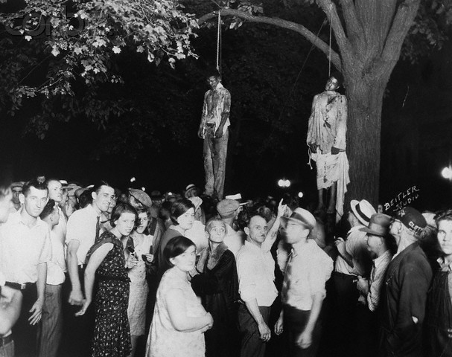

source: Madison 2011 (courtesy of the Indiana State Historical Society).

This famous Indiana lynching took place in Marion, Indiana, in Grant County. Accounts of this event focus on the extent to which this was not a typical lynching. Consider, for example, the account of James H. Madison (2011), the Thomas and Kathryn Miller Professor of History at Indiana University (whose account included this photo).

**“A Lynching in the Heartland:**

**Marion, Indiana, August 7, 1930**

**by James H. Madison**

On a hot August night in 1930 a crowd gathered in front of an Indiana jail—men, women, and children shouting and jeering, demanding that the sheriff release his three prisoners. Three African American teenagers—Tom Shipp, Abe Smith, and James Cameron—huddled inside their cells, charged with the murder of a white man and the rape of [a] white woman. Some among the thousands of people in front of the jail formed a mob. They beat down the jail doors, pulled the three youths from their cells, brutally beat them, and dragged them to a tree on the courthouse square. At the last minute the mob spared Cameron, the youngest and most boyish of the trio. Smith and Shipp died, lynch ropes around their necks, their bodies hanging as the town photographer captured one of the most famous lynching photographs in American history.” (Madison 2011)

Madison (2011) goes on to explain why this was not a typical lynching. “Unlike most it happened in the North and in a community with little harsh racial antagonism. It also happened ‘late,’ decades after the heyday of late nineteenth-century vigilante violence” (Madison 2011). This clearly was an act of racial terrorism, however, with black folks beaten and then killed and left hanging as a reminder to other blacks, photographed along with the crowd of white men and women who seemed proud or in some cases amused by the spectacle. One couple looks like they are on a date. Please note, however, that there are some women but no children visible in this photo, despite what Madison (2011) reports. By the time the crowd had become an angry mob it is likely that most women took their children home.

In any case, this is a typical lynching in the sense that it is a public display of mob violence in defiance of local authorities, intended to terrorize a particular population, in this case, Afro-Americans, who learn that even the sheriff cannot protect them. In this case, however, there was a public outcry after the fact. There was an anti-lynching ordinance passed and even a feeble attempt to prosecute the leaders of the mob.

Suffice it to say that the Marion, Indiana, lynching of 1930 was more typical of Northern lynching of this period.[6] In some ways it seems like a combination of early vigilantism and later public executions, with a strong dose of Ku Klux Klan racism hidden beneath the mask of vigilante justice. This should not be surprising in a state where not just slaves but free blacks were legally excluded from immigration before the Civil War (Foner 2011: 13; Wade 2011: 41-42), where the farmers organized an anti-horse thief association to lynch (mostly white) men accused of stealing horses (between 1858 and 1876) and where the Ku Klux Klan staged spectacular events as late as 1924 (McVeigh 2009).

Consider, for example the Klan march in Anderson in 1922. Note the children among the spectators.

Figure 3

Anderson, Indiana Ku Klux Klan Rally of 1922



source: Original photo from W. A. Swift Collection, Ball State University, copyright 2006

In fact, in the parade in New Castle, Indiana, in 1923, there was a float full of children, “Ku Klux Kiddies,” as seen in Figure 4.

Figure 4

Ku Klux Kiddies Parade in New Castle, Indiana, in 1923



source: Original photo from W. A. Swift Collection, Ball State University, copyright 2006

There was, however, no lynching in Anderson or New Castle between 1858 and 1930, according to the data that I have examined. In fact, it is not at all clear that lynching tended to occur when and where the Klan was most active, even though we tend to associate lynching with the Klan, particularly in Indiana, for reasons that will become apparent.

Both Klan rallies and lynching are racial terrorism. Both are public displays designed to intimidate blacks and Catholics, immigrants, and others who are not accepted by the Klan as citizens.[7] But the Klan staged rallies, appearing publicly but in disguise. Lynch mobs tended to act ad-hoc, without a lot of apparent organization and planning—although that too was more apparent than real, particularly in Indiana, as we shall see. On the Western frontier, they acted under cover of darkness, secretly, but then left their victims hanging in plain sight, where they remained as a warning to others (Dykstra 1968; Author 1990; Leonard 2002).

Generally, it appears that Klan rallies were urban phenomena, while lynching was rural. Lynching was bad for business and was discouraged in urban areas where local shopkeepers and merchants were firmly in control of local government. Vigilantism occurred sporadically, particularly in the West, when farmers, cattlemen, or other rural residents challenged the government of merchant and shopkeeper (Dykstra 1968; Author 1990). The Marion lynching seems to blend these two types of events, which indicates that the lynching repertoire was changing—lynching clearly was in decline in Indiana between 1900 and 1930.

**Figure 5**

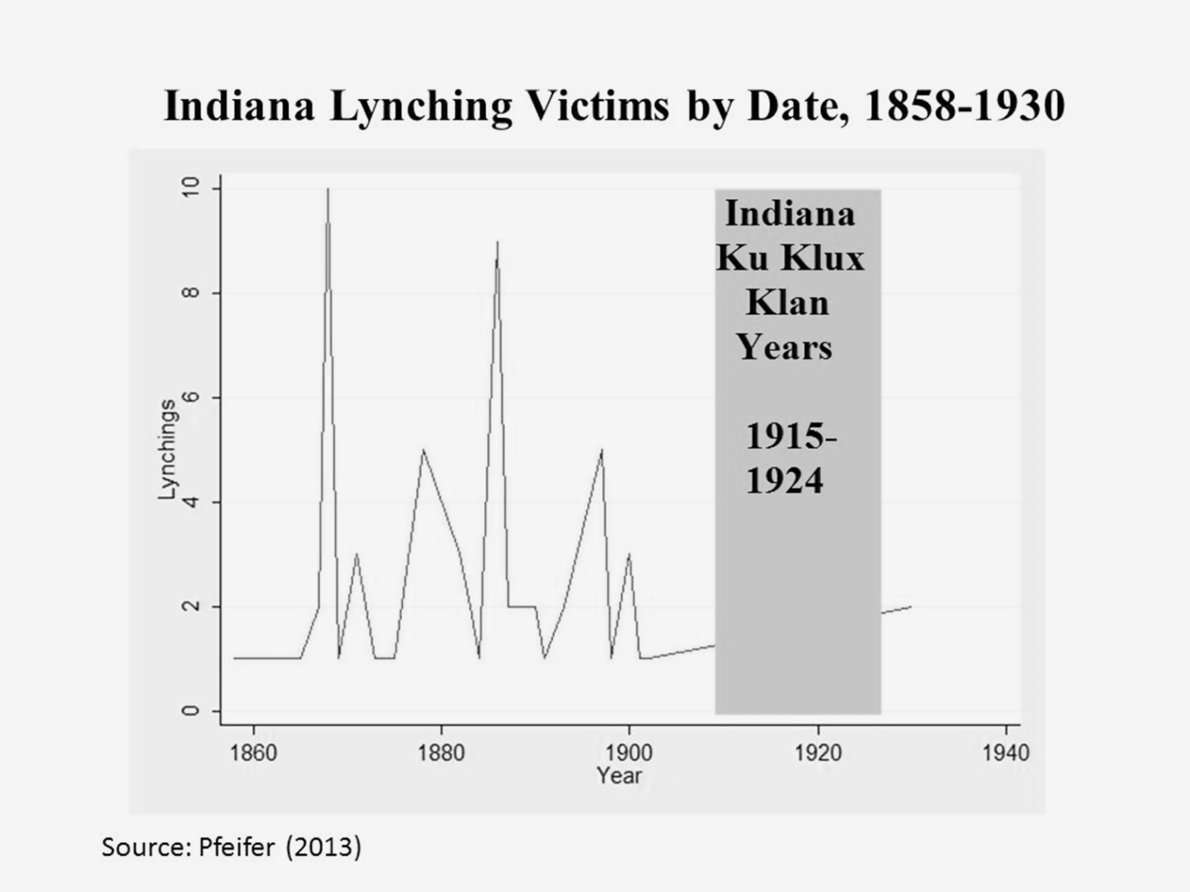

There were, in fact, two waves of lynching in Indiana—represented in Figure 5 by victims as opposed to events. The first wave was between 1858 and 1875—the Civil War and Reconstruction era, in which the Horse Thief Detective Association was active (Wade 2011).[8] This wave peaks in 1868 with an all-time high of ten victims. The second wave begins in 1878, after a brief hiatus, peaking in 1886, with nine victims, and effectively ending in 1902. In this context, the Marion lynching of 1930 appears to be particularly late—after the rise and fall of the Klan in Indiana politics and, as Professor Madison (2011) suggests, “decades” after the heyday of Indiana lynching in the late nineteenth century.

Madison (2011) also suggests that Marion was not the sort of town where one might expect lynching. Instead, this was “a community with little harsh racial antagonism.” According to McVeigh (2009), however, there was one local Klan event mentioned in the national Ku Klux Klan paper in 1923-1924, so it not clear that Marion was a racially progressive community. The Klan appears to have been at least somewhat active in Marion, as indicated by the photo of an initiation ceremony, in 1922, presented in Figure 6. The initiation of new members, as opposed to parades and other public events, suggests efforts to recruit new members, suggesting perhaps that the local Klan was not as large as in Indianapolis and elsewhere, although the presence of the Marion Klan in both McVeigh’s data and in the photographs of W. A. Swift suggest more racial tension than Madison (2011) reports.

Figure 6

Initiation Ceremony, Marion, Indiana, 1922



source: Original photo from W. A. Swift Collection, Ball State University, copyright 2006

Marion was, in 1870 and even in 1930, overwhelmingly white, with only about 3% black in all of Grant County. By 2012, Marion was almost 15% black (compared to 9% for Indiana as a whole), but the black migration came late.

In contrast, Marion County (home of Indianapolis) was nearly 10% black in 1890, almost 11% black in 1930, and nearly 28% by 2012. Lake County (home of Gary) was less than 1% black in 1890 but nearly 10% black in 1930 and nearly 26% black in 2012, at which point Gary was 85% black. As we shall see, most of Indiana was and is relatively white, but there was a Northern migration of black Hoosiers between 1860 and 1890 and, much later, a concentration of black Hoosiers in Gary and in Indianapolis.

Before we get lost in the study of black migration, however, we need to recognize that most lynching victims in Indiana were not black. Northern and Western lynching victims, in general, were white men accused of stealing horses or engaging in other behavior that authorities were not prepared to punish with swift and certain death. There was, however, a tendency for western lynching to become more racial and more barbarous after Reconstruction (after 1876).

**Table 1**

**Indiana Lynching Victims by Race by Date, 1858-1930 (N=66)**

|  |  |  |  |  |
| --- | --- | --- | --- | --- |
| **Date** | **Percent Black Victims (N)** | **Percent White Victims (N)** | **Percent Total (N)** | |
| **1858-1875** | 17% (04) | 83% (20) | 100% (24) |
| **1878-1930** | 33% (14) | 67% (28) | 100% (42) |
| **Total** | 27% (18) | 73% (48) | 100% (66) |

source: data from Pfeifer (2013)

This pattern is apparent in Table 1, which displays Indiana lynching victims, 1858-1930. Overall, as seen in the bottom (“Total”) row, only 27% of all victims were black. Pre-1876, only 17% of victims were black, but that figure almost doubles after Reconstruction. Fully 33 percent of Hoosier victims were black in lynching reported between 1878 and the infamous Marion lynching of 1930. Even in the later period, most victims were white, but blacks were over-represented among victims even during the Civil War, since they represented less than 3 percent of the population in most Indiana Counties. We shall return to this issue shortly.

**Table 2**

**Indiana Lynching Victims by Method of Execution,**

**1858-1875 and 1877-1930**

|  |  |  |  |
| --- | --- | --- | --- |
| **Method\*** | **1858-1875** | **1878-1930** | **Total** |
| **Hanging** | 100% (24) | 66% (28) | 81% (52) |
| **Shooting** | 0 | 11% (5) | 8% (5) |
| **Beating** | 0 | 14% (6) | 9% (6) |
| **Burning** | 0 | 2% (1) | 2% (1) |
| **Mutilation** | 0 | 2% (1) | 2% (1) |
| **Unknown** | 0 | 2% (1) | 2% (1) |
| **Total** | 100% (24) | 100% (42) | 100% (66) |

source: data from Pfeifer (2013)

At the same time, as lynching became more racial, it also seems to be moving closer to the Southern model of barbarism, which was also evident in the North in the Post-Reconstruction period. As we can see in Table 2, hanging was the only method used by the Horse Thief Detective Association, 1858-1875. After Reconstruction, however, there was a modest shift toward more barbaric forms of torture, including one burning and one mutilation. In fact, these data under-estimate the change, because the Marion lynching of 1930 is coded as a hanging, even though we know the men were brutally beaten before they were hanged.

Even though they were not included in Pfeiffer’s data, historians, including Chalmers (1987), Jackson (1967), and Wade (2011), argue that the Indiana Klan, particularly in Indianapolis, organized their own Detective Association in the 1920s, which served as D. C. Stephenson’s private police, after he was proclaimed Grand Dragon in 1923 (Chalmers 1987: 162-166). Nevertheless, even if these were state-sponsored (or at least sanctioned) terrorists, it is not clear that their activities would qualify as lynching, particularly if they were not inclined to murder their victims. Most sociologists follow the convention of defining lynching as “killing one or more blacks at the hands of an extra-legal mob of three or more individuals” (Beck and Tolnay 1990: 530). The measurement issues that concern us most at present are twofold: first, we will not limit our attention to black victims (thereby including vigilantism as well as lynching); second, we will report the number of victims (as opposed to the number of events). Thus our Marion, Indiana, lynching appears as 2 victimizations (in one event).

**Figure 7**

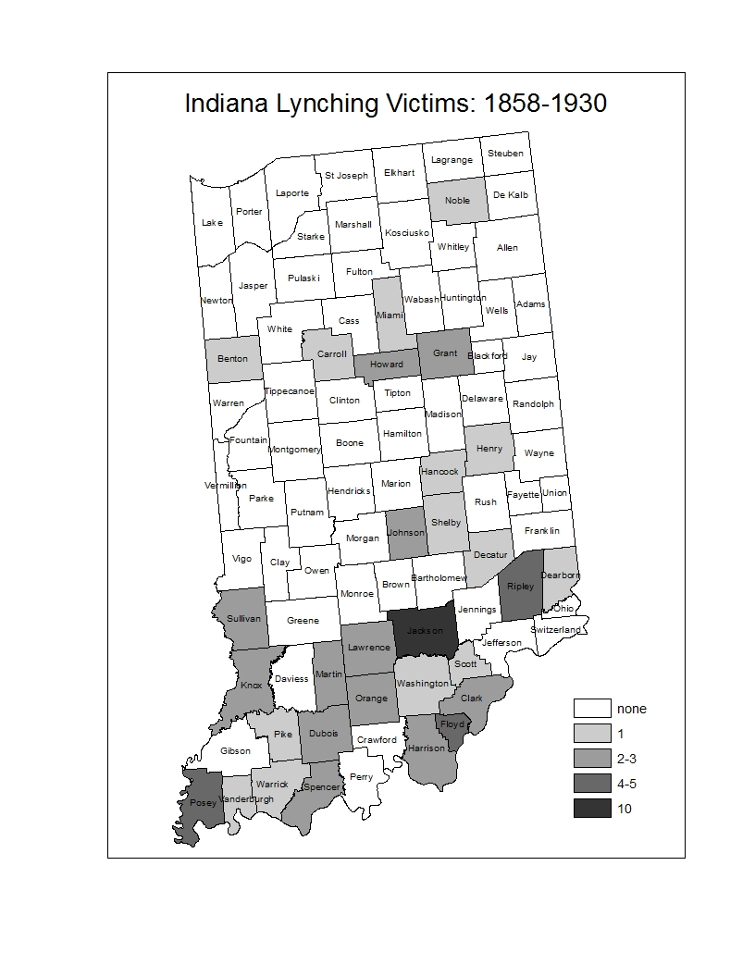

source: data: Pfeifer 2013; boundary file: Minnesota Population Center. *National Historical Geographic Information System: Version 2.0*. Minneapolis, MN: University of Minnesota 2011. [http://www.nhgis.org](http://www.nhgis.org/)

As seen in Figure 7, most Hoosier lynching was in Southern Indiana, although there is also a band of lynching victimizations north of Indianapolis (including, of course, two in Marion, Indiana, in Grant County, and two in Kokomo, in Howard County)—there were, however, none in Muncie or in Anderson, or in Lafayette or in Indianapolis, even though these urban centers were hotbeds of Klan activity between 1915 and 1924. It is quite likely that the Klan was terrorizing people in these counties, but they were not killing them “at the hands of an extra-legal mob.”

**Figure 8**

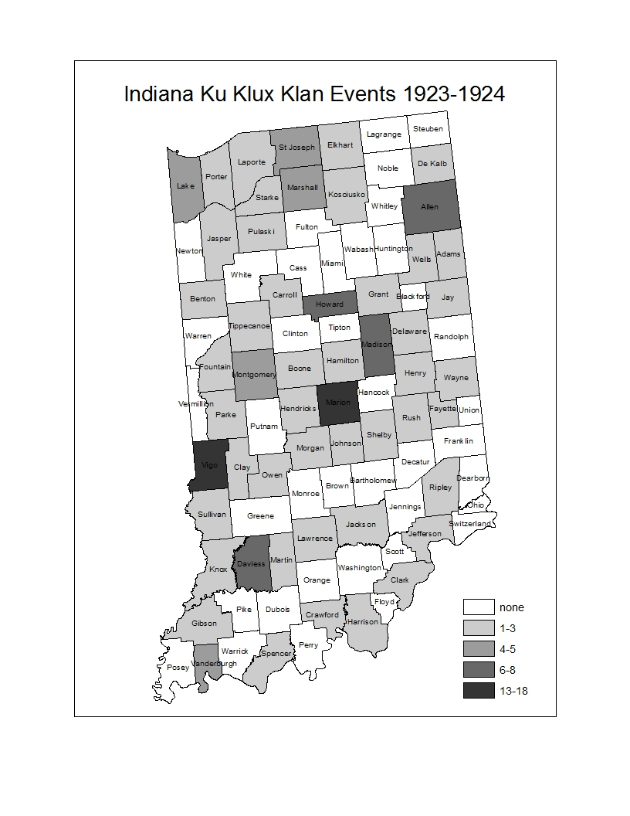

Source: data: McVeigh 2009; boundary file: Minnesota Population Center. *National Historical Geographic Information System: Version 2.0*. Minneapolis, MN: University of Minnesota 2011. [http://www.nhgis.org](http://www.nhgis.org/)

As we can see in Figure 8, Klan events tended to be concentrated in these urban centers, including Indianapolis, in Marion County, where there were 16 events. Similarly, 12 of 13 events in Vigo County were in Terre Haute, all 8 of the Howard County events were in Kokomo, and all three Delaware County events were in Muncie. Unlike Hoosier lynching, KKK marches and other publicized events were more likely to be in urban, commercial and industrial centers. All five of the Vanderburgh County events were in Evansville, as was the one lynching reported in 1882, where a white man accused of murder was beaten and shot by vigilantes.

Far from the urban centers of Indiana, Jackson County was the heart of lynch law in Indiana, claiming ten victims, mostly (7 of ten) in Seymour. Most (7 of ten, including six in Seymour) Jackson County victims were lynched before the end of Reconstruction, however, and only three Jackson County victims were killed after 1876. In fact, after Reconstruction, lynching was no longer concentrated in the South, between Indianapolis and Louisville, where yeoman farmers near the Kentucky border had been actively involved in lynching horse thieves. After 1876, the Southern bias remained, but there was also a band of lynching counties north of Indianapolis.

Does Race Matter?

So what explains the geography of lynching in Indiana? First, it clearly does reflect the effects of migration. The Border State culture of small scale yeoman farming entered Indiana along the Ohio River and brought with it the cultural baggage of Regulators and Judge Lynch and more or less violent struggles between upcountry or Appalachian or Cumberland Plateau yeomen versus planters and their slaves. The Civil War and Reconstruction brought a small black population into Southern Indiana, which moved into Indianapolis and, to a lesser extent, into the manufacturing cities to the North. The black migration continued after Reconstruction, but Northern Indiana remained virtually lily white. Adams was the only county with no black population, but the entire Northern region was virtually all white.

By 1920 there was a smattering of blacks in Northern Indiana, although still less than five percent of the population, even in Lake County, home of Gary, which is today nearly 85% black. Lake County reported a 4 percent black population in 1920, as the Chicago suburb was becoming increasingly urban and politically volatile, voting for Teddy Roosevelt, the Progressive, in his unsuccessful 1912 bid to defeat both Taft and Wilson and to reclaim the presidency.

Clearly, Hoosier political geography is complex, but in the critical presidential election of 1876, which effectively ended Reconstruction, there was a tendency for the Southern tier to vote Democratic—in favor of the Unreconstructed Southern Redeemer, still defending the lost cause.

The equally critical election of 1896 saw Silver Democrats in coalition with Populists in support of William Jennings Bryan, who would not be crucified on a cross of gold. This time the Republicans carried Indiana. Hoosiers seemed to prefer McKinley to Bryan, who was the Democratic as well as the Populist candidate. At the congressional level, however, not all Democratic communities were inclined to support Populist candidates. These “real Democrat” counties were the lynching counties, mostly along the Ohio River, but also including the emerging factory towns North of Indianapolis.

In the election of 1920, Indiana political geography resembled the election of 1876, but the Republicans carried Indiana again, and the Democratic counties were less concentrated in the South, as the party faithful surrounded without including Marion County, where Indianapolis is located. There was, in fact, a narrow band of Democratic partisanship extending from the Ohio River toward Indianapolis, then nearly surrounding Marion County. There were few Democratic counties north of Marion County—only Wells in the Northeast. Lake County polled 69% Republican, supporting Harding after its flirtation with Progressivism in 1912.

Predicting Lynching

My theory of petit bourgeois morality (Author 1990) tells me that lynching is bad for business and interferes with free trade and public order, so wherever you find a strong middle class, who promote churches and schools and good government, you will have fewer lynching victims than would be expected in such a petit bourgeois community that lacked the wholesome influence of women and children, sustaining churches and schools. Aside from that, black population and Democratic partisanship predict lynching. The fact that Indiana was not exactly under siege by an army of black immigrants is relatively unimportant. Things defined as real are real in their consequences (Thomas and Thomas 1928), and the Democratic newspapers promoted lynching, as indicated in this excerpt from a Georgia paper in 1870.



Source: Savannah *Daily News and Tribune* 10 December 1870, p. 2

Consequently, where percent black and percent voting Democratic were greater, more lynching was likely. Where there were no black people there would likely be no lynching (black population is the inflation factor, which predicts no lynching victims).

**Table 3**

**Zero Inflated Negative Binomial Predicting Indiana Lynching Victims, 1858-1930**

|  |  |  |  |  |
| --- | --- | --- | --- | --- |
|  | **Model 1: Pre-1876** | | **Model 2: Post 1876** | |
| **Predictor** | **coefficient** | **standard**  **error** | **coefficient** | **standard**  **error** |
| **percent black+** | 28.34** | 12.13 | -1.18 | 9.33 |
| **school kids+** | -.001*** | .0005 | -.000 | .000 |
| **Democratic**  **candidate++** | 9.66* | 5.01 | 2.45*** | .582 |
| **constant** | .480 | 3.85 | -1.95 | 1.08 |
| **inflation factor** |  |  |  |  |
| **black population+** | -.002* | .001 | -.004 | .005 |
| **constant** | 1.89*** | .469 | -.427 | 1.27 |
| N=92 | χ2=17.67*** | | χ2=23.70*** | |

+ percent black population or number of children in school in 1870 (Model 1)

or in 1890 (Model 2)

++ percent vote for Democrat for President in 1876 (Model 1),

or Democratic candidate for Congress (1=yes; 0=no) in 1896 (Model 2)

* p<.1 ** p<.05 *** p<.01

source: Pfeifer (2013) ICPSR 001 Historical Elections and ICPSR 003 Historical U.S. Census data available online:

<http://www.icpsr.umich.edu/icpsrweb/landing.jsp>

As seen in Table 3, that is exactly what we find for the Civil War-Reconstruction lynching model. After Reconstruction, however, as lynching becomes more racial, the effect of percent black (1870 or 1890) becomes insignificant. In fact, areas becoming increasingly black—notably, the cities such as Indianapolis, have few or no lynching victims.[9] The effect of the Democratic Party, however, is even more significant after Reconstruction, as seen in Model 2. Here we are looking at the congressional races (as we did in the map), but we are using a dummy variable to indicate whether the county fielded a Democratic candidate for congress (in 39 counties) or pitted Republican against Populist (53 counties).

What about the Klan? Table 4 reports three models that combine in varying degrees the essential elements of the lynching analysis in Table 3, but the dependent variable is KKK events reported by McVeigh (2009) in 1923-1924.

**Table 4**

**Zero Inflated Negative Binomial Predicting Indiana KKK Events in 1924**

|  |  |  |  |  |  |  |
| --- | --- | --- | --- | --- | --- | --- |
|  | **Model 1** | | **Model 2** | | **Model 3** | |
| **Predictor** | **Coefficient** | **standard**  **error** | **Coefficient** | **standard**  **error** | **Coefficient** | **standard**  **Error** |
| **Percent Black 1920** | 21.77*** | 5.96 | 21.80*** | 5.63 | 1.02 | 7.90 |
| **School Kids 1920** |  |  |  |  | .000** | .000 |
| **Democrat President**  **Candidate Cox 1920** |  |  | -4.18* | 1.93 | -2.11 | 1.90 |
| **Constant** | .277 | .213 | 1.95* | .793 | .929 | .789 |
| **Inflation Factor** |  |  |  |  |  |  |
| **Black Population** | -.004 | .003 | -.004 | .004 | -.005 | .004 |
| **Constant** | -.647 | .646 | -.620 | .676 | -.477 | .645 |
| **N=92** | **ϰ2=16.04\*\*\*** | | **ϰ2=20.83\*\*\*** | | **ϰ2=32.10\*\*\*** | |

* p<.05 ** p<.01 *** p<.001

source: : McVeigh (2009) ICPSR 001 Historical Elections and NHGIS Historical Census data available online: <http://www.icpsr.umich.edu/icpsrweb/landing.jsp>

<https://nhgis.org/>

The KKK represented the same petit bourgeois public order interests as the lynch mob, but was less conflicted by the contradictions of mass violence in the service of public order. KKK events tended to be “WUNC” displays—marches and demonstrations that indicated that the Klan was “Worthy, United, Numerous and Committed” (Tilly and Wood 2013: 4-5). As we have already noted, marches (unlike lynching) were family fun events.

Consequently, along with the threat of black population (and immigration, more generally) and the threat of Progressive politics, the effect of School Children is overwhelming and positive.[10] Race matters, as indicated in Model 1. Partisanship matters as well, as we see in Model 2. In this case, however, the partisanship effect is reversed, since the Republican Party in Indiana supported the Klan, particularly in Indianapolis, where D. C. Stephenson, appointed Grand Dragon of Indiana in 1923, with control of Klan operations in 23 Northern states, established his headquarters, rivaling the reach of Evans, the national Imperial Wizard by 1924 (McVeigh 2009: 2, 27, 103). McVeigh (2009: 15) identifies Evansville (4 events),[11] Fort Wayne (6), Indianapolis (16), South Bend (4), and Terre Haute (12) as “larger cities with Klan events,” but his data also indicate 8 events in Kokomo. There were no events reported in the young steel town of Gary, but there were four events in Lake County.

Lessons of History

Lynching changed after Reconstruction. Both the Klan and vigilantism came to Indiana from the Border States—crossing the Ohio River along with Freedmen and yeomen farmers who were attempting to escape the lash of the master’s plantation economy. In the early years, lynching blacks was just part of the general vigilantism of the Trans-Appalachian (or hillbilly) culture. Blacks were over-represented among victims, but that is true of criminal prosecutions and homicides even in the 21st century.

Ironically, as lynching became more racial, the significance of race in predicting lynching declined. After the failed efforts of Radical Republicans to keep blacks in the South by offering 40 acres and a mule, blacks moved increasingly into the cities of the North. Indiana communities continued to hold to line against racial integration in the late 19th century, however, effectively locking blacks out of the Northern farming region and even the Gary/SE Chicago region, which has now become virtually all black.

Even so, Democrats continued to play the race card, and those counties that were more inclined to support Democrats who were not Populists were also more likely to lynch. Places like Marion, Indiana, were far from the River and largely immune to black immigration, but they held the line with Democratic (or even Klan) support and the occasional resort to lynching. That is how terrorism works. You don’t need to kill someone every day.

By 1920, in fact, the emerging urban manufacturing towns of Indiana, on the border of the Northern expansion of lynching after Reconstruction, became centers of KKK activity. Kokomo and Indianapolis were important centers of the revitalized Klan. This was the thoroughly modern urban industrial Klan. This was not the Klan of the Reconstruction era South, which had engaged in lynching (or “outrages”) in Georgia in 1868 (Author 2011). The new Klan of the 1920s had their own police force, sanctioned by state legislation enabling the “Horse Thief Detective Association” to apprehend if not to execute horse thieves. According to McVeigh (2009: 135), these newly sanctioned and thoroughly organized Post-Reconstruction lynch mobs, “over 20,000 members strong, answered only to the Klan, not to the state governments.”

The Indiana Klan of the 1920s was different. It was aligned with the formerly Progressive Republican Party, and it defended public schools and temperance if not prohibition (McVeigh 2009, chapter 6). It also “drew upon familial and community ties—traditions of church suppers, kin reunions, and social celebrations—to circulate the Klan’s message of racial, religious, and national bigotry.” (Blee 1992: 3). This was the new KKK, which would soon move into abeyance (Taylor 1989), with the economic crisis of the 1930s, only to return with more violent as well as nonviolent efforts to defend Jim Crow in the 1950s (Cunningham 2013; Morris 1984; Morris 1993), but that takes us far beyond our current concerns and will have to be a topic for another day.

Meanwhile, perhaps our brief exploration of Terrorism in Indiana might help us to consider the historical and structural conditions that have inspired ISIS and other terrorist organizations to mobilize supporters for an Islamic state, perhaps a modern version of the Ottoman Empire. The end of the Cold War and the successive invasions of the Persian Gulf created opportunities. As Tarrow (2011: 160) explains, “When institutional access opens, rifts appear within elites, allies become available, and state capacity for repression declines, challengers see opportunities to advance their claims.” Clearly that is what has been happening in the Middle-East, which has facilitated terrorist challengers. Perhaps we should focus our international efforts toward creating opportunities for bourgeois colonial revolts, sustained by a global hegemonic bourgeoisie that might be willing to share the wealth with the less fortunate, in a more Progressive union that might be a better alternative to regime change without support for Radical Reconstruction.

**Appendix A**

After reading Beck (2000), I re-estimated the zinbe models predicting KKK events, using black population and foreign population (instead of percent black) and using native born white population (instead of black population) as the inflation factor. As seen in Table A1, this is a far superior model for predicting KKK events, with significant negative effects of both black and foreign born population. The net effect of partisanship remains insignificant, but when it is dropped from the model the inflation factor (Native White Population) achieves marginal significant (p<.1).

Most important, the highly significant effect of school children remains (and remains positive), but the effects of black and foreign population are consistently (and significantly) negative, as was the case in Beck (2000). In this case, however, these negative effects remain when change (as opposed to population) scores are included. Black and foreign population (or change in same) predicts fewer KKK events. Thus both the inflation factor and the main effects indicate that the size of the native white population predicts KKK events, which makes perfect sense, since that is the constituency being targeted. In this regard, I differ from Beck (2000) in interpreting percent black in 1870-1880 as indicative of black migration, which Democrats define as a threat. By 1890 it seems that the partisanship is more important than the reality. By 1920 this process may have reversed itself, but we do not find any evidence of sign reversal for a change effect. More research on all four waves of KKK challenges (1866-1990) is needed.

**Table A1**

**Zero Inflated Negative Binomial Predicting Indiana KKK Events in 1924**

|  |  |  |  |  |
| --- | --- | --- | --- | --- |
|  | **Model 1** | | **Model 2** | |
| **Predictor** | **Coefficient** | **standard**  **error** | **Coefficient** | **Standard**  **error** |
| **Black Population 1920** | -.000**** | .000 | -.000**** | .000 |
| **Foreign Population 1920** | -.000**** | .000 | -.000**** | .000 |
| **School Kids 1920** | .000**** | .000 | .000**** | .000 |
| **Democrat President**  **Candidate Cox 1920** | -2.22 | .1.78 |  |  |
| **Constant** | .387 | .759 | -.501* | .265 |
| **Inflation Factor** |  |  |  |  |
| **Native White Population** | -.000 | .000 | -.000* | .000 |
| **Constant** | .362 | 1.05 | .475 | .623 |
| **N=92** | **ϰ2=44.73\*\*\*\*** | | **ϰ2=43.14\*\*\*\*** | |

* p<.1 ** p<.05 *** p<.01 **** p<.001

source: : McVeigh (2009) ICPSR 001 Historical Elections and NHGIS Historical Census data available online: <http://www.icpsr.umich.edu/icpsrweb/landing.jsp>

<https://nhgis.org/>

References

Bailyn, Bernard. 1967. *The Ideological Origins of the American Revolution.* Cambridge, MA: Harvard University Press.

Beck, E. M. 2000. “Guess Who’s Coming to Town: White Supremacy, Ethnic Competition, and Social Change.” *Sociological Focus* 33, 2 (May): 153-174.

Beck, E. M. and Stewart E. Tolnay. 1990. “The Killing Fields of the Deep South: The Market for Cotton and the Lynching of Blacks, 1882-1930.” *American Sociological Review* 55, 4: 526-539.

Benford, Robert D. and David A. Snow. 2000. "Framing Processes and Social Movements: An Overview and Assessment," *Annual Review of Sociology* 26: 611-639.

Blee, Kathleen M. 1992. *Women of the Klan: Racism and Gender in the 1920s.* Berkeley: University of California Press.

Brown, Richard Maxwell. 1975. *Strain of Violence: Historical Studies of American Violence and Vigilantism.* NY: Oxford University Press.

Brundage, W. Fitzhugh. 1999. “Lynching.” *Violence in America: An Encyclopedia* 1: 297-303.

Callimachi, Rukimini. 2015. “ISIS and the Lonely Young American.” *New York Times* (June 28: A1).

Chalmers, David M. 1987. *Hooded Americanism: The History of the Ku Klux Klan.* Durham, NC: Duke University Press.

Cunningham, David. 2013. *Klansville, U.S.A.: The Rise and Fall of the Civil Rights-Era Ku Klux Klan.* NY: Oxford University Press.

Dykstra, Robert. 1968. *Cattle Towns.* NY: Knopf.

Einwohner, Rachel. 2003. “Opportunity, Honor, and Action in the Warsaw Ghetto Uprising of 1943.” *American Journal of Sociology* 109, 3: 650-675.

Foner, Eric. 2011. *The Fiery Trail: Abraham Lincoln and American Slavery.* NY: W.W. Norton, 2011.

Franzosi, Roberto, Gianluca De Fazio and Stefanie Vicari. 2012. “Ways of Measuring Agency: An Application of Quantitative Narrative Analysis to Lynchings in Georgia (1875-1930).” *Sociological Methodology* 42, 1: 1-42.

Gamson. William A. 1992. *Talking Politics*. Cambridge, U.K.: Cambridge University Press.

Goodwin, Jeff and James M Jasper. 1999. “Caught in a Winding, Snarling Vine: The Structural Bias of Political Process Theory.” *Sociological Forum* 14, 1: 27-54.

Hofstadter, Richard and Michael Wallace (editors). 1971. *American Violence: A Documentary History.* NY: Vintage.

Jackson, Kenneth T. 1967. *The Ku Klux Klan in the City, 1915-1930*. NY: Oxford University Press.

Kulikoff, Allan. 1989. “The Transition to Capitalism in Rural America.” *William and Mary Quarterly*, 3rd series, 46 (January): 120-144.

Leonard, Stephen J. 2002. *Lynching in Colorado: 1859-1919.* Boulder: University Press of Colorado.

Madison, James H. 2011. “Teaching the JAH.” *Journal of American History* (June) accessed on line 8/20/2015. <http://www.journalofamericanhistory.org/teaching/2011_06/sources/day2ex1_photo_madison.html>

Maier, Pauline. 1974. *From Resistance to Revolution: Colonial Radicals and the Development of American Opposition to Britain, 1765-1776.* NY: Vintage.

May, Robert E. 2013. *Slavery, Race, and Conquest in the Tropics: Lincoln, Douglas, and the Future of Latin America.* NY: Cambridge University Press.

McVeigh, Rory. 2009. *The Rise of the Ku Klux Klan: Right –Wing Movements and National Politics.* Minneapolis, MN: University of Minnesota Press.

Morgan, Edmund S. and Helen M.Morgan. 1974. *The Stamp Act Crisis: Prologue to Revolution.* NY: Collier-Macmillan.

Morris, Aldon.1984. *The Origins of the Civil Rights Movement: Black Communities Organizing for Change*. NY: Free Press.

Morris, Aldon.1993. "Birmingham Confrontation Reconsidered: An Analysis of the Dynamics and Tactics of Mobilization." *American Sociological Review* 58:621-636.

Pfeifer, Michael J. (editor) 2014**.** *Lynching Beyond Dixie****:*** *American Mob Violence outside the South*. Urbana: University of Illinois Press.

Piven, Frances Fox and Richard A. Cloward. 1977. *Poor People’s Movements: Why They Succeed, How They Fail*. NY: Pantheon Press,

Rubenstein, Richard E. 1970. *Rebels in Eden: Mass Political Violence in the United States*. Boston, MA: Little, Brown and Company.

Savannah *Daily News and Tribune* 10 December 1870, p. 2

Snow, David A., Peter B. Owens and Anna E. Tan. 2014. “Libraries, Social Movements, and Cultural Change: Toward an Alternative Conceptualization of Culture.” *Social Currents* 1: 35. The online version of this article can be found at: <http://scu.sagepub.com/content/1/1/35>

Snow, David A., E. Burke Rochford, Jr., Steven K. Worden, and Robert D. Benford. 1986. "Frame Alignment Processes, Micromobilization, and Movement Participation," *American Sociological Review* 51: 464-481.

Steinberg, Marc W.1998. “Tilting the Frame: Considerations on Collective Action Framing from a Discursive Turn.” *Theory and Society* 27, 6: 845-872.

Steinberg, Marc W. 1999. “The Talk and Back Talk of Collective Action: A Dialogic Analysis of Repertoires of Discourse among Nineteenth-Century English Cotton Spinners.**”** *American Journal of Sociology* 105, 3: 736-780.

Tarrow, Sidney G. 2011. *Power in Movement: Social Movements and Contentious Politics*, Third edition. NY: Cambridge University Press.

Taylor, Verta. 1989. "Social Movement Continuity: The Women's Movement in Abeyance," *American Sociological Review* 54: 761-775.

Thomas, William Isaac and Dorothy Swaine Thomas. 1928. *The Child in American, Behavioral Problems and Programs*. NY: A. A. Knopf.

Tilly, Charles. 1986. *The* *Contentious French.* Cambridge, MA: Harvard University Press.

Tilly, Charles. 1995. *Popular Contention in Great Britain, 1758-1834.* Cambridge, MA: Harvard University Press,

Tilly, Charles. 2007. *Democracy.* NY: Cambridge University Press.

Tilly, Charles. 2008. *Contentious Performances.* NY: Cambridge University Press.

Tilly, Charles and Leslie Wood. 2013. *Social Movements, 1768-2012* (Boulder, CO: Paradigm Publishers.

Useem, Bert. 1980. “Solidarity Model, Breakdown Model, and the Boston Anti-Busing Movement.” *American Sociological Review* 45, 3: 357-369.

Useem, Bert and Jack A. Goldstone. 2002. “Forging Social Order and Its Breakdown: Riot and Reform in U.S. Prisons.” *American Sociological Review* 67, 4: 499-525.

Wade, Eric C. 2011. *Constituting Whiteness: The National Horse Thief Detective Association and Racial Mores in Indiana, 1850-1930.*  West Lafayette, IN: Purdue University doctoral dissertation in American Studies, History. Online full text version is available through Purdue Libraries to Purdue faculty and staff, or through Inter-library Loan, for others.

1. We will review my (Author 2005) theory of class and party interests and explain how the Democratic and Republican parties supported lynching or the Klan and how this support varied or changed across time and place.
2. We can distinguish state sponsored terrorism on another occasion. He we focus on the civilian target.
3. Clearly, there could also be mobilization differences that interpret the effect of interests. We will distinguish interest-group threat measures (Beck 2000) from opportunity/threat measures (Tilly 1978; Tarrow 2011).
4. A second appendix (Appendix 2) contains tables produced by Stata that are offered for reviewers and interested readers but not included here in the text to save space.
5. These inflation (black population) and model (percent black) variables may seem to be the same, but they have very different effects when predicting zero victims as opposed to the number of victims.
6. I will spare you the gory details of the lynching of Sam Holt (aka Hose) in Newnan, Georgia, in 1899, reported in Franzosi et al. (2012). Out west, lynching in this period was somewhat less brutal than in the South, perhaps, but the mad rush for souvenirs was also part of the ritual in Colorado lynching of this period; see Leonard (2002: 137-9).
7. Beck (2000) finds that the more recent (circa 1980) wave of Klan events might have been a response to increasing Asian and Latino, as opposed to black, immigration, although he limits his attention to the Southern States.
8. Wade (2011) is not particularly interested in counting events or in defining events in such a way that sociologists could create data sets. For example, Wade (2011: 2-4) documents the seizure and hanging of a white man in 1861. Since the man was not killed, this would not be considered a lynching by most social scientists. In fact, it would qualify as a seizure and a hanging—clearly terrorism and vigilantism, but ultimately the captors did not execute their victim, who was, apparently, later found innocent and challenged his accusers with a civil suit. On definitions and methods, see Beck and Tolnay (1990); Franzosi et al. (2012).
9. After reading Beck (2000) I re-estimated these models using not only change in black population (1890/1870) but total foreign (Chinese and Japanese—very small numbers) and total nonwhite (black and Indian). I also tried using Native white males as the inflation factor. None of these were significant predictors, alone or in combination.
10. This remains true even when I used foreign instead of black and Native white males instead of blacks as the inflation factor. This “foreign/nativist” model is worth further discussion, in light of Beck (2000) findings, but that would take us far from present concerns (see Table A1 in Appendix A).
11. McVeigh (2009: 15) reports only four events in Evansville, but the appendix that he sent me includes five.