**Tilly’s Social Movements and Gordon’s KKK:**

**Toward a Dialectic of Interest and Identity Politics**

**Abstract**

The challenge of incorporating identities and the multi-dimensional interests that seem most popular in contemporary studies of social movements is accepted here in efforts to bridge the gap between the Dynamics of Contention (McAdam, Tarrow and Tilly 2001) approach to interests and organizations and the millennial take on new social movements (Milkman 2016). The ability to incorporate identities while retaining interests and maintaining a focus on organizations is demonstrated in an interpretation of the Ku Klux Klan and white nationalism (Gordon 2017). The challenge of moving from interactive to dialectical models is considered in conclusion.

Richard Hogan

Associate Professor of Sociology

Purdue University

January 2018

33 pages, 7,971 words (including title page, abstract, references (7 pages), and seven figures)

Keywords: social movements interests, identities, mobilization, Ku Klux Klan

Tilly (1978) was a paradigmatic revolution (Ritzer 1974), changing the ways that sociologists think about and study social movements. By 1986, Tilly (1986) had applied and elaborated his “Resource Mobilization” approach to incorporate time, specifying the interactive relations between social movements and social change in France. In 1995, Tilly (1995) reproduced the results of his French study, showing how the same forces (capitalism, state making, and contention) shaped the history of Great Britain in a similar fashion, albeit earlier and in a uniquely British manner. In 2007, Tilly (2007) added “democratization” to the processes that were transforming the Western world (McAdam, Tarrow and Tilly 2001). When he died in 2008, Chuck left us with lots of data and theory and paths toward analyses that should keep us all busy for another generation—at least.

But we are still not satisfied. Back in the 1990s, when I was teaching social movements to American Studies students, I asked Chuck why my students were so critical of Resource Mobilization theory. “It is because it is the dominant perspective,” Chuck explained. Just as we all criticized Parsons (1951)and even Merton (1968)and Coser (1957), in graduate school in the 1970s, later, in the 1990s, graduate students were criticizing Chuck, Bill Gamson (1990 [1975]), McCarthy and Zald (reprinted in Zald and McCarthy 1987). But there should be some forward progress—right? We are not simply doomed to repeat the sins of our fathers (and mothers), but there does seem to be a revival of relative deprivation theory (Smith and Pettigrew 2015). There are also a fair number of critics, including Tilly (Hogan 2004), who want to abandon the attempt to specify a structural equation model that predicts collective action. Even today, my students seem less than impressed, even with the latest version—Dynamics of Contention (hereinafter, DOC: McAdam, Tarrow and Tilly 2001). They seem more interested in New Social Movements or Intersectionality/Standpoint theory or some version of the politics of identity that eschews the study of interests and organization as the base of contention—from mobilization to revolution (Goodwin and Jasper 2004; Milkman 2016; Pischardo 1997).

Consequently, I have become increasingly inclined to incorporate identity as well as interests and to incorporate framing (Snow et al 1986; Snow and Moss 2014). Also, following Tarrow (2011), I have been attempting to incorporate the interactive relations between social movements and social change as lead and lagged effects. Here I will attempt to incorporate the dynamics of DOC (McAdam, Tarrow and Tilly 2001) and the specification of framing and identity effects in an interactive contingency model that might allow us to consider conditional probabilities, if not cause and effect relations, without resort to teleological or functional theories of structure and process. This will guide a brief interpretation of the Ku Klux Klan and white nationalism (Gordon 2017). Then, in conclusion, we will consider the challenge of specifying a dialectical model of social movements and social change.

Identities and Interests

At one point, I considered the possibility that identities and interests were equivalent concepts, associated with micro versus macro or processual versus structural approaches to collective action and social movements. One might argue that new social movements, such as Occupy and the Arab Uprisings are rooted in identities—young unemployed or underemployed professionals, with more education than occupational status, who see themselves as the representatives of the masses, in opposition to the elites (Milkman 2016). Exactly who “they” were and who were “the elites” was subject to negotiation, but the Occupiers hit upon the idea that “we” are the 99% and “they” are the 1%--the wealthiest and most powerful people in the world. In the Arab uprisings, it was clear that “they” were the hereditary and long-established leaders, tyrants, who were rich and powerful, while we were everyone else (Kienle 2012; Lynch 2014).

The identities of these all but leaderless and largely ephemeral movements were more clearly articulated than their interests, which might be considered “democracy” or “equal opportunity” or some version of bourgeois freedom or “rights.” These movements did not articulate programs or policies and did not generally contest elections successfully or shape politics in any clearly discernible long-term or even short-term campaigns that could be analyzed as interest group politics.

We could, of course, attribute interests to them—petit bourgeois young urban professional interests in jobs with high salaries and benefits, including opportunities for career advancement and eventual retirement as rentiers (Milkman 2016). This seems to be what Tilly (1978) would suggest as the objective interests that seem most useful in attempting to explain contention in the long run (16th-21st centuries). Marx and Engels (1978, on French peasants, p. 608; proletarians, p. 578) would explain that petit bourgeois peasants and other reactionaries (presumably, nomads as well as agriculturalists) tend to follow emperors, whether they be Bonapartist, Nazi, or Islamic. There are parallels from the 19th century small peasants in France to the rural populations of Iran and Syria, which indicate class-based conflicts between an urban proletariat, which sometimes has the support of shopkeepers, and a rural small proprietor culture that tends to be reactionary, but the process of class conflict and repression or facilitation is ultimately determinant. As we say, class conflict is the engine of history. Had the IWW been more successful in Portland, Oregon, the second coming of the Klan might have been quite different than it was, when Portland hosted the AFL convention in 1923 (Hogan 2009; Johnston 2003, pp. 246-247).

In the short run, however, we need to rely on the expressed interests of the challengers, which seem, at best, ill defined. We might, in fact, dismiss these movements on this basis. Identity politics seems to be effective in generating widespread discontent through injustice frames, but they are decidedly lacking in programmatic framing—demands on authorities or plans to change the world. Thus, identity politics looks like mob behavior or collective behavior—largely expressive and irrational (Le Bon 2002 [1896]); Smelser 1963).

We should, however, take identities more seriously. Radical feminists, Jesuits and other left-wing Christians and Jews, Pagans, Vegans, and Witches were all bases for affinity group organizations in both the anti-nuclear and the peace movements of the late 1970s. People who lived in these disparate communities shared a common interest in opposing nuclear energy and nuclear weapons. They engaged in direct action campaigns that were not really designed to stop war or nuclear power, although they did create problems and delays that helped undermine popular and government support for nuclear power if not nuclear weapons. Their most important contribution, perhaps, was modeling the peace and harmony of a new, radical community, dedicated to quality rather than quantity, consensus as opposed to majority rule in a “prefigurative” politics of modeling what communism (or communalism) might be if we worked hard enough to achieve it. The struggle was the process, a goal in and of itself. Life is a journey—not a destination (Epstein 1993 [1991]).

We structural determinists might be inclined to categorize identity politics as status (as opposed to class or party) politics—much like Gusfield’s view of Prohibition (Gusfield 1966) and Mothers Against Drunk Drivers (Gusfield 1981). My inclination, however, is to recognize that interests might be class-based, status-based, or purely partisan—as when the Republicans attempt to decide whether to support Trump or not. There are “new” and “old” social movements, but these are distinguished by repertoire, as Tilly (1978) and Tarrow (2011) have explained (Calhoun 1991). Beyond that, it is not clear that we need a new theory of collective action to explain reactionary or status interests, despite what the literature suggests (Blee and Creasap 2010; Calhoun 1993).

There is no need to abandon the basic premise of Resource Mobilization theory—that interests, organization, mobilization, power, and opportunity/threat predict collective action. While it is certainly true that means of communication, notably social media, affect organization and mobilization and, perhaps, even tactics, it is not clear that we should reduce the Arab Uprisings or the Occupy Movement to technological causes (Howard and Hussain 2013). Movable type was also revolutionary, and newspapers were important in facilitating mobilization, but they do not explain collective action—no less revolution (Hussain and Howard 2013; Tarrow 2011).

More pertinent, for the present, is the claim that the Resource Mobilization (or DOC) model cannot be used to explain or interpret identity politics (Goodwin and Jasper 2004). The challenge is to neither dismiss nor ignore interests and identities but to theorize and investigate their inter-relations and the extent to which they represent distinct effects on organization, mobilization, opportunity/threat, and power. First, we need to recognize that identities are not the same as interests. The best way to illustrate this is with a little social psychology, relying not on micro-economic (Olson 1965) but on micro-sociological theory (Calhoun 1993). Although Tilly (1978) seemed wedded to what we now call rational choice models, these were only suitable for organizational analysis. Organizations tend to be rational actors. Individuals are crazy, emotional, passionate and only sometimes rational or calculating (Marwell and Ames 1981).

Without an extended foray into social psychology, we might simply recognize that identity (like interest) is rooted in social (including economic) relations with other people. We can recognize others (who also have identities) and situations as constraints upon but also products of social action—in which actors take each other into account (Weber 1993). We could adopt symbolic interactionism or, at least, George Herbert Mead (1967), wholesale, except for the tendency to ignore conflict and individual or collective interests, not to mention the wholesale rejection of structural constraint in Blumer’s theory of joint action (Blumer 1956). If we could bring conflict and interests back into a Simmelian (Simmel 1964) dialectical interactionist theory of relations between self and other, it might look something like Figure 1.

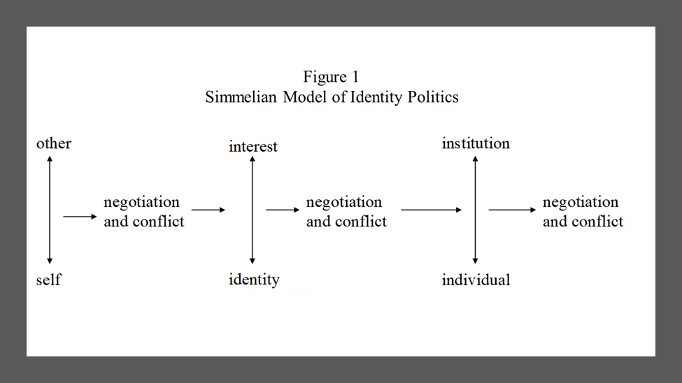

We might consider interests to derive from roles (e.g., worker) while identities derive from performances, but a dialectical or interactionist model of identity and interests would not require that we explain the exogenous forces (e.g., being raised by wolves) that might shape identity and interests in important and significant ways. Since we are willing to accept the existence of an institutional order (in the medium to long run) or expressed identities and interests (in the short term), these are not critical issues for us to resolve at this point. For our purposes, we can conclude that there is potential conflict as well as room for negotiation in performing roles—e.g. being a good son or daughter, which continue to shape individual behavior both in and out of institutional settings. This allows us to consider the distinction between institutional and extra-institutional behavior as largely irrelevant in determining interests or identities.

Unrepentant structural determinists need not accept this conclusion. Obviously, being a Jesuit (a Catholic religious order) within the institutional order of the Catholic church, at a time when the pope is also a Jesuit, is likely to be extremely salient, particularly given the history of intellectual and left-wing political activism among the Jesuits. In fact, we might say that this is an opportune time for radical Jesuit priests and their allies to challenge Trumpism and White Supremacy (or Nationalism). At the same time, of course, Trumpists and White Nationalists, have enjoyed the opportunities of this administration. While their identities and interests differ markedly, radical Jesuits and reactionary White Nationalists represent interests and identities that are more likely to mobilize, given the political opportunities: notably, divided elites, powerful allies, and a disinclination to repress challengers. The fact that opportunities within the religious community are different from opportunities within the polity, should not be a problem, so long as we recognize the structural constraints (Tarrow 2011; Tilly 1978).

Once again, our identities and interests, as they predict organization, mobilization, opportunities, and power, are rooted in relations. These might be relations of production (e.g. employment) or reproduction (e.g., marriage). They are not necessarily relations that are enthusiastically embraced. In fact, they may be rooted in exploitation or opportunity hoarding (Hogan 2001; Tilly 1998). Nevertheless, for better or worse, these relations constitute the basis for determining power in the original Resource Mobilization model (Tilly 1978). By 2004, Tilly (2004) had elaborated the web of social relations that constitute the potential resources that might line up on either side of a political challenge. As Tilly and Wood (2012) present this theory, it might look something like Figure 2.

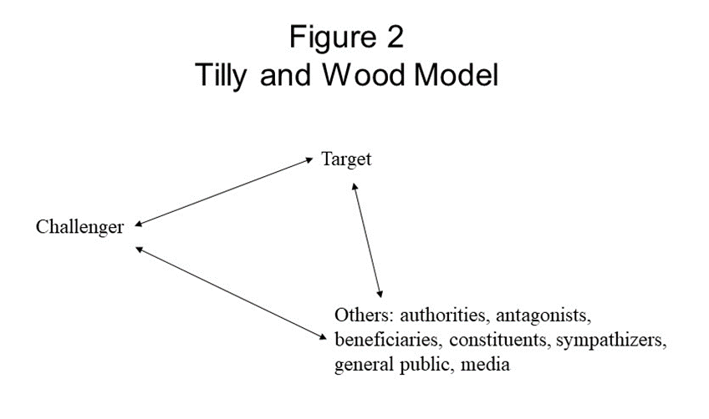

Once again, it really does not matter whether these relations are rooted in what might be considered interests or identities. Again, the challenge might involve the Jesuit and the pope, the White Nationalist and the president, Trumpists and Republicans, or women and the president (at the 2017 March on Washington). These relations can be understood as the base for constituting power and opportunities, just as the corresponding identity/interest of the challenger should affect organization and mobilization. Here, however, we might want to consider when interests and identities could yield divergent or at least different effects.

“Black Lives Matter” is a programmatic claim that could be considered a base for claiming that we are numerous (see Tilly 2004, on social movement definition, including Worthy United Numerous and Committed [WUNC] displays, pp. 3-4). Everyone agrees (or should agree) that black lives matter—even white people; maybe even Republicans. Nevertheless, making the claim that black lives matter is likely to generate patterns of support and opposition that are quite distinct from the identity claim, “we are black mothers,” who care about our children. You don’t have to be a black mother or a black teenager in a hoodie to proclaim that black lives matter, but the fact that you are black, male, and young is likely to create patterns of indifference if not opposition and, quite possibly, hostility and repression at the hands of authorities and civilian (private) police. In fact, it seems that relations between black teens or black men and police or citizen vigilantes created the opportunities/threats that inspired black mothers (and others) to mobilize. Here it is clear that identity is operating independently of interest. Anyone who promotes racial justice might generate opposition, but protesting while black is still a dangerous proposition (Davenport et al 2011).

Framing

Even the DOC folks, notably Tarrow (2011), recognize that framing is important. In fact, framing has become part of the mainstream DOC approach (McAdam, Tarrow and Tilly 2001) and has led some, at least, to expand beyond the use of frames as intervening variables toward the relatively autonomous status of culture in the social construction of knowledge (Gamson 1988, 1991, 1992; Gamson and Modigliani 1987 and 1989; Snow et al 1986; Snow and Moss 2014; Tarrow 2011). We empiricists (and “small ‘p’ positivists”) still are inclined to believe that organization, power, and even opportunities exist outside of our consciousness. We concede, however, that the effects of organization and opportunity on mobilization, and the effect of opportunity/threat on collective action (or contention) are interpreted or specified by framing. Organizations, including the mass media, frame interests and identities in ways that facilitate or impede mobilization. Similarly, the effect of media and organizational framing can help translate opportunities into actions. At the same time, people do not simply apply the culturally available media frames when thinking about politics. Their identities and interests and the process of negotiating same in small group settings (and, presumably, in large organized gatherings) are much more salient in predicting how people frame an issue (Gamson 1992).

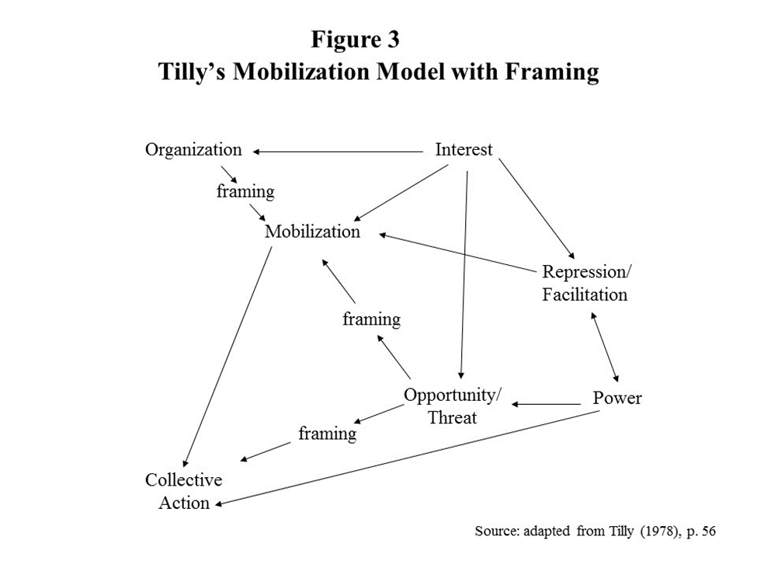

As indicated in Figure 3, we are inclined to maintain the general position that framing is an intervening variable, specifying effects that it cannot construct from whole cloth. As Marx said, people construct their material life (and, by extension) their consciousness, but they do not do so from whole cloth (Marx and Engels 1978, pp. 4, 150-155, 172-173, 595). There are structural constraints. The Jesuit pope and the new president are objective and real, even though they are socially constructed in media frames and in supportive or challenging collective claims. At the same time, however, things defined as real are real in their consequences (Thomas and Thomas 1928).

The presidential election of 2016 was celebrated by some but grieved by others. Well educated white women over 40—Hillary’s base, were shocked and awed but took some consolation in learning that she had won the popular vote (Torpey 2017, pp. 708-709). At that point, it was not so much denial or even anger as much as the injustice claim that motivated the Women’s March in 2017. The idea of a march, organized by white women, infuriated some black women, who, unlike their white sisters, had voted overwhelmingly for Clinton. This reaction inspired the organizers to invite prominent blacks and others, in attempting to broker a rainbow coalition that united the discontented across race, class, gender, sexual identity and orientation, age and whatever else might provide a base for mobilizing women and those who supported them in their moment of grief and pain, as they sought to mobilize for a challenge to the new administration. Even Roger Moore was there, with practical advice and phone numbers (to “call your representatives”).

Bringing the Dynamics into Contention

Contention is a process, as indicated above, in considering how the Women’s March developed in response not simply to the election and the opportunities/threats it represented but to the media and the reactions of others, who should have been allies but were, initially, angry instead of supportive. Here we see clearly the interaction of challenger with target (the new administration/regime) and others, and the attempts to broker a larger coalition. This brokering effort was confounded by the fact that some interests, notably Black Lives Matter, refused to take a partisan stand in the election. At the same time, some identities, notably, black women, were angered at the audacity of white women, who were not united in opposition to Trump.

The difficulty was exacerbated by the fact that the movement for racial justice—beginning with abolitionism, and the women’s movement—beginning with suffragettes, had a less than harmonious history. At some points, notably, after emancipation, the women compared themselves—the respectable and worthy white women, to the newly enfranchised former slaves. In contrast, black women contested the women’s claim to represent all women, in reminding their sisters, “Aint I a woman?” (Buechler 1990; Painter 1996; Robnett 1997; Rupp and Taylor 1987; Staggenborg and Taylor 2005; Taylor 1989 and 1999; Taylor and Whittier 1998; Washington 2009). Clearly there is a long history of race and gender identities and interests converging and diverging as they did in response to the call for a Women’s March on Washington. Attempting to capture these dynamics is a challenge for those who study social movements.

Tarrow (2011) attempts to incorporate the dynamics of contention by building on McAdam’s (1982) “political process model,” which is modified to incorporate relations between challengers and members in innovation as well as power. This is reproduced as Figure 4.

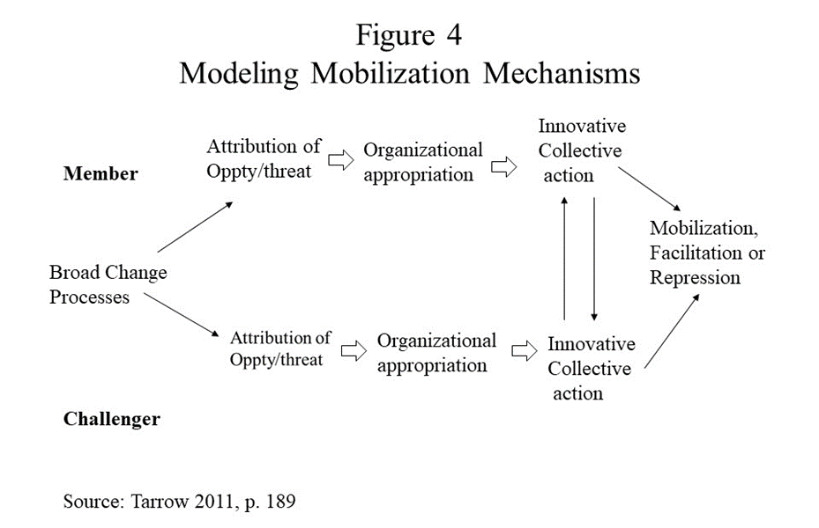

Here we should think about collective action not simply as an interaction between members and challengers but also as a lagged effect on mobilization and facilitation/repression, which were, in the original Resource Mobilization model, predictors of collective action. This yields something like Figure 5.

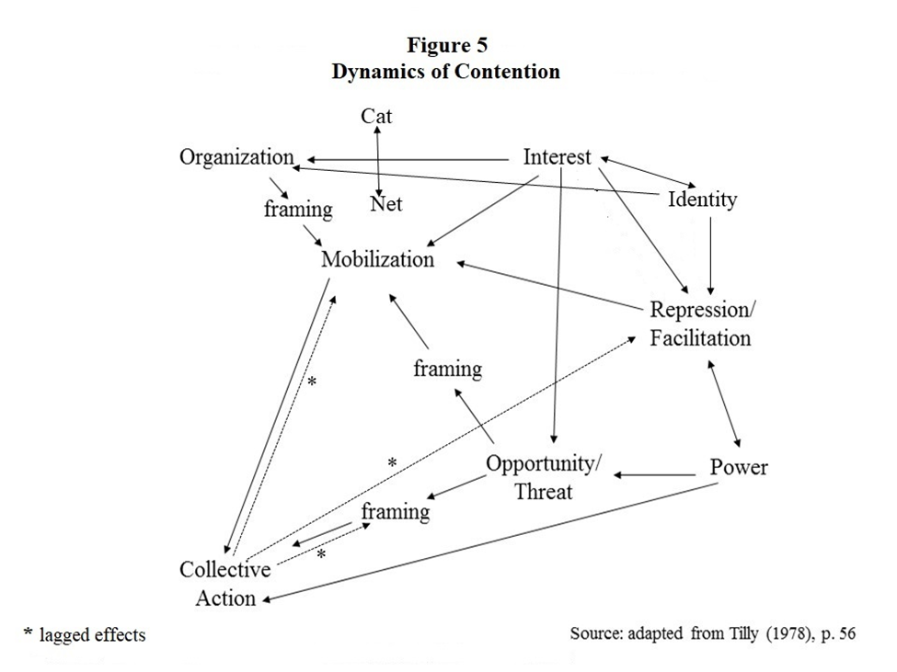

Figure 5 adds identities and the interaction of identity and interest, indicating their separate effects on organization and repression/facilitation, as discussed above. The “cat-net” interaction is added just as a reminder of what constitutes organization, which helps students to visualize how interests and identities might affect organization. Clearly, one could make a case for a direct effect of identities on mobilization as well, but that need not concern us now.

Aside from specifying the direct effects of collective action on repression/facilitation and mobilization, I have added a direct effect on the framing of opportunity/threat, indicating that the action would affect a retrospective framing of the opportunities/threats. Collective action is not directly affecting opportunities/threats but the framing of same. There is, however, an indirect effect of collective action on opportunity/threat, through the effects of repression/facilitation and power. Reactions to events (or campaigns) may increase or diminish the probability of future action, through its effects on mobilization (increased/decreased combat readiness) and repression/facilitation (increased/decreased cost of further action), as well as the effects on framing the opportunities/threats of further action. One might also make the case for direct or indirect effects on identity and interests (McAdam 1992), but this too might be deferred for another occasion. We will consider, below, how these additions to the model would make it even more difficult to focus on interests or identities at the individual level, as opposed to focusing on organizations.

Using DOC to Think about the KKK, White Nationalism, and Trumpism

Linda Gordon (2017) wants us to see the continuity in American [USA] political culture, from the 1920s to the election of 2016. This is a rather unusual goal for an historian, but it provides a useful base for considering the interests and identities and organizations that underlie these political challenges. Gordon (2017, pp. 6-7) suggests that the KKK was different from most social movements because it represented “100% Americans” who were extremely “mainstream” in the context of a “resurgence of … conservative populism.” In this regard, she is following the path of McVeigh (2009, p. 35), who claims that the emergence of “right-wing movements” is less dependent on “organizational resources and political opportunities” because they are “relatively privileged.” In a similar vein, Blee (1992, p. 3) explains how Klanswomen “do not fit the traditional categories that characterize political movements, such as right wing and left wing.” The complex set of identities and interests that these women espoused and defended defy conventional analysis.

Clearly, the “100% American” identity (Gordon 2017, pp. 1-23) of the second coming of the Klan combined the racism of the Southern “Redeemer” Democrats with the Nativism of the Northern Republicans. The roots are in the reactionary fringe of the major parties. Southern Democrats or “Redeemers” who were not yet Reconstructed or prepared to accept Civil Rights, even when proclaimed by federal judges, were one strain of reaction rooted in racism. Within the Republican party, nativism had roots in the Know Nothing or American party, which emerged before the election of 1860, in the segue from Democratic-Whig to Democratic-Republican partisanship (Du Bois 1998 [1935]; Foner 1974; Foner 1990). This same reactionary strain ran through the Progressive era and materialized not just in the second coming of the Klan but in Prohibition and Eugenics and the nativist base of Progressive attacks on political machines, particularly the Democratic machines, in Chicago and New York, which were rooted in immigrant aid networks at the precinct level.

The old Klan was born in Appalachia and combined the folklore, music and drama of the inbred mountain community with attempts to defend the border lands from the Freedmen who were empowered by Reconstruction in the South. This Klan, established in 1866, had moved into Georgia and elsewhere in the plantation South by 1868, where it was instrumental in Redeeming the black belt of the cotton region, relying on terror and legal machinations to re-establish white supremacy (Cunningham 2013, pp. 17-23; Hogan 2011; Kousser 1974).

Aside from the culture of the old Klan, which was appropriated in the second coming, the Appalachian culture was also part of the new Klan. In this regard, although the new Klan seems to be a more Northern, urban phenomenon, this varies from state to state. The national Klan paper, the Imperial Night Hawk, in 1923-1924, reports Klan events nationwide, allowing for analysis within as well as between states. In Pennsylvania, for example, there were far more Klan activities reported in Altoona (N=17) than in Philadelphia (N=3). The other major Klan site in Pennsylvania is Pittsburg (N=15) (based on McVeigh 2009 and the data that he so generously shared with me).

The same pattern is evident in Ohio, where there are more events in Columbus (N=10), Springfield (N=11), and even Marion and Youngstown (N=6) than in Cincinnati (N=4) or Cleveland (N=1). As illustrated in Figure 6, there is a tendency for Klan events to cluster in the more Appalachian or rural areas of the Northern states, even though they tend to occur in cities. Even in Georgia, it is the mountain (or near-mountain Northwestern) city of Atlanta (N=89) rather than Savannah (N=1) or Augusta, the home of Radical Republican Governor Bullock, elected in April of 1868 (Hogan 2011), which was one of the 22 cities of over 50,000 persons (in 1920) where no KKK events were reported (McVeigh 2009, p. 14).

**Figure 6**

**Appalachia**

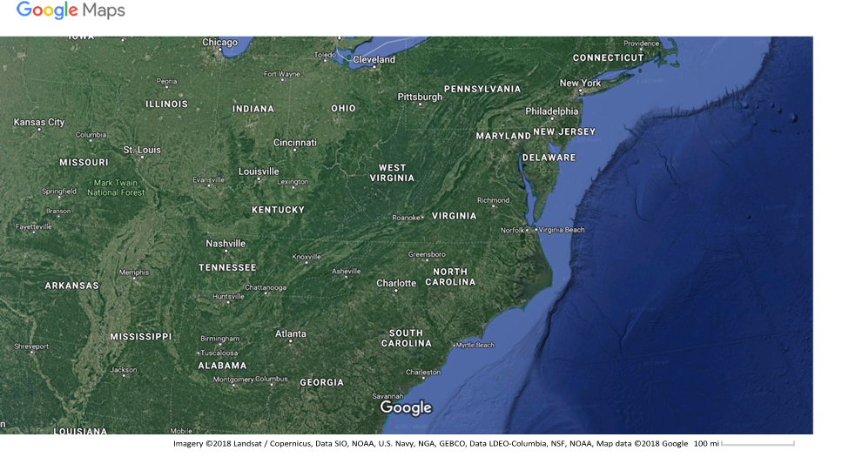

Gordon (2017, p. 25) also identified an interest in temperance—more accurately, prohibition, which McVeigh (2009, p. 176) confirms as a significant effect (in his state-level data on Klan events). Here we should recognize that the Appalachian hillbilly identity was directly in conflict with the interest in prohibition. The hill people resisted federal efforts to tax liquor, dating back to the Whiskey Rebellion of 1791-1794 (Gould 1996). Education is another interest, predictive of Klan events, which conforms to both the petit bourgeois family lifestyle or status and the anti-Catholic interest, but which also tends to divide the rural and urban proprietors. Similarly, McVeigh (2009) and Moore (1991) find evidence to support the assertion that Protestantism tended to facilitate the mobilization of KKK members, which also points to a potential conflict between a rural Protestant farming people and a more cosmopolitan urban population.

So, we can conclude that the Klan was able to broker an alliance among religious, racial, ethnic, and political interests and was able to frame their appeals to resonate with the petit bourgeois Protestant identity of those communities likely to facilitate Klan mobilization. We should add that the conflicts between small proprietors in the hills and in the industrial towns of the North confounded the brokering efforts. While the hillbilly farmers and the shopkeepers were both small proprietors, the whiskey culture (and economy) of the former (Gould 1996) and the evangelical tradition of the latter (Johnson 1978) created barriers to brokering across class and status cleavages. This might explain why Southern Indiana was relatively immune to Klan mobilization efforts, despite the tendency for Klan membership rates to be higher in rural areas (Moore 1991, p. 55-60)

Less convincing, is Gordon’s claim that the Klan was rooted in traditions of fraternalism and populism, although this claim could be defended if we reduce Populism to the racism of Georgia and ignore the qualitatively different coalitions underlying Populism in Colorado, for example, and the importance of class as a base for organizing fraternal or any other sort of association, particularly those that are related to occupation (Hogan 2009). This sort of revisionist effort would be helpful in specifying how already organized persons—Masons or others who were active in community life, and Protestants, could be mobilized through their existing networks. The Klan was very effective in recruiting Protestants through their churches and Masons through their fraternity. The key to success, as we will discuss below, is flexibility in response to local circumstances.

More important, for present purposes, those who reject the basic premises of Resource Mobilization for some version of identity or status politics invariably fall into the trap of logical reductionism, which they usually compound with ecological correlations or fancy new statistical tricks that allow us to ignore problems of model specification in a whirl of calculus that most of us don’t really understand and don’t even bother to read. The problem of statistical obfuscation would be less serious if it were not for the logical reductionism.

Rory McVeigh’s (2009, pp. 38-45) power devaluation theory is a case in point. He asks, implicitly, what motivates people to participate, when he really wants to know why events take place where they do. If we return to Figures 4 and 5 (above) or to the problem of collective behavior and rational choice, which inspired Resource Mobilization theory in the first place, it should be apparent that the micro-level is a dangerous place to start. We can look at interests and identities, which are multi-faceted and interactive if not dialectically linked in a complex web of social relations which are more, or less, salient and appropriate in inspiring someone to attend a Klan event or to join the local Klavern. We have already considered the possibility that the already complex relations between interests and identities and predictors of contention or collective action, might not be sufficiently complex in our models. Why do people engage in social action, in general? There are lots of reasons, and they are not mutually exclusive (Weber 1993).

Let us instead ask a simpler question. How did the Klan recruit members and attract spectators and participants? Now we can assume that the Klan (an organization) was deliberately created for some purpose, so it is rational (at least formally, if not substantively). We know, of course, that the founders of the Klan were running a confidence game, in pursuit of profits. This was a get-rich-quick scheme—a pyramid scheme, which professional promoters developed, using mass media and salesmen on commission—something like Amway. Soon, however, a new chief decided to fire the professional promoters and develop the Klan as the community base for a political party—something like the Farmers’ Alliance, but organized from the top down (like the Tea Party), without the class base that the farmers’ movement enjoyed. In fact, Evans reformed the Klan, replacing commissions with salaries and imposing moral standards, notably, honesty and temperance, which soon expanded into a litany of petit bourgeois family values that were to provide the identity and interest base for the organization, whose goal, ultimately, would be political power, to be used in the reformist spirit of the Women’s Christian Temperance Union and similar Progressive movements of that period.

Unfortunately, Evans was not a very good administrator. He hired Stephenson, who established himself in Indianapolis, as a gangster, for all intents and purposes. He was a great salesman and con artist, totally without scruples, who reactivated the Indiana Horse Thief Detective Association as his private police and thereby established a rather peculiar sort of hegemonic oppression. His was a reign of terror, but he effectively exploited the institutional authority of the Republican party to control state politics and the religious community—at least in its Protestant and particularly evangelical sects, to rule without resort to physical violence. Most of the time, the threat of Klan disapproval and the apparently overwhelming power of the Klan was enough to encourage white Protestants to join local Klaverns and to entice almost everyone white to attend the spectacles.

This was incredibly successful for a few years, although it was hard to get people to pay their dues, but it was finally destroyed by Stephenson’s fight for control of the national organization and his inability to restrain his sexual appetites and his violent temper. When Stephenson was arrested on charges of rape and murder, that was pretty much the end of the line (Chalmers 1987, pp. 28-38, 165-166, 291-299; Gordon 2017, pp. 11-36; Jackson 1967, pp. 44-146; Moore 1991, pp. 1-12; Wade 2011).

So how did the Klan manage to attract members? They used professional organizers to frame their organization and it activities as “100% American” in the defense of white American-born Protestant family values, against the threat of blacks (especially in the South) and immigrants, Catholics, etc. They were most successful in places like Indiana, where the base population was overwhelming white Native-born Protestant and the dominant party—Republican, cooperated, as did most of the Protestant clergy. Popular support, divided elites, powerful allies all came together as opportunities for a mass movement that maintained its independence from the two-party system (allying with either party, depending on the state or locality) and the religious community (refusing to become a sect or a cult).

The semi-autonomy of the Klan was critical in its success. It refused to be a political party or to be captured by either the Republican or the Democratic parties, supporting Democrats in Oregon (Johnston 2003, p. 243) and Republicans in Nebraska, effectively seizing control of local and state governments through its ability to get members to vote for the Klan candidates and to petition or walk the precincts, cajoling or intimidating opposition and effectively exploiting its widespread support (Gordon 2017, pp. 170-171). Its ultimate failure was rooted in its denial of Civil Rights or any rights that amendments to the constitution guaranteed and federal courts routinely defended.

In that regard, the Indiana Klan of 1924 was like the Indiana Republican supermajority of the twenty-first century. They can outlaw abortion or protect religious freedom (as defined by themselves), but their laws cannot withstand judicial scrutiny. They were, in some sense, like the Anti-federalists, secure in their control of local government and suspicious of the alien interests that would find protection in a federal authority, hamstrung with a Bill of Rights that would forever limit majority rule. In this regard, the early days of President Trump, with his administrative decrees, were similar, following this general pattern of reactionary non-democratic (or unconstitutional) rule (Torpey 2017).

Of course, the increasing economic and political power of Jews and Catholics and the internal struggles of the Klan leadership, their rampant hypocrisy, embezzlement, and criminal acts of rape and murder, all combined to undermine the Klan. Like Southern lynching, the Northern Klan went into abeyance during the Depression (Taylor 1989), when a new governing coalition—big labor, big capital, and big government, abandoned the petit bourgeois evangelical Protestant constituency of the Klan (Johnston 2003; Gordon 2017). The next wave of Klan mobilization, during the Civil Rights Movement, built on the networks that had been established in the 1920s and enjoyed the same set of political opportunities that inspired the Civil Rights Movement (McAdam 1982).

Here the Klan was more of a counter-movement, but it has now come out of the shadows with the opportunities for white nationalists to bask in the glory of Trumpism. The parallels between Trump—real estate speculator and reality TV star, and Stephenson are too easy to rehearse here, but this is not about him, any more than the Klan was about Stephenson. Trumpism is, like the Klan, a terrorist organization that has captured the dominant political institutions (the White House and the Republican party) through its campaign to instill fear in the hearts of the civilian population. No one dares to speak against him, even if the emperor has no clothes (Torpey 2017).

Gordon suggests that the Klan of the 1920s differed from fascism and other right-wing nationalist movements because it represented the ideology of the majority, albeit a challenged majority, which combined “middle class” (petit bourgeois) respectability with white evangelical Protestant fervor. According to Gordon (2017) the marriage of religion and populism—ill-defined here as a sort of anti-elitism that might resemble the Occupy claim that we are the 99%, is what make the Klan peculiarly American (which means, here, peculiar to the USA). This combination of interests and values, combined with self-righteous anger and racist/nativist fear and loathing, does not, however, make this an irrational movement. Here I think that Tilly (1978) and Gordon (2017) would agree, but, again, rooting social movement mobilization and demobilization in mass psychology or even individual interests and identities, makes for an entertaining but less than enlightening analysis or interpretation. People join movements for many reasons. Movements use a variety of strategies for mobilizing constituents. To the extent that we focus on the movements rather than the people who join them it becomes easier to accept the rational and irrational (instrumental or value rational, emotional or spiritual) interests and identities that resonate with social movement mobilization frames.

Toward a Dialectic

Interactive contingency models are weak on specifying cause and effect but strong on incorporating multiple variables that represent concepts that are popular in the current climate of academic and political discourse. Intersectionality, identity, and standpoint theories are excellent examples. They tend toward circularity in a world where everything affects everything and the effects are reciprocal. Any attempt to privilege one relationship (notably, class) is rejected out of hand as a “Eurocentric binary.”

Dialectical models are strong on specifying cause and effect relations but weak on incorporating multiple variables. Dialectical models become very complicated as more variables are added (Hogan 2005). Thus, it becomes necessary to generalize to avoid the tedious complexity of model specification. The spirit and the will, exploiter and exploited, theory and praxis, republican capitalism, are all examples of generalized dialectics that mask a plethora of messy details. Our task is to specify the dialectic of social movements and social change, which is the mechanism for transforming societies or governments from a pre-capitalist, non-democratic, pre-state, toward a capitalist democratic (or republican) state. The processes of state-making and capital accumulation describe a dialectic of economic determinism, which requires a second dialectic of democratization, with its own internal contradictions and conflicts, as well as the contradictions and conflicts between democratization and state-making, on the one hand, and democratization and capital accumulation (on the other). Specifying this double or triple dialectic, building on the life-work of Charles Tilly (especially 1978 and 2007), has been my special project for much of my career.

For now, we can forego that ambition and settle for a simpler task, toward a specification of the dialectic of interest and identity—already posed in our Simmelian model. Unlike Simmel (1964), we should construct a more Hegelian or Marxist dialectic, which has a beginning and an end (at least, in theory). Here the dialectic begins with life, experienced within the context of the alienation of life and work. This is characteristic not only of capitalism but of slave and even kin-based systems of exploitation (Wolf 1982). In other words, the alienation of life and work is experienced through virtually all known history, extending into prehistory (as Wolf 1982 explains). This yields a set of contradictory interests and identities—e.g., professional woman, that are mobilized by partisan or social movement organizations through networks that link persons with each other in their complex lives (or life and work). These organizations mobilize networks of people who are already active in community and political life by attempting to frame their appeals to resonate with the identities and interests of the recruits.



Ultimately, political action (like class conflict) is the engine of history, leading (in theory) to revolution and the reunification of life and work in a utopian world where each works according to ability and shares in the life-sustaining results, according to need. Specifying that path, of course, takes us far beyond our relatively simple task of specifying the relations of identity and interest as they affect contention, or, for that matter, partisanship.

References

Blee, Kathleen M. 1992 [1991c]. *Women of the Klan: Racism and Gender in the 1920s*. Berkeley, CA: University California Press.

Blee, Kathleen M. and Kimberly A. Creasap. 2010. “Conservative and Right-Wing Movements.” *Annual Review of Sociology* 36: 269-286.

Blumer, Herbert. 1956. “Sociological Analysis and the ‘Variable.’" *American Sociological Review* Vol. 21, No. 6 (Dec.): 683-690.

Buechler, Steven M. 1990. *Women's Movements in the United States: Woman Suffrage, Equal Rights and Beyond*. New Brunswick, NJ: Rutgers University Press.

Calhoun, Craig. 1991. "The Problem of Identity in Collective Action," In Joan Huber (ed.), *Macro-Micro Linkages in Sociology*, pp. 51-75. Newberry Park: Sage.

Calhoun, Craig. 1993. "'New Social Movements' of the Early Nineteenth Century," *Social Science History*, vol. 17. No. 3 (Fall):385-427.

Chalmers, David M. 1987. *Hooded Americanism: The History of the Ku Klux Klan.* Durham, NC: Duke University Press.

Coser, Lewis. 1957. "Social Conflict and the Theory of Social Change," *British Journal of Sociology* 8, 3 (September), pp. 197-207.

Cunningham, David. 2013. *Klansville, U.S.A.: The Rise and Fall of the Civil Rights-Era Ku Klux Klan*. NY: Oxford University Press.

Davenport, Christian, Sarah A. Soule and David A. Armstrong. 2011. “Protesting While Black: The Differential Policing of American Activism, 1960-1990.” *American Sociological Review* 76, 1:152-178.

Du Bois, W. E. B. 1998 [1935]. *Black Reconstruction in America, 1860-1880* (NY: Free Press).

Epstein, Barbara. 1993 [1991]. Political Protest and Cultural Revolution: Nonviolent Direct Action in the 1970s and 1980s. University of California Press.

Foner, Eric. 1974 [1970]. *Free Soil, Free Labor, Free Men: The Ideology of the Republican Party Before the Civil War*. Reprinted. NY: Oxford University Press.

Foner, Eric. 1990. *A Short History of Reconstruction, 1863-1877* (NY: Harper & Row).

Gamson, William A. 1990 [1975]. *The Strategy of Social Protest*, 2nd ed. Belmont, CA: Wadsworth.

Gamson, William A. 1988. "Political Discourse and Collective Action," *International Social Movements Research*, 1:219-244.

Gamson, William A. 1991. "Commitment and Agency in Social Movements," *Sociological Forum*, 6:27-50.

Gamson, William A. 1992. *Talking Politics*. Cambridge, U.K.: Cambridge University Press.

Gamson, William A. and Andre Modigliani.1987. "The Changing Culture of Affirmative Action," *Research in Political Sociology*, 3: 137-177.

Gamson, William A. and Andre Modigliani. 1989. "Media Discourse and Public Opinion on Nuclear Power: A Constructionist Approach," *American Journal of Sociology*, 95:1-37.

Goodwin, Jeff and James M. Jasper (editors). 2004. *Rethinking Social Movements. Structure, Meaning, and Emotion.* Lanham, MD: Rowman and Littlefield.

Gordon, Linda. 2017. *The Second Coming of the KKK: The Ku Klux Klan in the 1920s and the American Political Tradition*. NY: W.W. Norton.

Gould, Roger. 1996. “Patron-Client Ties, State Centralization, and the Whiskey Rebellion.” *American Journal of Sociology* 102, 2 (September): 400-429.

Gusfield, Joseph R. 1966. *Symbolic Crusade. Status Politics and the American Temperance Movement.* Urbana: University of Illinois Press.

Gusfield, Joseph R. 1981. *The Culture of Public Problems: Drinking-Drivin*g *and the Symbolic Order*. Chicago: University of Chicago Press.

Hogan, Richard. 2004.“Chuck Tilly Takes Three Giant Steps From Structure Toward Process: Mechanisms for Deconstructing Political Process.” C*ontemporary Sociology* 33 (3):273-277.

Hogan, Richard. 2005. "Political Opportunity and Capitalist Crisis," pp. 161-176 in Maria Kousis and Charles Tilly (editors), *Economic and Political Contention in Comparative Perspective*. Boulder, CO: Paradigm Publishers.

Hogan, Richard. 2009. “Class, Party, and Status from Progressive to Postmodern: A Social History Perspective.” *Journal of Urban History* 35 (7): 1037-1045.

Hogan, Richard. 2011. “Resisting Redemption: The Republican Vote in 1876 Georgia.” *Social Science History* 2011, 35, 2:133-166.

Howard, P. N. and M. Hussain. 2013. *Democracy’s Fourth Wave? Digital Media and the Arab Spring*. Oxford University Press.

Hussain, M. and P. N. Howard. 2013. What Best Explains Successful Protest Cascades? ICTs and the Fuzzy Causes of the Arab Spring. *International Studies Review* 15 (1):48-66.

Jackson, Kenneth T. 1967. *The Ku Klux Klan in the City, 1915-1930*. NY: Oxford University Press.

Johnson, Paul E. 1978. *A Shopkeeper's Millennium: Society and Revivals in Rochester, New York, 1815-1837*. NY: Hill and Wang.

Johnston, Robert D. *The Radical Middle Class: Populist Democracy and the Question of Capitalism in Progressive Era Portland, Oregon*. Princeton, NJ: Princeton University Press.

Kienle, Eberhard. 2012. “Egypt without Mubarak, Tunisia after Bin Ali: Theory, History and the ‘Arab Spring,’” *Economy and Society*, 41:4, 532-557

Kousser, J. Morgan. 1974. *The Shaping of Southern Politics: Suffrage Restriction and the Establishment of the One-Party South, 1880-1910*. New Haven: Yale University Press.

Lynch, Marc. 2014. (editor) *The Arab Uprisings Explained: New Contentious Politics in the Middle East*. NY: Columbia University Press.

LeBon, Gustave. 2002 [1896]. *The Crowd*. Dover Publishing, Inc.

Marx, Karl and Frederick Engels. 1978. *The Marx-Engels Reader (*Edited by Robert C. Tucker). Norton.

Marwell, Gerald and Ruth Ames. 1981. "Economists Ride Free, Does Anyone Else?" *Journal of Public Economics* 15:295-310.

McAdam, Doug. 1982. *Political Process and the Development of Black Insurgency, 1930-1970*. Chicago: University of Chicago Press.

McAdam, Doug. 1992. "Gender As a Mediator of the Activist Experience: The Case of Freedom Summer," *American Journal of Sociology*, 97, 5:1211-1240.

McAdam, Doug, Sidney Tarrow, and Charles Tilly. 2001. *Dynamics of Contention*. Cambridge, U.K.: Cambridge University Press.

McVeigh, Rory. 2009. *The Rise of the Ku Klux Klan: Right-Wing Movements and National Politics*. Minneapolis: University of Minnesota Press.

Mead, G. H. 1967. *Mind, Self, and Society.* Chicago, IL: University of Chicago Press.

Merton, Robert K. 1968. *Social Theory and Social Structure*. NY: Free Press.

Milkman, Ruth. 2016. “A New Political Generation: Millennials and the Post-2008 Wave of Protest.” *American Sociological Review* 82: 1-31.

Moore, Leonard J. 1991. *Citizen Klansmen: The Ku Klux Klan in Indiana, 1921-1928*. Chapel Hill, NC: University of North Carolina Press.

Olson, Mancur, Jr. 1965. *Logic of Collective Action: Public Goods and the Theory of Groups*. Harvard University Press.

Painter, Nell Irvin. 1996. *Sojourner Truth: A Life, A Symbol*. NY: Norton.

Pichardo, Nelson. 1997. "New Social Movements: A Critical Review." *Annual Review of Sociology* 23:411-430.

Parsons, Talcott. 1951. *The Social System*. NY: Free Press.

Ritzer, George. 1974. *Sociology: A Multiple Paradigm Science*.Allyn and Bacon.

Robnett, Belinda. 1997. *How Long? How Long? African-American Women in the Struggle for Civil Rights*. NY: Oxford University Press.

Rupp, Leila J. and Verta Taylor. 1987. *Survival in the Doldrums: The American Women's Rights Movement, 1945 to the 1960s*. NY: Oxford University Press.

Simmel, G. 1964. *The Sociology of Georg Simmel.* NY: Free Press.

Smelser, Neil J. 1963. *Theory of Collective Behavior*. NY: Free Press.

Smith, Heather and Thomas Pettigrew (editors). 2015. “Advances in Relative Deprivation Theory and Research,” *Social Justice Research*, volume 28.

Snow, David A., E. Burke Rochford, Jr., Steven K. Worden, and Robert D. Benford. 1986. "Frame Alignment Processes, Micromobilization, and Movement Participation," *American Sociological Review* 51:464-481.

Snow, David A. and Dana M. Moss. 2014. “Protest on the Fly: Toward a Theory of Spontaneity in the Dynamics of Protest and Social Movements.” *American Sociological Review* 79, 6: 1122-1143.

Staggenborg, Suzanne and Verta Taylor. 2005. "Whatever Happened to the Women's Movement?" *Mobilization* 10:37-52.

Tarrow, Sidney G. 2011. *Power in Movement: Social Movements and Contentious Politics, Revised and Updated Third Edition*. NY: Cambridge University Press.

Taylor, Verta. 1989. "Social Movement Continuity: The Women's Movement in Abeyance," *American Sociological Review* 54:761-775.

Taylor, Verta. 1999. "Gender and Social Movements. Gender Processes in Women's Self-Help Movements." *Gender & Society* 13:8-33.

Taylor, Verta and Nancy Whittier (editors). 1998. "Gender and Social Movements, Part I." special issue of *Gender & Society* 13:8-33.

Thomas, W.I. and D.S. Thomas. 1928. *The Child in America: Behavior Problems and Programs.*  NY: Knopf.

Tilly, Charles. 1978. *From Mobilization to Revolution*. Reading, MA: Addison-Wesley.

Tilly, Charles. 1986. *The Contentious French*. Cambridge: Harvard University Press.

Tilly, Charles. 1995. *Popular Contention in Great Britain, 1758-1834*. Cambridge, MA: Harvard University Press.

Tilly, Charles. 1998. *Durable Inequality*. Berkeley, CA: University of California Press.

Tilly, Charles. 2004. *Social Movements, 1768-2004*. Paradigm Publishers.

Tilly, Charles. 2007. *Democracy*. NY: Cambridge University Press.

Tilly, Charles and Leslie J. Wood. 2012. *Social Movements, 1768-2012.* Paradigm Publishers.

Torpey, J. 2017. “The End of the World as We Know It? American Exceptionalism in an Age of Disruption.” *Sociological Forum* 32: 701–725.

Wade, Eric C. 2011. *Constituting Whiteness: The National Horse Thief Detective Association and Racial Mores in Indiana, 1850-1930.*  West Lafayette, IN: Purdue University (doctoral dissertation in American Studies, History).

Washington, Margaret. 2009. *Sojourner Truth’s America*. Urbana: University of Illinois Press.

Weber, Max. 1993. Sociological Writings. Continuum.

Wolf, Eric R. 1982. *Europe and the People without History*. Berkeley, CA: University of California Press.

Zald, Mayer, and John D. McCarthy (eds.). 1987. *Social Movements in Organizational Society*. New Brunswick, NJ: Transaction.