**Repertoires, Cycles and Frames: Accounts of Vigilantism and Lynching in the USA**

Richard Hogan

## Office Home

Sociology Department 825 Robinson Street

Stone Hall, 700 West State Street West Lafayette, IN

Purdue University 47906-2742

West Lafayette, IN 47907-2059 (765) 743-3019

Phone: (765) 494-4668

FAX: 765-496-1476

e-mail: hoganr@purdue.edu

19 May 2014

47 pages (12,515 words) plus 4 tables and 16 figures

**Repertoires, Cycles and Frames: Accounts of Vigilantism and Lynching in the USA**

There is probably not much that can be added to expand on what Charles Tilly and his colleagues have offered on Repertoires and Cycles of political opportunity. In the words of Verta Taylor:

“They locate the roots of social protest in broad social change processes that destabilize existing power relations and increase the leverage of challenging groups. In contrast to theorists who have viewed social movements as a collective response to deprivation, to the availability of resources, or to the contradictions of late capitalist society, these writers are political-process theorists who view external structural and cultural processes as key to understanding the strategies and cycles of social protest.” (Taylor 1996)

So why would anyone accuse Tilly and his colleagues of ignoring the state or culture (Goodwin and Jasper 1999)? Perhaps, these critics are not reading the same Tilly et al. that his students are reading (Hogan 2004). Perhaps this is another example of the cultural turn of the Eighties and Nineties (Swidler1986), criticizing the dominant perspective, not for what it offers, but for what is missing. Taylor (1996), for example, comments on the missing voice of women. Where is Kim Voss (1993) when we need her? But Taylor ultimately recognizes that repertoires are part of political culture and a decidedly contested terrain. Perhaps the cultural critics do not share our definition of political and cultural. Here I can offer assistance in starting a conversation on what we are arguing about by distinguishing the “social” (collective action) in social movements from the political (“contention”) and cultural (“repertoire”). The key is to be found in borrowing not just from Max Weber (1993), who offers definitions for everything, but also from Goffman (1974) and the army of sociologists who appropriated the “frame” as a social construction embedded in a culture (or “framework,” or “repertoire”) of frames (Benford and Snow 2000; Gamson 1992; Snow, Owens, and Tan 2014; Steinberg 1991; 1999).

Here, at a more micro level we can connect the social construction of collective action campaigns, including tactics and strategies, with the culturally available but socially constructed repertoires. The decidedly social, “situational” constraints on adopting appropriate tactics include both situated identity and strategy, as well as political opportunities, power (repression/toleration/facilitation) and, of course, repertoire. Here we may speak of “resonance” as an aspect of key/frame limiting the extent to which tactics, strategy, power and repertoire converge within tolerable limits of structural constraint to allow for improvisation (Snow et al. 1986). We might say that key/frame, strategy, tactic, and repertoire need to be in tune, or the performers need to retune if they are ever to return to a story line that will accommodate their identities and performances, hopefully without embarrassment (Goffman 1959). Bringing a knife to a gunfight, for example, might be embarrassing, unless of course one is able to disarm her adversary.

It is imperative that we recognize that frames and keys, identities and definitions of the situation are socially constructed and subject to negotiation, disputation, and change (Snow et. al. 2014). Social movement WUNC displays include all of these elements (Tilly and Wood 2013). When the demonstrators are beaten or killed by authorities (or adversaries), it is clear that the definition of self and situation (including frames and keys) is being challenged by an adversary whose legitimacy and coercive capacity might very well become an issue in the next round of contention. Reading the riot act is a good example of explicitly defining situated identities and situations. The interaction between Malcolm X and the Harlem police, after one of his lieutenants was arrested, is a classic literary and cinematic representation of a negotiation that is largely nonverbal. The tone and the character of the interaction change as the officers realize that an army of black men are standing at attention, forming a wall between the precinct office and the residents of Harlem.[1]

Although it is somewhat unusual for authorities to explicitly state definitional claims, this is much more likely in a contentious moment of madness (Swidler 1986; Tarrow 1993; Zilborg 1972). In the slide show presentation of his prison simulation, Philip Zimbardo, playing warden, claims that he lost control of the experiment. He reminded the students, who were presenting themselves as prisoners and guards in a simulated prison riot, “This is not a prison. This is an experiment, and the experiment is over.”[2] Perhaps the warden lost control, but the students clearly recognized the voice of the professor and agreed to resume their roles as students in an experiment. One of the great ironies of this performance is that the experimenter was able to control the subjects after announcing that the experiment was over.

Zimbardo, as warden, was losing control of the prison and needed to redefine the situation. The experimenter had created the prison, so, in theory, he had the authority to end the prison simulation whenever he decided to do so. Zimbardo had lost control as warden but not as experimenter. Formally, he surrendered that power when he declared that the experiment was over, but, substantively, this was not the case. Anyone who has seen the slide show will recognize that the experiment was not over, despite what Zimbardo said. Only the simulation was over. What followed was a de-briefing that was essential for the subjects to reclaim their student identities without embarrassment about their behavior as guards or prisoners.

Tilly, even in his early writings, recognized that collective action was more like improvisational jazz than opera, even in the old (Fifteenth Century Western European) days. Although Tilly (1978) sometimes appears as what we would now call a Rational Choice theorist and sometimes appears as a structural Marxist, he was thoroughly Weberian and social constructionist. He invariably offered interactive contingency models, even when he claimed to be modeling dialectics or attempted to estimate structural equation models (Hogan 2005). The methodological/statistical critiques of Tilly’s work, including the unpublished critique by Paul Siegel, a demographer by trade (see Siegel 1965), is infamous among Tilly students who tried to learn structural equation models with Duncan’s (1975) book and Siegel’s lectures. Obviously, Tilly’s reputation as a structural determinist was not earned in the coefficients championship at the competing centers of Michigan sociology. Perhaps when Jeff Paige and Bill Mason taught graduate methods they were better able to dispel this myth. Those of us who came before just learned that Tilly and his students sometimes faced serious specification problems, as Paige and Mason could certainly appreciate, but it is still hard to imagine why anyone, including Chuck, would think that Tilly was a structural determinist.[3]

Tilly (1978, p. 56) offered a simple model that predicts collective action based on interests, as these predict organization, mobilization, repression/facilitation, and opportunity/threat. In these terms, the model (Tilly 1978, p. 140) predicts that mobilized, powerful interests will respond to opportunities/threats to achieve/defend their interests. Although Tilly later characterized this model as static structural reductionism (Hogan 2004, p. 273), it still works fairly well in predicting when an organized interest will decide to act, as opposed to preparing its troops to fight another day. This resource mobilization model can be operationalized to predict election results, for example, and can also accommodate change, relying primarily on Tilly’s subsequent research, over the past three decades (Hogan 2011).

The resource mobilization model predicts decisions for a particular organization at a particular time and place with regard to specific issues that provide opportunities for collective action. We used this model in my Social Movements course to predict how Planned Parenthood would react to Indiana legislation threatening the survival of their West Lafayette clinic. In cases like these, the model is very instructive, but it does not help us much in explaining why the Right to Life Movement has adopted a new set of tactics in State by State campaigns for legislation imposing more restrictions on abortion clinics in the expressed interest of “protecting women’s safety” (Think Progress 2013).

Of course, Tilly (2008) recognized this limitation and argued that we need to look for innovation at the edge of established repertoires. He also developed the argument that repertoires follow a history of contention that begins with sponsored or patronized local action and moves toward autonomous national action, as nations move on or off the path toward powerful central state making and democratization (Tilly 1977; 1986; 2007). Tarrow (1994) suggests that the change of repertoire occurs within cycles of contention, associated with political opportunities. Within these cycles we see a tendency for challengers to move from violence to disruption toward convention, or sectarianism, in which some opt for convention while others pursue violence. Tarrow (1994) also acknowledges the importance of framing and the importance of what McAdam (1982) called cognitive liberation, as well as moments of madness (Tarrow 1993).

Tilly (2008, p. 210) embraces all these contributions in his model of regimes and opportunity structures (at the macro level) and contention and repertoires (at the micro level) intersecting as constraints on strategy. On the micro level, we have actors using strategy (or tactics) embedded within repertoires and using frames articulating resonance between strategy and repertoires in calls to action or mobilization (Snow et al 1986). In fact, frames also work across constituencies, as part of a dialogue or interaction ritual (Steinberg 1991; 1999). Here we find shifting scenes and problems maintaining fronts and audience segregation. This is where Benford and Snow (2000), Goffman (1959; 1974), Gamson (1992), and Steinberg (1991; 1999) offer a more micro, interactionist approach that tends to blur the distinction between what is said and what is done, focusing instead on who is presenting self to whom. Tilly and Wood (2013) embrace this in talking about social movements as public displays of Worthy, United, Numerous, and Committed partisans—WUNC displays.

In some cases, however, the presentation of self is qualitatively different. The lynch mob is Armed, Determined and Dangerous (ADD), as is the Al Qaeda cell or, for that matter, the Black Panthers. Considering violence as a tactic, it does not matter, in some sense, whether the challenger actually uses violence or not (Gamson 1975). That is how terrorism works. Suicide bombings and marches are tactics rather than strategies. As such, they are embedded in campaigns and associated with repertoires, old and new, but campaigns are not necessarily limited to tactics from a particular repertoire, particularly in the case of marches. Suicide bombs are direct action, patronized and local: characteristic of the old repertoire of non-democratic or weak states. Marches could be used as part of a terrorist strategy or an electoral appeal. That is what Tarrow (1994) means by “modular.” In fact, KKK marches and lynching represent two tactics that were used strategically in terrorist campaigns of racist/nativist Americans (in the USA) between 1890 and 1930. Both lynching and Klan marches had cultural roots in the Border States of the nineteenth century, and they diffused into Georgia and Indiana, where they were combined in campaigns of racial and ethnic terrorism, which were revived on a more limited basis during the Civil Rights Movement, when bombing churches and lynching Northern whites and Southern blacks were part of the strategic resistance to Civil Rights in the South.[4]

Unless all of these Tilly inspired social movement scholars are mistaken, however, marching through town in sheets is qualitatively different from castrating, burning, then hanging and finally mutilating black men accused of raping white women. Both are racial terrorism, but the former is a variant on the march (not unlike the March on Washington), a staple of the modern social movement, designed as a WUNC display. The latter is more like vigilantism or the Spanish Inquisition—local, patronized, direct action, designed to carry out traditional punishment where traditional authorities are lacking or derelict in their duties. This is part of the old repertoire and is barbaric.

Tilly (2003, pp. 14-15) associates lynching and public executions with “violent rituals,” that “reflect and reinforce existing systems of inequality” (2003, p. 87). These are likely to flourish in weak (“low-capacity”), undemocratic regimes (2003, p. 92), including the antebellum USA. As Tilly (2003, p. 99) explains, “From the Civil War to the 1920s, the United States moved from our low-capacity democratic quadrant toward notably higher capacity.”

Thus, at the macro level, focusing on regimes and opportunity structures, we face a problem in our efforts to sort contention into repertoires within which strategies and frames are culturally constrained. In the United States of North America (USA) we have Abolitionism (1733-1863), a social movement that predates the modern era, and lynching (1890-1930), a tactic that seems to reach its peak in the modern era. Aside from the problem of establishing when the old repertoire disappears or the new one emerges (Calhoun 1993), it is also clear that there is a relationship between Abolitionism (viewed as one phase of the struggle for racial justice) and lynching, as well as slave revolts and various of acts of rebellion. To make matters worse, there is a rather complex relation between actions and the names that we use to describe those actions. Naming is an important part of framing (Ferree et al. 2002), which is, of course, embedded in the dialogical contestation surrounding slavery and subsequent forms of racial oppression in the exploitation of black labor on the North American continent (Ellington 1995). Of course, Tilly recognizes this. In fact, Tilly (2002, p. 122) asserts, “Whatever else it requires, the explanation of political contention demands that analysts take mere speech acts and their nonverbal equivalents seriously.”

Here we need to recognize that marches, demonstrations, riots, lynching, and vigilantism are tactics—not strategies. Racial/ethnic/nationalist terrorism is a strategy. A campaign of terrorism is used strategically to intimidate blacks, Catholics, immigrants and others who might challenge the claims of the Democrats, the Know Nothing Party, or the Ku Klux Klan and its supporters. Marches down Main Street in full Klan regalia, burning crosses, and even lynching can be made to resonate with the frame of true American patriots defending the American Dream. Since multiple tactics can be used in the same strategy it is important that we distinguish between vigilantism and lynching, barbarous old tactics, which conscience constituents (Zald 1987, p. 321) explicitly defend as necessary due to extenuating circumstances, and marches, which are new tactics defended as WUNC displays.

Strategically, all three are part of the same campaign of terrorism, but the tactics are different. It is hard to frame lynching and vigilantism as the work of reasonable men in a well policed modern urban industrial setting, where legal alternatives to violence are clearly available. Perhaps a neighborhood watch campaign, or private security, in cooperation with local police, would better resonate with the social (collective action), cultural (repertoire), and political (contention) context. Of course, we must concede that there are regions within the city where conditions are more barbaric if not primitive, where gangs effectively monopolize the concentrated means of coercion and citizens cooperate with police at their peril. Under these conditions, riots and vigilantism might better resonate with barbaric conditions. One might argue that rural militia districts in Appalachia or in the more remote Western regions might also provide circumstances that resonate with the “politics of expedience” frame that justified vigilantism on the Western frontier and lynching in the Border States.

So the boundaries of time and space are less clearly delineated than a structural determinist or historicist might like. Repertoires, strategies, and tactics that might work in one region at one time might not work in the same region at a later or earlier date. Even in simultaneous campaigns or, indeed, even within the same campaign there may be tactics that diverge sharply in resonance with conditions that might at first seem quite similar. Whatever shall we do?

Rather than embracing the postmodern condition of de-centered, unpredictable, nonlinear and recursive historical or literary narratives (Goodwin and Jasper 1999; Melucci and Lyyra 1998), I suggest that we impose a little discipline, even structure, on our analysis, clearly articulating a theory of repertoire change with its embedded cycles and performances that yield comprehensible path dependent if not determined outcomes, in word and deed. Although McAdam, Tarrow and Tilly (2001) were moving away from structures, toward processes and mechanisms, I propose that we bring structure back as a foundation for analyzing regimes and political opportunities as these impinge upon strategy and tactics, repertoires and contention.

Specifically, the capacity and democratic nature of regimes is predicated on a hegemonic bourgeoisie. We can begin with the insights of Marx (1974 [1852]) in his analysis of the failed republic in 1848 France and extend this line of argument with Burawoy’s (1985) concept of hegemonic factory regimes. This allows us to view hegemony as a variable that rises and falls over time and place and to consider the bourgeoisie on a path toward or away from hegemony as the basis for movement toward or away from democracy and state capacity.[5] On that foundation we can trace the shift in repertoire, applying Tilly (1986) to the USA. By connecting Burawoy (1985) with Tilly (1986), we maintain the focus on relationships, rather than simply counting and classifying events across time and place. Hegemony is a relationship between a dominant and a subordinate class—exploiters in relations with exploited. The same relationship (e.g. tenancy) might be hegemonic in one place and coercive in another. Similarly, a hegemonic tenancy system might deteriorate into coercion or oppression as market constraints are no longer sufficient to tie labor to the land, or because property rights are no longer secure, or because mortgages become worthless in the depth of a global depression or an inflationary spiral of interest rates and currency futures.

This allows us to contrast regional and even local political economies. Then we can trace the cycles of economic crisis and political opportunity, following Hogan (2005) and adding a consideration of critical elections in the USA: 1800, 1824, 1840, 1860, 1876, 1896, and 1932. Within that context we can consider strategies and tactics used by challengers and how these are named and framed by the partisan press, by authorities, and by the challengers themselves. Here we can consider the rise and fall of parties: notably, Federalist, Jeffersonian, Jacksonian, Whig, Know Nothing, Greenback, Agrarian Socialist, Socialist Labor, and Populist parties, in tandem with the rise and fall of classes (and hegemony), economic and political crises, and the names used to identify rising and falling challengers (especially the Republicans and the Democrats) and their relations to each other and to other challengers, as well as their success in gaining authority by winning elections (or otherwise) and in monopolizing coercive violence.

Clearly, the use of coercion and the ability to monopolize coercion are intimately related and dependent upon hegemony (among other things that Tilly [2007, pp. 137-139] has specified). We should, however, acknowledge the extent to which the state (and the States) are not simply targets or tools but are quasi-independent and constrained by relations with other states (or States) as well as by the mysterious effects of culture, which Goodwin and Jasper (1999) warn us not to ignore. Here we find Tilly’s relational work on Durable Inequality (1998) to be most useful. We sociologists can limit our attention to actions that are subjectively meaningful and thereby take others into account (Weber 1993). To the extent that others are living and breathing contemporaries (or extant organizational positions/relations) who (that) are part of extant social networks (meaning that we have routine access to each other), we can call these “social” actions/relationships. To the extent that they are persons or positions associated with actions that have been passed down from ancestors or diffused from other regions (outside our social networks) we can consider these “cultural” (as opposed to social).

Obviously, both social and cultural relations overlap and change over time and place. We might even imagine inventing ancestors or mythical lands (e.g., heaven or Atlantis [Anderson 1983]), but the effects of these imaginary cultural constructions are decidedly social in their causes and effects (Gottdiener 1985). It is only when they are defined as real that they are real in their consequences (Thomas and Thomas 1928). These and other more tangible cultural and social effects might be political when they entail power (the ability to achieve goals despite resistance [Weber 1993], which frequently entails relations with authorities and the exercise of influence). They also frequently affect economic actions, associated with collective efforts to produce and distribute the necessities of life. This rather lengthy dissertation on Weberian concepts and definitions (Weber 1993) is offered only to demystify calls to bring the state back in and to bring culture back in, as if either had ever left the polity.

None of these distinctions, which might be elaborated to yield a set of Parsonian boxes, should suggest that we cannot eliminate all categorical relations that are not based on either exploitation or opportunity hoarding as largely irrelevant in the study of social change (Tilly 1998). Here we argue (along with Tilly and Wood 2013) that collective action that is political (contention) is the source of social change. Rights (for example) appear in the Bill of Rights as a set of promises that were designed to reduce opposition to the U.S. Constitution by States (Confederated former colonies) that were reluctant to sacrifice their autonomy to a federal government. Of course, people (who later became both Federalists and Anti-Federalists) fought and died for these rights. They were not freely given in the Magna Charta or anywhere else. Also, like the national debt and the national currency, their value is sustained not by faith in the divine but by the coercive power of the state that claims a monopoly on coercion in the control of the national population and territory. In other words, rights come from “interest-driven bargaining” (Tilly 2002, p. 137). Of course, culture matters, but hegemony is both more important and more easily operationalized in the behavior, rather than the beliefs and values, of polity members.[6]

Thus we can ignore all social relations that do not qualify as elements in enduring inequality, with the assurance that opportunity hoarding and exploitation are ubiquitous in the real world (Tilly 1998) and provide the most readily observed and analyzed basis for contention (including voice, if not exit and loyalty [Hirschman 1970]). In grounding contention in interests associated with relations of durable inequality, we are connecting the Tilly of structural determinism (1978) with the Tilly of relations (1998) and performances (2008). In the process it should become apparent that there is more continuity than change in three decades of contentious Tilly.

Lest we suffer intellectual nosebleed at the heights of abstraction, I shall ground this theoretical effort in an empirical analysis of vigilantism and lynching in the USA, 1830-1930, focusing on how these behaviors and the ways in which we speak of them change over time and place. In this regard, we shall borrow generously from Walton’s (2001) method of doing local history, paying attention to both what happened and what people say about what happened. This is particularly important in the analysis of vigilantism and lynching, where the newspaper editor is both a partisan and a source and where the voice of the victim is virtually always missing, at best represented by a sympathetic witness, since “dead men tell no tales.”

Repertoires and Transitions in the USA

Let us set the stage by repeating a few definitions that were offered above to clarify how state and culture are incorporated in the political process model of contention and repertoire change. The state is an organization that nominally dominates a polity—a population of members (perhaps citizens or residents) and the social networks that connect them to each other and to others (perhaps aliens or challengers or simply nonresidents) who are at least nominally considered to be under the control of the state. The boundaries of this control can be defined by populations and territories, but these are permeable boundaries that are periodically subject to change and routinely challenged. Whether Crimea and Crimeans are under the nominal control of the Russian or the Ukrainian state is currently (May 2014) disputed. Given the disputed boundaries of states (in both population and territory) it is not clear that legitimacy or hegemony is ever achieved, so it is not clear that “monopoly on legitimate use of force” is a very useful definition. Clearly, however, states make these claims, but so do rebels and other non-state organizations.

We might instead consider states as strong or weak, centralized or decentralized, facilitative, tolerant, or repressive, as Tilly (1978) suggests. For present purposes, it is critical that we recognize states as claiming authority over a population and territory that we might consider a polity, including members with routine access to authorities and nonmembers or challengers who might be defined as residents or aliens who lack the status (or, more accurately, the political standing or resource) of membership. In centralized, legal bureaucratic states there are a range of certified residential and nonresidential statuses (or political designations) that can be claimed and policed through the use of cards or other documents (visas or passports). The ability of states to police their boundaries in this way is one dimension of power or authority. The ability to repress rival claims, particularly from other states or rebels who claim the right to govern, is a second dimension of power. The ability to cooperate with and participate in extensive international organizations, particularly as charter members of nation-state alliances (e.g., the United Nations or UN) is a third dimension of power. As evident in the comparison of Russia and Ukraine, there is an empirical but not necessarily a significant correlation between these three dimensions of state power. In this case, despite the best efforts of the “international community” of nation-states (and the UN) the power of Russia and the weakness of Ukraine are apparent, regardless of how important we might consider political culture or relations with other states to be.

Political culture, for our purposes, merely refers to those aspects of political life that are cultural as opposed to social. Following Snow et al. (2014, p. 35) we include products, practices, and systems within the realm of culture and society. We impose the permeable boundary to separate that which is *transmitted*: either passed down from generation to generation or diffused from one region to another, versus that which is *acted out*, in the Blumerian sense of “joint action” (Blumer 1969, pp. 70-72). We recognize frames as cultural (Goffman 1974) and definitions of the situation as social (Goffman 1959). We also recognize the process through which claims or claimants (social and political) are granted as new advantages or accepted as members (Gamson 1975). We might even extend this recognition to encompass the processes of *revitalizing* or *fabricating* (which refer to social and political processes), as well as the resulting frames (which are cultural and political products); when these processes result in relatively enduring products we might even use the word *canonize* (Snow et al, 2014) to describe subsequent efforts to institutionalize these cultural products (which by our definition must be transmitted in some form).

If we speak in these terms we might then conclude that what Tilly (1986) and Tarrow (1994) have called “repertoires” are paradigms for challenging authorities or polity members, composed of tactics that challengers can frame as appropriate and potentially effective in campaigns to gain new advantages or to gain the privileges of membership. These tactics or repertoires can be framed for different purposes to different audiences in order to recruit, mobilize, influence, threaten or even terrorize constituents, antagonists, or authorities. Like frames or definitions of the situation, these repertoires entail identities and interests, associated with claims. The claim that we are Worthy, United, Numerous, and Committed (the WUNC display) is characteristic of the modern social movement repertoire. We might consider the claim that we are Armed Determined and Dangerous (ADD) to be the claim of the traditional (or old) repertoire, where the challengers ask not but take what they want, or they demand (not ask) that authorities do what they are supposed to do (e.g., distribute grain or release the Black Muslim minister).

(Figure 1 about here)

With a little imagination, one can see how Figure 1 applies Tilly’s (1986, p. 395) model of repertoires to the USA. Here the North American Civil War is the watershed (as opposed to the French revolution), and once again it takes some time (until after WWII) before the new repertoire becomes institutionalized (or canonized). Furthermore, as we shall see, the extent to which the USA has achieved a strong state that effectively controls a democratic polity is variable. Like Switzerland, the USA followed a somewhat different path as a federal republic where States (or cantons in Switzerland) claimed democratic autonomy long before the central control of the federal government was institutionalized, or canonized (Tilly 1990; 2004, p. 174; 2007). As late as the Nineteen Fifties and Sixties there were State’s Rights claims denying the authority of the federal government and requiring federal troops to recapitulate the Reconstruction experience. Civil Rights, an important component of democracy for Tilly (2007, p. 118), was institutionalized (or canonized) in the late twentieth century and is still contested terrain today.

Thus it is critical that we recognize the provisional nature of repertoire changes that are associated with the centralization of strong state control and the incorporation of virtually all residents into the polity as citizens or at least residents/visitors to whom the state extends constitutional and civil rights and freedoms, even if they might have expired visas or lack documented identities. The extent to which immigrant and colonized populations enjoy these rights varies over time and place, largely as a function of state capacity, capital accumulation and, importantly, bourgeois hegemony. In the USA, particularly in Western railroad, cattle, and mining industries and in Southern agriculture, bourgeois hegemony was problematic. In some cases, it was the challenge of labor discipline, in others it was the challenge of establishing honor among thieves (Hogan 1990; 2011, p. 134). In either case, establishing bourgeois democracy was a challenge in and of itself. Resistance to local or national threats to local actors who claimed to be dominant if not hegemonic (be they miners, mine owners, railroads, ranchers, farmers or plantation owners) was more or less protracted, particularly between 1830 and 1930.

Cycles and Opportunities, 1830-1930

Simply stated, between 1830 and 1930 in the USA, economic and political crises created political opportunities for challengers, including Abolitionists, slave revolts, labor uprisings, racial pogroms, vigilantism, lynching, consumer cooperatives and third party political movements, not to mention blacks and women, Jacksonian, Whig, Democratic and Republican, as well as Greenback, Populist, Socialist and Progressive parties.

State making and capital accumulation, before and particularly after the Civil War, was a process rife with conflicts and contradictions including not only crises of overproduction, circa 1837, 1858, 1878, 1898 and 1929, but also contradictory economic and political battles associated with the inevitable clash of Southern plantation slavery and entrepreneurial industrial and agricultural capitalist development in the Northeast and West.

(Figure 2 about here)

The incredible capitalist accumulation after the defeat of Populism, circa 1900, leading up to the Great Depression of the 1930s, is apparent in Figure 2, which plots the value of private production from 1830 until 1940.

(Table 1 about here)

The boom and bust cycle between 1900 and 1930 is apparent in Figure 1, as is the relatively slow and uneven growth of capital prior to the Civil War. Table 1 makes it clear that there was little economic growth between 1800 and 1830. In fact, looking at private production per-capita (in thousands of dollars) it was not until 1860, when the Republican Party victory inspired the Confederate secessionist movement, that the economy recovered from the Panic of 1837 and the chaos of the bank wars and the general Whig versus Democratic political battles of this period (Remini 1967). Again, after 1870, one sees the combined effects of economic and political crises as the body politic weathers the storm of Greenback and then Populist campaigns, together with the labor uprising and consumer cooperative movements that challenge unbridled capitalist accumulation and national governing authority until the storm subsides in 1900 (Timberlake1993). Then the boom and bust cycle of mature industrial capitalism is manifest in the early twentieth century elevator ride that ushers in the Great Depression (Hogan 2005).

(figure 3 about here)

As seen in Figure 3, the accumulation of capital was accompanied by an incredible increase in the territorial as well as the population base of the USA. From the original 13 Colonies to the 48 continental States a series of wars and treaty negotiations, including the Louisiana Purchase of 1803, created a vast national territory, which was incorporated into the federal system of States between 1820 and 1920, in fits and starts. At the outbreak of the Civil War there was a huge gap between Missouri and California, where Kansas, Nebraska, Utah and the Indian territories were scarcely settled and hardly governed, despite the Colorado gold rush of 1859 and the valiant efforts of Coloradans, who mustered regiments to fight on both sides of the war in New Mexico, with and against the Texans (Hogan 1990; Pomeroy 1947).

(Figure 4 about here)

Along with the sectional crisis that ultimately erupted in Civil War there was the more protracted attempt to establish a federal government and competitive elections that would ultimately integrate local and national partisan struggles through a confusing array of parties that eventually became party systems, most notably the enduring bipartisan system of 1860-2014, which seems unlikely to collapse in the short run (Hofstadter 1969). Initially, however, the partisan cleavage divided Federalists and Antifederalists on the issue of constitutional government. The Federalists carried the day by offering the Bill of Rights to assure the States that they would maintain some degree of sovereignty in this new federal system. Washington was not really elected and could have served indefinitely, but his determination to limit his presidency to two four-year terms, along with his aversion to parties, provoked the electoral crisis of 1796 (Hofstadter 1969, pp. 96-102) , represented in Figure 4. John Adams (Washington’s Vice President) won the electoral vote despite the fact that his support was limited to the Northeast and the coastal/commercial regions of what might be considered the border and Southern States.

(Figure 5 about here)

Four years later, as seen in Figure 5, Jefferson won by capturing New York and his home State of Virginia. This was the beginning of the one-party system of the Jeffersonian Republican (sometimes called the Democratic Republican) party (Cunningham 1957). For the next twenty-four years, Jefferson, his Secretary of State and chosen successor, James Madison, and then his Secretary of State and chosen successor, James Monroe, would exercise nearly unchallenged power over the increasingly insignificant Federalist Party, which by 1820 was called the Democratic Republican party, led by John Quincy Adams, the son of John Adams, the first, last and only Federalist president. His son, John Quincy Adams, carried only New Hampshire in 1820, as seen in Figure 6, in a lopsided victory that marked the end of the legacy of Jeffersonian Republicans.

(figure 6 about here)

As seen in Figure 7, by 1824 Adams was able to expand his influence throughout New England and into New York, benefitting from divisions within the Democratic Republican Party (as all four candidates were identified). With Jackson, Crawford and Clay dividing the opposition, Adams was able to win the presidency in 1824, in what proved to be a short-run opportunity in the face of divided elites, potential allies, and reluctance to repress challengers.

(figure 7 about here)

By 1828 Jacksonian Democrats established control, ushering in what should be considered the first party system, in which Whigs and Democrats competed and the prospects for challengers, including the Whigs, increased dramatically, in contrast to the Jeffersonian period (Hofstadter 1969, pp. 212-271). The general chaos of Jacksonian economic and political policy, combined with the steady increase in capital accumulation (as seen in Figure 1 and Table 1) provided the resources and the opportunities that challengers required. Thus Abolitionists were able to move out of the shadows between 1830 and 1860, ultimately destroying Democrat-Whig bipartisanship and facilitating Republican Party dominance, beginning in 1860 (Hofstadter 1969, p. 268-271).

(figure 8 about here)

Although Jackson dominated the presidential election of 1828, as seen in Figure 8, the Whig Party emerged from the ashes and actually gained the White House in 1840, after two terms of Jackson and only one term of his Vice President, Martin Van Buren, the organizational man behind what came to be the Democratic Party. In 1840, as seen in Figure 9, the Democrats were not able to maintain their control of the electorate in the Midwest or Border States or even in the South.

(figure 9 about here)

Between 1840 and 1860 the political divisions burst the fetters imposed by the Democratic-Whig bipartisan system, despite various efforts to compromise or to reconstitute governing coalitions and parties. Ultimately, in the election of 1860, the victory of the emerging Republican Party marked not only the demise of the Whigs but the rupture of the republic, as the sectional divisions between the Slave South and Free Labor (if not market) North exploded in Civil War (Foner 1970; Stampp 1974). The sectional divisions are clear in Figure 10. The Northeast-West coalition—vote yourself a tariff, vote yourself a farm, transcended the Great American Desert, from Bloody Kansas to Utah, a region that could not be admitted into the Union so long as the Confederate States remained in congress.

(figure 10 about here)

As seen in Figure 11, the split between North and South was not resolved during Reconstruction, even as the Western Territories were beginning to enter the union. The only Southern States to support the Republicans in the contentious election of 1876 were Louisiana and South Carolina, which were still occupied by federal troops, and Florida, where it was alleged that the election had been stolen (Foner 1990, pp. 242-247; Holt 2008; Lemann 2006).

(figure 11 about here)

In fact, even after the storm of Populism and Free Silver had subsided, with the defeat of the Democratic Populist coalition in 1896, the North-South sectional partisan rift had not been healed. As seen in Figure 12, there was, instead, just a temporary shift in the allegiance of the Western States, which were rapidly expanding the territorial base and bridging the gap between Missouri and California. The Democratic-Populist alliance brought South and West together in opposition to the Civil War Republicans, but this was really the last gasp of the Civil War political and economic crises (McNall 1988; Schwartz 1988). By 1900, despite periodic threats from the Progressive elements in both parties, the hegemony of industrial capitalism was unchallenged (Goodwin 1978; Wiebe 1989).

(figure 12 about here)

It was not until the Great Depression of the 1930s that a new governing coalition was established, as big labor, big capital, and big government formed the foundation for a New Deal that sustained the Democrats until the Civil Rights era in this new phase of Democratic hegemony, where most people self-identified as Democrats, even if they could not always be counted on to vote on election day (Hogan 2005). The extent to which the Democrats dominated the Republicans is apparent in Figure 13.

(figure 13 about here)

Frames, Narratives, and Missing Voices

Just because there are economic crises and political opportunities does not mean that challengers will inevitably rise and inevitably succeed in displacing their antagonists. Instead of the triumph of Civil Rights, 1866-1876, sustained by black yeomen with 40 acres and a mule, we got contract and convict labor, outrages and the Ku Klux Klan. One hundred years later the campaign for Civil Rights was more successful, thanks in part to the March on Washington and the earlier March on Washington organization, which achieved its goals without ever marching (Bynum 2010; Morris 1984; Pfeffer 1990).

McAdams (1982) would stipulate that contention requires “cognitive liberation,” which might be either cause or consequence of successful campaigns by social movement organizations, whose leaders were able to articulate the message of hope and to share the benefits of experience, while offering the strength of fellowship. Clearly, there is a dialogue (Steinberg 1991; 1999) and a clash of media and movement frames (Gamson 1992) that shape and give shape to campaigns (Ferree et al. 2002). Just because capitalism and laissez-faire Republican partisanship went down in flames in 1932 does not mean that proletarian revolution quickly mopped up the wreckage and established proletarian hegemony.

The history of what happened and what was said and done by partisans who managed to institutionalize (or canonize) a particular frame or story is complicated. There is always a dominant narrative or voice, but there are also competing accounts as well as missing voices in the decidedly partisan accounts of the Jacksonian Democracy, Civil War, Reconstruction, the Industrial Revolution (or Gilded Age), the Progressive Era, and the New Deal. Here we can rely on guidance from an expert storyteller and social historian who has taken the cultural turn and become a reflective if not repentant empiricist, recognizing that what happened and what they say about what happened are contested terrains, subject to revision over time and place (Walton 2001).

Limitations of time and space do not permit a more thorough analysis of Walton’s (2001) method or an example of a Waltonesque social history that is national in scope but limited to the 1830-1930 history of the rise and fall of industrial capitalism in the USA. Fortunately, some pieces of this history have been constructed already. We know, for example, that the industrial revolution came to Rochester, New York, early in our story, bringing a sedentary Protestant laboring class and a floating pool of intemperate surplus labor (Johnson 1978). These Irish and German refugees of the Rochester revival joined the flotsam and jetsam of the army of deviants that threatened the public order in the Ohio and Indiana territories, where farmers banded together to protect themselves from livestock thieves.

Here in the Heartland, as early as 1830, we find a revitalization of the Revolutionary War efforts of Judge Lynch, who preyed on Loyalists in Virginia, much like the vigilantes of the next generation in the Kansas Cattle Towns (Dykstra 1968), the California Gold Rush of 1849, and the Colorado reprise in 1859 (Grimstead 1998; Hogan 1990; Leonard 2002). While the frontier moved westward and then doubled back to fill-in the blanks between Missouri and California, after 1849, vigilantism moved along as part of the repertoire of local, patronized terrorism, tolerated as expedient in the political void of the wild frontier. At the same time, as vigilantism was moving along with frontier settlement, supplemented at times with religious persecution and racial pogroms, lynching was developing in the South, again between 1830 and 1930, again in waves of economic and political crises and opportunities that inspired challengers to revitalize or to modify the tactics used in their terrorist campaigns and, to some extent, the targets of their wrath and the justifications (frames) for their barbarism. Since vigilante and lynching actions and the stories told to describe these actions changed dramatically over time and place between 1830 and 1930, it will be helpful to begin with ideal types of vigilantism and lynching and then to offer some empirical evidence to indicate patterns of change.

Vigilantism and Lynching as Ideal Types

Brundage (1999) traces the use of the term, “lynching” to the guerilla warfare of Judge Lynch, during the American Revolution.

“Charles Lynch (1736-1796), a justice of the peace in Bedford County, Virginia, and his followers whipped and occasionally hanged suspected local Loyalists. Apparently, Lynch’s vigilantism was sufficiently notorious that ‘Lynch’s law’ became an American colloquial expression for vigilante violence.” (Brundage 1999, p. 297)

Brundage (1999, p. 297) asserts that this vigilante tradition continued into the nineteenth century in violence against “abolitionists, Mormons, Catholics, immigrants, and blacks.” This was institutionalized as vigilantism after the California gold rush of 1849. What we might consider vigilantism, as opposed to lynching, is epitomized by the San Francisco vigilance committees, which certainly provided a model for Colorado vigilantism in the gold rush of 1859 (Hogan 1990).

Brundage (1999) argues that lynching changed after 1830, declining in the North but still sustained on the Western frontier. Primarily, however, lynching came to be characteristic of the racial violence that preceded, accompanied and followed the Civil War. He also suggests that there was a divergence between vigilantism, including the use of posse and other ad-hoc frontier criminal justice efforts, and the more routine use of coercive violence and torture by secret societies, notably white cappers and the Ku Klux Klan, and the massive lynch mobs that tortured blacks in the South, particularly after Reconstruction, between 1880 and 1930.

(table 2 about here)

Following the general lines of this interpretation, Table 2 distinguishes the ideal types of vigilantism and lynching. Vigilantism, as ideal type, can be distinguished by class, status, and power, as well as modus operandi. Generally, vigilantism is a form of terrorism inflicted by petit bourgeois merchants and shopkeepers (sometimes cattlemen or farmers) upon a category of alleged criminal, whose crimes are allegedly not effectively prosecuted by the institutionalized authorities. Consider a classic example.

“On 1 September 1860, nine men formed a posse to pursue livestock thieves. They reported that they were unsuccessful, but within the next few days Black Hawk, John Shear, and A. C. Ford were executed by ‘unknown parties.’

‘Who constituted that grim tribunal that condemned and executed these three alleged members of the alleged great western association of horse-thieves, no one undertook to inquire.’” (Hogan 1990, p. 31, quoting Smiley 1901, p. 348).

This classic example of vigilantism, in 1860, in Denver, Colorado [then Kansas Territory], can be contrasted with a similarly archetypical lynching, near Newnan, Georgia, in 1899.

“The Springfield *Daily Republican* of April 24, 1899, reported the following news:

NEWNAN, Ga., Apr. 23— Sam Holt [also known as Sam Hose, after assuming that name upon moving to Coweta County, Georgia], the murderer of Alfred Cranford and the ravisher of the latter’s wife, was burned at the stake, near Newnan, Ga., this afternoon, in the presence of 2000 people. The black man was first tortured before being covered with oil and burned. An ex-governor of Georgia made a personal appeal to his townspeople to let the law take its course, but without the slightest avail. Before the torch was applied to the pyre, the Negro was deprived of his ears, fingers and genital parts of his body. He pleaded pitifully for his life while the mutilation was going on, but stood the ordeal of fire with surprising fortitude. Before the body was cool, it was cut to pieces. The bones were crushed into small bits, and even the tree upon which the wretch met his fate was torn up and disposed of as ‘souvenirs.’ The Negro’s heart was cut into several pieces, as was also his liver. Those unable to obtain the ghastly relics directly paid their more fortunate possessors extravagant sums for them. Small pieces of bones went for 25 cents, and a bit of the liver crisply cooked sold for 10 cents. As soon as the Negro was seen to be dead there was a tremendous struggle among the crowd, which had witnessed his tragic end, to secure the souvenirs. A rush was made for the stake, and those near the body were forced against it and had to fight for their freedom. Knives were quickly produced and soon the body was dismembered.” (Franzosi, De Fazio and Vicari, p. 42).

Here the perpetrators or the ringleaders are likely to be petit bourgeois as well, but the victims tend to be proletarian or lower class vagrants or criminals, unlike the leader of the Denver horse thieving ring, who was a local lawyer and as petit bourgeois as his accusers, who were also likely to have been local shopkeepers and businessmen if not lawyers. The lynching, however, has a large cast of followers, who tend to be more proletarian, and it is staged as a public event, in defiance of local authorities, who pretend, at least, to oppose the illegal use of violence.

Most important, perhaps, is the fact that the victim is brutally murdered, tortured, and then dismembered. This is nothing like the silent reminder that the vigilantes leave, typically, a man hanging from a tree with a note warning all others that he was a horse thief. Although we should not romanticize vigilantism or justify this type of terrorism, it is important to see how it attempts to mirror the standard of legal executions and to show some respect for the victim, who is considered a bad man but still a man. The lynch mob operates more like the religious fanatics or superstitious persons who burn heretics or witches as fiends. Not only the deeds but the words used to describe these deeds tend to diverge in a similar fashion. Consider this report of what seems like routine administration of justice, from 1870 Georgia.



Source: Savannah *Daily News and Tribune* 10 December 1870, p. 2

Here the newspaper editor is framing what seems to be an attempted assault as a capital offense that would, in the ante bellum days, have inspired a lynch mob to torture, kill, and then mutilate the “inhuman fiends.” As we shall see, burning or otherwise torturing slaves was typical of antebellum lynching, in sharp contrast to the tactics of Western vigilantes.

Counting Victims

Here we shall spare the reader details of empirical analyses that might explain or interpret the rise and fall of lynching and vigilantism, 1830-1930, or test hypotheses that different theories suggest. There are many scholarly works that offer varying degrees of large datasets based on what might be considered representative samples of lynching and vigilantism, usually for a single state (Leonard 2002) but sometimes for Southern States (Pfeifer 2011; Tolnay and Beck 1995) or for a non-representative collection of non-Southern States (Pfeifer 2013), covering the period of interest. Here we can simply look at a couple of tables that indicate how the tactics associated with vigilantism or lynching change during this period, in the South and outside the South, between 1830 and 1930. To minimize the chronic problem of comparing apples and oranges, we will use only data provided from the same source, or, at least, collated and edited by the same scholar, in an attempt to create a dataset which should allow for systematic comparisons. While that dataset does not yet exist, the following pieces should suffice as suggestive evidence that tactics if not repertoires were changing during this period.

Table 3 displays black lynching victims in the ante bellum South by date and method of execution. Clearly, there is an increase in reported lynching victimization in the later years, 1850-1862. Between 1824 and 1849 there were only 18 victimizations reported—less than one per year. Between 1850 and 1862 there were 36 victims—nearly three per year. At the same time, however, there appears to be a dramatic shift away from burning toward hanging as the modal execution method.

(table 3 about here)

Table 4 displays victims by execution method and by race of victim for the Non-South, for the frontier era, 1837-1889, and for the modern era, 1890-1943. Here we see the decline of vigilantism after the frontier period, and we also see the predominance of hanging white men, particularly before 1890. Overall, 79% of victimizations were hangings and 72% of the victims were white men. Prior to 1890, however, during the peak years of frontier vigilantism, 84% were hangings and 78% were white victims. Although the scope of the change is less dramatic than was seen in the ante bellum South, there is still a tendency toward convergence during what came to be seen as the heyday of Southern lynching, 1890-1930.

(table 4 about here)

Accounting for Violence

Lynching and vigilantism were terrorist tactics, part of the old repertoire of local, direct action, with roots in the backcountry of Virginia, during the American Revolution, when Judge Lynch terrorized Loyalists. As part of the political culture of the USA, vigilantism and lynching were available as tactics in campaigns to protect livestock on the Western frontier and to defend white yeomen of the South (and their families) from the runaway slaves of the plantation. Although cultural roots were similar, the social contexts of the campaigns were quite different. In the North, relations between East and West, particularly after 1830 and prior to the Populist challenge of the 1890s, were much more cooperative and less antagonistic than the relations between Southern plantation owners and backcountry yeoman. Planter-yeomen relations were decidedly antagonistic, dating back to the Colonial era and the Backcountry Regulators of South Carolina, in 1760 (Brown 1975, pp. 71-81; Hogan 1990, p. 2; Rubenstein 1870, p. 58).

The burning and torture of ante bellum blacks was not an attempt to preempt or imitate the discipline of the planter. It was not an attempt to facilitate the efforts of runaway slave patrols. It was, instead, an attempt to terrorize the invaders of the backcountry or upcountry or hills, where the white yeomanry lived in recurring conflict with the flatlanders. In the early days, regional conflict pitted the rural western edge of colonial settlement against the more urban or commercial if not industrial eastern coastal settlement that dominated the early patriot and then Federalist interests of bankers and merchants or planters and merchants, who managed to cooperate between 1760 and 1860, through two wars of Independence (including 1812-1815) and a series of increasingly rancorous conflicts between 1830 (when New England threatened secession) and 1860 (when the South seceded from the union).

As we have already seen, in examining presidential elections, the North-South split developed between 1800 and 1860, essentially replacing the East-West split, but the violent struggle against the eastern interests who threatened western farmers, and later miners and railroad workers, continued. These became more or less overt and violent as state making and capital accumulation proceeded to civilize and modernize Western and Southern politics, creating a variety of opportunities and threats between 1830 and 1930.

Between 1830 and 1860, the Appalachian or hill country war on invaders was increasingly threated by Abolitionist influence in federal government and Slave Uprisings or Rebellions, both real and imaginary. These were not unreasonable fears, but they gave rise to terrorist campaigns that were increasingly difficult to justify within the frame of “temporary expediency” in the face of limited formal government authority. Southern lynching, 1830-1860, was too barbarous. Torturing “fiends” was like burning witches. This did not resonate with the “frontier necessity” frame that justified frontier vigilantism in Colorado, where Territorial Authority (1861) was predicated on sanctioning the actions of the frontier miners and farmers and the legal standing of their court and claim club actions (Hogan 1990, pp. 65-66).

Pfeifer (2011, Chapter 3), explains that ante bellum Southern lynching tended to be on the periphery of the black/plantation belt, where the white yeomanry challenged not simply the invading blacks but the plantation/slave owners, who were the root of the problem. It was the planter who brought these black creatures to America (p. 33). Pfeifer (2011) documents the extent to which the 56 ante bellum lynching victims he identified were killed in the periphery—not in the cotton belt (p. 36). He also documents the fact that by 1850, as the challenge of slave revolt and Abolitionism mounted precipitously, lynch mobs began to negotiate the wisdom of traditional practices, most specifically burning as opposed to hanging their victims.

A Mobile, Alabama newspaper editor, in May of 1835, justified the burning of two alleged murderers, because of the “‘barbarity’ of the crime” (Pfeifer 2011, p. 42). By August of 1853, however, another editor, this time in Columbia, Missouri, published the plea of the prosecutor, who begged the mob to refrain from barbarism in burning an alleged would-be rapist. Instead, if you must break the law “go about it coolly and … decently and in order, not as demons” (Pfeifer 2011, p. 43). Consequently, the crowd voted to hang the accused. Thus we see that the lynch mob recognized that it was hard to justify barbarism. Burning and torturing the victims did not resonate with “temporary expediency in these trying times” and with the effort to frame lynching as vigilantism rather than terrorism. Clearly, the burning of black men was feeding the flames of Northern Abolitionist rhetoric if not inspiring the desperate actions of rebels among the enslaved.

Ante bellum Southern lynch mobs moved from burning to hanging in order that their tactics might better resonate with the framing of the campaign “to keep the peace” in the chaos leading up to Civil War. Even as part of an old repertoire, vigilantism still resonated better with the campaign for “public order in these trying times,” surrounded by runaway slaves and Northern troublemakers. As Grimsted (1998, p. 135) indicates, quite apart from the vigilantism or lynching in the periphery, there was considerable repressive force used in the suppression of slave revolts, both real and imaginary. These military or paramilitary troops claimed hundreds of victims, mostly slaves, between 1830 and 1860.[7] It is, perhaps, ironic that the military slaughter of over 400 slaves was acceptable at a time when it was deemed barbaric to burn one black man accused of attempted rape, traditionally a capital offense when committed across racial lines. Such is the nature of political violence. All is not fair in love or war, but the rules governing soldiers and citizens diverge sharply in a modern democratic polity, or even on the edges of such a polity, in the backwaters of the modern democratic polity, where Southern gentlemen would soon unite in open rebellion against the established democratic republic.

More perplexing, perhaps, is the less pronounced but still apparent trend toward barbarism outside the South after 1890. Here, in the context of the industrial revolution, the robber barons, bloody battles between labor and the private police (or public troops) of the corporate capitalist class, as well as bitter struggles between producers and transportation and commercial capitalists, it seems that racism and nationalism were rearing their ugly heads in what might be considered the Progressive alternative to class warfare. Racial pogroms inspired by Democratic partisans were not new in Colorado. The Chinese riot of 1880 was all but orchestrated and later celebrated by the Denver Democratic Party (Hogan 1990, pp. 45-46). In subsequent battles between Populist and Socialist Democratic partisans, the lines were blurred, but the war between labor and capital was the focal concern (Wright 1974).

The Denver Republican Party was the party of peace and prosperity, the Democrats the party of racism and reaction, but both claimed to be above the selfish interests of class. Neither seemed to be above appeals to nationalism and even racism, however, particularly when faced with the problems of free silver and populism, as these became confounded with the racism of Southern Democratic Populists, particularly in Georgia, as the hill people continued to mobilize in opposition to Yankees and blacks who were still attempting to impose Republicanism on the South. Although the racial cleansing efforts of the Old South, in the heyday of lynching, 1880-1930, did not extend unchallenged to the West, the Ku Klux Klan rallies and the vestiges of the nationalist Republicans continued to challenge Democratic partisans who did not wish to miss the boat on race-baiting.

Although KKK marches were part of the new repertoire of contention, the “racial and national pride” campaign that the Klan promoted was compatible, in some limited sense, with the more barbarous and generally rural lynching events that seemed increasingly racial and barbarous in the context of the chaos of socialist, populist, and progressive challengers who seemed almost as bad as the fiends that the Old South Redeemers were burning at the stake. Western executions, even the legal ones, were becoming increasingly public, commercial events that mimicked the frivolity of the Colonial Virginia elections or a rousing Fourth of July celebration. In the small town of Marion, Indiana, in 1930, and in Denver, Colorado, in 1893, there were lynching events that seemed to mimic the Southern tactics in their campaign for “re-establishing the racial order.”

The Southern lynching repertoire of 1875-1930 was in some ways a return to the torture characteristic of the antebellum lynching. It was, however, a more spectacular public event, as were the Western lynching events and even the legal executions. Consider, for example the case of Andrew Green, a black man legally executed in Denver in 1886, after the Arapahoe County Sheriff successfully faced down a lynch mob.

“Convicted of murder, Green was legally hanged on July 27, 1886, before a gathering of 15,000 to 20,000 people. Popcorn and candy vendors worked the crowd, as men and women held children up and jostled one another to get a good view.” (Leonard 2002:145).

But the Colorado lynching of this era was more barbarous, although still a public spectacle.

Consider the lynching of Italian, Daniel Arata, in Denver in 1893.

“We are going to lynch the Dago.” … The mob grew to 10,000 and eventually, by some accounts, to 50,000—including women, leading citizens, and many other curious onlookers. … He was taken to a nearby cottonwood tree and hanged, then shot four times. When the rope broke, he fell into the gutter. “The crowd laughed and cheered and yelled, ‘Burn him; burn him, as they do in Texas.’” [but instead they] rehanged him from a telegraph pole at Seventeenth and Curtis Streets. Souvenir seekers hacked away at the bloody pole until 3:00 A.M. (Leonard 2002:137-139).

Here we find something closely akin to the lynching of Sam Hose [or Holt], although Daniel Arata was not castrated and burned before he was hung, even if his body was mutilated after the fact.

Clearly, Coloradans were learning to lynch, and they were very much aware of the Southern model, in this case, in Texas, which they might choose to emulate in their ethnic cleansing efforts. It is not clear that Coloradans or even Hoosiers were capable of the barbarism witnessed south of the Mason-Dixon Line, but it is clear that they were very much aware of the tactics, the campaigns, and the repertoires. Just as the South imitated the vigilantism of the West in the 1850s the West imitated Southern lynching in the 1890s. As the Civil War approached, Southern lynch mobs cleaned up their act, imitating the more businesslike vigilantism of Colorado. Then, after Reconstruction, in the chaos and conflict of capital accumulation and violent class conflict, Coloradans imitated their Southern counterparts in racial or ethnic cleansing campaigns, as Southern lynch mobs adopted the more public, carnival-like settings for lynching, which, in this case, imitated the legal executions of the West in their public performance, while revitalizing the barbarism of the antebellum lynching.

Did the Repertoire Really Change?

The fact that riots and marches might be part of the same campaign, as evidenced in the Chinese Riot in Denver in 1880, indicates the need to recognize the dynamics of contention and the possibility of framing collective violence as somehow legitimate in the context of an electoral campaign. In this case, the Democrats who organized the rally did not claim responsibility for the riot. They blamed the Republicans. First, the Democratic newspaper editor claimed that the Republican candidate for governor would support the capitalists with troops in order to replace miners with Chinese laborers.

“[W]hen they commence importing Chinamen to work for seventy-five cents per day [they] will call upon the governor … to declare martial law and assist them to put the workingman’s nose to the stone and grind the life out of him by degrees.” (Hogan 1990, p. 46)

Then the editor claimed that the riot was the fault of the Denver authorities, who aggravated the anti-Chinese sentiments of the local residents. Finally, the editor celebrated the result (if not the means), by proclaiming, “Chinese Gone … Washee Washee is all cleaned out in Denver.” (Hogan 1990, p. 46)

Here we have a partisan account of an election rally that was well organized and planned, followed by a riot that was spontaneous—an understandable but unfortunate case of frustrations producing aggression that exploded into violence. We can find similar accounts of racial pogroms, ghetto revolts, cross burnings, bombing of churches or lynching, even after the repertoire has changed toward WUNC displays by social movements that eschew violence.

During the heyday of Southern lynching, 1880-1930, we also witness a resurgence of the Ku Klux Klan. Both lynching and Klan marches and rallies were imported into the North as part of the cultural baggage of Gilded Age and Progressive Era politics. Just as the Chinese Riot in Denver in 1880 seems to mark a somewhat fuzzy border between old and new repertoires, the same can be said of political violence in Indiana, 1880 and 1930.

The change of repertoire from vigilantism and lynching to marches, meetings and demonstrations is apparent in the comparison of waves of vigilantism/lynching and Ku Klux Klan campaigns in Indiana. As witnessed elsewhere outside the South, Hoosier vigilantism/lynching clearly followed two waves, in this case, from 1858-1875, when white men were hanging white men under the auspices of the farmers Anti-Horse Thief Association, and after Reconstruction, when the rise of the Klan and the nativist campaigns seemed to affect the nature of lynching, making it both more racial and more barbarous. This is apparent in Figure 14, which indicates victims by year in Indian, 1858-1930.

(figure 14 about here)

Also apparent in Figure 14 is the fact that lynching was essentially over before the Ku Klux Klan campaign of 1915-1924 commenced. Although there was one lynching (two victims) in 1930, this was the first event since 1902. There were no lynching events or victims reported during the era of the Indiana Klan, 1915-1924 (McVeigh 2009).

(figure 15 about here)

Furthermore, as seen in Figure 15, lynching in Indiana, 1858-1930, was largely limited to the Southern region and to the semi-circle of manufacturing towns of the periphery of Indianapolis and Lafayette. As seen in Figure 16, the Klan events reported in their national newspaper, from March 1923 to November 1924, were located in the more urban areas, including Marion County, home of Indianapolis. Not only were the Klan events later, as we should expect since they were part of the new repertoire of contention, using marches as terrorist tactics, they were also more urban. This too makes sense, since the rural regions were less well integrated into the bourgeois republican capitalistic polity. Still today we find rural militias challenging bourgeois hegemony and republican government. Even if they target urban areas, such as Oklahoma City, their base of operations tends to be rural. The same might be said of Al Qaeda terrorism, which tends to be sustained in weak regimes and in areas where bourgeois hegemony and the efforts to establish bourgeois democracy have failed to penetrate.

(Figure 16 about here)

References

Anderson, Benedict. 1983. *Imagined Communities: Reflections on the Origin and Spread of Nationalism* (New York: Verso).

Benford, Robert D. and David A. Snow. 2000. "Framing Processes and Social Movements: An Overview and Assessment," *Annual Review of Sociology* 26:611-639.

Blumer, Herbert. 1969. *Symbolic Interactionism* (Berkeley: University California Press).

Brown, Richard Maxwell. 1975. *Strain of Violence: Historical Studies of American Violence and Vigilantism* (NY: Oxford University Press).

Burawoy, Michael. 1985. The Politics of Production: Factory Regimes under Capitalism and Socialism. New York: Verso.

Bynum, Corneilius L. 2010. *A. Philip Randolph and the Struggle for Civil Rights* (Urbana: University of Illinois Press)*.*

Cunningham, Noble E., Jr. 1957. *The Jeffersonian Republicans: The Formation of Party Organization, 1789-1801* (Chapel Hill: University of North Carolina Press)

Duncan, Otis Dudley. 1975. *Introduction to Structural Equation Models* (NY: Academic Press)

Ellington, Stephen. 1995. "Understanding the Dialectic of Discourse and Collective Action: Public Debate and Rioting in Antebellum Cincinnati." *American Journal of Sociology* 101:100-144.

Ferree, Myra Marx, William A. Gamson, Jürgen Gerhards, and Dieter Rucht. 2002. *Shaping Abortion Discourse: Democracy and the Public Sphere in Germany and the United States.* (Cambridge: Cambridge University Press).

Foner, Eric. 1970. *Free Soil, Free Labor, Free Men: The Ideology of the Republican Party Before the Civil War* (NY: Oxford University Press).

Foner, Eric. 1990. *A Short History of Reconstruction, 1863-1877* (NY: Harper & Row).

Franzosi, Roberto, Gianluca De Fazio and Stefania Vicari. 2012. “Ways of Measuring Agency: An Application of Quantitative Narrative Analysis to Lynchings in Georgia (1875-1930),” *Sociological Methodology* 4:1-42

Gamson, William A. 1975. *The Strategy of Social Protest*, 2nd ed. (Belmont, CA: Wadsworth).

Gamson. William A. 1992. *Talking Politics*. Cambridge, U.K.: Cambridge University Press.

Goffman, Erving. 1959. *The Presentation of Self in Everyday Life* (New York: Doubleday).

Goffman, Erving. 1974. *Frame Analysis: An Essay on the Organization of Experience* (NY: Harper & Row).

Goodwin, Jeff and James M Jasper. 1999. “Caught in a Winding, Snarling Vine: The Structural Bias of Political Process Theory.” *Sociological Forum*, Vol. 14, No. 1:27-54.

Goodwyn, Lawrence. 1978. *The Populist Moment: A Short History of the Agrarian Revolt in America* (NY: Oxford University Press).

Gottdiener, M. 1985. *The Social Construction of Urban Space* (Austin, TX: University of Texas Press).

Grimsted, David. 1998. *American Mobbing, 1828-1861*. NY: Oxford University Press.

Halley, Alex. 1973. *The Autobiography of Malcolm X* (NY: Random House [Ballantine Books]).

Hirschman, Albert O. 1970. *Exit, Voice, and Loyalty: Responses to Decline in Firms, Organizations, and States*. (Cambridge, MA: Harvard University Press).

Hofstadter, Richard. 1969. *The Idea of a Party System: The Rise of Legitimate Opposition in the United States, 1780-1840* (Berkeley: University California Press)

Hogan, Richard. 1990. *Class and Community in Frontier Colorado* (Lawrence: University Press of Kansas).

Hogan, Richard. 2004. “Chuck Tilly Takes Three Giant Steps From Structure Toward Process: Mechanisms for Deconstructing Political Process,” C*ontemporary Sociology* 33, 3 (May):273-277.

Hogan, Richard. 2005. "Political Opportunity and Capitalist Crisis," pp. 161-176 in Maria Kousis and Charles Tilly (editors), *Economic and Political Contention in Comparative Perspective*. Boulder, CO: Paradigm Publishers.

Hogan, Richard. 2011. "Resisting Redemption: The Republican Vote in 1876 Georgia" *Social Science History* 35, 2:133-166.

Holt, Michael F. *By One Vote: The Disputed Election of 1876* (Lawrence: University Press of Kansas).

Johnson, Paul E. 1978. *A Shopkeeper's Millennium: Society and Revivals in Rochester, New York, 1815-1837*. NY: Hill and Wang.

Lemann, Nicholas. *Redemption: The Last Battle of the Civil War* (NY: Farrar, Straus, and Giroux).

Leonard, Stephen J. 2002. *Lynching in Colorado: 1859-1919*. Boulder: University Press of Colorado.

McAdam, Doug. 1982. *Political Process and the Development of Black Insurgency, 1930-1970*. (Chicago: University of Chicago Press).

McAdam, Doug, Sidney Tarrow, and Charles Tilly. 2001. *Dynamics of Contention*. (New York: Cambridge University Press).

McNall, Scott G. 1988. *The Road to Rebellion: Class Formation and Kansas Populism, 1865-1900* (Chicago: University of Chicago Press).

Morris, Aldon. 1984. *The Social Origins of the Civil Rights Movement: Black Communities Organizing for Change* (NY: Free Press).

Pfeifer, Michael J. 2011. *The Roots of Rough Justice: Origins of American Lynching* (Urbana: University of Illinois Press).

Pfeifer, Michael J. (editor). 2013. *Lynching beyond Dixie****:*** *American Mob Violence outside the South* (Urbana: University of Illinois Press).

Pfeffer, Paula F. 1990. *A. Philip Randolph, Pioneer of the Civil Rights Movement* (Baton Rouge: Louisiana State University Press).

Pomeroy, Earl S. 1947. *The Territories and the United States, 1861-1890: Studies in Colonial Administration* (Seattle: University of Washington Press).

Remini, Rober V. 1967. *Andrew Jackson and the Bank War: A Study in the Growth of Presidential Power* (NY: W. W. Norton).

Rubenstein, Richard E. 1970. *Rebels in Eden: Mass Political Violence in the United* States (Boston: Little, Brown and Company).

Schwartz, Michael. 1988 [1976]. *Radical Protest and Social Structure: The Southern Farmers’ Alliance and Cotton Tenancy, 1880-1900* (Chicago: University of Chicago Press [reprint of NY: Academic Press, 1976]).

Siegel, Paul M. 1965. “On the Cost of Being a Negro.” *Sociological Inquiry* 35: 41–57.

Smiley, Jerome C. 1901. *History of Denver* (Denver: Old Americana Publishing Company, limited edition reproduction of 1978)

Snow, David A., Peter B. Owens and Anna E. Tan, “Libraries, Social Movements, and Cultural Change: Toward an Alternative Conceptualization of Culture.” *Social Currents* 2014 1: 35. The online version of this article can be found at: <http://scu.sagepub.com/content/1/1/35>

Snow, David A., E. Burke Rochford, Jr., Steven K. Worden, and Robert D. Benford. 1986. "Frame Alignment Processes, Micromobilization, and Movement Participation," *American Sociological Review* 51:464-481.

Stampp, Kenneth (editor). 1974 [1959]. *The Causes of the Civil War* (Englewoos Cliffs, NJ: Prentice-Hall).

Steinberg, Marc W.1998. “Tilting the Frame: Considerations on Collective Action Framing from a Discursive Turn.” *Theory and Society* 27, 6:845-872.

Steinberg, Marc W. 1999. “The Talk and Back Talk of Collective Action: A Dialogic Analysis of Repertoires of Discourse among Nineteenth-Century English Cotton Spinners.**”** *American Journal of Sociology* 105, 3:736-780.

Swidler, Ann. 1986. “Culture in Action: Symbols and Strategies.” *American Sociological Review* 51, 2:273-286.

Tarrow, Sidney. 1993. “Cycles of Collective Action: Between Moments of Madness and the Repertoire of Contention.” *Social Science History* 17, 2:281-307.

Tarrow, Sidney. 1994. *Power in Movement: Social Movements, Collective Action and Politics*. NY: Cambridge University Press.

Taylor, Verta. 1996. “[untitled review of] Repertoires and Cycles of Collective Action, by Mark Traugott [editor].” *Contemporary Sociology* 25, 4:485-487.

Think Progress. 2013. <http://thinkprogress.org/health/2013/05/01/1948011/indiana-snuck-through-trap/> ) accessed 2/12/2014.

Thomas, William Isaac and Dorothy Swaine Thomas. 1928. *The Child in America: Behavior Problems and Programs* (NY: Knopf).

Tilly, Charles. 1977. “Getting it Together in Burgundy, 1675-1975.” *Theory and Society* 4, 4:479-504.

Tilly, Charles. 1978. *From Mobilization to Revolution* (Reading, MA: Addison-Wesley Publishing).

Tilly, Charles. 1984. *Big Structures, Large Processes, Huge Comparisons* (NY: Russell Sage Foundation).

Tilly, Charles. 1986. *The Contentious French* (Cambridge, MA: Harvard University Press).

Tilly, Charles. 1990. *Coercion, Capital, and European States, AD 990-1992* (Cambridge, MA: Blackwell Publishers).

Tilly, Charles. 1997. *Roads from Past to Future* (Lanham, MD: Rowman and Littlefield).

Tilly, Charles. 1998. *Durable Inequality* (Berkeley, CA: University of California Press).

Tilly, Charles. 2002. *Stories, Identities, and Political Change* (Lanham, MD: Rowman and Littlefield).

Tilly, Charles. 2003. *The Politics of Collective Violence* (NY: Cambridge University Press).

Tilly, Charles. 2007. *Democracy* (NY: Cambridge University Press).

Tilly, Charles. 2008. *Contentious Performances* (NY: Cambridge University Press).

Tilly, Charles and Leslie J. Wood. 2013. *Social Movements, 1768-2012* (Boulder, CO: Paradigm Publishers).

Timberlake, Richard H. 1993. *Monetary Policy in the United States: An Intellectual and Institutional History* (Chicago: University Chicago Press).

Tolnay, Stewart E. and E. M, Beck. 1995. *Festival of Violence: An Analysis of Southern Lynching, 1882-1930* (Urbana: University of Illinois Press)

Voss, Kim. 1993. *The Making of American Exceptionalism: The Knights of Labor and Class Formation in the Nineteenth Century*. Ithaca, NY: Cornell University Press.

Walton, John. 2001. *Storied Land: Community and Memory in Monterey* (Berkeley: University of California Press).

Weber, Max. 1993. *Sociological Writings* (Continuum).

Wiebe, Robert H. 1989 [1962]. *Businessmen and Reform: A Study of the Progressive Movement* (Chicago: Ivan R. Dee [reprint of Cambridge: Harvard University Press, 1962]).

Wright, James E. 1974. *The Politics of Populism: Dissent in Colorado* (New Haven, CT: Yale University Press).

Zald, Mayer. 1987. “The Future of Social Movements,” pp. 319-336, in Mayer Zald and John D. McCarthy (eds.), *Social Movements in Organizational Society*. New Brunswick, NJ: Transaction.

Zilborg, Aristide R. 1972. "Moments of Madness," *Politics and Society*, 2:183-207.

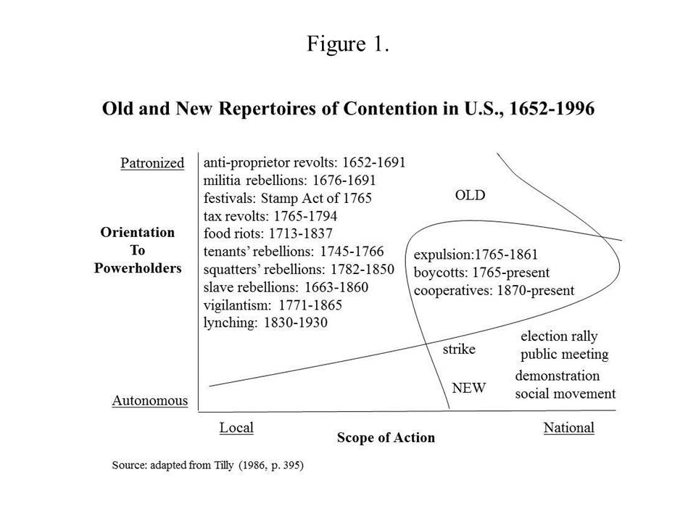

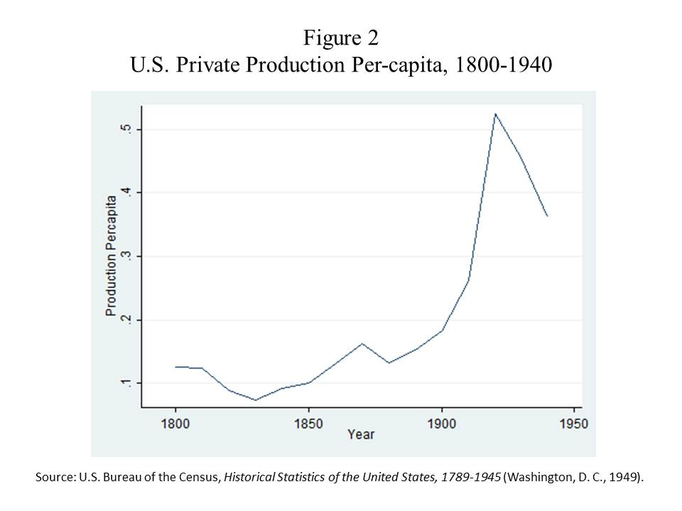

**Table 1**

**Population, Private Production Value (in millions) and Product Value Per-capita for the U.S., 1800-1940**

|  |  |  |  |
| --- | --- | --- | --- |
| Year | Population | Private Product | Product  Per-capita |
| 1800 | 5,308,483 | 668 | .1258363 |
| 1810 | 7,239,881 | 901 | .1244496 |
| 1820 | 9,638,453 | 855 | .0887072 |
| 1830 | 12,866,020 | 947 | .0736047 |
| 1840 | 17,069,453 | 1577 | .0923873 |
| 1850 | 23,191,876 | 2326 | .1002937 |
| 1860 | 31,443,321 | 4098 | .1303297 |
| 1870 | 38,558,371 | 6288 | .1630774 |
| 1880 | 50,155,783 | 6617 | .131929 |
| 1890 | 62,947,714 | 9578 | .152158 |
| 1900 | 75,994,575 | 13836 | .1820656 |
| 1910 | 91,972,266 | 24033 | .261307 |
| 1920 | 105,710,620 | 55539 | .5253871 |
| 1930 | 122,775,046 | 55872 | .4550762 |
| 1940 | 131,669,275 | 47589 | .3614283 |

Source: U.S. Bureau of the Census, *Historical Statistics of the United States, 1789-1945* (Washington, D. C.: U. S. Government Printing Office, 1949)

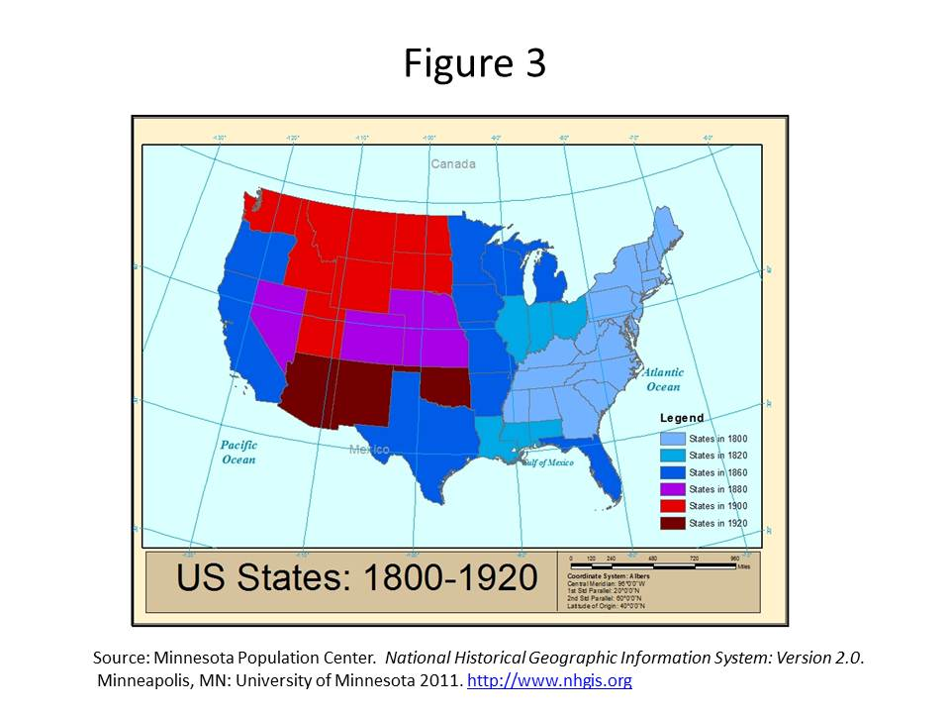

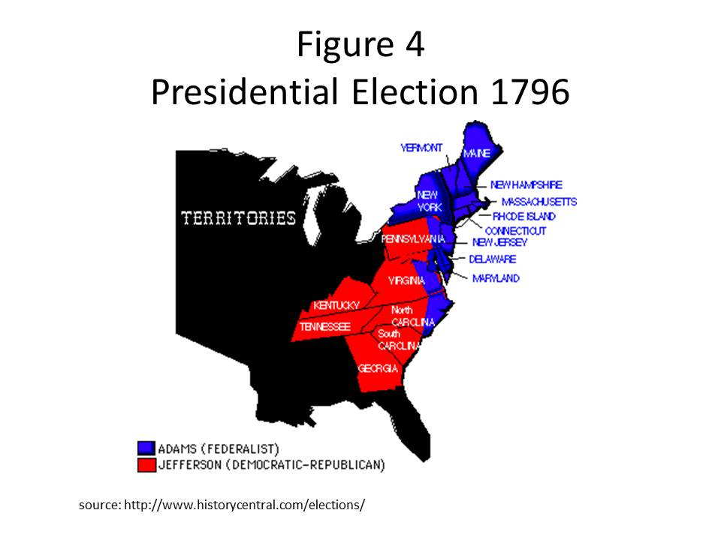

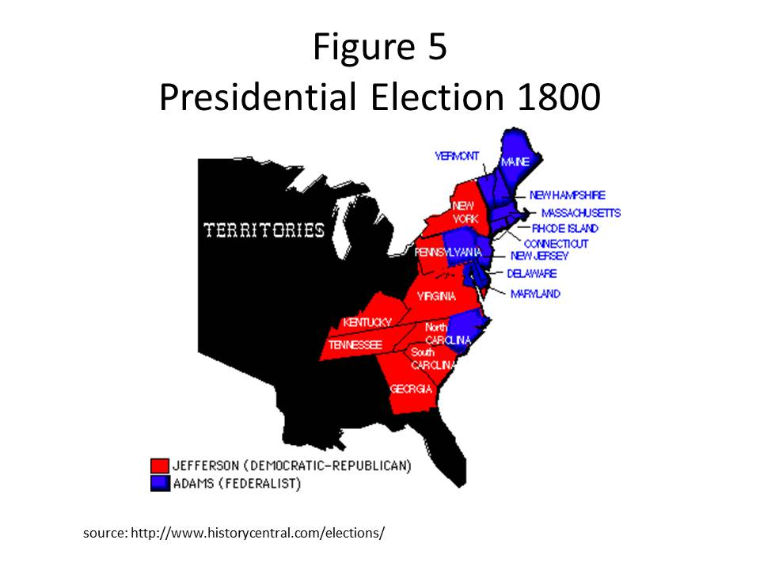

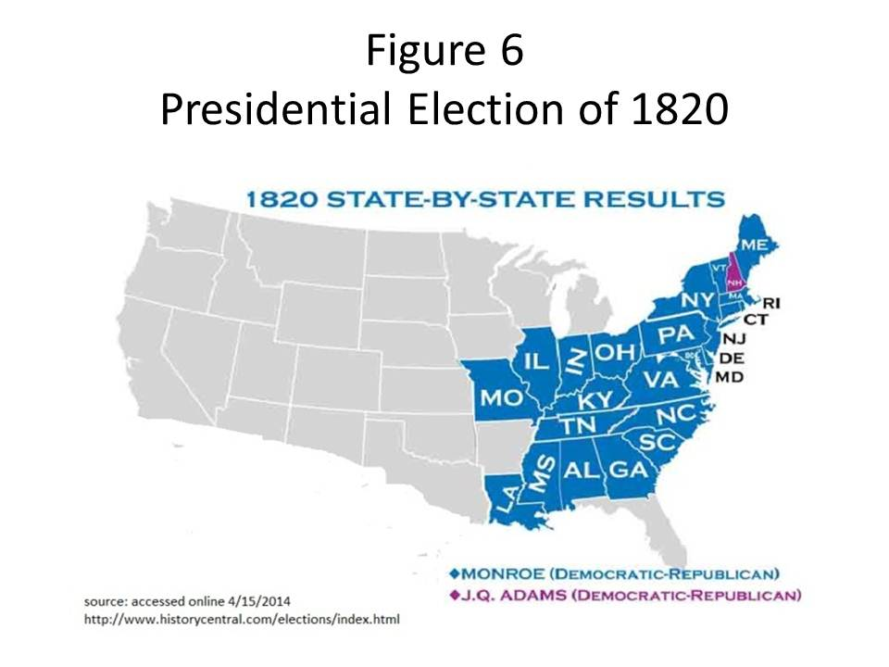

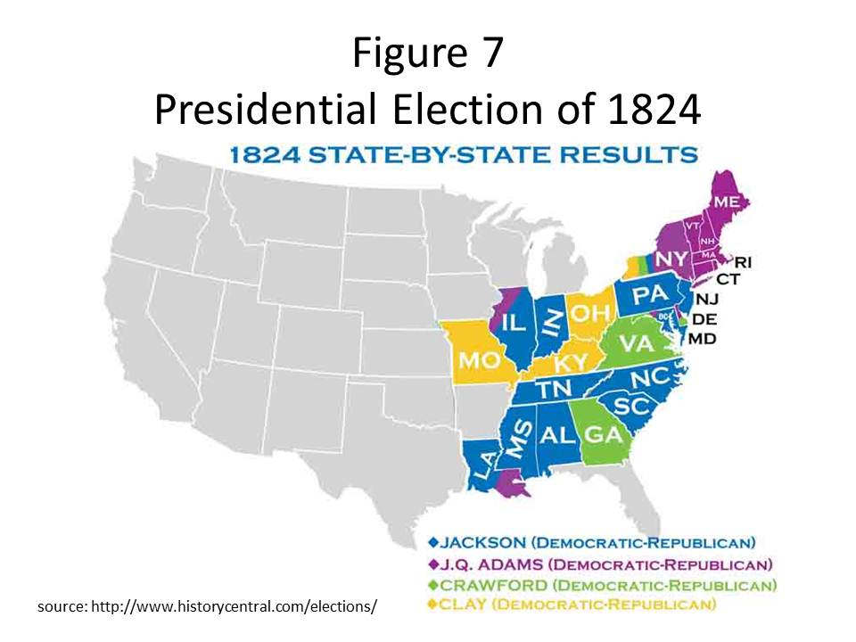

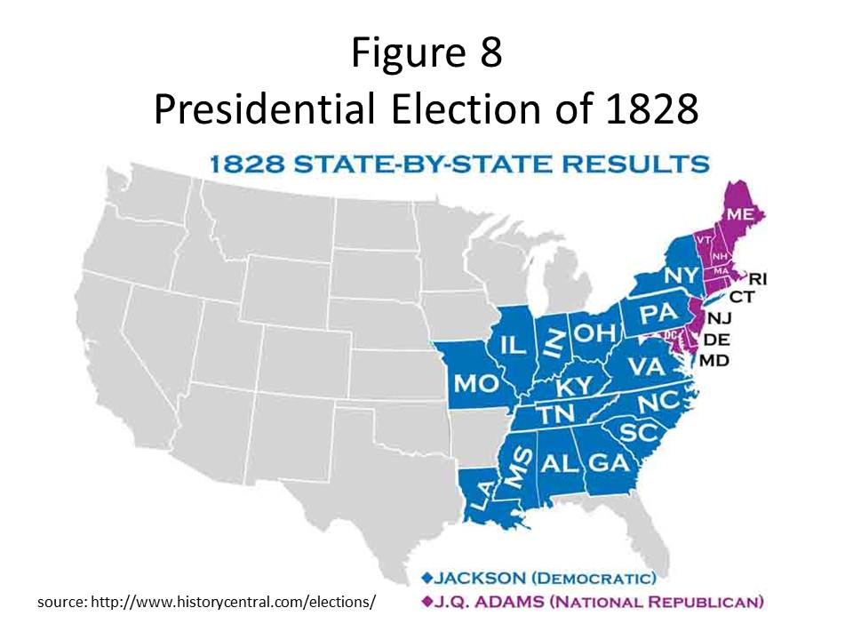

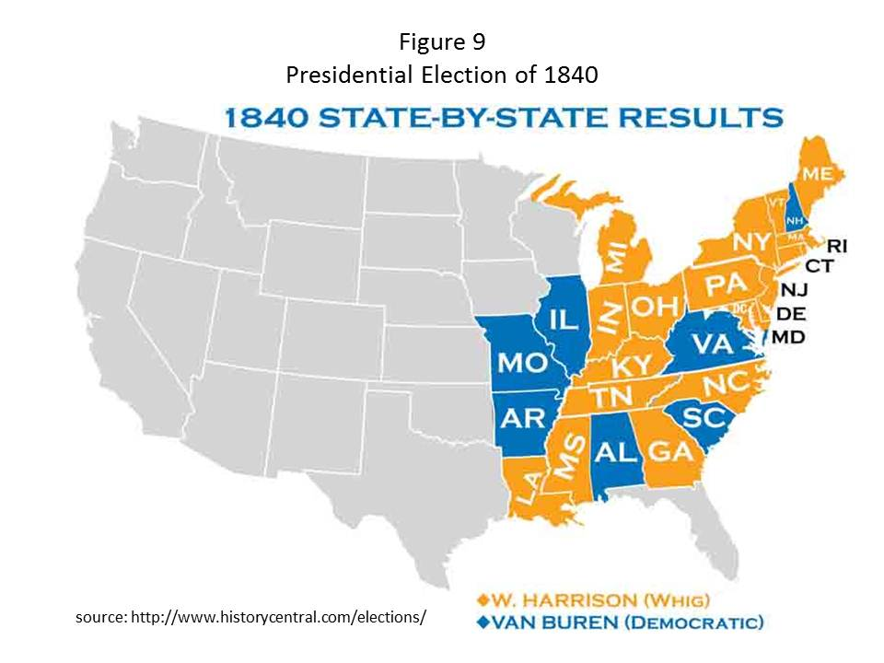

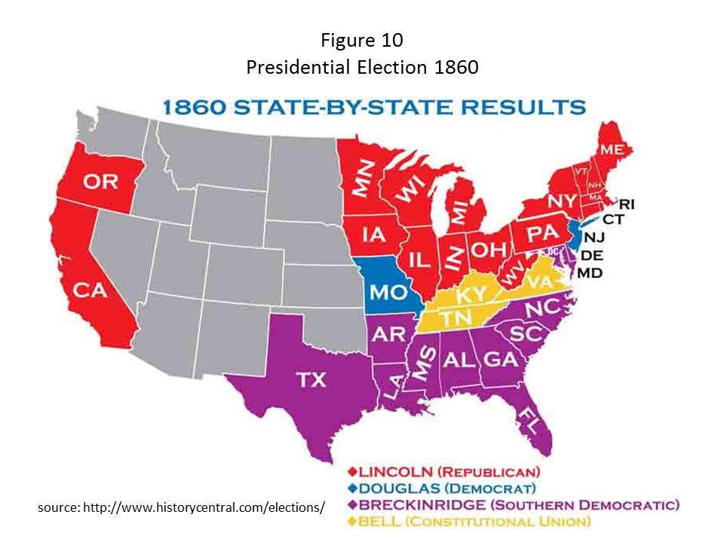

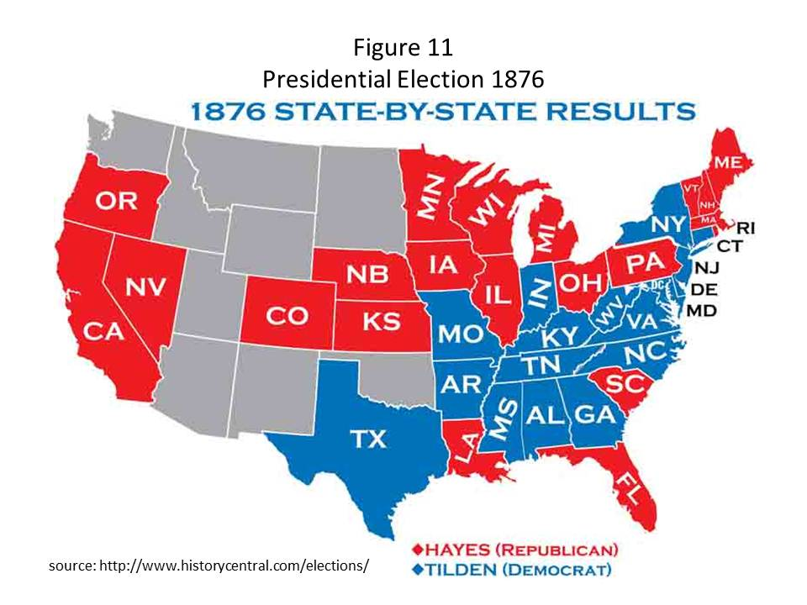

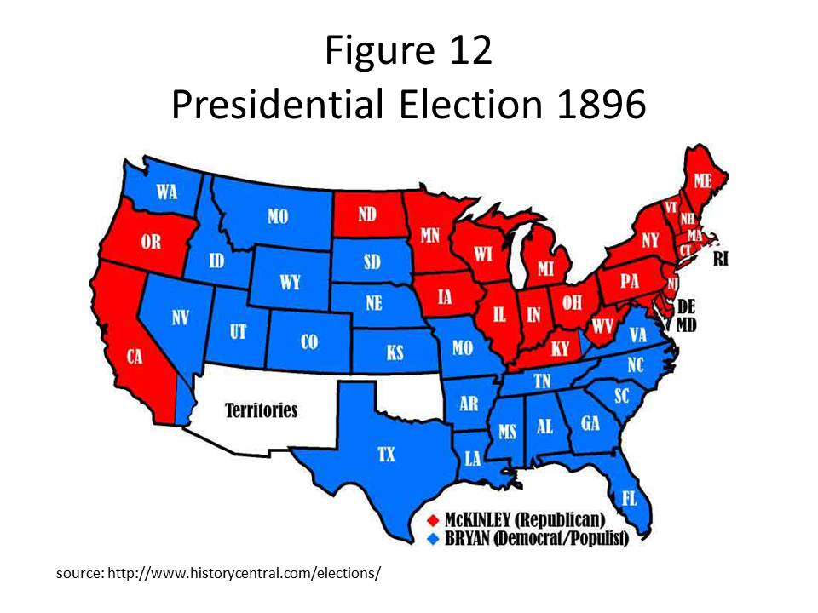

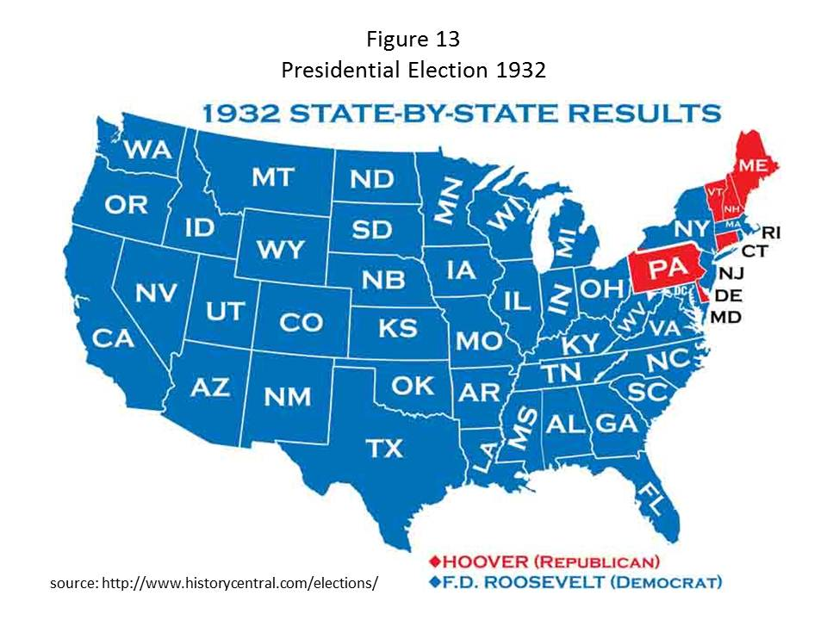

**Table 2**

**Distinguishing Vigilantism and Lynching by Class, Status and Party**

|  |  |  |  |
| --- | --- | --- | --- |
| **Type of Terrorism** | **Class** | **Status** | **Party** |
| Vigilantism | Petit bourgeois | Good white men killing bad white men | Private execution preempting authorities |
| Lynching | Petit-bourgeois leaders, proletarian followers, mass audience;  proletarian victims | White men killing black fiends | Public torture and mutilation defying authorities |

Table 3

Black Vigilante Lynching Victims Reported for South, 1824-1862, by Date and Method (N=56)

|  |  |  |  |  |  |  |  |  |  |  |
| --- | --- | --- | --- | --- | --- | --- | --- | --- | --- | --- |
| **Time** | **Burning** | | **Hanging** | | **Shooting** | | **Unknown** | | | **Total** |
| **1824-1849** | 67% | (12) | 17% | (3) | 11% | (2) | | 5% | (1) | 18 |
| **1850-1862** | 37% | (14) | 61% | (23) | - | (0) | | 3% | (1) | 38 |
| **Total** | 46% | 26 | 46% | 26 | 4% | (2) | | 4% | (2) | 56 |

Source: Pfeifer (2011), Appendix

**Table 4**

**Lynching Outside the South by Method and by Race of Victim**

**1837-1889 and 1890-1943 (N=578)**

**Victimization by Method\***

|  |  |  |  |  |  |  |  |  |  |  |
| --- | --- | --- | --- | --- | --- | --- | --- | --- | --- | --- |
| **Years** | **Burning** | | **Hanging** | | **Shooting** | | **Other\*\*** | | | **Total** |
| **1837-1889** | 1% | (3) | 84% | (351) | 7% | (31) | | 8% | (33) | 418 |
| **1890-1943** | 3% | (5) | 66% | (105) | 14% | (23) | | 17% | (27) | 160 |
| **Total** | 1% | (8) | 79% | (456) | 9% | (54) | | 10% | (60) | 578 |

**Victimization by Race**

|  |  |  |  |  |  |  |  |  |  |  |
| --- | --- | --- | --- | --- | --- | --- | --- | --- | --- | --- |
| **Years** | **White** | | **Black** | | **Other** | | **Unknown** | | | **Total** |
| **1837-1889** | 78% | (321) | 9% | (36) | 13% | (56) | | 1% | (5) | 418 |
| **1890-1943** | 61% | (97) | 28% | (45) | 11% | (17) | | 1% | (1) | 160 |
| **Total** | 72% | (418) | 14% | (81) | 11% | (63) | | 1% | (6) | 578 |

* coded to include only most barbaric (in descending order: mutilation, burning, strangulation, beating, flogging, hanging, shooting) if more than one method was used

** includes unknown

Source: Pfeifer 2013, Appendix.

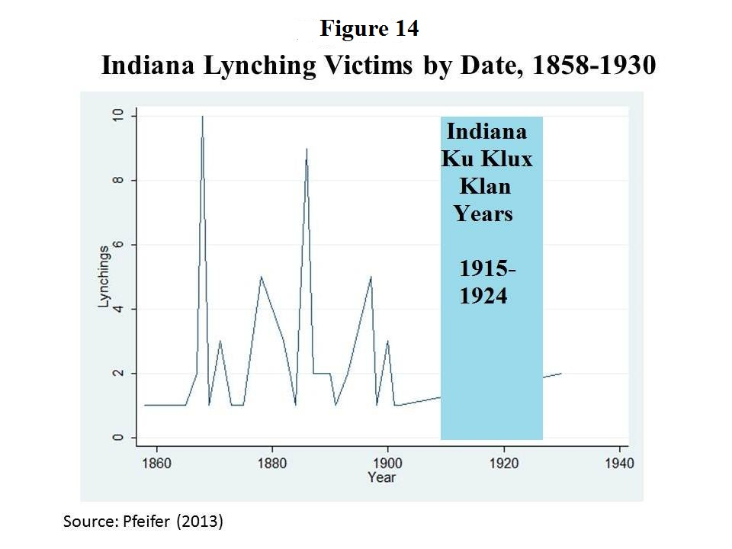

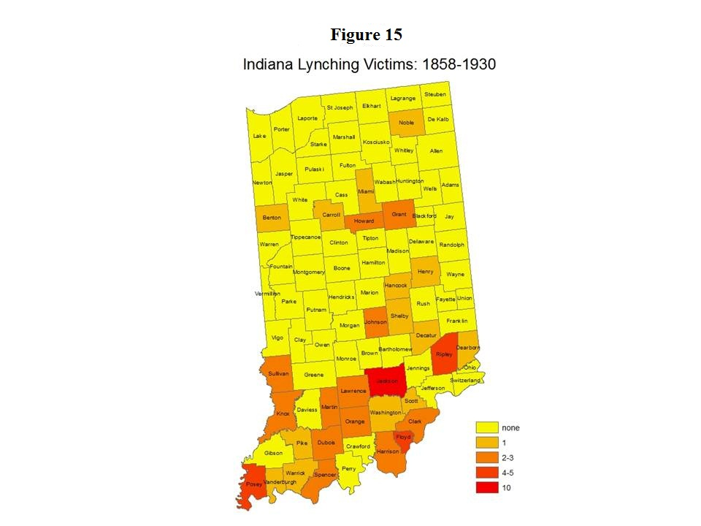

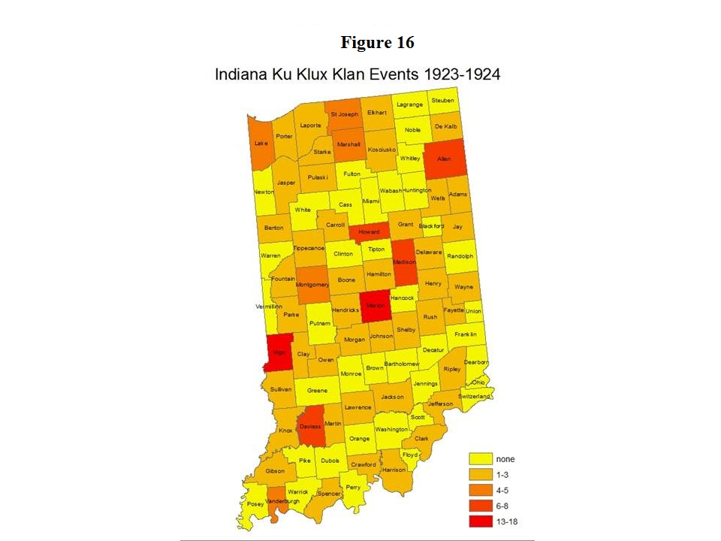

1. This is one case where the film, “Malcolm X” was successful in capturing the tension that was palpable in the transcription of Malcolm’s account (Halley 1973, pp. 233-235).
2. This is my recollection from watching the slide show of the Zimbardo Prison Experiment in Andre Modigliani’s Social Psychology seminar at the University of Michigan. Andy and I were supposed to publish the paper I wrote for that course, but I guess that will never happen, since he is no longer with us.
3. Andre Gunder Frank, lecturing during his interview for a distinguished professor chair in the early 1990s remarked, “I am an economic determinist.” We structural determinists find the honor of this status to be worthy of our efforts to hoard the opportunity to claim this status. Chuck was many things, but he was not a structural determinist, even back in 1975, when we were reading mimeographed copies of “From Mobilization to Revolution.”
4. Snow et al. (2014 would call this “revitalization” as opposed to “fabrication” or “canonization.”
5. As Tilly (2007, pp. 162, 164-165) clearly indicates, we can find strong states which are not democratic but not democratic states that are weak.
6. Here we might consider the analogy of the library that Snow et al. (2014) offer. Perhaps “canonization” might be related to hegemony, but the distinction between oppressive/coercive versus hegemonic regimes is lost in the library analogy.
7. Grimsted (1998, p.175), also refers to “wide-scale hanging and burning to death of blacks” in the Texas mob actions of 1860, but his account of these actions does not refer to any burnings or suggest the same degree unspeakable torture as in the events of the 1830s. Unfortunately, Grimsted does not provide an enumeration of victims or events, and my initial attempt to establish such an enumeration based on his narrative met with frustration.