During the winter of 1812-13 Tecumseh and some 1200 warriors joined forces with 900 regulars and militia under the recently promoted haughty, hefty, red-faced Brigadier General Henry Procter. Their assaults on two American forts proved unsuccessful and by the end of July morale among them flagged as a result of the heavy casualties they had suffered. The situation on the Detroit frontier worsened with the defeat of a British fleet at the Battle of Put-in-Bay on Lake Erie in September. The Natives marvelled at the roar of the guns and watched intently as the heavy smoke of battle drifted over the lake.When the thunder of the cannons had ceased and the smoke that obscurred the sky had cleared they eagerly asked who had won. Fearing the warriors might leave if they learned of the British defeat, Procter said the British vessels had beaten the Americans. He knew the worst had happened for his life-line with Niagara was cut. Lacking supplies and fearing an attack at any time by Harrison, Procter's forces at Detroit prepared to withdraw. As they set fire to the fort and threw broken guns, cannon balls and garbage into the well, Tecumseh looked on with alarm.
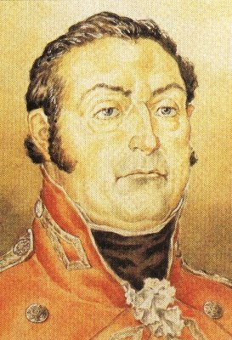
Henry Procter
Despite Tecumseh's pleas to stand and fight, Procter was determined to retreat. Tecumseh,infuriated at Procter's seeming fear of fighting delivered with fiercesome glare his last powerful speech.
In His Own Words
Father, listen to your children. You have them now all before you. You always told us you would not draw your foot off British ground, but now you are drawing back and we are sorry to see our father doing so without seeing the enemy. We must compare our father's conduct to a fat dog that carries its tail on its back, but when fearful drops it between its legs and runs off. You have the arms and ammunition our great father sent for his red children. If you intend to retreat give them to us and you may go and welcome. Our lives are in the hands of the Great Spirit. We are determined to defend our lands and if it is His will, we wish to leave our bones upon them."
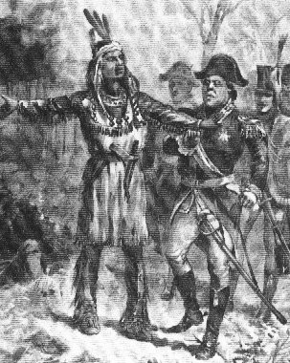
Tecumseh & Procter
Procter did not share Tecumseh's fervor to fight nor his pledge to abandon his bones on hallowed Native ground, but he was fearful of risking a rupture with the Aboriginals. Despite this real concern Procter believed retreat was in their best interest and he prepared to do so. His plan was to withdraw up the Thames valley and in so doing extend Harrison's lines of communication and keep his own forces well away from Lake Erie. What the British could not carry they burned. When stores and equipment were loaded on every craft that would float, the ships set sail across Lake St. Clair for the River Thanes. Procter retreated overland in a cart up the valley of the Thames towards Lake Ontario. An angry and disgusted Tecumseh followed the fleeing British forces.
On the 5th October 1813, the pursuing American army caught up with Procter at present day Thamesville. While awaiting the start of the shooting, Tecumseh talked with a few of his chief warriors. One asked, "Father, what are we to do? Shall we fight the Americans?" Tecumseh replied,"Yes, my son, We will be in their smoke before sunset. My body will remain on the field of battle." He then set aside his anger and despair and for the last time shook Procter's hand, saying simply, "Father, have a big heart." Even as bugle blasts rang through the forest announcing the coming of the American cavalry, Tecumseh was moving among his men to motivate and sustain. Dressed in deer skin and wearing a handkerchief fashioned into a turban in which was placed a fine white ostrich feather, he could be seen shaking hands with each British officer as he passed. "He made some remark in Shawnee," one of them remembered, "which was sufficiently understood by the expressive signs accompanying his comment and then passed away forever from our view."
Harrison's horsemen charged the thin red lines at a gallop, and the shock of the mounted menon the tired and hungry soldiers was swift and overwhelming. They breeched the British ranks, cutting down all opposition with sabres and trampling men under foot.
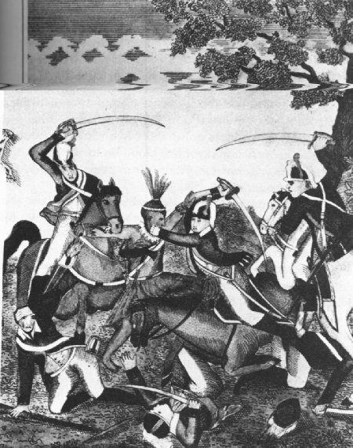
Cut by the Cavalry
Once through the red ranks, they turned about and the redcoats found themselves fired on from both sides. It was all over in a few minutes. Demoralized by hunger, fatigue and lack of supplies, the British broke and ran. General Procter, whose leadership was less than inspired, decided to quit the field of battle. Mounting an excellent charger and accompanied by his personal staff, Procter sought safety in flight to the east.
As Tecumseh and some five hundred braves prepared to face their fate at the hands of 3000 Americans, all eyes followed the familiar figure in his tanned buckskin. In his belt was his silver-mounted tomahawk and his knife in its leather case. About his head a handkerchief rolled like a turban in which was a white feather. The Natives had lain silent until Colonel Johnson's cavalry had advanced to within range. Then Tecumseh's loud war-cry rang out the signal for battle. Above the clamour of the frenzied hand-to-hand combat, Tecumseh roared out his challenge. A few saw him, blood on his face, defending his heroic but hopeless vision to the last. Tecumseh's keen eye singled out the leader and he rushed to strike him down, his tomahawk gleaming above his head. Before he could send it on its deadly flight, there was a flash and a bang. The colonel fired the fatal shot. Tecumseh's tomahawk dropped harmlessly to the ground and in the forty-fourth year of his life, the noblest of the red warriors fell dead on the spot. Stilled was the war cry and silver eloquence that had urged his followers to fight. Tecumseh was no more.
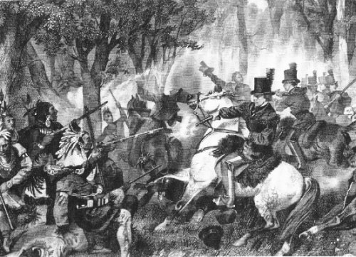
Death of Tecumseh
No funeral oration was uttered over his grave. No totem marks his resting place. To this day no one knows what his followers did with his body. The red man's secret was jealously guarded. With the death of Tecumseh, the last hope of Native unity in the West vanished and effective Aboriginal resistance south of the lakes ceased. Of Tecumseh's confederacy nothing remained. His arch-rival, Harrison, described his fallen foe as "one of those uncommon geniuses which spring up occasionally to produce revolutions." The revolution of the tragic hero "ever merciful and magnanimous" had been crushed. "His loyalty was not to Canada nor to the British in Canada, but to a dream of a pan-Indian movement that would secure for his people the land necessary for them to continue their way of life."
Gloom, silence and solitude rest on the spot
Where the hopes of the red men perished.
But the fame of the hero who fell shall not
By the virtuous, cease to be cherished.
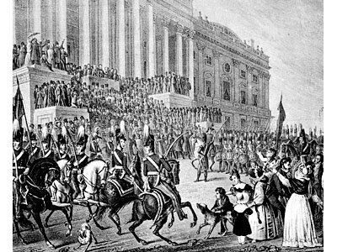
Inauguration of Harrison
[*]Wampum the part-mystical, part-monetary strings of beads recognized as a medium of trade and diplomacy by Native Americans.
[**]Harrison's satisfaction was short-lived. At his inauguration in Washington on March 4, 1841, President William Henry Harrison declined the offer of a closed carriage and rode on horseback to the Capitol, braving cold temperatures. After speaking for more than an hour, one of the longest inauguration speeches in U.S. history, he rode back to the White House, catching a chill that eventually turned to pneumonia. He died on April 4th, 1841, one month after taking office, the first president to die in office. Tyler finished his term.
Previous / Review / Next
Copyright © 2010 W. R. Wilson
Source: http://www.uppercanadahistory.ca/1812/18122.html

