**Terrorism in the Heartland:**

**Vigilantism, Lynching, and the Klan in Indiana, 1858-1930**

**Abstract**

Sometimes, it appears that we are returning to the Golden Age of structural functional and psychological or economic reductionism, as the twin pillars of sociological approaches to collective behavior. The popular image of the terrorist is particularly susceptible to the ahistorical, cultural and psychological reductionism of collective behavior and collective choice theories of the Sixties. So, toward an historical and macro-institutional perspective on the War on Terrorism, this paper looks at terrorism in Indiana between 1830 and 1930, focusing on the Horse Thief Detective Association and the Ku Klux Klan, during two waves of terrorism: Civil War: 1858-1876 and Post-Reconstruction: 1877-1930, challenging racial and ethnic threat theories, while emphasizing the petit-bourgeois, reactionary interests and the shifting bases of partisan support for lynching and the Klan.

Richard Hogan, Associate/partially Emeritus Professor

Purdue University, Sociology Department, College of Liberal Arts

West Lafayette, IN 47907-2059 [hoganr@purdue.edu](mailto:hoganr@purdue.edu)

March 2018

A version of this paper was presented at the Indiana Academy of Social Science meeting,

Evansville, IN, 9 October 2015, another at the American Sociological Association meetings, Seattle, WA, 20 August 2016. Comments and suggestions from E. M. Beck, Sarah Mustillo and Shawn Bauldry were particularly helpful.

keywords: terrorism, repertoires, collective violence, Indiana history, lynching, KKK

10,498 words (47 double spaced pages, including title, abstract, endnotes, references, 12 figures and 4 tables).

**Terrorism in the Heartland:**

**Vigilantism, Lynching and the Klan in Indiana, 1858-1930**

We can blame it on 9-11, I suppose, but the confusion surrounding terrorism is reversing progress made since 1970 in the study of social movements and social change. Scholars and the mass media have returned to old theories of the Cold War era—mass society, relative deprivation, and collective behavior, to explain the “radical Islamic terrorist campaign,” which is corrupting women and children in Western Europe and even here in America’s Heartland (Callimachi 2015; Smith and Pettigrew 2015). Alternatively, some scholars have returned to collective choice (now called rational choice) to explain reactionary political movements as calculated responses to economic or racial and ethnic threat (Andrews and Seguin 2015; Beck 2000; McVeigh 2009). How can we hope to turn the tide of fear and ignorance that seems to be perpetrating the twin threats of conservative reaction and anti-intellectual hysteria? We can begin with two assertions.

First, vigilantism, lynching and the early Klan costume parties—including forays into Georgia in 1868, where “men in white sheets” terrorized GA Freedmen (Bullock 1868), were all part of what Tilly (1986; 1995; 2008) and Tarrow (2011) call the “Old” repertoire of contention—rooted in the U.S. Colonial revolt of the late 18th century (Brundage 1999).1 Second, lynching changed rather dramatically between its 18th century origins and its 19th century re-emergence. It also changed as it moved from East to West (Dykstra 1968; Hogan 1990; Leonard 2002) and from Border State to South (Beck and Tolnay 1990) and North (Pfeifer 2014). Ultimately, people and places made the shift from old school militias and lynch mobs toward modern social movement organizations when and to the extent that capital accumulation and state-building provided an adequate foundation for corporate liberal (democratic) state sanction of contention and local efforts to deal with same (Tilly and Wood 2013).

Unlike the Border State Klan of Reconstruction or the Southern “Redeemer” (Hogan 2011) Democratic lynch mobs of the late nineteenth century, the Indiana Klan of the 1920s was a thoroughly modern social movement, with symbolic national appeals, parades, and lots of meetings, but the Klan kept private police on call for occasions when it was necessary to go old school. Ironically, as the threat of organized horse-thieving and the need for lynching declined, the old Indiana Horse Thief Detective Association was revitalized as a private urban police force, serving as the private face of Republican Party and Klan rule, which became essentially indistinguishable, particularly in Indianapolis in the 1920s (McVeigh 2009; Moore 1991; Wade 2011).

Before we turn to theory and data, and the story of Hoosier terrorism, however, it is important to recognize that repertoire change is independent of the interests and organizations involved. ISIL can use parades and public executions, in tandem, just like county and municipal governments did in the late 19th century. It is not because they are reactionary and petit bourgeois (or small peasant/nomad) that ISIL and the KKK use or do not use violence, although this seems to be the implication of Blee and Creasap (2010: 270-271), who define right-wing movements by their predominant interest in race or ethnicity and/or their predominantly violent tactics. By this definition, one might argue that the Indiana Klan was not a right-wing movement, since their predominant interests were public schools and temperance and they tended to use violence sparingly (Moore 1991).

The difference between the early vigilantism and lynching campaigns, particularly between 1858-1876, and the rise of the Klan in the 1920s is less about interests than tactics and less about tactics than repertoire. The interests of rural and urban petit bourgeois farmers, merchants, and shopkeepers diverged sharply on temperance and public schools, as we shall see, but they did not differ fundamentally on race or ethnicity or on the use of violence in the defense of property or public order. The problem, in the 1920s, was how to legitimate or frame the use of collective violence to resonate with the corporate liberal (democratic) tradition or the image of the contenders as Worthy, United, Numerous, and Committed (Tilly and Wood 2013). Bourgeois (or republican-capitalist) hegemony provides an adequate foundation for Social Movements and Corporate Liberal state policies (Tilly 2004). When lacking this economic base, gangs, militias, and mobs prevail (Tilly 2003). Whether it be West, South or Middle-East, the story is pretty much the same.

Terrorism is a strategy for inciting fear within a civilian population. Lynching is a tactic that might prove effective in this endeavor, but it is not the only tactic available. In fact, as we have learned from Tilly (1986; 1995; 2008) and Tarrow (2011), there has been a sea change in the repertoire of contention between the American Revolution of 1776 and the resurgence of the Klan in the early 20th century (1915-1924). McAdam et al. (2005) suggest that there may be a new, late 20th century repertoire change, but that need not concern us here. More important for our purpose here, there was, in the late nineteenth and early twentieth century, a decline in the use of direct action and patronized actions, in which challengers imitated the actions of authorities while taking the law into their own hands—this includes food riots as well as vigilantism and lynching. The fact that this was also the peak of Southern lynching indicates a lack of republican capitalist hegemony in that region, but, again, that need not concern us here (Tolnay and Beck 1995).

Public meetings and petition campaigns were not invented in the nineteenth century, but they came to predominate in the British repertoire of contention (Tarrow 2011: 47 and 51). Similarly, after the invention of the modern social movement, old forms of direct action and patronized local actions continued, but they were less common, particularly in relatively stable modern democratic states.

Tilly, Tarrow, and their Critics

With their rise to the status of the dominant perspective, there has been growing opposition to the Resource Mobilization and Political Process models of contention that will guide this analysis (with a healthy dose of historical materialism to complement these models). Some of the earliest critics (Useem 1980) took aim at some of the weakest claims, attributing to Resource Mobilization theory the claim that discontent does not matter, but these critics later became more sophisticated in defending social disorganization theory from a state-centered perspective (Useem and Goldstone 2002). As sociologists took the cultural turn (Goodwin and Jasper 1999), critics claimed that Political Process and Resource Mobilization theories were static structural theories that ignored culture. Still others (Einwohner 2003; McVeigh 2009) claimed that these theories could not explain the revolt of the powerless, who lack opportunities, or right-wing middle-class movements with ample resources.

Blee and Creasap (2010: 271) assert that right-wing movements require new theories. As they explain:

Rightist movements fit awkwardly into the theoretical templates of social movements that were largely developed in studies of feminism, the New Left, and civil rights. Such progressive movements, based on “claim making by disadvantaged minorities” (McAdam et al. 2005: 2), are poor models for movements of privileged groups (Blee 2006, Wright 2007).

Blee (2006) and Blee and Creasap (2010) imply that McAdam (et al. 2005) and Wright (2007) support their call for a new theory for right-wing movements. McAdam (et al 2005: 4) was not, however, proposing that we substitute a “new” or “right-wing” movements model for the misguided Sixties image of the modern social movement.

[T]his contradicts Tilly’s fundamental insight regarding the historically contingent nature of collective action. More importantly, it may well blind re-searchers to subtle, but clearly, discernible changes in the action forms, claims, and loci of contemporary movements.

It is, in fact, the dynamics of innovation in repertoire change, generalized at the organizational level, that McAdam, Tarrow and Tilly (2001) explored in their pioneering work on mechanisms and processes. Similarly, Wright (2007:25) explicitly states that he applies the Dynamics of Contention model (McAdam, Tarrow and Tilly 2001) to the Oklahoma City bombing. The critics seem to be missing the point here in arguing for a new social movement theory or a theory of right-wing movements.

More helpful than these criticisms are more micro-level theories that use framing and discourse theory to augment the structural analysis of interests and opportunities (Benford and Snow 2000; Gamson 1992; Snow et al. 1986; Snow et al. 2014; Steinberg 1998; Steinberg 1999). This allows us to consider how the Republican Party, after its flirtation with Progressivism, accommodated if not fully supported the reactionary ravings of the Ku Klux Klan and even the most reactionary elements within the genetic engineering movement. At the same time, some of these pioneers of Progressivism have since been claimed by community organizers and pro-choice feminists who are able to frame the questionable aspects of Progressivism within a more liberal, reformist stance that recognizes the racism within early feminism, for example, and the fact that Progressive tools, such as the referendum and the recall, can be used for reactionary as well as radical goals, as evidenced in the California Tax Revolt and the California Coastal Act (Hogan 2003).

How these framing and discourse theories can help us to steer a path between structural determinism and post-modern whimsy should become evident as we look at three waves of terrorism in Indiana: Civil War and Reconstruction vigilantism, Post-Reconstruction lynching, and the Klan. For now, it might suffice to indicate how framing specifies the relations between organizations, opportunities, mobilization and collective action, as indicated in Figure 1.

**Figure 1**

W:\www\Soc 525\Tilly’s Mobilization Model.tif

Figure 2 identifies the interests, organizations, and actions associated with Indiana terrorism, 1858-1930. The objectively defined class-based interests are the reactionary interests of petit bourgeois shopkeepers and farmers who initially promoted but eventually opposed the expansion of republican capitalism, including the expansion of federal authority and the accumulation of capital. Both were viewed as external threats to locals, who organized, initially, horse thief detective associations and less formal vigilante or lynch mobs, and organized, eventually, local Klaverns of the Ku Klux Klan. Their efforts were facilitated or tolerated in varying degrees, initially, by the Democratic and, later, by the Republican parties, which facilitated mobilization.

C:\Users\Owner\Documents\research\What an Outrage\KKK and lynchings\SOC_Purdue_2016\Interests_Orgs_Repertoires.tif

This theory of interests, organizations, and power will guide the analysis that follows. We will be skeptical of the claims made by Wade (2011), who argues that vigilantism, lynching, and Klan were all expressions of a hegemonic whiteness, sustained by the authority of the Indiana Constitution, which sanctioned collective violence wielded initially by the Indiana Horse Thief Detective Association and later by the Klan. The fact that the Indiana Klan used legislative sanction for the Detective Association as a ruse for establishing a vigilante private police force, during the 1920s, makes this case more compelling (Chalmers: 1987: 165-166; Jackson 1967: 145-146; McVeigh 2009: 135). Nevertheless, we shall suggest that neither victimization by lynch mob nor intimidation by the mass-based mobilization of the Klan can be explained simply by racism or even nativism, although clearly both were evident in the actions of the lynch mob, particularly after 1876, and the Klan, particularly in the 1920s.

Not only did the vigilantes and the Klan share the same reactionary, exclusionary, interest—typically petit bourgeois, they availed themselves of the same organization—the Indiana Horse Thief Detective Association, sanctioned by the state legislature and appropriated by the Klan. From a Resource Mobilization perspective (Tilly 1978: 56), these challengers differed only in opportunity/threat, relations with authorities/power and, of course, repertoire (Tilly and Wood 2014). For our purposes, Presidential elections represent the most important, recurring opportunity, where divisions between elites and the potential for powerful allies make repression less likely and toleration if not facilitation more likely (Tilly 1978; Tarrow 2011).

In the analysis that follows, the critical elections of 1876 (the end of the Greenback challenge and of federal support for Reconstruction), 1896 (the Democrat-Populist coalition), and 1920-1924 (Republican-Klan coalition in Indiana) are used to indicate political opportunities, which varied by county according to partisanship. County level variation in proportion black and foreign born will be considered a measure of racial/ethnic threat (Beck 2000), as will be explained below. Relations with authorities are represented by proportion voting Democratic or Republican in federal presidential elections of 1876 and 1896 and in the gubernatorial election of 1924, when the Republican candidate supported and was supported by the Klan (Moore 1991).

In addition, percent of local children enrolled in school will be used as an indicator of petit bourgeois, particularly shopkeeper, interests. As McVeigh (2009), Moore (1991) and Blee (1992) report, the Klan was vocal in its support for public schools, as well as opposition to Catholic schools, so this is an indicator of their expressed interest. These indicators of interest, facilitation/repression and power are expected to have direct effects on mobilization and mostly indirect effects on collective action (operating via opportunity structures and power)—as indicated in Figures 1 and 2. To the extent that school enrollment indicates petit bourgeois power as well as interest, it would also have a direct effect, but we should expect the effect on mobilization, particularly for Klan membership, to be most prominent. Lynching, unlike Klan events, is not expected to be supported to the same degree by powerful and well-established petit bourgeois shopkeepers and merchants, because lynching is generally considered to be an indication that the local community is not safe for women and children, and this is bad for business (Hogan 1990).

The new collective choice theories have adopted racial competition as a predictor of collective action, but they tend to ignore the fact that competition is a relationship. Even the best of these studies, which explore the “multi-dimensionality” of ethnic and racial threat—economic, social, and political, rather than simply demographic, still do not model repression/facilitation as a relationship between resourceful and organized (and mobilized) contenders (Cunningham 2013: 8, 234 n8). Even adding “mediation” (Cunningham 2013: 8-10, 234 n9), as we do below when quoting a Democratic newspaper editor, does not change the fact that these are static structural rational choice models, as opposed to dynamic relational models of contentious interaction (Tilly 2008). This is true even of the best methodological and conceptual efforts to separate the benefits of constituent density from the threat of ethnic/racial intruders (Andrews and Seguin 2015).

If the threat of black or foreign immigration predicts lynching or Klan mobilization, then Indiana should have neither lynching victims nor the Klan, because it was and is virtually all native born white people. So how and why does lynching, the Klan, and support for Donald Trump figure so largely in Indiana history? Clearly, it has something to do with partisan and media framing and class-based petit bourgeois reactionary interests that initially support but later oppose the expansion of federal authority and the accumulation of capital in a national and international economy (Hogan 1990).

Particularly in Indiana, where the threat of black or foreign competition was (and still is) more apparent than real, it is misleading to consider threat or even perceived threat independent of the relations between whites and blacks. Thus, proportion black or even the size of the black or foreign population indicates, at best, the possibility of a threat to the native white constituency of the local branches of the National Horse Thief Detective Association or the KKK. It is only in counties such as McIntosh County, Georgia, during Reconstruction, where black Freedmen dominated local politics and managed to sustain an economic, cultural, and partisan base, that we can reasonably assert that black population and migration threatened white bourgeois hegemony, which was, in fact, tenuous in Georgia, even statewide, in 1868 (Hogan 2011).

In places like Indiana, 1858-1930, blacks and foreigners did not threaten whites in any substantial manner—not even in the same way that the Chinese threatened the Irish Catholic Democrats of Colorado in 1880 (Hogan 1990). In both cases, it was the carefully constructed partisan image of threat that was effective in mobilizing partisans, who already shared an interest in opposition to both lumpen proletarian and capitalist/employer class fractions. Their artisanal or petit bourgeois interests were rooted in relations of production and relations with other classes. Their willingness to kill or threaten ethnic and racial minorities required more partisan organizational effort than objective evidence of labor market competition. We must then specify the intermediate effect of framing the threat, particularly in the partisan press, which interprets the effects of opportunity/threat on mobilization and collective action, as indicated in Figure 1.

Thus, the challenge in what follows is to defend two simple assertions that might inform the historical and sociological debates. First, parties represent material interests, but these are frequently contradictory interests that are provisionally allied in a platform or program, whose realization tends to make the contradictions manifest, thereby undermining the coalition. For example, Radical Whigs and Reactionaries in Virginia were accommodated in the bourgeois colonial coalition that defended confederacy in opposition to the crown (Bailyn 1967). The Articles of Confederation, once the colonial revolt was complete, defined the limited terms for coalition in an umbrella government that was designed—like the modern European Community, to facilitate cooperation among independent states. Of course, this government could not govern, which led to extended conflict, compromise, and a certain amount of rebellion and repression in establishing a federal government that, initially, was defended by the Federalists, including conservatives like Alexander Hamilton and liberals like James Madison.

Clearly, the Federalist Party did not survive its victory either, but the two-party system, first Whig versus Democrat and then Democrat versus Republican, seems to have endured and might yet endure deep into the 21st century. Most important, for present purposes, is the fact that none of these parties were ever ideologically homogeneous. Neither all Whigs nor all Republicans were Radicals—but some of them were. Not all Democrats were Reactionaries—but the Redeemers clearly were. In fact, there is a Reactionary strain that runs deep among Southern Democrats, who have now become Republicans, but that change—effected by Nixon in the 1970s, need not concern us today.

More important for now is our second assertion. To the extent that the local community is effectively under the control of a hegemonic republican capitalist regime—what Tilly (2007) would call a “democracy,” political challenges tend to be relatively tame and symbolic, compared to the direct action of vigilantes and lynch mobs. This remains true, even when the challengers represent reactionary interests of Redeemers and Klansmen. Lynching will tend to diminish as the civilizing effects of petit bourgeois churches and schools and vibrant family life provide a more suitable base for the repertoire of the modern social movement—including demonstrations and protests by Indiana Pro-Life, which seems in some ways reminiscent of a Klan rally.

On that note, with the promise to return to thinking about terrorism in the 21st century, let us turn to the Indiana frontier and look for evidence that might support these assertions. We will proceed slowly, beginning with some photos, then maps, moving to a chart, and then presenting some simple descriptive statistics on Indiana lynching victims. Having thus illustrated the major points of our analysis, we can examine some negative binomial and ordinary least squares regression models to test for “status competition” measures: race and ethnicity, and the Resource Mobilization measures of interest-based status: school enrollments, and party: voting.

If the race/ethnic competition theory holds then we should see race and ethnicity predicting lynching victims and Klan membership density—as lynch mobs and local Klavern mobilize in response to this threat to native white male hegemony (Andrews and Seguin 2015; Beck 2000; McVeigh 2009). If this is about “hegemonic whiteness” then race but not ethnicity should be significant predictors (Wade 2011). If, on the other hand, this is really about status and party interests that are class (as opposed to race or ethnicity) based, then we should find petit bourgeois concerns for public education, particularly in opposition to parochial schools, in the Klan era, (Blee 1992; McVeigh 2009; Moore 1991) and Democratic partisanship facilitating lynching in the nineteenth century while opposing the Klan in the twentieth century.

Methods and Statistics

Most generally, Klan and lynching data gathered by Moore (1991), Pfeifer (2014) and McVeigh (2009) are combined with two of the oldest ICPSR data sets—Historical, Demographic, Economic and Social Data (ICPSR 3) and United States Historical Election Returns (ICPSR 1). These data are combined in various ways to produce the tables and maps that we will be analyzing here. Both the lynching victims reported by Pfeifer (2014) and the Klan events from McVeigh (2009) came to us as Microsoft Excel files that we read into Access and manipulated in various ways to get counts by counties over time. Eventually, these data were written back into Excel files and then read into STATA, to generate Negative Binomial regression (nbreg) models predicting the number of lynching victims, as reported by Pfeifer (2014). The STATA data were also written back into Excel files and then read into ARCGIS and matched with NHGIS State and county boundary files. The cases are the 92 Indiana Counties, and these boundaries did not substantially change between 1870 and 1920, which makes the mapping and the statistical analysis relatively simple.

Both datasets purport to be populations, although they are based on the coding of newspaper reports (by Pfeifer 2014 or his colleagues, or by McVeigh 2009). Pfeifer’s (2014) data report victimizations rather than events. McVeigh (2009) used the official national KKK newspaper to code events by city (when possible). We later attributed county to cities and treated events not identified with code-able places as missing data. McVeigh’s (2009) events probably over-estimate KKK events, since that is the point of the national paper. Pfeifer’s (2014) victimizations are probably low estimates and probably do not indicate subtle differences in method of execution.

Moore (1991) found county Klan membership lists for 89 of the 92 counties in 1925. He reports the number of members by county in Table 3.1 (pp. 48-50), along with the percent of white adult native born males who were members. In STATA, we used the data editor to add the number of KKK members for each county (N=89) and then calculated the Klan density figure that Moore (1991, pp. 48-50) reports—dividing members by the white adult native-born male population of the county. Virtually all these numbers were within rounding error of the numbers that Moore (1991) reported. The number of events that McVeigh coded was correlated (r=.80) with the number of members that Moore (1991) reported, which provides some degree of construct validity for the Klan indicators. Also, we coded some data that Moore (1991) used, most notably, South, which was a dummy variable coded “1” for counties in the southern tier and zero otherwise. This variable was helpful in describing changes in racial and ethnic composition between 1870 and 1920, but is not used in the analyses presented below.

One last qualification is in order. Working with small datasets that are putatively populations (as opposed to samples) gives us more confidence in the validity of our measures—at least, on the dependent variables. The independent variables were downloaded from ICPSR. Combining descriptive tables and maps with predictive models also should contribute to some comfort on matters of validity. We can see which counties were lynching or Klan centers—at least in quantity of victims or events, and we can see how the independent variables distinguish these counties.

The more serious problem here, with only 92 (or 89) cases, is reliability, particularly since these are essentially ecological correlations.2 A model that seems to capture inter-county differences in lynching before the end of Reconstruction (1876) does not do so well after Reconstruction, and it might well be that the differences are rooted in the relationship between total population (or other measures of urban places) and black population—the denominator and numerator (respectively) of proportion black. Thus, we can take solace in those effects which seem to be particularly robust, although we could certainly argue about model specification.

We could also spend more time explaining how negative binomial regression effects should be interpreted. Personally, I have never found the algebra to be particularly enlightening, so I might just say that effects are estimated as they predict the likelihood of cases with higher or lower values on the predictor having higher or lower values on the dependent variable—in our case, lynching victims, which range from zero to seven (1858-1875) or zero to five (1877-1930). So, the positive effect of proportion black would indicate that counties with a proportionally greater black population would be more likely have significantly more lynching victims, net of all the other effects included in the model.

Since Klan density is an interval scale variable, with a range from .01 to .37 (Klan members in 1925 range from 40 to 25000), we will use Ordinary Least Squares regression to predict Klan density, using essentially the same variables that we used to predict lynching victims. We use data from the 1870, 1890, and 1920 census of population and households to code four variables that we will use in this analysis. Proportion black was calculated as the ratio of black/total population; proportion foreign born for 1890 and 1920 were coded similarly. For 1870, we had to use household head (or spouse) with one or more foreign born parents, because we had no county level reports of foreign born—just enumerations of Chinese and Japanese (there were none) and Indians (very few). Proportion of children in school (1870, 1890 and 1920) was coded from the census by dividing the number of children in school by the number of children of that age range (7-13 in 1920).

Most important, perhaps, in comparing the actions of lynch mobs and the Klan, is the lack of organizational records that indicate the membership of the lynch mobs or even the Indiana Horse Thief Detective Association. For the Klan, we have membership as well as event data, so we can look at how elections created opportunities to mobilize members, particularly in areas where support for the Democratic party was greater or lesser (as we shall see). We could, in fact, predict Klan events, using McVeigh (2009), or membership, using Moore (1991), or both. Here we will limit our attention to lynching victims and Klan events in mapping and descriptive data. We will retain the focus on victims but turn to analysis of Klan density in the regression analysis. Someday, we hope to expand this analysis of the Indiana Klan, but that will have to wait for another occasion. For now, let’s look at some pictures that might help us to appreciate the phenomenon under study.

Terrorism Hoosier Style

The most famous Indiana lynching took place in Marion, Indiana, in Grant County, in 1930. It has entered the historical record through the following account.

On a hot August night in 1930 a crowd gathered in front of an Indiana jail—men, women, and children shouting and jeering, demanding that the sheriff release his three prisoners. Three African American teenagers—Tom Shipp, Abe Smith, and James Cameron—huddled inside their cells, charged with the murder of a white man and the rape of [a] white woman. Some among the thousands of people in front of the jail formed a mob. They beat down the jail doors, pulled the three youths from their cells, brutally beat them, and dragged them to a tree on the courthouse square. At the last minute the mob spared Cameron, the youngest and most boyish of the trio. Smith and Shipp died, lynch ropes around their necks, their bodies hanging as the town photographer captured one of the most famous lynching photographs in American history.” (Madison 2011)

**Figure 3**

**Lynching in Marion, Indiana, 1930**

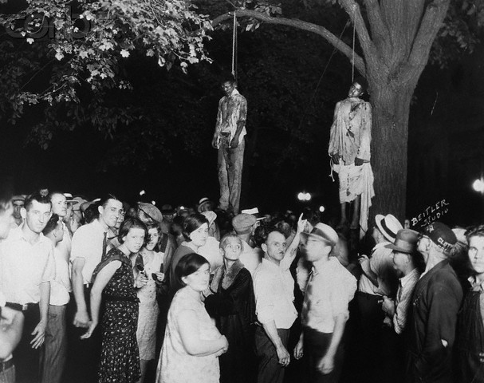

source: Original photo from W. A. Swift Collection, Ball State University, copyright 2006

Madison (2011) goes on to explain that this was not a typical lynching. “Unlike most it happened in the North and in a community with little harsh racial antagonism. It also happened ‘late,’ decades after the heyday of late nineteenth-century vigilante violence.” (Madison 2011). Nevertheless, this clearly was an act of racial terrorism, with black folks beaten and then killed and left hanging as a reminder to other blacks, photographed along with the crowd of white men and women who seemed proud or in some cases amused by the spectacle. One couple looks like they are on a date. Please note, however, that there are some women but no children visible in this photo, despite what Madison (2011) reports. By the time the crowd had become an angry mob it is likely that most women took their children home.

In any case, this is a typical lynching in the sense that it is a public display of mob violence in defiance of local authorities intended to terrorize a particular population, in this case, Afro-Americans, who learn that even the sheriff cannot protect them. In this case, however, there was a public outcry after the fact. There was an anti-lynching ordinance passed and even a feeble attempt to prosecute the leaders of the mob.

Suffice it to say that the Marion, Indiana, lynching of 1930 was more typical of Northern lynching of this period. In some ways it seems like a combination of early vigilantism and later public executions, with a strong dose of Ku Klux Klan racism hidden beneath the mask of vigilante justice. This should not be surprising in a state where not just slaves but free blacks were legally excluded from immigration before the Civil War (Foner 2011: 13; Wade 2011: 41-42), where the farmers organized an anti-horse thief association to lynch (mostly white) men accused of stealing horses (between 1858 and 1876) and where the Ku Klux Klan staged spectacular events as late as 1924 (McVeigh 2009; Moore 1991).

Consider, for example the Klan march in Anderson in 1922. Note the children among the spectators.

**Figure 4**

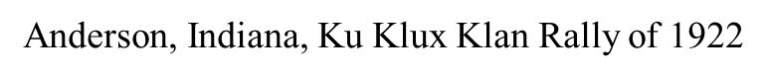

****

source: Original photo from W. A. Swift Collection, Ball State University, copyright 2006

In fact, in the parade in New Castle, Indiana, in 1923, there was a float full of children, “Ku Klux Kiddies,” as seen in Figure 5. There was, however, no lynching in Anderson or New Castle between 1858 and 1930, according to the data that I have examined. In fact, it is not at all clear that lynching tended to occur when and where the Klan was most active, even though we tend to associate lynching with the Klan, particularly in Indiana, for reasons that will become apparent.

**Figure 5**

**Ku Klux Kiddies Float, New Castle, Indiana, 1923**

****

source: Original photo from W. A. Swift Collection, Ball State University, copyright 2006

Both Klan rallies and lynching are racial terrorism. Both are public displays designed to intimidate blacks and Catholics, immigrants, and others who are not accepted by the Klan as citizens. But the Klan staged rallies, appearing publicly but in disguise. Lynch mobs tended to act ad-hoc, without a lot of apparent organization and planning—although that too was more apparent than real, particularly in Indiana, as we shall see. On the Western frontier, they acted under cover of darkness, secretly, but then left their victims hanging in plain sight, where they remained as a warning to others (Dykstra 1968; Hogan 1990; Leonard 2002).

Generally, it appears that Klan rallies were urban phenomena, while lynching was rural. Lynching was bad for business and was discouraged in urban areas where local shopkeepers and merchants were firmly in control of local government. Vigilantism occurred sporadically, particularly in the West, when farmers, cattlemen, or other rural residents challenged the government of merchant and shopkeeper (Dykstra 1968; Hogan 1990). The Marion lynching seems to blend these two types of events, which indicates that the lynching repertoire was changing—lynching clearly was in decline in Indiana between 1900 and 1930.

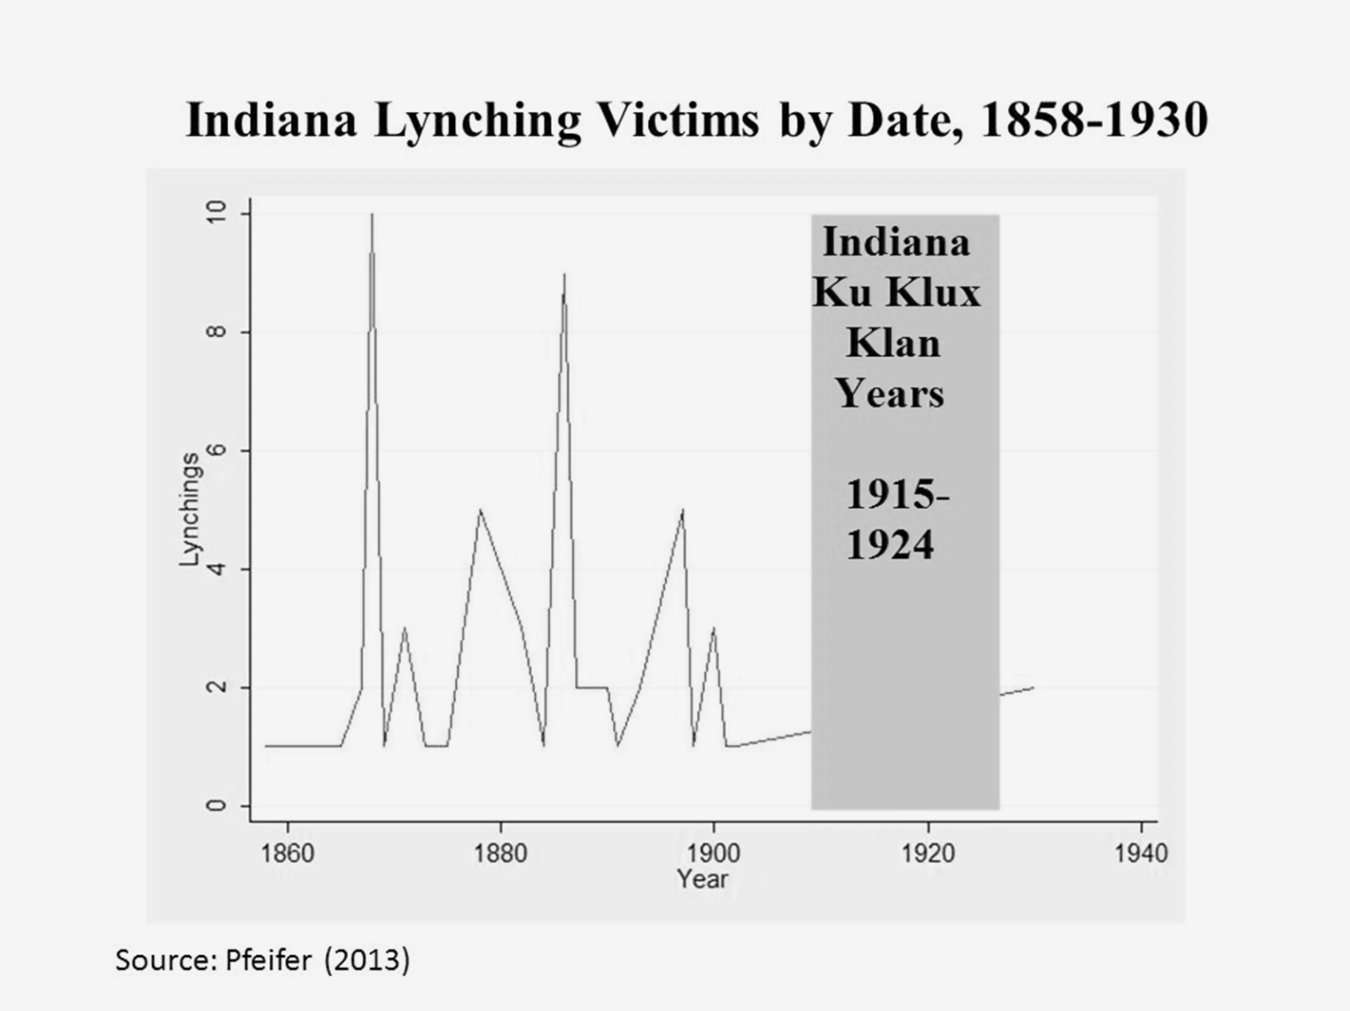

There were, in fact, two waves of lynching in Indiana—represented in Figure 6 by victims as opposed to events. The first wave was between 1858 and 1875—the Civil War and Reconstruction era, in which the Horse Thief Detective Association was active (Wade 2011). This wave peaks in 1868 with an all-time high of ten victims. The second wave begins in 1878, after a brief hiatus, peaking in 1886, with nine victims, and effectively ending in 1902. There was no lynching reported in the data examined here between 1902 and 1930, which includes the rise and fall of the Indiana Klan, 1915-1924, at which time there was no lynching reported in these data. In this context, the Marion lynching of 1930 appears to be particularly late—after the rise and fall of the Klan in Indiana politics and, as Professor Madison (2011) suggests, “decades” after the heyday of Indiana lynching in the late nineteenth century.

Madison (2011) also suggests that Marion was not the sort of town where one might expect lynching. Instead, this was “a community with little harsh racial antagonism.” According to McVeigh (2009), however, there was one local Klan event mentioned in the national Ku Klux Klan paper in 1923-1924, so it not clear that Marion was a racially progressive community. Marion was, in 1870 and even in 1930, overwhelmingly white, with only about 3% black in all of Grant County. By 2012, Marion was almost 15% black (compared to 9% for Indiana as a whole), but the black migration came late. Nevertheless, Moore (1991, p. 48) reports 2,329 Klansmen in Grant County in 1925—a density of 15%. Fifteen percent of the white adult native-born men in Grant County were listed as Klansmen in 1925, when not more 3% of county residents were black.

In contrast, Marion County (home of Indianapolis) was nearly 10% black in 1890, almost 11% black in 1930, and nearly 28% by 2012, and Marion County had 25,000 Klansmen in 1925, with a density of 27%. Lake County (home of Gary) was less than 1% black in 1890 but nearly 10% black in 1930 and nearly 26% black in 2012, at which point Gary was 85% black. In 1925, however, Lake County had 5,000 Klansmen—a 20% density (Moore 1991, p. 49). Most of Indiana was and is relatively white, but there was a Northern migration of black Hoosiers between 1860 and 1890 and, much later, a concentration of black Hoosiers in Gary.

Before we get lost in the study of black migration, however, we need to recognize that most lynching victims in Indiana were not black. Northern and Western lynching victims, in general, were white men accused of stealing horses or engaging in other behavior that authorities were not prepared to punish with swift and certain death. There was, however, a tendency for western lynching to become more racial and more barbarous after Reconstruction (after 1876).

**Table 1**

**Indiana Lynching Victims by Race by Date, 1858-1930 (N=66)**

|  |  |  |  |  |
| --- | --- | --- | --- | --- |
| **Date** | **Percent Black Victims (N)** | **Percent White Victims (N)** | **Percent Total (N)** | |
| **1858-1875** | 17% (04) | 83% (20) | 100% (24) |
| **1878-1930** | 33% (14) | 67% (28) | 100% (42) |
| **Total** | 27% (18) | 73% (48) | 100% (66) |

source: data from Pfeifer (2013)

This pattern is apparent in Table 1, which displays Indiana lynching victims, 1858-1930. Overall, as seen in the bottom (“Total”) row, only 27% of all victims were black. Pre-1876, only 17% of victims were black, but that figure almost doubles after Reconstruction. Fully 33 percent of Hoosier victims were black in lynching reported between 1878 and the infamous Marion lynching of 1930. Even in the later period, most victims were white, but blacks were over-represented among victims even during the Civil War, since they represented less than 3 percent of the population in most Indiana Counties. We shall return to this issue shortly.

At the same time, as lynching became more racial, it also seems to be moving closer to the Southern model of barbarism, which was also evident in the North in the Post-Reconstruction period. As we can see in Table 2, hanging was the only method used by the Horse Thief Detective Association (or vigilantes), 1858-1875. After Reconstruction, however, there was a modest shift toward more barbaric forms of torture, including one burning and one mutilation. In fact, these data under-estimate the change, because the Marion lynching of 1930 is coded as a hanging, even though we know the men were brutally beaten before they were hanged. Thus, the hanging was more barbaric than these data suggest, given the way the data were coded.

**Table 2**

**Indiana Lynching Victims by Method of Execution,**

**1858-1875 and 1877-1930**

|  |  |  |  |
| --- | --- | --- | --- |
| **Method\*** | **1858-1875** | **1878-1930** | **Total** |
| **Hanging** | 100% (24) | 66% (28) | 81% (52) |
| **Shooting** | 0 | 11% (5) | 8% (5) |
| **Beating** | 0 | 14% (6) | 9% (6) |
| **Burning** | 0 | 2% (1) | 2% (1) |
| **Mutilation** | 0 | 2% (1) | 2% (1) |
| **Unknown** | 0 | 2% (1) | 2% (1) |
| **Total** | 100% (24) | 100% (42) | 100% (66) |

source: data from Pfeifer (2013)

Although not included in Pfeiffer’s (2013) data, historians, including Chalmers (1987), Jackson (1967), and Wade (2011), argue that the Indiana Klan, particularly in Indianapolis, organized their own Detective Association in the 1920s, which served as D. C. Stephenson’s private police, after he was proclaimed Grand Dragon in 1923 (Chalmers 1987: 162-166). Even if these were state-sponsored (or sanctioned) terrorists, their activities would not qualify as lynching, unless they murdered their victims. Sociologists follow the convention of defining lynching as “killing one or more blacks at the hands of an extra-legal mob of three or more individuals” (Beck and Tolnay 1990: 530). The measurement issues that concern us most at present are twofold: first, we will not limit our attention to black victims (thereby including what might be considered vigilantism as well as lynching); second, we will report the number of victims (as opposed to the number of events), as indicated in Figure 7.

**Figure 7**

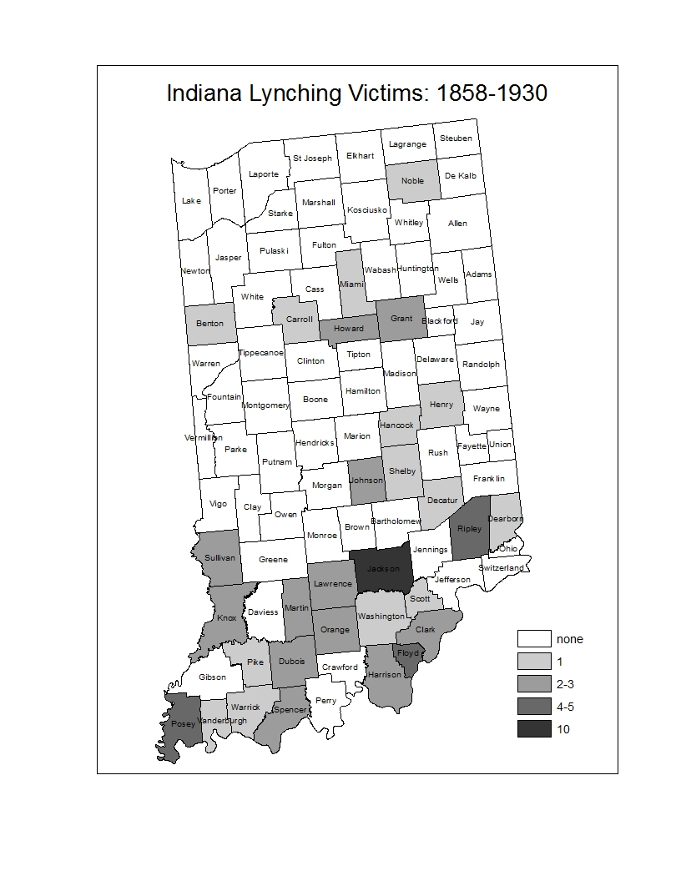

source: data: Pfeifer 2013; boundary file: Minnesota Population Center. *National Historical Geographic Information System: Version 2.0*. Minneapolis, MN: University of Minnesota 2011. [http://www.nhgis.org](http://www.nhgis.org/)

Figure 7 indicates Hoosier lynching mostly in Southern Indiana, with band of lynching north of Indianapolis (two victims in Marion, in Grant County, and two in Kokomo, in Howard County)—but there were none in Muncie or in Anderson, or in Lafayette or in Indianapolis, even though these urban centers were hotbeds of Klan activity between 1915 and 1924. It is quite likely that the Klan was terrorizing people in these counties but not killing them. Nevertheless, far from the urban centers of Indiana, Jackson County was the heart of lynch law.

Figure 8 indicates that Klan events (reported by McVeigh 2009) were concentrated in the urban centers. All 16 Marion County events were in Indianapolis, 12 of 13 events in Vigo County were in Terre Haute, all 8 Howard County events were in Kokomo, and all three Delaware County events were in Muncie.

**Figure 8**

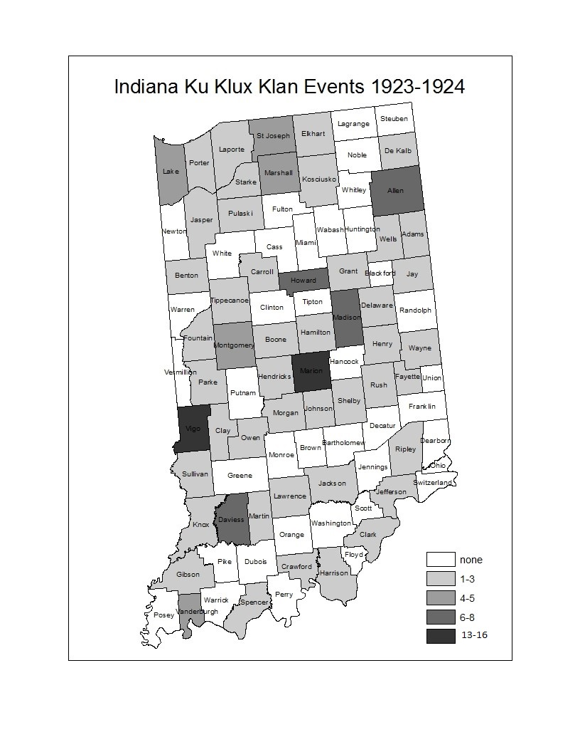

Source: data: McVeigh 2009; boundary file: [http://www.nhgis.org](http://www.nhgis.org/)

Unlike Hoosier lynching, KKK marches and other publicized events were more likely to be in urban, commercial and industrial centers. All five of the Vanderburgh County events were in Evansville, as was the one lynching reported in 1882, where a white man accused of murder was beaten and shot by vigilantes. Jackson County, as already noted was the lynching capital of

Indiana, claiming ten victims, mostly (7 of ten) in Seymour. As we can see, in Figure 9, however, most (7 of ten, including six in Seymour) Jackson County victims were lynched before the end of Reconstruction.3

**Figure 9**

**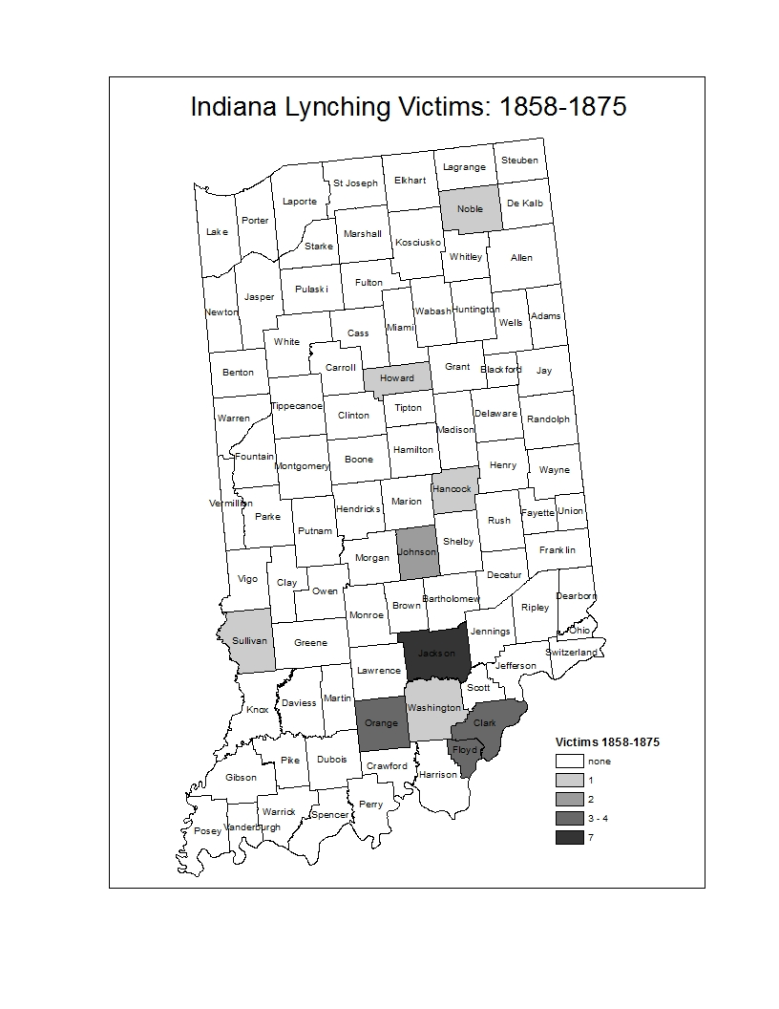**

source: Pfeifer (2013) data; boundary file: [http://www.nhgis.org](http://www.nhgis.org/)

As indicated in Figure 10, there were only three Jackson County victims after 1876. In fact, Figure 10 indicates that, after Reconstruction, lynching was no longer concentrated in the South, between Indianapolis and Louisville, where yeoman farmers near the Kentucky border had been actively involved in lynching horse thieves and train robbers. After 1876, the Southern bias remained, but there was also a band of lynching counties north of Indianapolis.

**Figure 10**

**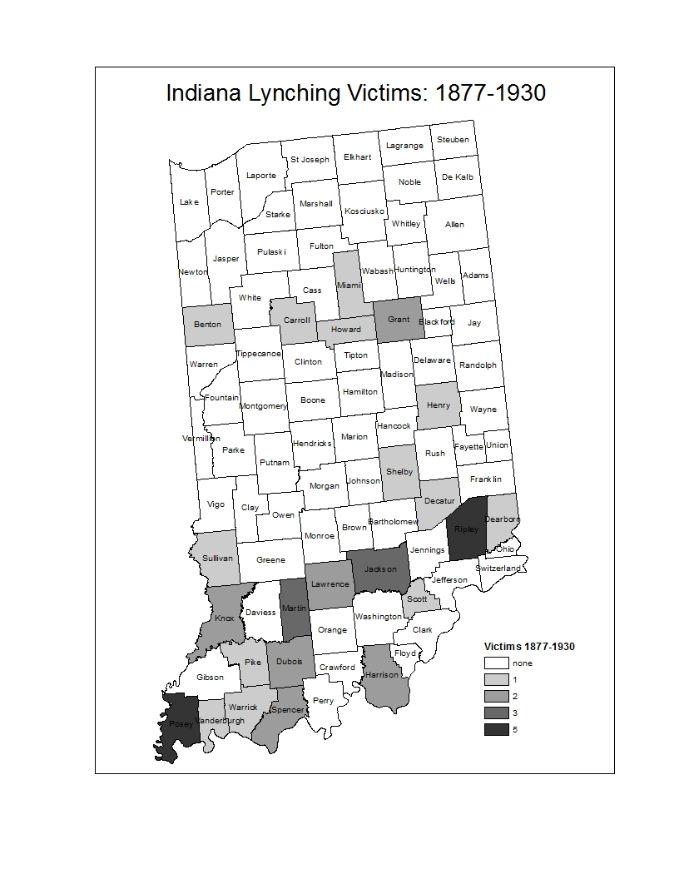**

source: Pfeifer (2013) data; boundary file: [http://www.nhgis.org](http://www.nhgis.org/)

Does Race Matter?

What explains the geography of lynching in Indiana? The Border State culture of small scale yeoman farming, Regulators, Judge Lynch and violent struggles between yeomen versus planters and their slaves, entered Indiana along the Ohio River. Both percent black and percent of household heads (or spouses) with at least one foreign-born parent were substantially greater in the South—correlated .28 (black) and .20 (foreign) with South—as coded by Moore (1991). The Civil War and Reconstruction brought a small black population into Southern Indiana, which moved into Indianapolis and, to a lesser extent, into the manufacturing cities to the North, but Northern Indiana remained virtually lily white, as seen in Figure 11.

**Figure 11**

**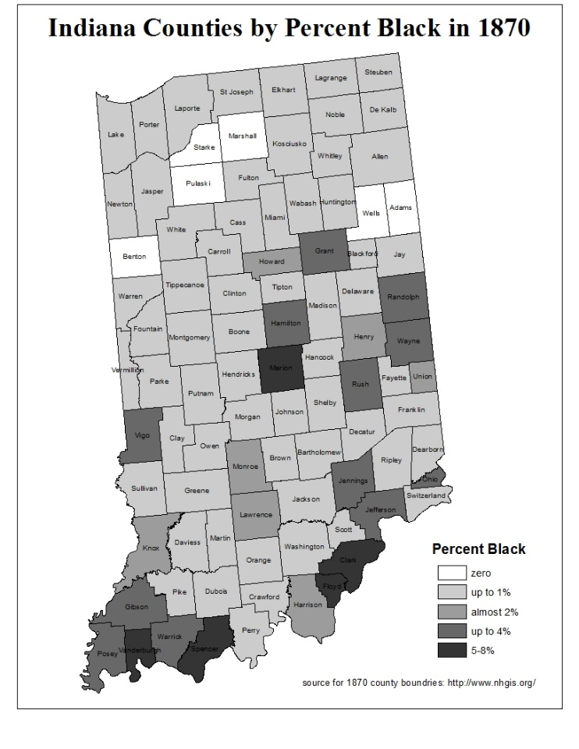**

source: ICPSR 2 census data; boundary file: [http://www.nhgis.org](http://www.nhgis.org/)

By 1920 there was a smattering of blacks in Northern Indiana, although still less than five percent of the population, even in Lake County, home of Gary, which is today nearly 85% black. Lake County reported a 4 percent black population in 1920, as the Chicago suburb was becoming increasingly urban and politically volatile, voting for Teddy Roosevelt, the Progressive, in his unsuccessful 1912 bid to defeat both Taft and Wilson and to reclaim the presidency.

Hoosier political geography is complex, but in the critical presidential election of 1876, which effectively ended Reconstruction, there was a tendency for the Southern tier to vote Democratic—in favor of the Unreconstructed Southern Redeemer, still defending the lost cause. The equally critical election of 1896 saw Silver Democrats in coalition with Populists in support of William Jennings Bryan, who would not be crucified on a cross of gold. This time the Republicans carried Indiana. Hoosiers seemed to prefer McKinley to Bryan, who was the Democratic as well as the Populist candidate. At the congressional level, however, not all Democratic communities were inclined to support Populist candidates. We can see in Figure 12 that these “real Democrat” counties were the lynching counties, mostly along the Ohio River, but also including the emerging factory towns North of Indianapolis.

**Figure 12**

**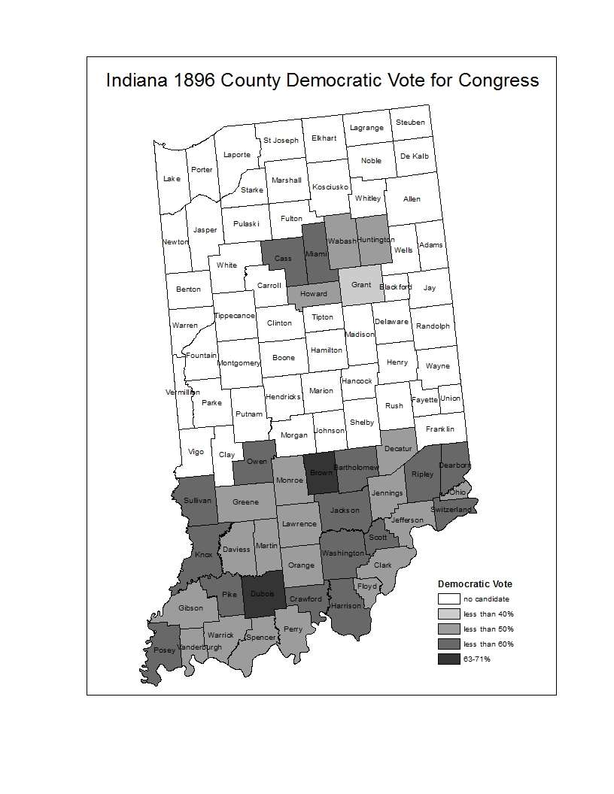**

source: ICPSR 1 election data; boundary file: [http://www.nhgis.org](http://www.nhgis.org/)

In the election of 1920, Indiana political geography resembled the election of 1876, but the Republicans carried Indiana again, and the Democratic counties were less concentrated in the South, as the party faithful surrounded without including Marion County, where Indianapolis is located. There was, in fact, a narrow band of Democratic partisanship extending from the Ohio River toward Indianapolis, then nearly surrounding Marion County. There were few Democratic counties north of Marion County—only Wells in the Northeast. Lake County polled 69% Republican, supporting Harding after its flirtation with Progressivism in 1912.

Predicting Lynching

Lynching is bad for business and interferes with free trade and public order, so wherever you find a strong middle class, promoting churches and schools and good government, you will have fewer lynching victims than would be expected in such a petit bourgeois community that lacked the wholesome influence of women and children, sustaining churches and schools. Beck et al (2016) find evidence to support this assertion in the South. Here we find modest empirical support: a correlation of -.13 between proportion of children in school in 1870 and lynching victims, 1858-1877, which increases to a -.14 correlation between proportion of children in school in 1890 and lynching victims, 1877-1930. In both cases, the net effects are not significant in the multivariate models that we shall examine below.

Aside from that, black population, foreign population, and Democratic partisanship predict lynching. The fact that Indiana was not exactly under siege by an army of black immigrants is relatively unimportant. Things defined as real are real in their consequences (Thomas and Thomas 1928), and the Democratic newspapers promoted lynching, as indicated in this excerpt from a Georgia paper in 1870.



Source: Savannah *Daily News and Tribune* 10 December 1870, p. 2

Consequently, our ethnic and racial threat theory predicts that where proportion black and foreign-born were greater more lynching was likely. Resource Mobilization predicts voting Democratic effects to be greater.

**Table 3**

**Negative Binomial Regression Predicting Indiana Lynching Victims, 1858-1930**

|  |  |  |  |  |
| --- | --- | --- | --- | --- |
|  | **Model 1: Pre-1876** | | **Model 2: Post 1876** | |
| **Predictor** | **coefficient** | **standard**  **error** | **coefficient** | **standard**  **error** |
| **proportion black+** | 50.82\*\* | 24.21 | .291 | 8.81 |
| **proportion foreign+** | -8.09\* | 4.22 | 3.71 | 4.89 |
| **Democratic**  **Candidate++** | 18.43\*\*\* | 6.31 | 2.58\*\*\* | .585 |
| **Constant** | -10.77\*\*\* | 3.25 | -2.84\*\*\* | .626 |
| N=92 | χ2=13.44\*\*\* | | χ2=26.14\*\*\* | |

**+** black or foreign population in 1870 (Model 1) or in 1890 (Model 2)

**++** proportion vote Democrat for President in 1876 (Model 1), or Democratic candidate running for Congress (1=yes; 0=no) in 1896 (Model 2)

**\*** p<.1 **\*\*** p<.05 **\*\*\***p<.01

source: Pfeifer (2003); ICPSR 1 elections; NHGIS census data

As seen in Table 3, both theories might claim some support in predicting lynching victims for the Civil War-Reconstruction period. Race does matter—proportionately more blacks makes more lynching likely, but the opposite is true for the foreign born. The effect is small and not significant at p<.05 (the conventional limit of significance tests), but this finding is still troubling for those defending a status competition model.

Yet more troubling, after Reconstruction, as lynching becomes more racial, the effect of percent black (1870 or 1890) becomes insignificant. In fact, areas becoming increasingly black—notably, the cities such as Indianapolis, have few or no lynching victims.4 The effect of the Democratic Party, however, is even more significant after Reconstruction, as seen in Model 2. Here we are looking at the congressional races (as we did in the map), but we are using a dummy variable to indicate whether the county fielded a Democratic candidate for congress (in 39 counties) or pitted Republican against Populist (53 counties).5

What about the Klan? Table 4 reports OLS regression models that combine in varying degrees the essential elements of the lynching analysis in Table 3, but the dependent variable is KKK membership density in 1925 (Moore 1991) and proportion of children in school is added as a predictor, indicating petit bourgeois family values, in Model 2.

**Table 4**

**Ordinary Least Squares Regression Predicting Indiana KKK Membership Density (per white adult native born male) in 1925**

|  |  |  |  |  |
| --- | --- | --- | --- | --- |
|  | **Model 1** | | **Model 2** | |
| **Predictor** | **Coefficient** | **standard**  **error** | **Coefficient** | **standard**  **error** |
| **Proportion Black 1920** | .126 | .494 | -.012 | .481 |
| **Proportion Foreign 1920** | -.120 | .222 | .002 | .220 |
| **Proportion Democratic Governor Vote 1924** | -.635\*\*\* | .143 | -.548\*\*\* | .143 |
| **School Enrollment 1920** |  |  | .937\*\* | .362 |
| **Constant** | .502\*\*\* | .072 | -.432 | .368 |
| **N=89** | **R2=.17\*\*\*** | | **R2=.23** | |

\* p<.1 \*\* p<.05 \*\*\*p<.01

source: Moore (1991) ICPSR 1 elections and NHGIS census data

The KKK represented the same petit bourgeois public order interests as the lynch mob, but was less conflicted by the contradictions of mass violence in the service of public order. KKK events tended to be “WUNC” displays—marches and demonstrations that indicated that the Klan was “Worthy, United, Numerous and Committed” (Tilly and Wood 2013: 4-5). As we have already noted, marches (unlike lynching) were family fun events.

Consequently, our Resource Mobilization “interest-based” status and party measures: school enrollments and partisanship, jointly predict Klan membership density, as indicated in Model 2. In fact, race matters little in either model, nor does foreign-born. Partisanship matters most, as we see in Model 1, and it continues to matter most in Model 2, where we also see a significant effect of school enrollment, which is associated with greater Klan density, as we expected.

As noted above, number of lynching victims, in either period, was modestly negatively correlated (-.13 and -.14) with proportion of children enrolled in school (in 1870 and 1890), but this effect did not achieve significance after controlling for Democratic partisanship. In examining Klan density, however, the correlation with school attendance is positive and substantially greater (.33), thus achieving significance in the model that includes Democratic partisanship.

In contrast to the lynching analysis, when predicting Klan density both school enrollment and partisan effects are reversed. The mobilization of Klan members, unlike the organization of the lynch mob, was facilitated by the petit bourgeois shopkeeper interests that supported public schools as well as Fourth of July parades in the cities and counties where agriculture and manufactures thrived.6 Unlike the lynch mob, in the early years of the Horse Thief Detective Association, which tended to thrive in Southern Democratic counties, the Klan mobilization was facilitated by the Republican Party, in Indiana in 1924, particularly in Indianapolis, where D. C. Stephenson, appointed Grand Dragon of Indiana in 1923, with control of Klan operations in 23 Northern states, established his headquarters, rivaling the reach of Evans, the national Imperial Wizard by 1924 (McVeigh 2009: 2, 27, 103).

McVeigh (2009: 15) identifies Evansville (4 events),7 Fort Wayne (6), Indianapolis (16), South Bend (4), and Terre Haute (12) as “larger cities with Klan events,” but his data also indicate 8 events in Kokomo, where Moore (1991, p. 76) reports “perhaps the most famous” Indiana Klan event of the 1920s. There were no events reported in the young steel town of Gary, but there were four events in Lake County.

Lessons of History

Lynching changed after Reconstruction. Both the Klan and vigilantism came to Indiana from the Border States—crossing the Ohio River along with Freedmen and yeomen farmers who were attempting to escape the lash of the master’s plantation economy. In the early years, lynching whites and blacks was just part of the general vigilantism of the Trans-Appalachian (or Cumberland Plateau) culture. Blacks were over-represented among victims, but that is true of criminal prosecutions and homicides even in the 21st century.

Ironically, as lynching became more racial, the significance of race in predicting lynching declined. After the failed efforts of Radical Republicans to keep blacks in the South by offering 40 acres and a mule, blacks moved increasingly into the cities of the North. Indiana communities continued to hold to line against racial integration in the late 19th century, however, effectively locking blacks out of the Northern farming region and even the Gary/SE Chicago region, which has now become virtually all black.

Even so, Democrats continued to play the race card, and those counties that were more inclined to support Democrats who were not Populists were also more likely to lynch. Places like Marion, Indiana, were far from the River and largely immune to black immigration, but they held the line with Democratic (or even Klan) support and the occasional resort to lynching. That is how terrorism works. You don’t need to kill someone every day.

By 1920, in fact, the emerging urban manufacturing towns of Indiana, on the border of the Northern expansion of lynching after Reconstruction, became centers of KKK activity. Kokomo and Indianapolis were important centers of the revitalized Klan.8 This was the thoroughly modern urban industrial Klan. This was not the Klan of the Reconstruction era South, which had engaged in lynching (or “outrages”) in Georgia in 1868 (Bullock 1868). The new Klan of the 1920s had their own police force, sanctioned by state legislation enabling the “Horse Thief Detective Association” to apprehend if not to execute horse thieves. According to McVeigh (2009: 135), these newly sanctioned and thoroughly organized Post-Reconstruction lynch mobs, “over 20,000 members strong, answered only to the Klan, not to the state governments.”

Nevertheless, the Indiana Klan of the 1920s was different from the lynch mobs. It was aligned with the no-longer Progressive Republican Party, and it defended public schools and temperance if not prohibition (McVeigh 2009, chapter 6; Moore 1991). It also “drew upon familial and community ties—traditions of church suppers, kin reunions, and social celebrations—to circulate the Klan’s message of racial, religious, and national bigotry.” (Blee 1992: 3). This was the new KKK, which would soon move into abeyance (Taylor 1989), with the economic crisis of the 1930s, only to return with more violent as well as nonviolent efforts to defend Jim Crow in the 1950s (Cunningham 2013; Morris 1984; Morris 1993), but that takes us far beyond our current concerns and will have to be a topic for another day.

Meanwhile, perhaps our brief exploration of Terrorism in Indiana might help us to understand the historical and structural conditions that have inspired ISIL and other terrorist organizations to mobilize supporters for an Islamic state. The end of the Cold War and the successive invasions of the Persian Gulf created opportunities. As Tarrow (2011: 160) explains, “When institutional access opens, rifts appear within elites, allies become available, and state capacity for repression declines, challengers see opportunities to advance their claims.” Clearly that is what has been happening in the Middle-East, which has facilitated terrorist challenges. Perhaps we should focus our international efforts on creating opportunities for bourgeois colonial revolts, sustained by a global hegemonic bourgeoisie that might be willing to share the wealth with the less fortunate, in a more Progressive union that might be a better alternative to regime change without support for Radical Reconstruction. Perhaps we will get it right eventually.

References

Andrews, Kenneth T. and Charles Seguin. 2015. “Group Threat and Policy Change: The Spatial Dynamics of Prohibition Politics, 1890-1919.” *American Journal of Sociology* 121, 2 (September): 475-510.

Bailyn, Bernard. 1967. *The Ideological Origins of the American Revolution.* Cambridge, MA: Harvard University Press.

Beck, E. M. 2000. “Guess Who’s Coming to Town: White Supremacy, Ethnic Competition, and Social Change.” *Sociological Focus* 33, 2 (May): 153-174.

Beck, E. M. and Stewart E. Tolnay. 1990. “The Killing Fields of the Deep South: The Market for Cotton and the Lynching of Blacks, 1882-1930.” *American Sociological Review* 55, 4: 526-539.

Beck, E. M., Stewart E. Tolnay, and Amy Kate Bailey. 2016. “Contested Terrain: The State versus Threatened Lynch Mob Violence.” *American Journal of Sociology* 121, 6 (May): 1856–84.

Benford, Robert D. and David A. Snow. 2000. "Framing Processes and Social Movements: An Overview and Assessment," *Annual Review of Sociology* 26: 611-639.

Blee, Kathleen M. 1992. *Women of the Klan: Racism and Gender in the 1920s.* Berkeley: University of California Press.

Blee Kathleen M. 2006. “Forum: Can We Learn from Racists?” *Mobilization* 11 (4):479–82.

Blee, Kathleen M. and Kimberly A. Creasap. 2010. “Conservative and Right-Wing Movements.” *Annual Review of Sociology* 36: 269–86.

Brundage, W. Fitzhugh. 1999. “Lynching.” *Violence in America: An Encyclopedia* 1: 297-303.

Bullock, Governor Rufus E. 1868. “Report of Outrages Committed upon Citizens State of Georgia From Jan 1st to Nov 15th, 1868” and “Additional Report of Outrages and Wrongs Committed upon Citizens State of Georgia since Nov 1868.” Correspondence, Record Group 1, Series 5. Photographed by the Georgia State Archives and purchased as TIFF files, Morrow, GA, August 2010.

Callimachi, Rukimini. 2015. “ISIS and the Lonely Young American.” *New York Times* (June 28: A1).

Chalmers, David M. 1987. *Hooded Americanism: The History of the Ku Klux Klan.* Durham, NC: Duke University Press.

Cunningham, David. 2013. *Klansville, U.S.A.: The Rise and Fall of the Civil Rights-Era Ku Klux Klan.* NY: Oxford University Press.

Dykstra, Robert. 1968. *Cattle Towns.* NY: Knopf.

Einwohner, Rachel. 2003. “Opportunity, Honor, and Action in the Warsaw Ghetto Uprising of 1943.” *American Journal of Sociology* 109, 3: 650-675.

Foner, Eric. 2011. *The Fiery Trail: Abraham Lincoln and American Slavery.* NY: W.W. Norton, 2011.

Gamson. William A. 1992. *Talking Politics*. Cambridge, U.K.: Cambridge University Press.

Goodwin, Jeff and James M Jasper. 1999. “Caught in a Winding, Snarling Vine: The Structural Bias of Political Process Theory.” *Sociological Forum* 14, 1: 27-54.

Hogan, Richard. 1990. *Class and Community in Frontier Colorado*. Lawrence, KS: University Press of Kansas.

Hogan, Richard. 2003. *The Failure of Planning: Permitting Sprawl in San Diego Suburbs, 1970-1999.* Columbus, OH: Ohio State University Press.

Hogan, Richard. 2011. "Resisting Redemption: The Republican Vote in 1876 Georgia" *Social Science History* 35, 2: 133-166.

ICPSR 1 [**United States Historical Election Returns, 1824-1968**](http://www.icpsr.umich.edu/icpsrweb/ICPSR/studies/1?searchSource=revise&q=ICPSR+1), Inter University Consortium for Political and Social Research, Institute of Social Research, University of Michigan, Ann Arbor, Michigan: data available online: <http://www.icpsr.umich.edu/icpsrweb/landing.jsp>

ICPSR 3 [**Historical, Demographic, Economic, and Social Data: The United States, 1790-1970**](http://www.icpsr.umich.edu/icpsrweb/ICPSR/studies/3?searchSource=revise&q=ICPSR+3), Inter University Consortium for Political and Social Research, Institute of Social Research, University of Michigan, Ann Arbor, Michigan: data available online: <http://www.icpsr.umich.edu/icpsrweb/landing.jsp>

Jackson, Kenneth T. 1967. *The Ku Klux Klan in the City, 1915-1930*. NY: Oxford University Press.

Leonard, Stephen J. 2002. *Lynching in Colorado: 1859-1919.* Boulder: University Press of Colorado.

Lewis, John M., III. 2002. *The Reno Story: The World’s First Train Robbers, The Facts, The Fictions, The Legends*. Seymour, IN: Seymour Sesquicentennial Committee and Seymour Oktoberfest, Inc.

Madison, James H. 2011. “Teaching the JAH.” *Journal of American History* (June) accessed on line 8/20/2015. <http://www.journalofamericanhistory.org/teaching/2011_06/sources/day2ex1_photo_madison.html>

McAdam, Doug, Sidney Tarrow, and Charles Tilly. 2001. *Dynamics of Contention*. Cambridge, U.K.: Cambridge University Press.

McAdam Doug, Robert J. Sampson, Simon Weffer and Heather MacIndoe. 2005. “There will be Fighting in the Streets”: The Distorting Lens of Social Movement Theory. *Mobilization* 10:1–18

McVeigh, Rory. 2009. *The Rise of the Ku Klux Klan: Right –Wing Movements and National Politics.* Minneapolis, MN: University of Minnesota Press.

Moore, Leonard J. 1991. *Citizen Klansmen: The Ku Klux Klan in Indiana, 1921-1928*. Chapel Hill: University of North Carolina Press.

Morris, Aldon.1984. *The Origins of the Civil Rights Movement: Black Communities Organizing for Change*. NY: Free Press.

Morris, Aldon.1993. "Birmingham Confrontation Reconsidered: An Analysis of the Dynamics and Tactics of Mobilization." *American Sociological Review* 58:621-636.

NHGIS. U.S. County Boundary files, Minnesota Population Center. National Historical Geographic Information System: Version 2.0. Minneapolis, MN: University of Minnesota 2011.downloaded online: boundary file: [http://www.nhgis.org](http://www.nhgis.org/)

Pfeifer, Michael J. (editor) 2014**.** *Lynching Beyond Dixie****:*** *American Mob Violence outside the South*. Urbana: University of Illinois Press.

Piven, Frances Fox and Richard A. Cloward. 1977. *Poor People’s Movements: Why They Succeed, How They Fail*. NY: Pantheon Press,

Savannah *Daily News and Tribune* 1870 (10 December, p. 2).

Smith, Heather and Thomas Pettigrew (editors). 2015. “Advances in Relative Deprivation Theory and Research,” *Social Justice Research*, volume 28.

Snow, David A., Peter B. Owens and Anna E. Tan. 2014. “Libraries, Social Movements, and Cultural Change: Toward an Alternative Conceptualization of Culture.” *Social Currents* 1: 35. The online version of this article can be found at: <http://scu.sagepub.com/content/1/1/35>

Snow, David A., E. Burke Rochford, Jr., Steven K. Worden, and Robert D. Benford. 1986. "Frame Alignment Processes, Micromobilization, and Movement Participation," *American Sociological Review* 51: 464-481.

Steinberg, Marc W.1998. “Tilting the Frame: Considerations on Collective Action Framing from a Discursive Turn.” *Theory and Society* 27, 6: 845-872.

Steinberg, Marc W. 1999. “The Talk and Back Talk of Collective Action: A Dialogic Analysis of Repertoires of Discourse among Nineteenth-Century English Cotton Spinners.**”** *American Journal of Sociology* 105, 3: 736-780.

Tarrow, Sidney G. 2011. *Power in Movement: Social Movements and Contentious Politics*, Third edition. NY: Cambridge University Press.

Taylor, Verta. 1989. "Social Movement Continuity: The Women's Movement in Abeyance," *American Sociological Review* 54: 761-775.

Thomas, William Isaac and Dorothy Swaine Thomas. 1928. *The Child in American, Behavioral Problems and Programs*. NY: A. A. Knopf.

Tilly, Charles. 1986. *The* *Contentious French.* Cambridge, MA: Harvard University Press.

Tilly, Charles. 1995. *Popular Contention in Great Britain, 1758-1834.* Cambridge, MA: Harvard University Press.

Tilly, Charles. 2003. *The Politics of Collective Violence*. NY: Cambridge University Press.

Tilly, Charles. 2004. *Contention & Democracy in Europe, 1650-2000*. NY: Cambridge University Press.

Tilly, Charles. 2007. *Democracy.* NY: Cambridge University Press.

Tilly, Charles. 2008. *Contentious Performances.* NY: Cambridge University Press.

Tilly, Charles and Leslie Wood. 2013. *Social Movements, 1768-2012.* Boulder, CO: Paradigm Publishers.

Tolnay, Stewart E. and E. M. Beck. 1995. *Festival of Violence: An Analysis of Southern Lynchings, 1882–1930*. Urbana: University of Illinois Press.

Useem, Bert. 1980. “Solidarity Model, Breakdown Model, and the Boston Anti-Busing Movement.” *American Sociological Review* 45, 3: 357-369.

Useem, Bert and Jack A. Goldstone. 2002. “Forging Social Order and Its Breakdown: Riot and Reform in U.S. Prisons.” *American Sociological Review* 67, 4: 499-525.

Wade, Eric C. 2011. *Constituting Whiteness: The National Horse Thief Detective Association and Racial Mores in Indiana, 1850-1930.*  West Lafayette, IN: Purdue University doctoral dissertation in American Studies, History. Online full text version is available through Purdue Libraries to Purdue faculty and staff, or through Inter-Library Loan, for others.

Wright Stuart A. 2007. *Patriots, Politics, and the Oklahoma City Bombing*. New York: Cambridge University Press

Notes

1. Here we will use vigilantism and lynching interchangeably, although the first wave of lynching (before 1876) appears quite different from the Southern lynching of the later years.

2. Here I refer to the ability to reproduce these findings with different models and measures, or different populations/samples. The analysis is based on the coding of census data, which are plagued by collinearity. Variance Inflation Factor scores for the OLS models presented here were all well below 3.0. Descriptive statistics, including inter-item correlations, are available upon request.

3. Seymour, Indiana appears to be proud of its vigilante tradition. The Mayor and the local historical society claim that local vigilantism was a response to the threat of train robbers—allegedly, the Reno gang perpetrated the first train robbery in the USA in 1866—well before the more famous James gang (Lewis 2002).

4. After reading Beck (2000) I re-estimated these models using change in black population and in foreign population. Neither of these were significant predictors, alone or in combination.

5. The same results obtain when we use this model to predict total victims, 1858-1930. Only partisanship seems to predict lynching.

6. After reading Beck et al (2016) I ran factor analysis, using agricultural and manufacturing census data to characterize big and small factory and farm economies. The one factor that predicts neither events nor members nor even membership density is small farming communities, and there is virtually no evidence to indicate that rapid urbanization or industrialization or declining economic status are good predictors.

7. McVeigh (2009: 15) reports only four events in Evansville, but the appendix that he sent me includes five.

8. The center of Klan membership and events is clear—it was Marion County, with 25,000 members (Moore 1991) and sixteen events (McVeigh 2009), but White County had the highest Klan density—members per white adult native born male in the county.