ESE Location (Campus Map)

In the morning the Engineering and Science Extravaganza will begin at Lilly Hall of Life Sciences. The bus/car can drop off the students on S. Russell Drive, which is next to Lilly Hall.

The buses/cars can then go park at the Discovery Parking Lot. The parking lot can be reached by following Russell Drive and making a right at Nimitz Drive. The parking lot will then be on the left.

The event will end at Stewart Center on Memorial Mall. The buses/cars can just pull up in front of Stewart to pick up the students.

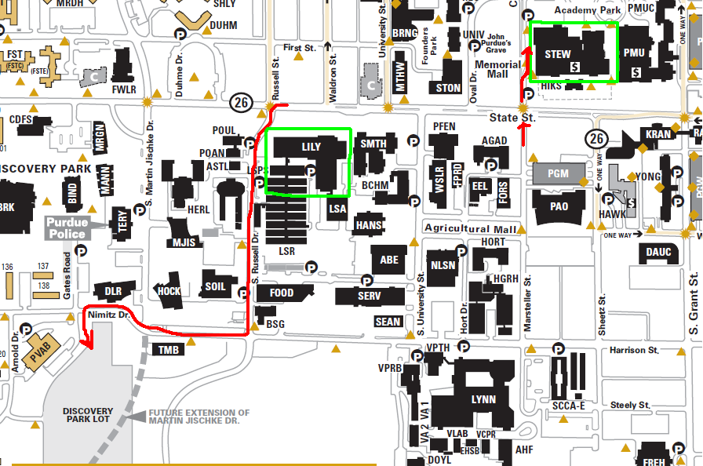
Pick up
Drop off
Parking

