MIT-JWEL Şenay Purzer purzer@purdue.edu
BREAKOUT GROUP TASK #1 (15 minutes)
The following solarized houses are designed by two students. The next page includes a design review conversation between Mike and a Design Reviewer.
Please review the images, brief descriptions, and the design review conversation and type your answers in the table provided below
What do you notice in these designs?

What inferences can you make about student thinking and learning?
What questions would you ask these students to elicit their reasoning about their design decisions?
What new inferences can you make about Mike’s reasoning after reading this conversation?
What do you notice about the design reviewer and their questions?

Lisa’s House
Mike’s House

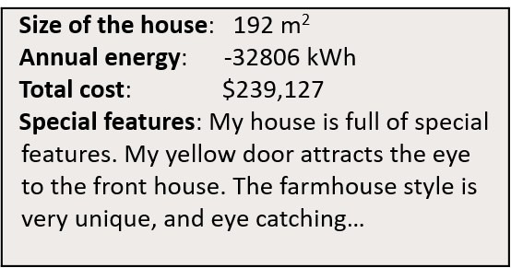
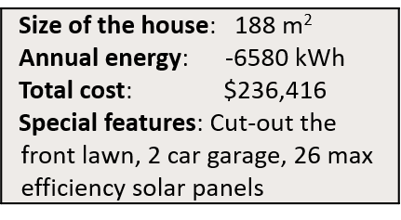

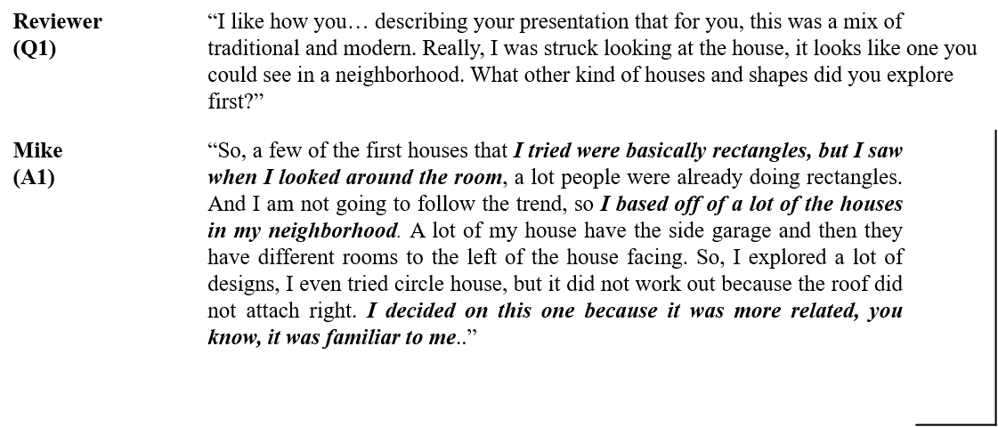
Design Review Conversation with Mike

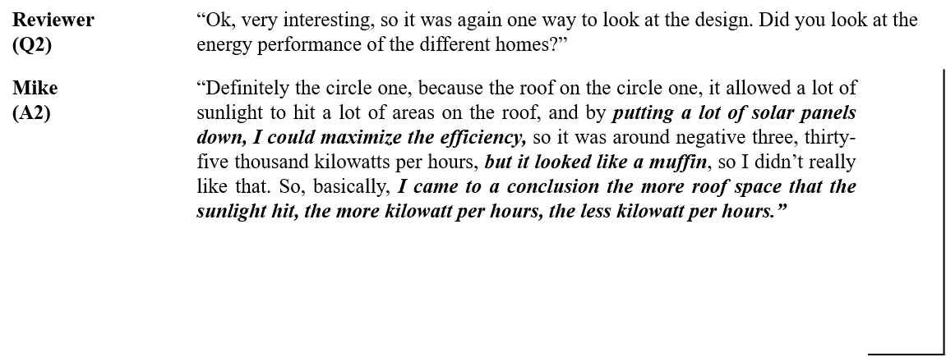

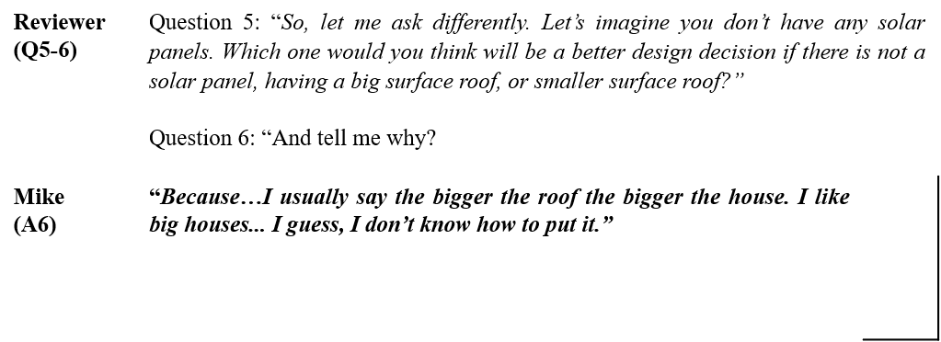

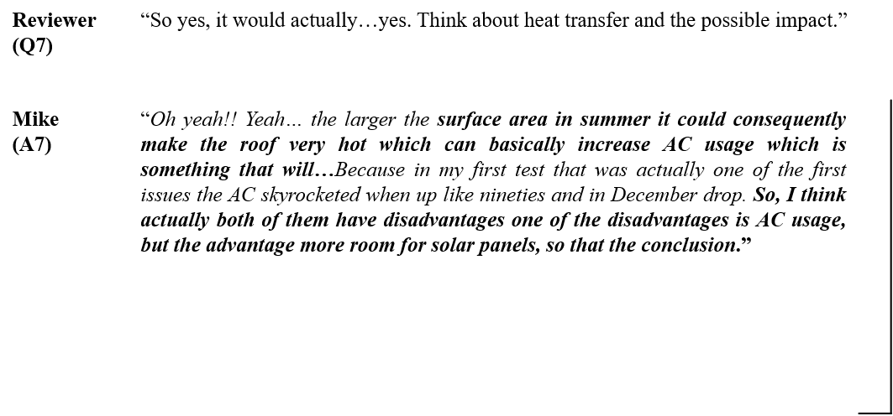

BREAKOUT GROUP TASK #2 (15 minutes)
Please choose your adventure, work on either option 1 or option 2
OPTION 1 (15 minutes)
Solarize a house (5 minutes)
- First, draw a very basic sketch of a house you lived when you were in middle school.
- Please include a compass to show the orientation of the building and provide a few details.
- Your goal is to maximize KWh generated while maintaining the maintaining eh residential elements and cultural values of the city/neighborhood
Role playing (10 minutes)
- Two volunteers act as Designers present their houses to the group
- Two other volunteers act as the Design Reviewer and seeks to understand the design using the Design Coaching Tool provided.

OPTION 2 (15 minutes)
Identify ways you can use the Design Coaching Tool or the Reasoning Quadrants Framework or the Honeycomb of Engineering in your own teaching and design

Class | Details

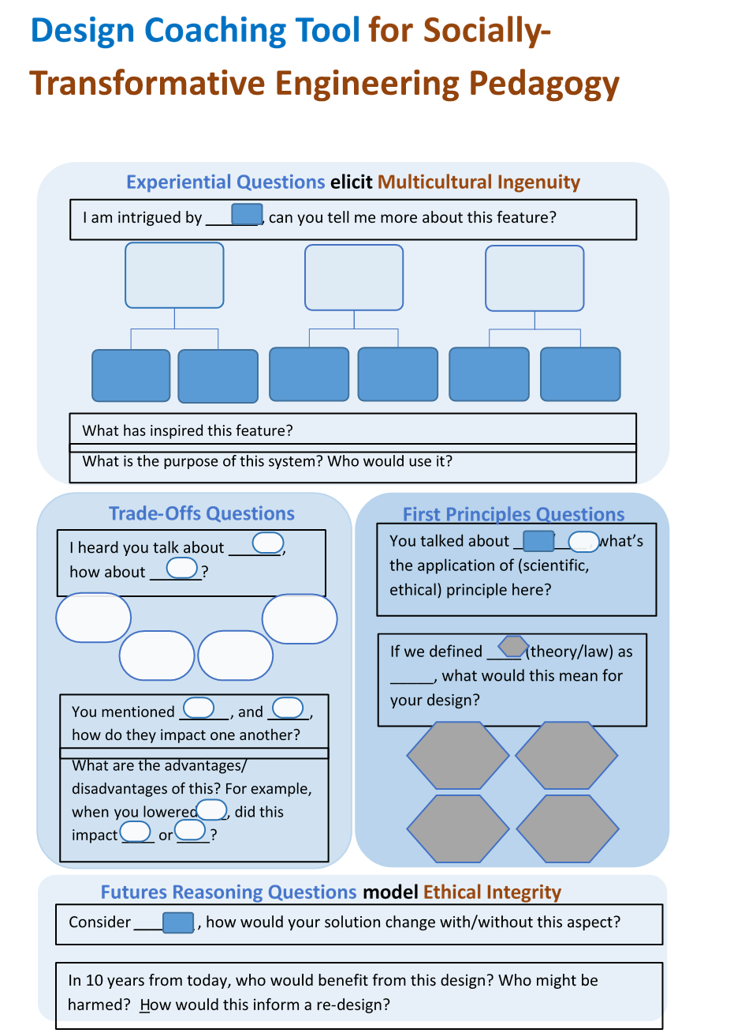

Honeycomb of Engineering
Purzer, Ş., Quintana-Cifuentes, J., & Menekse, M. (2021). The honeycomb of engineering framework: Philosophy of engineering guiding precollege engineering education. Journal of Engineering Education, 111( 1), 19– 39. https://doi.org/10.1002/jee.20441
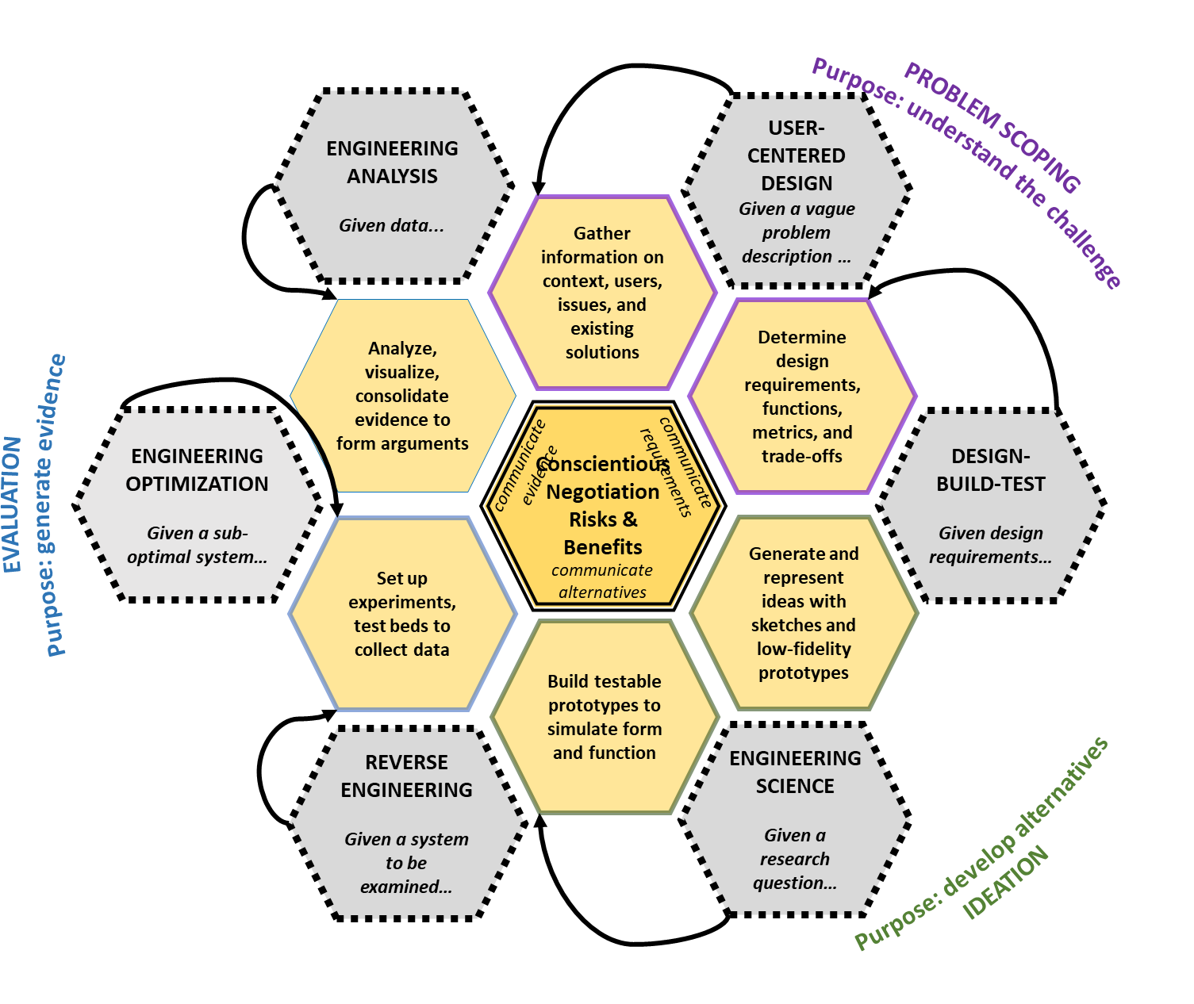
- User-centered design
- Design build test
- Engineering science
- Engineering optimization
- Engineering analysis
- Reverse engineering

