Maps and Parking instructions
Soccer Tournament:
Location: East Gym (E/W Gym), Court 10 and 11
W Stadium Avenue , West Lafayette, IN
Parking: The parking area is on W Stadium Ave (See link below). If you are going west on W Stadium Ave, after passing the intersection with Martin Jischke Dr., the parking area will be on the left
Direction: Just follow the arrows to go to the main entrance of East/West Gym.
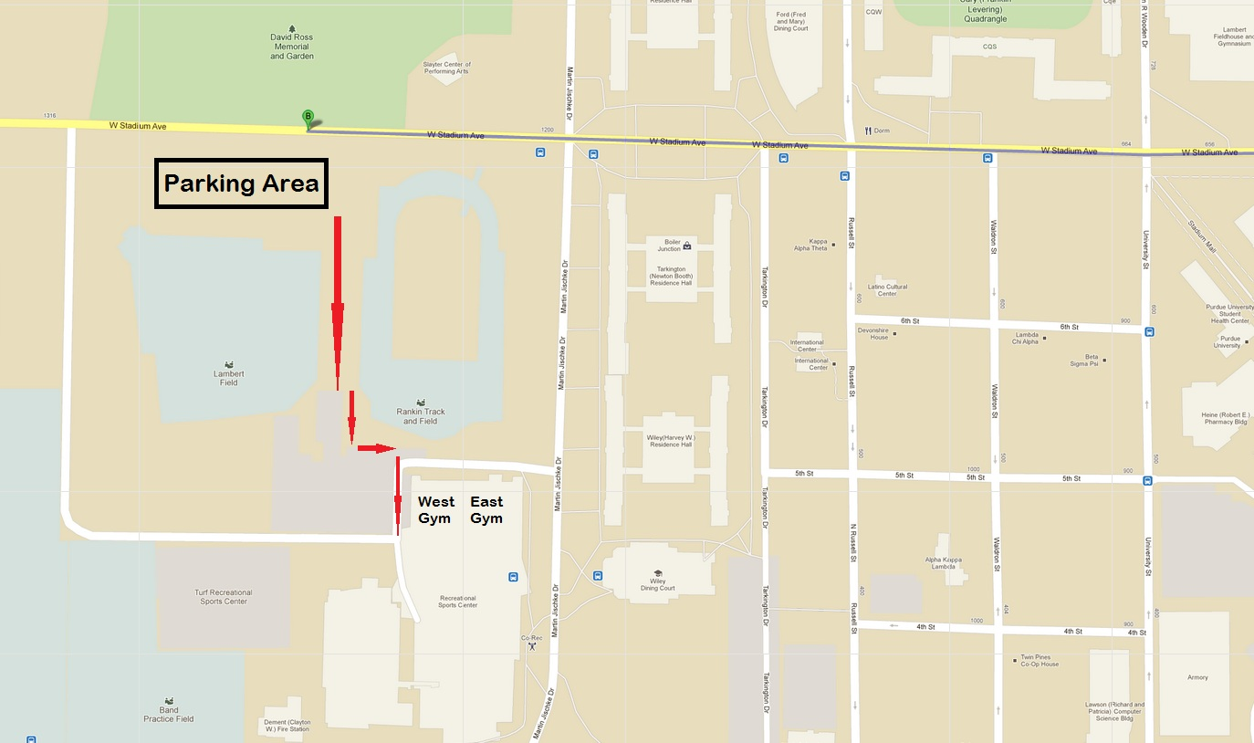
Google Maps link: http://g.co/maps/x4b9f

Lunch and social activities:
- If no rain: BBQ @ Fort Ouiatenon Park:
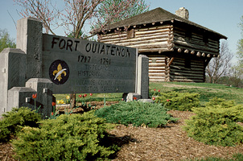
Google Maps link to go from East Gym to Fort Ouiatenon Park: http://g.co/maps/tw875
When you driving West on South River Road, the park will be on your left.

- If rain: BBQ @ Squirrel Park:
Google Maps link to go from East Gym to Squirrel Park: http://g.co/maps/epws7
Parking: on-street parking on Airport Road.

Karaoke:
Location: Matthews (MTHW) 210, Purdue University
2nd Street, West Lafayette, IN
Parking: The parking garage is on the 2nd Street (See the link below). There could be some parking slots available on Waldron St and 1st Street (red line mark)
Please note that the entrance to Matthews Hall is on the East side of the building.
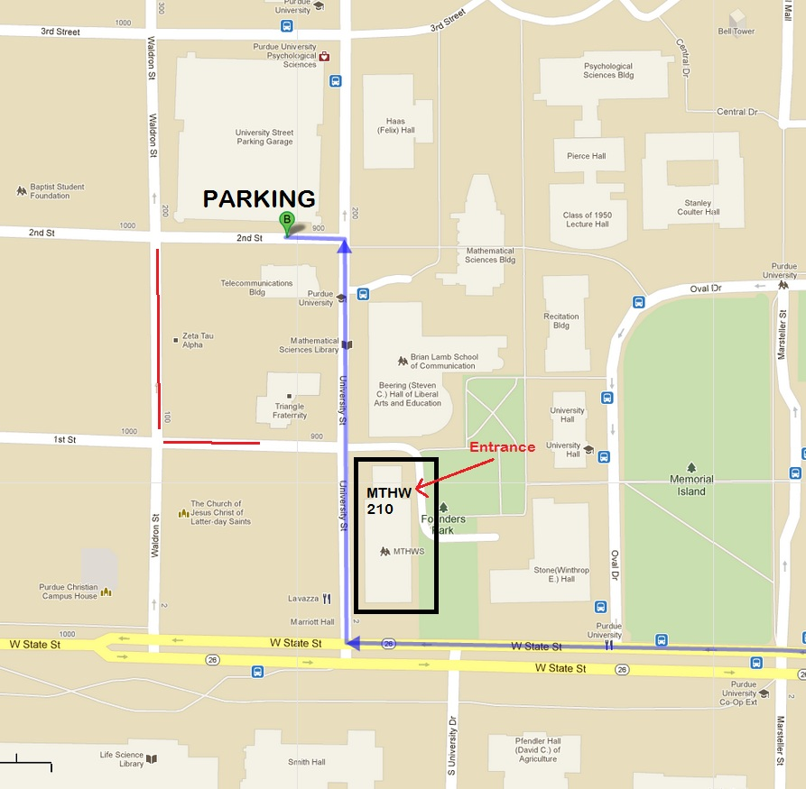
Google Maps link: http://g.co/maps/7whdd

