Vietnamese Midwest Soccer Tournament
Spring 2012 Program Schedule
- Soccer Tournament:
  - Time: 10am – 1pm
  - Location: East Gym, Court 10 and 11
  - Prize: $100 for the winner
  - Participated teams: Chicago, IU, Purdue, UIUIC
  - Tournament schedule: We will shuffle at the beginning of the tournament to decide team numbers, then follow the schedule here: https://docs.google.com/spreadsheet/ccc?key=0AhJMa6iSdNifdHhxVXRnX1h3QmxXNmc5WGdseUdKNUE
- Lunch and social activities:
  - Time: 2pm – 5pm
  - Location:
    - If no rain: BBQ @ Fort Ouiatenon Park
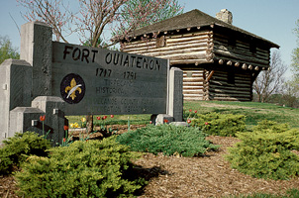
History about the park: http://www.tippecanoe.in.gov/egov/docs/1154005928875.htm
    - If rain: BBQ @ Squirrel Park
Please see “Maps and Driving instructions - Saturday.docx” for driving and parking instructions.

