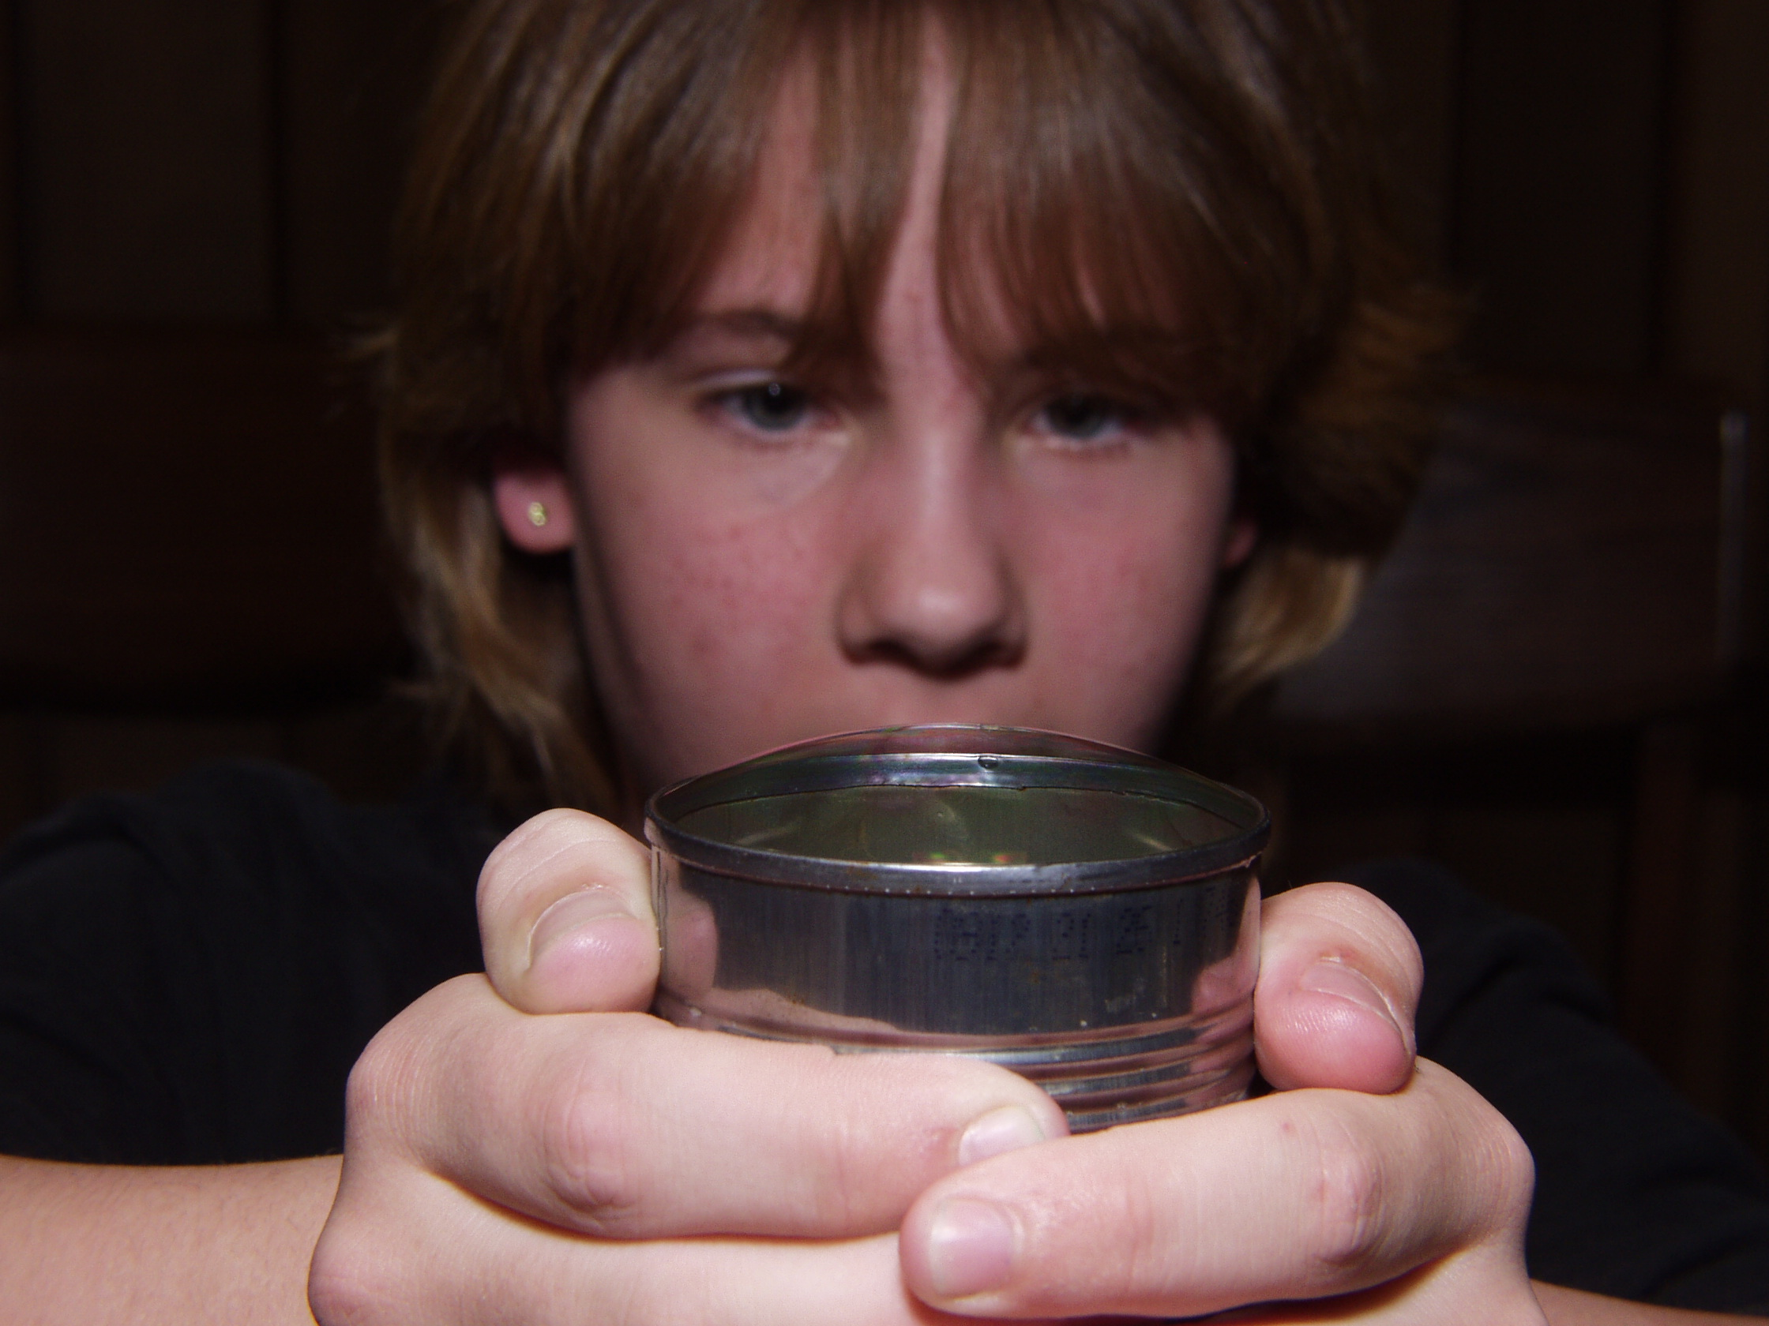 Heat Transfer—
Convection Currents
What happens when air is heated?
What is Needed

- Your hands and mouth
- A cold can
- A small bowl containing dish soap with some glycerine

What to Do

With your mouth open, blow on your hand. Now, repeat, but this time, pucker your lips and make a small hole so your breath expands as it leaves your mouth. Notice the difference in how it feels when your mouth is wide open compared to when you pucker.

Now get an ice cold can. Dip the top of the can in the bubble juice containing glycerine that is in the small bowl. Make certain the top opening of the can has a soap film on it. Turn the can upright and hold it with both hands so your hands are warming the can. YOU DO NOT HAVE TO SQUEEZE THE CAN to allow the heat from your hands to warm it. Watch the bubble that forms. Why do you think it does this?

What is happening?

Liquids and gasses transmit heat mainly by convection currents, which is heat transfer due to the motion of the fluid itself. Convection can occur in all fluids, whether liquids or gases. You breath is a gas!

With your mouth open, your breath is warm. When you pucker, the air is much cooler. Expanding air cools. This is the opposite of what occurs when air is compressed. If you’ve ever compressed air with a tire pump, you probably noticed that both air and pump became quite hot.

Heat travels by convection; that is, warm air rises, and this is called convection. Heating causes molecules to move faster. The faster they move, the hotter the air is. As molecules move faster, they are generally moving apart. Because there is more space between the molecules, the air is less dense than the surrounding matter and the hot air
rises.

 Purdue University
Department of Physics
Physics on the Road Hands-On

