 Quarter and a Can 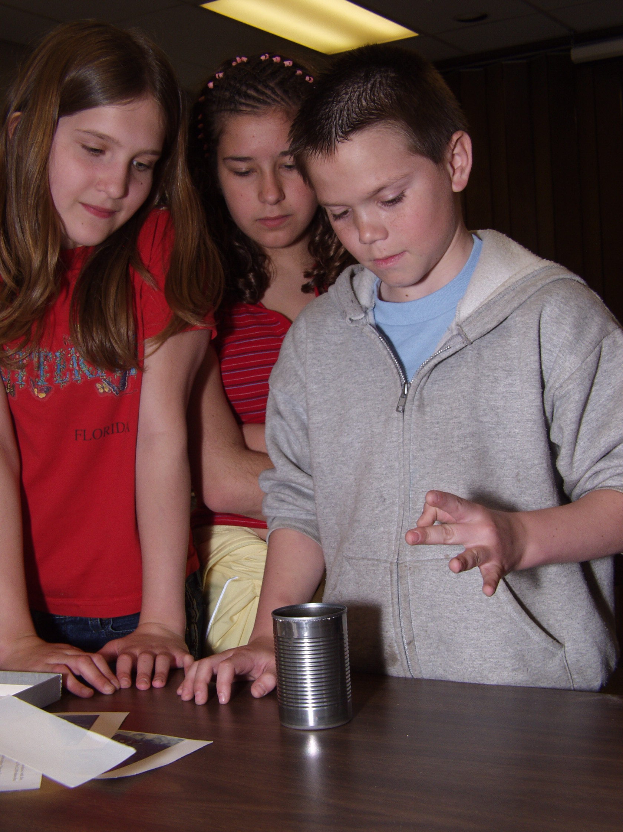
What will happen to the quarter?

_________________________________________________________

What is Needed

- A quarter
- An index card
- A drinking glass or soup can

________________________________________________________________________

What to Do

Place an index card over the open end of a drinking glass or soup can. Place a quarter in the center of the index card. Now give the card a sudden snap on the edge with your finger. The card will scoot away, and the quarter will drop into the glass or can. Why?

________________________________________________________________________

What is Happening?

Purdue University
Department of Physics
Physics on the Road—Hands-On

