 ROOT BEER FLOAT 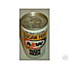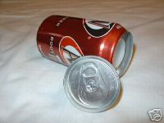
Regular or Diet? Why does a can of Root Beer
float or not float?

What is Needed

- Two large containers of water
- One can of Regular Root Beer
- One can of Diet Root Beer

What to Do

Take one of the cans in you left hand and one of the cans in your right. They probably feel about the same—same size, same weight. Now, slowly put each of the cans into a container filled with water. What happens? Why does this happen?

What is Happening?

One of the cans sinks and one floats. Do you know why this happens? Do you know why ANYTHING floats in water rather than sinks? The reason has to do with relative densities of materials. The density of water is 1 gram/cm³. If the density of an object is less than 1 gram/cm³, then the object floats in water. If the density of an object is more than 1 gram/cm³, the object will sink in water.

Now we know that the density of one of the cans is greater than 1 gram/cm³. What could account for the difference? Let’s assume that there is the same amount of liquid and air inside of the cans. Let’s also assume that there is the same amount of aluminum in each o f the cans. NOW can you think of what would make the difference in densities?

The answer is that there is a difference between the two cans because of the difference in density between sugar and the sugar substitute used in diet drinks.
 Purdue University
Department of Physics
Physics on the Road –Hands-On

