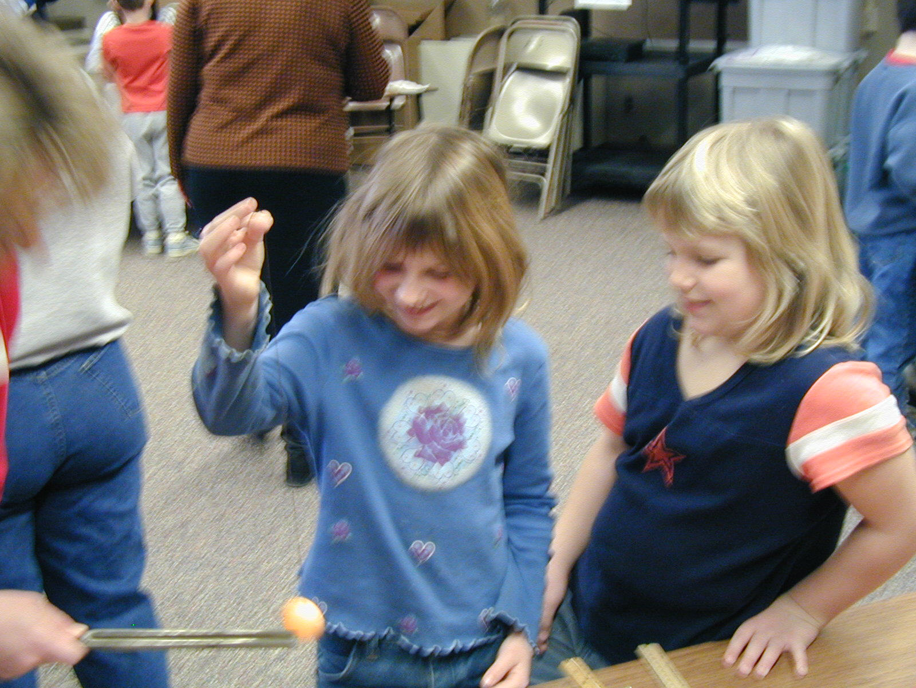 Sound is Vibration
How can you see the effects of sound waves?

What is Needed

- A ruler
- A ruler with a pencil pushed under a rubber band to make a stringed instrument
- A ping pong ball on a thread
- A tuning fork
- A glass of water

What to Do
First, hold one edge of a ruler tightly on the table top. Pluck the other end of the ruler lightly. Listen. Make the ruler longer. Make the ruler shorter. How does the sound differ?

Strike a tuning fork on your shoe, on the floor, or on the edge of the table. Watch and listen. And now, MAKE A BIG SPLASH! Put the vibrating tuning fork into a glass of water. What do you see?

Hold the ping pong ball by the thread in your left hand. Strike the tuning fork again. Touch the ping pong ball with the tuning fork. Watch. What do you see?

Make a mini ukulele by wrapping a rubber band around a ruler and pushing a pencil under the rubber band. Pluck the rubber band. Watch and listen. Move the pencil to make the rubber band longer and shorter. Pluck each time and listen.

What is Happening
Energy must be used to make sound. Whether it is the plucking of the strings of a guitar, the striking of a drum, or the blowing of a trumpet, energy is involved. The energy causes the object to vibrate, producing a sound.
Whenever a sound is produced, something is quivering, throbbing, or vibrating. Such movements are the basis of the sound we hear. Sound vibrations can be something we see, like a violin string vibrating, or it can be something we feel, like the vibration of some material.
In order for sound to be heard, the vibrating material must move back and forth at least 16 times a second.
 Purdue University
Department of Physics
Physics on the Road—Hands-On

