
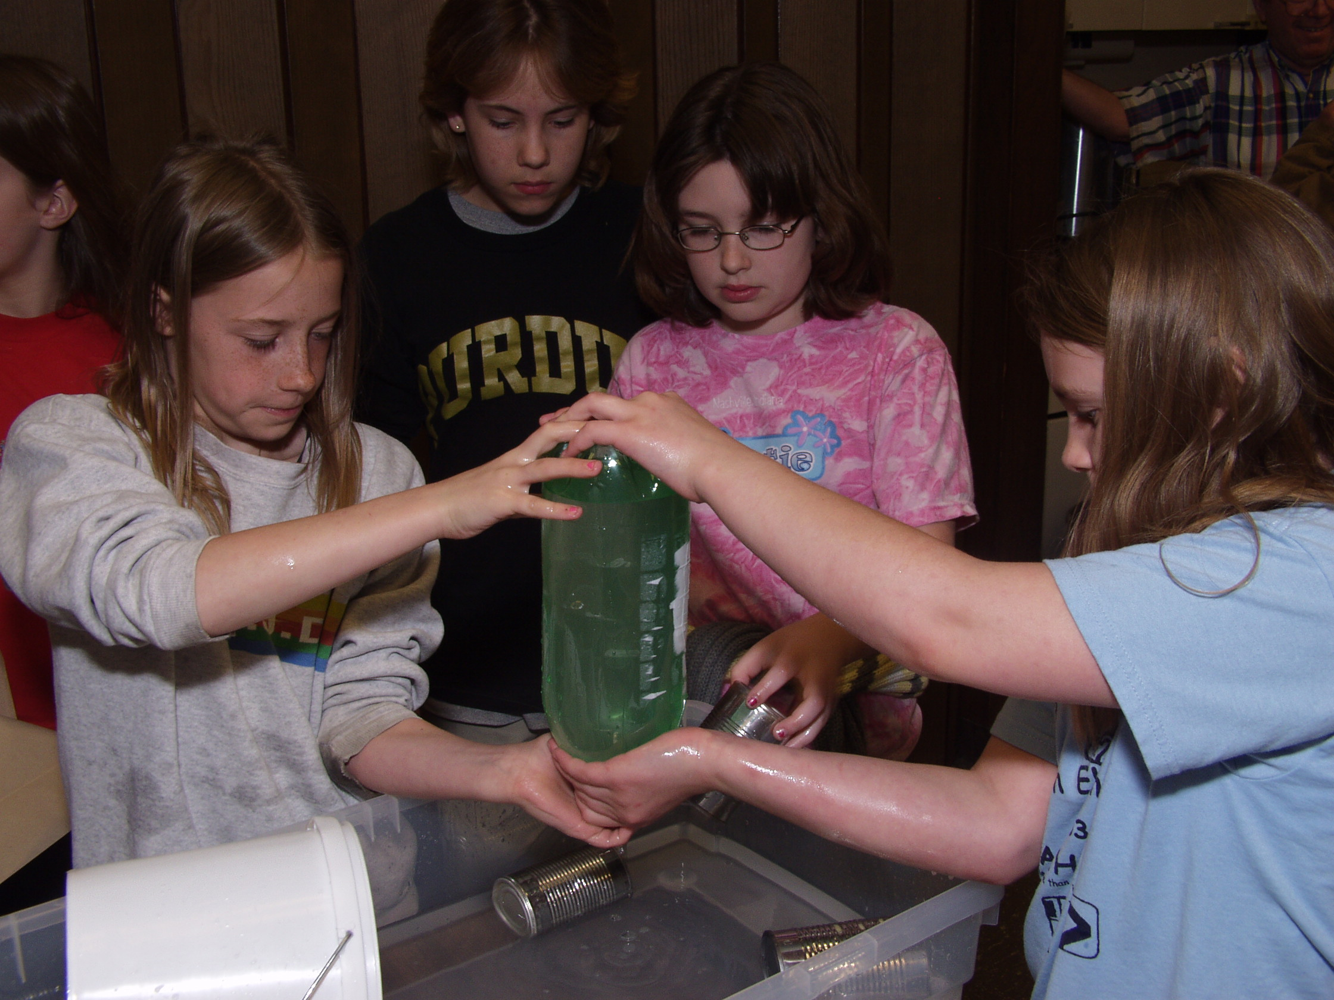
LOOK OUT BELOW II
What if the card is removed when the water jar is inverted? What’s the largest opening area of an inverted, water-filled container that can be supported by air without the use of a barrier at the water-over-air interface?
What is Needed?
• Collection of jars, bottles, or other cylindrical containers having various opening diameters
• Source of water
• Smooth cards, index cards, laminated cards or other flat surfaces (used to support water/air interface while inverting the bottle.
What to Do
Fill a soup can or baby food jar with water. Cover with a laminated index card. Slowly remove the care. What do you observe.
Fill various bottles with small diameters (like Tabasco sauce or sample-size shampoo bottles). Invert the water-filled container and observe whether the water stays in after a few drops drip out.
If water does flow out, place a smooth laminated index card at the water-air-interface. Slowly slide it off the opening. Observe what happens.
What is Happening?
When you inverted the baby food jar or soup can with water, inverted it, and removed the index card, you had a water-above-air interface and you observe the water spills out. Part of the reason for water spilling is gravity, but we know from experience with a card over the opening that air pressure is adequate to hold up the water in the jar. Something in addition to gravity must be happening to get the water spilling. That additional effect is called Rayleigh-Taylor Instability(RTI). The effect is that ripples at the water-over-interface grow larger and larger because the higher-density fluid (water) is above the lower-density fluid (air). The water-above-air interface is an unstable fluid interface.
When a water-filled bottle is turned upside down, the water will easily pour out if the bottle opening is sufficiently large. Sometimes it pours smoothly while other times it pours roughly , making a “glug-glug-glug” sound. The water pours out because ripples quickly form at the water-over-air interface and then RTI causes the ripples to grow rapidly into the stream or “glugs” of pouring water.
When a liquid-filled bottle with an opening only a few millimeters in diameter is turned upside down, most of the liquid stays in the bottle. Most of the liquid stays in the inverted bottles because surface tension smoothes the water-over-air interface so that RTI is blocked. Controlling RTI keeps the water within the bottles.

