
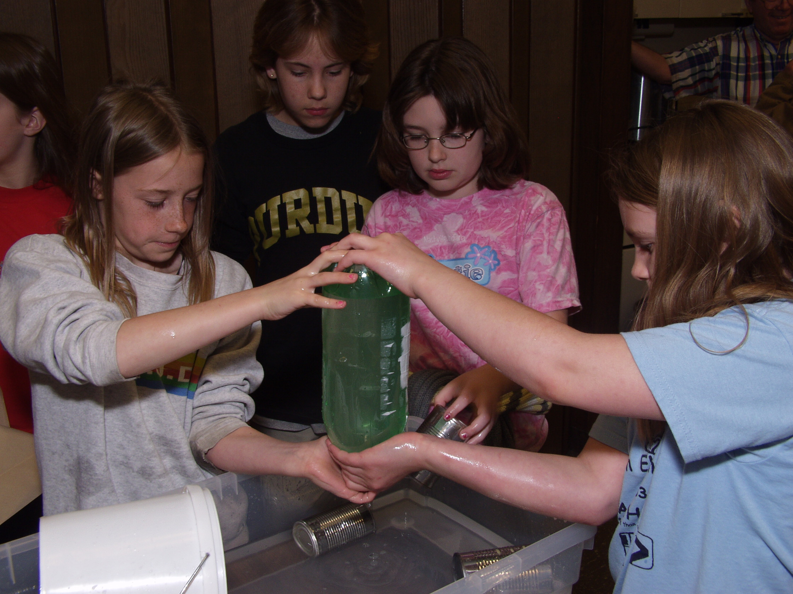
Upside-Down Can
Can you keep the water in an upside-down
soup can with a piece of cardboard?
What is Needed?
• Soup can
• Source of water
• Small, square light cardboard wide enough to cover the top of the soup can
• Kleenex
• Gauze
• Pop bottle
What to Do

Get a small, square light cardboard wide enough to cover the top of a soup can. Fill the soup can to the brim with water. Press the cardboard on top of the can. Make sure that the cardboard touches the can all the way around the rim. Now invert the soup can. Remove your hand from the cardboard. What happens? Next, try replacing the cardboard with a Kleenex.
What is Happening?

Try This

Now that you’ve gained courage with the soup can and Kleenex, fill a 2-liter pop bottle with water. Wrap a piece of gauze around the top tightly, single-layered. Now, invert the 2-liter bottle. As you watch, think about the fact that gauze has holes in it!

