
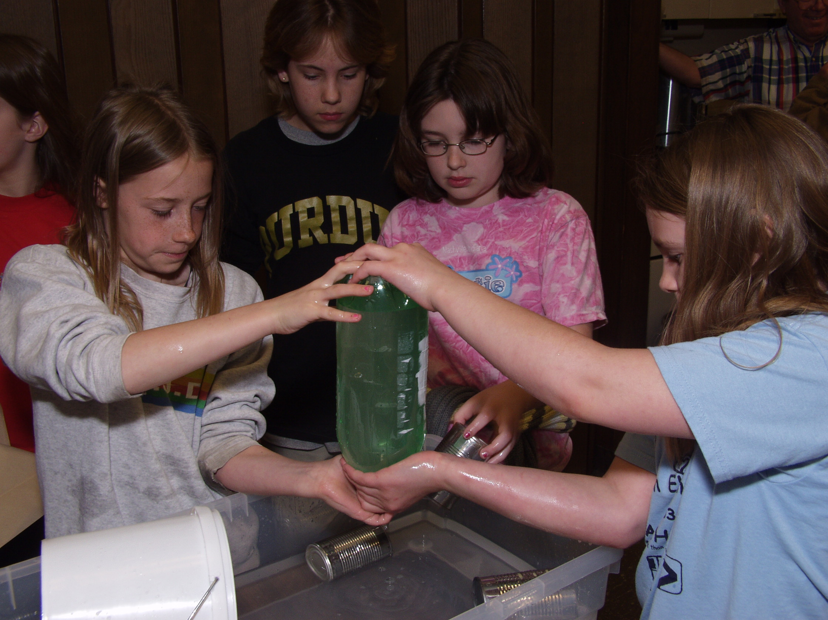
Upside-Down Can
Can you keep the water in an upside-down
soup can with a piece of cardboard?
What is Needed?
• Soup can
• Source of water
• Small, square light cardboard wide enough to cover the top of the soup can
• Kleenex
• Gauze
• Pop bottle
What to Do

Get a small, square light cardboard wide enough to cover the top of a soup can. Fill the soup can to the brim with water. Press the cardboard on top of the can. Make sure that the cardboard touches the can all the way around the rim. Now invert the soup can. Remove your hand from the cardboard. What happens? Next, try replacing the cardboard with a Kleenex.
What is Happening?

When you and I look “up” from Earth, we seem to be surrounded by a beautiful blue sky that appears to extend forever outward. Some folks think we live on top of the world. Actually, we live at the bottom of a great sea of air over 600 miles high and weighing more than 5 quadrillion (5 million billion) tons. The “blanket” of air is squeezing down on every square foot of your body with an overwhelming pressure of 2,016 pounds! The only reason you aren’t flattened out is that air is also inside your body pushing out.

And so it is with the soup can. Air pressure pushing up against the cardboard or Kleenex should hold the water in the container.
Try This

Now that you’ve gained courage with the soup can and Kleenex, fill a 2-liter pop bottle with water. Wrap a piece of gauze around the top tightly, single-layered. Now, invert the 2-liter bottle. As you watch, think about the fact that gauze has holes in it!

No matter, the air pressure pushing up against the bottom of the gauze is greater than the air pressure inside the bottle pushing down, so the water remains in the bottle.

