Byrd Visualization
Laboratory
Note: Use this template to document your research progress over the 8-week program, and should include work done on both the visualization and research parts of the project. You should delete this note (do not remove the logo & logo) before submitting this document as your final documenation report.

Project Report
  - SROP Summer 2017

Name: <Add your name here>
Research Mentor: <Add your research mentor’s name and department here>
Research Mentor: <Add your research mentor’s name and department here>
Date Submitted: <add date submitted>
Contents
Abstract 1
Project Description 3
Project Goals 5
Week 1 6
Week 2 7
Week 3 8
Week 4 9
Week 5 11
Week 6 13
Week 7 15
Week 8 17
Project Poster 18
Project Files 19
Project Data Description 20
Visualization Tools 21
Acknowledgements 22

Abstract

checklist: parts of an abstract
For each section address the research and visualization aspects of your project.
Source: https://users.ece.cmu.edu/~koopman/essays/abstract.html
Motivation
Why do we care about the problem and the results? If the problem isn't obviously "interesting" it might be better to put motivation first; but if your work is incremental progress on a problem that is widely recognized as important, then it is probably better to put the problem statement first to indicate which piece of the larger problem you are breaking off to work on. This section should include the importance of your work, the difficulty of the area, and the impact it might have if successful.
Problem Statement
What problem are you trying to solve? What is the scope of your work (a generalized approach, or for a specific situation)? Be careful not to use too much jargon. In some cases it is appropriate to put the problem statement before the motivation, but usually this only works if most readers already understand why the problem is important.
Approach
How did you go about solving or making progress on the problem? Did you use simulation, analytic models, prototype construction, or analysis of field data for an actual product? What was the extent of your work (did you look at one application program or a hundred programs in twenty different programming languages?) What important variables did you control, ignore, or measure?
Results
What's the answer? Specifically, most good computer architecture papers conclude that something is so many percent faster, cheaper, smaller, or otherwise better than something else. Put the result there, in numbers. Avoid vague, hand-waving results such as "very", "small", or "significant." If you must be vague, you are only given license to do so when you can talk about orders-of-magnitude improvement. There is a tension here in that you should not provide numbers that can be easily misinterpreted, but on the other hand you don't have room for all the caveats.
Conclusions
What are the implications of your answer? Is it going to change the world (unlikely), be a significant "win", be a nice hack, or simply serve as a road sign indicating that this path is a waste of time (all of the previous results are useful). Are your results general, potentially generalizable, or specific to a particular case?

Other considerations
An abstract must be a fully self-contained, capsule description of the paper. It can't assume (or attempt to provoke) the reader into flipping through looking for an explanation of what is meant by some vague statement. It must make sense all by itself. Some points to consider include:
- Meet the word count limitation. If your abstract runs too long, either it will be rejected or someone will take a chainsaw to it to get it down to size. Your purposes will be better served by doing the difficult task of cutting yourself, rather than leaving it to someone else who might be more interested in meeting size restrictions than in representing your efforts in the best possible manner. An abstract word limit of 150 to 200 words is common.
- Any major restrictions or limitations on the results should be stated, if only by using "weasel-words" such as "might", "could", "may", and "seem".
- Think of a half-dozen search phrases and keywords that people looking for your work might use. Be sure that those exact phrases appear in your abstract, so that they will turn up at the top of a search result listing.
- Usually the context of a paper is set by the publication it appears in (for example, IEEE Computer magazine's articles are generally about computer technology). But, if your paper appears in a somewhat un-traditional venue, be sure to include in the problem statement the domain or topic area that it is really applicable to.
- Some publications request "keywords". These have two purposes. They are used to facilitate keyword index searches, which are greatly reduced in importance now that on-line abstract text searching is commonly used. However, they are also used to assign papers to review committees or editors, which can be extremely important to your fate. So make sure that the keywords you pick make assigning your paper to a review category obvious (for example, if there is a list of conference topics, use your chosen topic area as one of the keyword tuples).

Conclusion
Writing an efficient abstract is hard work, but will repay you with increased impact on the world by enticing people to read your publications. Make sure that all the components of a good abstract are included in the next one you write.

Project Description
Use this section to provide a description of your research project. Recall from week 1, the Introduction to Data Visualization presentation, Data Visualization is an Iterative Process. The seven steps to visualizing data was presented (see figure below), and over the course of the 8-week program you have been working through the visualization process in an iterative fashion. Use this section to provide a high level overview of your project (low level details will be provided in subsequent sections), your project goals, and what was done in each of the seven stages of the visualization process to achieve those goals.
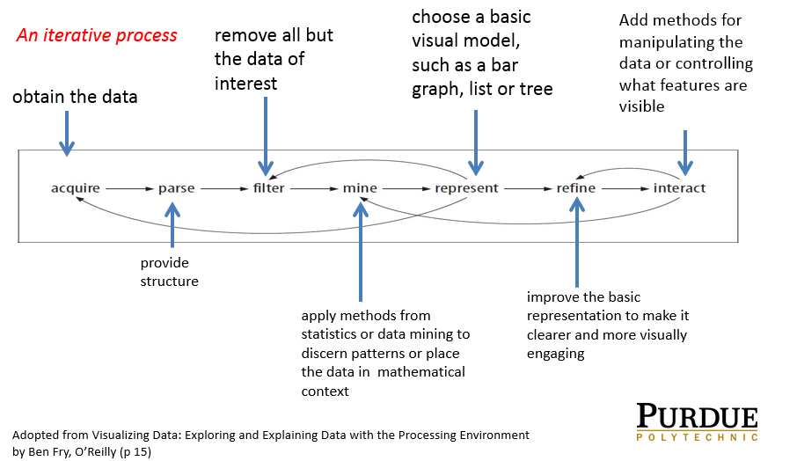
Figure 1 Data Visualization Process
Acquisition
<Add your text here>

Parse
<Add your text here>

Filter
<Add your text here>

Mine
<Add your text here>

Represent
<Add your text here>

Refine
<Add your text here>

Interact
<Add your text here if applicable >

Project Goals

List your Project goals
- Goal 1
- Goal 2
- Goal 3

Week 1

Administrative tasks
Week one was basically filled with administrative tasks, use this space to document what tasks were completed during week 1 (for example CITI Training).

Research related tasks
<Add your text here>

visualization related tasks
<Add your text here> Recall the questions you were asked to think about and get answers to regarding the data you will be working with. Add that information here.

Week 2
Use this space to document what tasks were completed during week 2. Recall, group meetings were held, and preliminary project goals were established, are a few things that occurred in week 2. Review your notes for any other events that took place.

Goals for Week 2 (list goals for this week)
<Add your text here>

Administrative tasks
<Add your text here>

Research Goals
<Add your text here>

Visualization Goals
<Add your text here>

Week 3
Use this space to document what tasks were completed during week 3.

Goals completed in Week 2

List the goals from Week 2 along with comments regarding the staus of these goals, and comment on why any goals WERE NOT met from last week, and how you plan to work towards reachinhg that goal.
<Add your text here>

Challenges encountered in Week 2
<Add your text here>

Goals for week 3: (list goals for this week)
<Add your text here>

Administrative tasks
<Add your text here>

Research Goals
<Add your text here>

Visualization Goals

<Add your text here>

Week 4

List the goals from Week 3 along with comments regarding the staus of these goals, and comment on why any goals WERE NOT met from last week, and how you plan to work towards reachinhg that goal.
<Add your text here>

Challenges encountered in Week 3
<Add your text here>

Goals for week 4: (list goals for this week)
<Add your text here>

Administrative tasks
<Add your text here>

Research Goals
<Add your text here>

Visualization Goals
<Add your text here>

Research Goals
<Add your text here>

Visualization Goals

<Add your text here>

Week 5

List the goals from Week 4 along with comments regarding the staus of these goals, and comment on why any goals WERE NOT met from last week, and how you plan to work towards reachinhg that goal.
<Add your text here>

Challenges encountered in Week 4
<Add your text here>

Goals for week 5: (list goals for this week)
<Add your text here>

Administrative tasks
<Add your text here>

Research Goals
<Add your text here>

Visualization Goals
<Add your text here>

Research Goals
<Add your text here>

Visualization Goals
<Add your text here>

Week 6

List the goals from Week 5 along with comments regarding the staus of these goals, and comment on why any goals WERE NOT met from last week, and how you plan to work towards reachinhg that goal.

Challenges encountered in Week 5
<Add your text here>

Goals for week 6: (list goals for this week)
<Add your text here>

Administrative tasks
<Add your text here>

Research Goals
<Add your text here>

Visualization Goals
<Add your text here>

Research Goals
<Add your text here>

Visualization Goals

<Add your text here>

Week 7

List the goals from Week 6 along with comments regarding the staus of these goals, and comment on why any goals WERE NOT met from last week, and how you plan to work towards reachinhg that goal.
<Add your text here>

Challenges encountered in Week 6
<Add your text here>

Goals for week 7: (list goals for this week)
<Add your text here>

Administrative tasks
<Add your text here>

Research Goals
<Add your text here>

Visualization Goals
<Add your text here>

Research Goals
<Add your text here>

Visualization Goals
<Add your text here>

Week 8

List the goals from Week 7 along with comments regarding the staus of these goals, and comment on why any goals WERE NOT met from last week, and how you plan to work towards reachinhg that goal.
<Add your text here>

Challenges encountered in Week 7

<Add your text here>

Project Poster
Insert a screen shot of your final poster here.

Project Files
List ALL project files and their locations in the table below; add more rows as needed by positioning the cursor in the last cell of the table and pressing the tab key.
Filename  (name of the file) | location  (Complete Path) | brief description
ExampleFilename.docx | C:\foldername\subfoldername

Project Data Description
<Provide a detailed description of your project data here>

Visualization Tools
Provide a description of the data visualization tools explored and considered for your project. Provide some rationale as to why you used the visualization tools you used, and why you did not choose the others listed.

Acknowledgements
Use this space to acknowledge the help and collaboration of others who helped you on the project and during the 8-week program
<Add your text here>

